


Empowering Communities

DOCUMENTATION OF CLIMATE CHANGE ADAPTATION PRACTICE: THE CASE OF LIVESTOCK

REPORT

Civil Society Network on Climate Change
Plot No. LK 388, Along Glynn Jones Rd, Namiwawa
P O Box 1057
Blantyre, MALAWI

e: www.cisonecc.org
t.: +265 (0) 212 700 104

ACKNOWLEDGEMENTS

CISONECC isgrateful to all the smallholder farmers in Dedza and Chikwawa who are working with CADECOM and participated in this study. They participated with great enthusiasm and contributed a wealth of knowledge during the data collection period. Last but not the least, gratitude goes to the following individuals: Chimwemwe Phiri and Yusuf Mkungula of CADECOM office, Mr George Chasakala and Wilfred Tsabola both from Chikwawa CADECOM, MrBenardKanyumba (Programme Coordinator) and Joseph Chimdzakazi (field officer) from Dedza CADECOM officewho contributed a wealth of knowledge and other logistical support.

Special thanks are due to the consulting team led by Associate Prof. Timothy Gondwe and comprising Daniel Chiumia and Wilson Nandolo for investing their time and skills in this exercise.

ACRONYMS

ARCC African and Latin American Resilience to Climate Change
AVOs Assistant Veterinary Officers
CADECOM Catholic Development Commission
CISONECC Civil Society Network on Climate Change
EPA Extension Planning Area
FAO Food and Agriculture Organization of the United Nations
FGD Focus Group Discussions
GHG Greenhouse Emissions
HH Households
KI Key informant
LSD Lumpy Skin Disease
LUANAR Lilongwe University of Agriculture and Natural Resources
M&E Monitoring and Evaluation
M&E Monitoring and Evaluation
MoAFS Ministry of Agriculture and Food Security
NGO None Governmental Organisations
PPP Public Private Partnership
SCC Swedish Cooperative Centre
SD Standard Deviation
SPSS Statistical Products and Services Solutions

TABLE OF CONTENTS

ACKNOWLEDGEMENTS i
ACRONYMS ii
TABLE OF CONTENTS iii
LIST OF TABLES v
LIST OF FIGURES vi
LIST OF BOXES vii
LIST OF CASE STUDIES viii
EXECUTIVE SUMMARY ix
1 BACKGROUND 1
1.1 Project overview 1
1.2 Understanding of replicable climate change adaptation practices 1
1.3 Specific tasks of the Study 1
1.4 General approach 2
1.5 Specific approach 3
1.6 Expected outputs 4
2 METHODOLOGY 4
2.1 Data collection 4
2.1.1 Literature Review 4
2.1.2 Household survey 4
2.1.3 Key informant interviews 5
2.1.4 Focus Group Discussions 5
2.1.5 Observations 5
2.2 Demographic information 5
2.3 Data Analysis 6
2.4 Limitations 6
3 DESCRIPTION OF THE STUDY AREAS 7
3.1 Levels and sources of income 7
3.2 Livestock production statistics 11
3.2.1 Livestock ownership and status 11
3.2.2 Livestock diversity 12
3.2.3 Livestock flock and herd sizes 13
3.2.4 Livestock production and housing systems 14
3.2.5 Purposes for keeping livestock 15
3.2.6 Livestock health and veterinary services 17
3.2.7 Estimation of the values of livestock products and services for the year 2013 17
3.2.8 Livestock products and services trends 18
3.2.9 General and climate related challenges facing livestock production 19
3.3 Relationship between household income and livestock ownership 21
3.4 Climate changes and the adaptability of livestock and households 21
3.4.1 Farmers’ perception of climate change issues 21
3.4.2 Climate change impacts on livestock and adaptability of livestock to the impacts 22
3.4.3 Integration of irrigation agriculture and livestock production 23
3.4.4 Preference for livestock breeds in the context of climate change 24
3.4.5 The adaptability of households to the effects of climate change 24
3.5 Recommended livestock model for the study areas 25
3.6 Recommended livestock species to promote as priority 29
4 CONCLUSIONS AND RECOMMENDATIONS 31
4.1 Conclusions 31
4.1.1 Replicable livestock practices and technologies 31
4.1.2 Economic activities 31
4.1.3 Livestock diversity and production practices 31
4.1.4 Livestock utilisation 31
4.1.5 Livestock challenges 32
4.1.6 Relationship between livestock and household income 32
4.2 Recommendations 32
5 APPENDICES 33
Appendix 1: Statistics tables 33
Appendix 2: Household interviews semi-structured questionnaire 34
Appendix 2: Focus Group Discussion interview guide 46
Appendix 3: Key informants interview guide 50

LIST OF TABLES

Table 2-1: Demographic information 6
Table 3-1: Household characteristics 7
Table 3-2 : Sources of income 8
Table 3-3: Levels of income from each income source in 2013 9
Table 3-4: Livestock ownership 11
Table 3-5: The Gini coefficients for the ownership inequality of each of the livestock species 12
Table 3-6: Flocks and herd sizes of different species of livestock 14
Table 3-7: Production and housing systems, and purposes for keeping livestock 14
Table 3-8: The products and services obtained from livestock 15
Table 3-9: Value of products and services in the last accounting period (growing season) 17
Table 3-10 : Livestock challenges in general and those related to climate change impact 19
Table 3-11: The correlation between different variables and the number of different types of livestock owned per household 21
Table 3-12: Farmers’ understanding of the term climate change (n = 48) 21
Table 3-13: Climate change effects and factors that are exacerbating them 22
Table 3-14: Impacts of climate change on livestock and adaptability of livestock to the impacts 22
Table 3-15: Farmer's preference for livestock breeds in the context of climate change 24
Table 3-16: Ways how households use livestock to increase their resilience to climatic shocks 25
Table 5-1: Total number of livestock owned in Golomoti and Mbewe EPAs 33
Table 5-2: Mean number of livestock per household by extension planning area 33
Table 5-3: Mean number of livestock per household by gender of household head 33

LIST OF FIGURES

Figure 3-1: Average proportions of different sources of income in the last growing season in both study areas. 8
Figure 3-2: Respective contribution of household income from different sources in three agro-ecological zones. 10
Figure 3-3: Respective sources of household income from livestock by species among male and female headed households. 11
Figure 3-4: Flock distribution of various livestock species among farmers in Dedza and Chikhwawa CADECOM impact areas. 12
Figure 3-5: Percentage of households owning different types of livestock 13
Figure 3-6: Trends in the levels of different products and services derived from livestock 19
Figure 3-7: Cattle grazing in climate affected zones with long dry seasons. 20
Figure 3-8: Livestock and Conservation Agriculture without or with partial integration 26
Figure 3-9: Livestock and Conservation Agriculture with integration and intensification 27
Figure 3-10: Livestock and Irrigation without integration 28
Figure 3-11: Optimal Livestock and Irrigation integration 28

LIST OF BOXES

Box 1: Improvement of nutrition through more livestock ownership: does it work all the time? 16
Box 2: Effects of climate change on livestock diseases 20
Box 3: Balancing livestock production and irrigation agriculture 24

LIST OF CASE STUDIES

Case study 1: Household utilisation of livestock as a tool for increasing resilience to climate change effects 16
Case study 2: Livestock diversification, a pathway for significant contribution of livestock to household income and resilience to climate change effects 21
Case study 3: Livestock and household adaptation mechanism to feed scarcity 23

EXECUTIVE SUMMARY

This study was commissioned by CISONECC to document best bet livestock practicestoclimate change adaptation based on field work experience and isolate lessons with higher potential for out and up scaling. CISONECC is involved in a three year project, ending 2016,which is aimedat increasing food security, income and resilience to climate change among households in selected districts in Southern Malawi by developing and implementing interventions that lead to;a) sustainable food, and related to that, nutrition security, b) increasing contribution to household income from the interventions, andc) climate change compatible. Hence the necessity to document livestock practices or technologies which are compatible and integratableinto the existing or slightly modified production systems favourable to smallholder farmers and less privileged members of the communities.

Hundred a twenty four respondents from Dedza and Chikhwawa districts CADECOM impact areas participated in this study through household interviews (50), FGD (67) and KI interviews (7). The respondents defined climate change in respect to change in rainfall pattern, low crop yields, high temperature and drought.The respondents reported that climate change effects have negatively affected cattle, goats and chicken production comparatively higher than other species through a) scarcity of feed, b) lack of or access to drinking water, c) increased livestock diseases; and d) reduced area for grazing which are resulting in low livestock production and poor breeding. However, the study has reviewed that selected livestock species, for instance cattle and goats, have adapted to the effects of climate change by increasing the diversity of feed sources and grazing area coverage. For instance, farmers have of late observed cattle eating soil and goats eating shrubs which was not the case in the past. At farm level, the majority of households raisinglivestock have adopted grazing and scavenging feeding systems, as management practices toincrease livestock adaptation to climate change effects. Inevitably, the modification offeeding systems is resulting in farmers encroaching forest and irrigated areas. The later challenge is being addressed by fencing off the irrigated areas without restricting farm animals’ access to water points.

The results further showed that when there are droughts, floods and other disasters, livestock are normally sold. It was also noted that livestock are sold to buy farm inputs even in periods of normal climatic conditions, which makes the livestock a very important part of the diverse production systems.This report includes case studies and available also invideo format to validate:
- How household utilise livestock as a tool for increased resilience to climate change effects.
- How livestock diversification significantly contributes to household income and resilience to dynamic shocks, climatic related inclusive, and
- Existing mechanism or strategies for livestock and household adaptation to feed scarcity and conflict with smallholder irrigation.

In short, the study has demonstrated that some practices and technologies have the potential for out and up-scaling livestock integration into diverse production systems in the context of climate change among smallholder farmers. The selection of practices also ensures 1) enhanced livelihood contribution 2) equitable distribution of livestock, and 3) climate compatibility. The selected practices and technologies include:
- Controlled grazing and scavenging feeding systems
- Construction of raised goat houses (kraal)
- Fencing irrigated areas while providing access to water points for increased synergy with irrigation farming
- Establishment of drug boxes
- Livestock diversification at household level with priority species being indigenous goats and chickens which were more equitably distributed than any other livestock species. Additionally, goats are high disease resistant and easy to feed, provided water, sell and secure.

It is in view of the results from this study thatthe following recommendations were made:
- There is need to use appropriate livestock species in order to meet the intended objectives of the intervention. For instance, goats and poultry, preferably indigenous breeds,are ideal for increasing household resilience to climate change among smallholder farmers.
- There is need to improve livestock diversity in the study areas in order to make the usability of livestock as a tool for adapting to climate change more effective.
- To address the problem of livestock diseases in the CADECOM impact areas or beyond, it is suggested that:
  - There should be a stronger collaboration with the government veterinary health workers responsible for the areas (Public Private Partnership model).
  - To complement limited Government human resource in veterinary services, use of Community Animal Health Workers should be enhanced in the region. These should be empowered to operate on business, profit oriented model rather than mere cost recovery model.
  - Existing drug boxes must be revived, and farmers should be appropriately trained in drug box concept (underlying principles) and the training should be offered by the project implementers in collaboration with government officers.
- Irrigation agriculture and livestock production should be seen as complementary activities, and efforts should be made to integrate the two to ensure utilisation of the potential synergy between the two. Some of the possible improvements include:
  - Facilitating establishment of by-laws to collectively reserve certain watering points for use by livestock.Village Development Committee and Chiefs should take a leading role in close collaboration with Government officers and project implementers should actively participate in the process.
  - Where resources exist, promoting fencing around the cultivated field only but leaving the water points outside the fence so that they are also easily accessible to livestock.
  - Strengthening livestock farmers’relationship with people owning irrigated fields in “Dambo” to supply the latter with manure in exchange for rights to use the latter’s crop residues and crop by-products where possible, instead of having the residues burnt.
  - Promote a culture of feed conservation during period of plenty (from rain-fed and irrigable lands) to supplement during period of scarcity. This is especially for cattle and goats, utilising both from irrigable and rain fed cropping.
- The promotion of indigenous livestock breeds’ calls for the need to facilitate community based breeding programs (farmer based selection of breeding stock) that will provide improved but adapted local livestock breeds and enhance breed development to increase yield and adaptation to local environments.
- A shift towards livestock intensification for some species, especially cattle need to be integral component of the program. This will allow proper integration into the crop-irrigation – livestock system.

BACKGROUND

Project overview
The Civil Society Network on Climate Change (CISONECC) and the Catholic Development Commission (CADECOM) partnered in a project called “increasing Food Security, Income and Resilience to Climate Change in Southern Malawi” in order to document replicable livestock practices that can be used for climate change adaptation fromCADECOM project impact areas in Chikhwawa and Dedza. The project seeks to document and share best practices in climate change mitigation and adaptation practices or technologies based on field work experience and lessons for duplication and scaling up. Documentation on livestock adaptation practices had a goal to integrate livestock sector related practices into the broader conceptfor the climate change adaptation.

Understanding of replicable climate change adaptation practices
The aforementioned project aims at increasing food security, income and resilience to climate change among households in selected districts in Southern Malawi by developing and implementing interventions that lead to 1) sustainable food, and related to that, nutrition security, 2) increasing contribution to household income from the interventions, and 3) are climate change compatible. In addition, such interventions have to be compatible and integratedinto the existing or slightly modified production systems while ensuring enhanced equity of distribution of outputs and benefits to include even the less privileged members of the communities.

The above mentioned factors do not spare livestock production, both small-scale and large-scale production. Essentially, livestock is a key element to positive and negative mitigation of climate change effects. Two scenarios exist for livestock and climate change: 1) negatively influencing climate change by way of greenhouse emissions (GHG), diminishing land holding sizes and land degradation, especially marginal lands and fields designated as water sheds or for irrigation; loss of diverse species or breeds due to floods, draughts or negative interaction between climate and livestock; 2) positively influencing climate change in the sense that livestock is a key frontline adaptationmeasure against climate change effects, and usually provides complementarity and synergy when integrated into other production systems.

It is a common understanding that a properly packaged livestock model is essential to drive food security, enhance income growth and equity for majority of community households while negating climate change consequences. One key principle of this model is that it should be systems specific, adoptable and adaptable, in conformity with community practices. This required complete documentation of current practices, identification of strengths and opportunities and exploring options for weaknesses and threats, hence this action.

Specific tasks of the Study
The study to documentlivestock production as a climate change adaptation practice based on experiences from CADECOM project impact areas of Chikwawa and Dedzahad the following specific tasks:
- Analyse the national context of vulnerability to climate change in relation to livestock production and the existing and potential contribution of livestock to household food security and livelihoods enhancement in the context of climate change in Malawi;
- Document prevailing practices of livestock production and distribution systems in CADECOM project impact areas of Chikwawa and Dedza including mechanisms that farmers employ to sustain their livestock in the context of a changing climate;
- Document and analyse factors that favour and/or hamper sustainable livestock production in the face of climate change in CADECOM target areas of Chikhwawa and Dedza including interaction of livestock with cropping systems, geophysical conditions and socio cultural factors;
- Compile case studies in selected project impact areas of CADECOM Chikhwawa and Dedza to demonstrate the contribution of livestock production to climate change adaptation at household level; and
- Based on the documentation and analysis, provide recommendations for scaling up and ensuring sustainable livestock production to enhance local adaptation to climate change within and beyond the locality of the selected CADECOM target areas of Chikhwawa and Dedza.

Generalapproach
The following key areas were considered and investigated in carrying out the assignment:
- The present and potential livestock sector contribution to human livelihood, mainly using direct indicators of income contribution by species and breeds within species; and valuing tangible and intangible outputs from sampled household flocks or herds. Annual household income, and specific proportions of income from different sectors (crops, livestock, and off-farm) were first evaluated. Firstly, reports of monitoring and evaluation (M&E) for projects that contain the livestock indicator and the indicator of income contribution as per Harmonised M&E Manual of the Ministry of Agriculture and Food Security(MoAFS)were reviewed (MoAFS 2012). Additional data werecapturedthrough a householdsurvey, key interviews and focus group discussion.
- The role livestock plays in food security enhancement. This was assessed indirectly by analysing the role livestock plays in terms of people’saccess tofood from harvests (e.g. manure, direct labour payment), food purchase (using income from livestock) or food barter (direct exchange of livestock with energy food).
- The influence of livestock to land use and degradation, and potential contribution to greenhouse gas emissions (GHG)(Pathak et al. 2013).The livestock sector, especially grazing animals, are believed to contribute to land degradation, critical to this current decade of use of marginal lands due to increased human population, and changing cropping systems as mitigation measures of climate change adaptation(Malawi Government, 2011). These plus associated factors were evaluated from both reports and interviews.
- Interaction of cropping and livestock systems in the project areas. The crop sector adaptation to negative influences of climate changes considered include expansion of usage of wetlands under the promotion of irrigation farming, and promoting use of crop residues in conservation agriculture practices. These lead to limited access of feed and water inputs to livestock if not well articulated into the implementation plans. On the other hand, majority of livestock technologies implemented are, obsolete and had no consideration of emerging cropping systems. The interaction between livestock and crop farming systems will require systems shift and adaptation to compromise the two and optimise synergies. All species elements of the integration (including livestock to livestock integration) were evaluated and documented.
- Combined effect of livestock integration. Majority of households keep diversity of livestock species and breeds within species. This diversity is key to sustainable utilisation, while it provides basis of a risk averse adaptation to disasters, important for food security under subsistence farming systems. Livestock integration provides window of circulation of inputs, leading to an enhanced output. The elements of integration, species included, breeds within species, and their specific roles were evaluated and documented. Later, through a modelling approach, a combination of components that can bring optimised outputs were establish.
- Evaluation of existing technologies in livestock interventions.A checklist of existing technologies and interventions were used to document their existence and usage, and if adopted but later not practiced by households, reasons for such were also captured. From the data, level of adoption of technologies by households was analysed, alongside the practicability of such interventions. Critical analyses were done on impact of such interventions on increased livestock numbers, increased productivity, impact on natural resources including other production systems, and impact on equity of distribution of livestock and its benefits among households.
- Evaluation of production constraints and how farmers cope with or exacerbatethe challenges. Alongside approach Number 6, constraints to current production and potential coping means that households adopt were captured through questionnaire or checklist of focus group discussion. The analyses helped to establish traditional practices beyond classical theories that farmers employ to sustain their livestock.
- Developing sector specific livestock strategies and models. Based on the analyses from the approaches stated above, sector specific strategies for sustainable livestock production in the face of climate change were developed through modelling and simulations of all factors. Where possible, the proposed strategies and models were pre-tested using available data collected to safeguard against erosion of biodiversity (key to sustainability), climate change incompatibility and inequality of socio-economic status of households.

Specific approach
All general approaches were implemented holistically by the following specific actions:
- Analysis ofthe national context of vulnerability to climate change in relation to livestock production and the existing and potential contribution of livestock to household food security and livelihoods enhancement in the context of climate change in Malawi;
- Documentation of the prevailing practices of livestock production and distribution systems in CADECOM target areas of Chikhwawa and Dedza including mechanisms that farmers employ to sustain their livestock in the context of a changing climate;
- Documentation and analysis of the factors that favour and/or hamper sustainable livestock production in the face of climate changein CADECOM target areas of Chikhwawa and Dedza including interaction of livestock with cropping systems, geophysical conditions and socio cultural factors;
- Compilation of case studies in selected CADECOM impact areas of Chikhwawa and Dedza to demonstrate the contribution of livestock production to climate change adaptation at household level; and
- Recommendations for scaling up and ensuring sustainable livestock production to enhance local adaptation to climate change

Expected outputs
The expected outputs from the study were as follows:
- A valued livestock sector in the Dedza and Chikwawa CADECOM impact areas in terms of holistic and specific species contribution towards household income, and values of food, income and social outputs, and values of losses due to deaths, predation or theft of animals. Target livestock species were identified for further in-depth analyses and recommendations.
- General and species specific contribution of livestock to food security was determined for the study area, to guide important location/system-specific species to promote.
- The impact of different livestock on natural resources management was positioned.
- An integrated situation analysis of livestock to livestock, and livestock to crop integration produced for informed selection of suitable and climate compatible cropping and livestock systems.
- A combined livestock integrated model developed for testing and implementation in Dedza and Chikwawa CADECOM impact target areas.
- A documentation of common practices currently in place in Dedza and Chikwawa CADECOM project impact areas, their adoption and practicability on livestock and other systems. This formed a base data for modelling a proposed system of practices that include ability to out and up-scale the interventions.
- A matrix of constraints and their traditional coping means documented for use during developing best bet practices for the livestock sector

METHODOLOGY

Data collection

Literature Review
This involved review of existing project and relevant documents and literature in Malawi and other countries;and other sources. This was done in order tocoherently contextualise factors that potentially would enable and/or impede scaling up and sustainability of the livestock practices as a tool for adapting to climate change effects and impacts among the smallholder farmers.

Household survey

Structured Questionnaires
A structured questionnairewas used tocollectdata required to determine specific output indicators specified in Sections 4.1 to 4.3.Additionally, it provided quantitative farmers’ disaggregated data while complementing the other qualitative tools and methods by highlighting how different farmers use livestock as adaptive tool to climate change. This tool had specific sections to collect data on
- Demographics, the farmers’ economic activities and sources of income
- Livestock statistics, management, utilisation and challenges
- The farmers’ understanding of climate changes issues
- The place of livestock in climate change and climate change mitigation and adaptation

The questionnaire was in English. Enumerators visited the selected households and interviewed the household heads or the next person responsible for the household in the absence of the household head. The enumerators asked the questions in the vernacular language and recorded the responses in the provided spaces. The data were then validated by the supervisors before entry into a data file.

Sampling procedure
Households that were interviewed in the survey were selected randomly from a list of the households participating in CADECOM development activities in the study areas. Initially, a sample size of not less than 60 was to be selected from both areas (at least 30 from each), but due to time constraints, a sample of 10 was drawn from Dedza and 40 from Chikhwawa (see Table 2.1).

Key informant interviews
A key informant questionnaire was used to collect technical data from veterinary, agriculture, butcher men and other field workers involved in livestock production and marketing in the study areas. The questionnaire essentially had similar questions to the household questionnaire, but emphasis was on trying to get a broader picture for the informant’s area of jurisdiction/operation. A total of 15 key informants were interviewed. Each informant was interviewed separately. The key informants’ information was very invaluable, since individual farmers’ responses tended to vary very widely on variables such as livestock growth parameters and product prices.

The key informant interviews provided an in-depth understanding of the consultant tasks and targeted outputs. It provided detailed explanations for livestock practices, factors related to the success and failure of the factors in relation to use livestock in the context of climate change. The method also provided information required for documentation of the case studies demonstration how households use livestock to increase their resilience to climate change shocks. The checklists were developed based on assigned specific tasks in the contract, consultant knowledge and information from other relevant documents reviewed prior to field work.

Focus Group Discussions
Focus Group Discussions (FGD) ensured that more participatory methods were used to collect data and that more households from the project impact areas of CADECOM got involved in this documentation process. Three FGDs were conducted to get the general view of the farmers on how livestock in their areas use it in respect to the changing environment.

Observations
Continuous observations were made to substantiate thestrategic quantitative and qualitative data collectedthrough the aforementioned tools.

Demographic information
Based on the above sections, the current study involved household interviews among CADECOM beneficiaries in Golomoti (10) (Dedza) and Mbewe (40) (Chikhwawa) EPAs; 3 and 4 key informants’ interviews and FGDs with a total of 15 and 52 farmers participants, respectively. Majority of the participants were elderly with enough experience on climate changes related effects and impacts in their respective areas; the average age of household head was 45 years. Fewer households were sampled in Golomoti EPA (10) than in Mbewe EPA (40) as given inError: Reference source not found. The majority of the respondents (96%) were either the husband or the wife in the household. The majority of the household heads (92%) were male.

Table 2-1: Demographic information
Variable | District | Frequency | Percent
District (also corresponding to EPA Golomoti and Mbewe, respectively) | Dedza | 10 | 20
 | Chikhwawa | 40 | 80
Position of respondent in the household | Husband | 26 | 52
Position of respondent in the household | Wife | 22 | 44
Position of respondent in the household | Child | 1 | 2
Position of respondent in the household | Other | 1 | 2
Gender of household head | Male | 46 | 92
 | Female | 4 | 8

Data Analysis
Quantitative data from questionnaires was analysed using IBM Statistical Products and Services Solutions(SPSS)version 22. Qualitative data from in-depth interviews or consultations with partners, FGDs, and participant observations were transcribed, coded and then interpreted based on tasks specified in the study. The transcripts were analysed using a coding process to add key words that became the basis for the analysis. Throughout the analysis, the adequacy of existing scientific data and information to support the responses were considered.In order to collect farmers disaggregated data, FGDs involved farmers by gender categories both women and men. There was also triangulation of data from all quantitative and qualitative data collection tools to complement each method’s findings and build consensus on the results/findings. Documents were analysed using content analysis bearing in mind the audience and aims of the documents to avoid using biased information.

Limitations
The study was designed to capture both quantitative and qualitative data. However, it was discovered that some of the farmers had just started keeping animals in the recent past, so there were a lot of missing data for some of the variables that were planned to be analysed. The data collection exercise was rushed due to the client’s short time demands. There was also an indication of poor communication between the Head and Field offices, which delayed the data collection process. This led to a further reduction of the sample size. This has resulted on heavy reliance on key informants and focus group discussions.

DESCRIPTION OF THE STUDY AREAS

3.1 Socioeconomic Characteristics
Demographic information is provided in Section 2.2. Presented here is the socio-economic status of households. There were no significant differences between the EPAs in terms of household characteristics such as age of household head (44.5 years) and household size (5.6 people per household) as given inTable 3-2. The household size was close to the national average. Farmers in Mbewe EPA (Chikhwawa) had relatively more land under active cultivation than those in Golomoti (Dedza), although the land holding sizes were the same. The amount of irrigable land was small (0.1 ha), and such land is normally fenced off and solely reserved for growth of crops, keeping out livestock in the process (potential conflict between livestock and irrigation systems). In both EPAs, this occurs at the same time livestock are in need of drinking water, during the period from May to November. On the other hand, there is more land for grazing in Golomoti than in Mbewe.

Table 3-2: Household characteristics
Category | Variable | Extension planning area | Mean | Standard deviation | p(t)
Demographics | Age of the household head (years) | Golomoti | 39.9 | 9.26 | 0.316
Demographics | Age of the household head (years) | Mbewe | 46.2 | 17.2 | 0.316
Demographics | Age of the household head (years) | Overall | 44.5 | 16.1 | 0.316
Household size | Number of Males | Golomoti | 2.90 | 1.10 | 1.00
Household size | Number of Males | Mbewe | 2.92 | 1.53 | 1.00
Household size | Number of Males | Overall | 2.90 | 1.43 | 1.00
Household size | Number of Females | Golomoti | 3.10 | 2.38 | 0.530
Household size | Number of Females | Mbewe | 2.62 | 1.02 | 0.530
Household size | Number of Females | Overall | 2.70 | 1.37 | 0.530
Household size | Household size | Golomoti | 6.00 | 2.71 | 0.592
Household size | Household size | Mbewe | 5.54 | 1.89 | 0.592
Household size | Household size | Overall | 5.60 | 2.05 | 0.592
Land holding (hectares) | Amount of land owned by household | Golomoti | 2.15 | 1.83 | 0.052
Land holding (hectares) | Amount of land owned by household | Mbewe | 3.91 | 3.80 | 0.052
Land holding (hectares) | Amount of land owned by household | Overall | 3.50 | 3.53 | 0.052
Land holding (hectares) | Land that is actively under cultivation | Golomoti | 1.23 | 0.960 | 0.006
Land holding (hectares) | Land that is actively under cultivation | Mbewe | 2.97 | 3.18 | 0.006
Land holding (hectares) | Land that is actively under cultivation | Overall | 2.58 | 2.93 | 0.006
Land holding (hectares) | Land that is lying idle | Golomoti | 0.830 | 1.017 | 0.904
Land holding (hectares) | Land that is lying idle | Mbewe | 0.804 | 1.240 | 0.904
Land holding (hectares) | Land that is lying idle | Overall | 0.793 | 1.182 | 0.904
Land holding (hectares) | Land that is used for grazing animals | Golomoti | 0.100 | 0.316 | 0.517
Land holding (hectares) | Land that is used for grazing animals | Mbewe | 0.031 | 0.192 | 0.517
Land holding (hectares) | Land that is used for grazing animals | Overall | 0.044 | 0.219 | 0.517
Land holding (hectares) | Land that can be irrigated | Golomoti | 0.172 | 0.231 | 0.427
Land holding (hectares) | Land that can be irrigated | Mbewe | 0.104 | 0.248 | 0.427
Land holding (hectares) | Land that can be irrigated | Overall | 0.118 | 0.244 | 0.427

Levels and sources of income
Table 3-3shows the main source of income for the farmers from crops, mostly cotton, maize and sorghum, in that order. According to the farmers, livestock are the next most important source of income. Farmers described livestock as very useful sources of cash in times of emergencies. They use the income realised from livestock to buy food or to pay for school fees and when all other sources have failed. Salaries and wages from provision of casual labour and home industries are on position three and four, respectively. In times of hunger, farmers in Mbewe EPA also known asMsiyamphanjeusually go to work on other people’s farms and at Illovo Sugar Company in order to earn income. They also engage in home industrial activities which include vending, beer brewing and making of palm leaf products such as baskets, which they sell for cash or exchange with food.

Table 3-3: Sources of income
Source of income | Number | % most important | % second most important source | Overall rank
Crops | 46 | 60.9 | 32.6 | First
Livestock | 32 | 18.8 | 62.5 | Second
Salary and wages | 18 | 38.9 | 22.2 | Third
Home industry | 14 | 57.1 | 14.3 | Fourth

Sale of crop produce and home industries were the most important sources of income, followed by livestock, and salaries and wages (Figure 3-1). Farmers in Mbewe EPA also get more income from cotton and livestock than those in Golomoti EPA. Based on income contribution to households (Table 3-4), livestock is more important in Mbewe EPA than in Golomoti EPA.
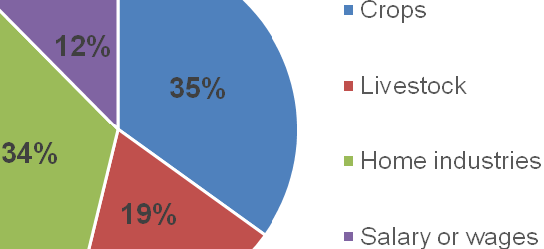
Figure 3-1: Average proportions of different sources of incomein the last growing season in both study areas.

Table 3-4: Levels of income from each income source in 2013
Source of income | Golomoti EPA |  |  |  | Mbewe EPA |  |  |  | Overall
Source of income | N | Mean | Standard deviation | Median | N | Mean | Standard deviation | Median | N | Mean | Standard  deviation | Median
All crops | 9 | 56044ª | 52258 | 60000 | 37 | 87741ª | 133657 | 50000 | 46 | 81539 | 122223 | 52500
Cotton | 9 | 25822^{b} | 25900 | 21000 | 34 | 94206ª | 149864 | 52500 | 43 | 79893 | 136259 | 40000
Maize | 6 | 21167ª | 16928 | 18000 | 21 | 34381ª | 65886 | 7000 | 27 | 31444 | 58529 | 8000
Sorghum | 5 | 16000ª | 30241 | 3000 | 12 | 6783ª | 20031 | 0 | 17 | 9494 | 22874 | 0
Livestock | 8 | 11000^{b} | 13342 | 6000 | 24 | 55100ª | 88733 | 25000 | 32 | 44075 | 79109 | 21000
Home industries | 6 | 69333ª | 69867 | 55000 | 8 | 86000ª | 94639 | 25000 | 14 | 78857 | 82301 | 30000
Salary or wages | 4 | 37000ª | 28213 | 35000 | 14 | 26679ª | 26640 | 19750 | 18 | 28972 | 26508 | 20000
Means with different superscripts in the same row are significantly different at p (t) = 0.05. 1 US$ ~ MK400.00).

Findings from other previous studies in three agro-ecological zones were computed and compared to position importance of livestock on household income (Figure 3-2). The results demonstrate that livestock is important contributor to household income, more in Lower Shire than other areas. On the other hand, in Mzuzu and Lilongwe, households earn more income from non-farm sources (usually remittances in Mzuzu due to labour migration within and outside Malawi) and through casual labor in Lilongwe. Non-farm proportion is small in Lower Shire, and likely this is an impact of keeping livestock.

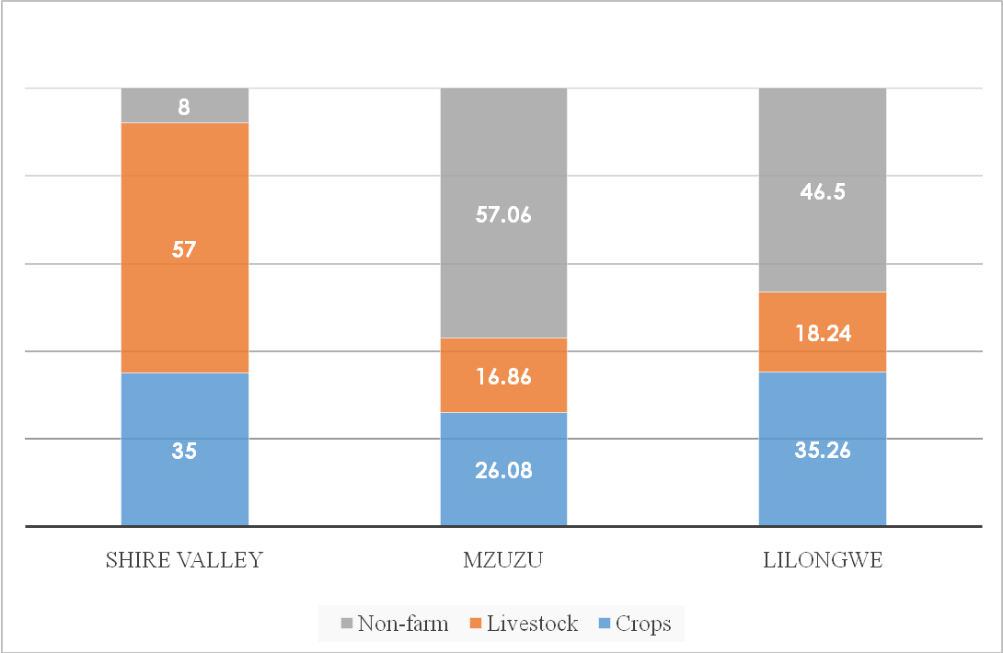
Labor migration
Casual labor
Non-Farm Income dominating

Figure 3-2: Respective contribution of household income from different sources in three agro-ecological zones.

Source (Adapted from CARD Report, 2008 and AREDP Baseline, 2006)

Livestock, therefore, has income roles that also helps to mitigate households from adopting non-desirable livelihood strategies. CARD Report (2008) showed that of the livestock, majority contribution to income is coming from goats, seconded by chickens. These income are more among female headed than male headed households (Figure 3-3).
- Non-farm sources of income are more of coping strategies than usual livelihood
- Farming interventions should aim at reducing these non-farm income
- Livestock reduces dependence on non-farm income livelihood
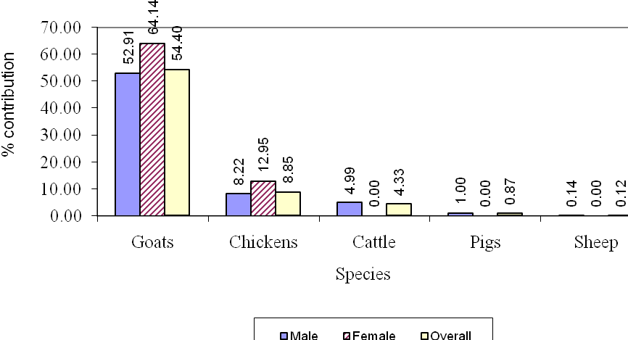
Figure 3-3: Respective sources of household income from livestock by species among male and female headed households.
Source: (CARD Report, 2008)

Livestock enhancement can increase greater dependence on livestock than crops and non-farm sources

Livestock production statistics

Livestock ownership and status
Table 3-5: Livestock ownershipshows diversity of livestock reared by the farmers in the study areas. The most commonly owned livestock are goats (86%),chickens (72%),cattle (36%) and pigs (26%). Pigeons are the least owned livestock (4%).Overall, only 12% and 10% of the farmers keep ducks and guinea fowls, respectively.

Table 3-5: Livestock ownership
District |  | Village | Cattle | Goats | Pigs | Chickens | Ducks | Guinea fowls | Pigeons
Dedza |  | James | × | √ | √ | √ | × | × | ×
Dedza |  | Mganja | √ | √ | √ | √ | √ | × | ×
Dedza |  | Mkwaila | √ | √ | × | √ | × | × | √
Nsanje |  | Bikamu | √ | √ | × | √ | × | × | ×
Nsanje |  | Chaima | √ | √ | × | × | × | × | ×
Nsanje |  | Chigaka | √ | √ | √ | √ | √ | √ | ×
Nsanje |  | Christina | √ | √ | √ | √ | √ | √ | √
Nsanje |  | Lodaviko | × | × | × | √ | × | × | ×
Nsanje |  | Mandimu | √ | √ | √ | √ | √ | × | ×
Nsanje |  | Msiyamphanje | √ | √ | × | √ | √ | √ | ×
Nsanje |  | Nyamitanzi | √ | √ | √ | √ | × | × | ×
Nsanje |  | Sintobinda | √ | √ | √ | √ | × | √ | ×
 | √ = available × = not available

Livestock was also assessed in terms of equity of distribution among households. Lorenz Curves and Gini Coefficients were used to evaluate inequality. Table 3-6shows that goats and chickens were more equitably distributed than the other species (). The implication is that these two livestock species have a higher chance of contributing to the adaptation of the farmers to the effect of climate change, and their enhancement would ensure greater contribution to majority households.

Table 3-6: The Gini coefficients for the ownership inequality of each of the livestock species
Livestock species | Gini coefficient
Cattle | 0.8544
Goats | 0.7302
Pigs | 0.8828
Chickens | 0.7408
Ducks | 0.9398
Guinea fowls | 0.9297
Pigeons | 0.9559
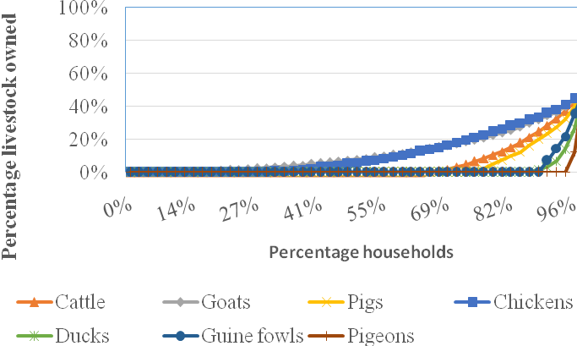
Figure 3-4: Flock distribution of various livestock species among farmers in Dedza and Chikhwawa CADECOM impact areas.

Livestock diversity
Generally resource poor households tend to keep different livestock species, usually of small stocks and in small flock sizes. This diversity helps to achieve multiple roles of livestock and mitigate risks. Figure 3-5shows that there were only few households with more than five different types of livestock, with the majority having between 2 and 3 different livestock species. There were no significant differences in the number of different types of livestock owned in the two EPAs (p (t) = 0.498). However, greater diversity was observed in Lower Shire than in Dedza, signifying greater risks mitigation from livestock in Lower Shire.

The number of different types of livestock owned (livestock diversification)was related to a household’s ability to sail through difficult times because each particular household had more choices to make. When a household has different types of livestock, it is not likely that all the livestock will be affected by catastrophes to the same extent, so the adaptability of the household is enhanced. This is especially important in the context of climate change. In Malawi, livestock is seen as a means to store accumulated wealth and it has also been adopted by many as a strategy for food security. However, in the context of climate change, in most cases farmers raise enough livestock to sell in order to buy food, and breeding more to replace those sold (ARCC, 2013). Similar to CADECOM approach of including livestock component in climate change resilience programmes, previously Food and Agriculture Organisation (FAO) and Swedish Cooperative Centre (SCC) promoted goats and poultry in areas vulnerable to climatic shocks (Stein et al., 2007). These are the species which were also reported to be the highest in the visited CADECOM impact areas of Dedza and Chikhwawa. In this study, goats, pigs and chickens were the top three preferred species, with goats emerging to be the highest asappropriate specie for increasing household resilience to climate change shocks.

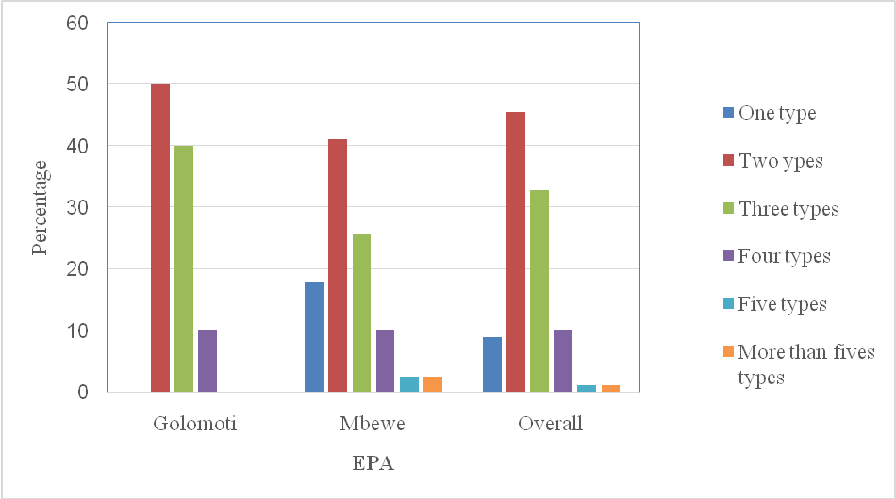
Figure 3-5: Percentage of households owning different types of livestock

When a household has different types of livestock, adaptability is enhanced. This is especially important in the context of climate change.

Livestock flock and herd sizes
Table 3-7shows flocks / herd sizes of different species of livestock. Generally, there were fewer households that owned livestock in Golomoti than in Mbewe EPA. Gender wise, male-headed households had more goats than female-headed households.

Table 3-7: Flocks and herd sizes of different species of livestock
Extension Planning Area |  | Cattle | Goats | Pigs | Chickens | Ducks | Guinea fowls | Pigeons
Golomoti | Number | 2 | 8 | 4 | 9 | 1 | - | 1
Golomoti | Mean | 4 | 4.3 | 2.8 | 8.2 | 7 | - | 12
Golomoti | Median | 4 | 3 | 3 | 8 | 7 | - | 12
Mbewe | Number | 16 | 35 | 9 | 27 | 5 | 5 | 1
Mbewe | Mean | 4.19 | 6.3 | 3.2 | 7.5 | 4.2 | 8.2 | 4
Mbewe | Median | 3.5 | 4 | 2 | 6 | 2 | 6 | 4

Livestock production and housing systems
Most of the livestock are reared using the extensive system of management, in which the livestock are confined at nightbut generally either grazed (goats and cattle) or allowed to scavenge for food for pigs and the smaller livestock (Table 3-8). Cattle and nearly half of the goats were housed in open kholas. The rest of the goats were housed in raised kholas, which were also roofed. Pigs were reported to be kept in roofed kholas while the chickens were kept in roofed kholas, raised kholas and people’s dwelling houses in almost equal proportions.

Table 3-8: Production and housing systems, and purposes for keeping livestock
Species  (number of cases) | Variable | Value | Proportion (%)
Cattle (n =18) | Systems of production | Extensive | 61
Cattle (n =18) | Systems of production | Semi-intensive | 33
Cattle (n =18) | Housing type | Open khola | 89
Goats (n = 43) | Systems of production | Semi-intensive | 37
Goats (n = 43) | Systems of production | Extensive | 62
Goats (n = 43) | Housing types | Roofed khola | 44
Goats (n = 43) | Housing types | Raised khola | 49
Pigs (n=13) | Systems of production | Intensive | 30
Pigs (n=13) | Systems of production | Semi-intensive | 23
Pigs (n=13) | Systems of production | Extensive | 46
Pigs (n=13) | Housing types | Open khola | 7
Pigs (n=13) | Housing types | Roofed khola | 92
Chickens (n = 36) | Systems of production | Semi-intensive | 33
Chickens (n = 36) | Systems of production | Extensive | 63
Chickens (n = 36) | Housing types | Roofed khola | 33
Chickens (n = 36) | Housing types | Dwelling house | 33
Chickens (n = 36) | Housing types | Raised khola | 33
Ducks (n = 6) | Systems of production | Semi-intensive | 20
Ducks (n = 6) | Systems of production | Extensive | 80
Ducks (n = 6) | Housing type | Roofed khola | 100
Guinea fowls (n = 5) | Systems of production | Semi-intensive | 40
Guinea fowls (n = 5) | Systems of production | Extensive | 40
Guinea fowls (n = 5) | Systems of production | Backyard | 20
Guinea fowls (n = 5) | Housing systems | None | 40
Guinea fowls (n = 5) | Housing systems | Roofed khola | 20
Guinea fowls (n = 5) | Housing systems | Raised khola | 40

Purposes for keeping livestock
The main products and services obtained from livestock are given inTable 3-9. The Table shows that the major products and services from the large animals (cattle, goats and pigs) are cash and manure, while the rest of the animals give meat or cash.

Table 3-9: The products and services obtained from livestock
Species | Meat | Cash | Manure | Eggs
Cattle |  | √√ | √
Goats |  | √√ | √
Pigs |  | √√ | √
Chickens | √√ | √ |  | √
Ducks | √
Guinea fowls | √
Pigeons | √

Based on FGDs, cattle are mostly kept for sale to obtain cash for making big purchases, and also as a form of investment. In both study areas, there were no significant numbers of dairy animals, and the cattle were generally not milked except by the herders for their own nourishment or for sale. The use of ox-drawn implements was limited in both study areas. Cattle were rarely reported to be slaughtered just for food, except when animalis sick.

Goats are mostly kept for sale. They are the most reliable source of income from livestock. The demand for goats is currently very high, although during the times of hunger the prices are very low since the buyers know that the farmers do not have many choices. Goats are generally sold in order to buy inputs for other enterprises such as crop production. Slaughter of goats just for domestic consumption is uncommon. Pigs, like goats, are also mainly used for sale for cash.

Chickens, guinea fowls pigeons and ducks are used for meat. However, the chickens and guinea fowls are also very marketable, and are frequently sold for cash. All the birds, and especially the chickens, pigeons and ducks, are also kept for aesthetic reasons. People just feel good having them around. The people are also compelled to keep livestock like ducks and pigeons because occasionally, there are traditional medical prescriptions that require meat from such animals.

ONLY CHICKENS SHOW MULTIPLE ROLES ON HOUSEHOLDS

Box 1: Improvement of nutrition through more livestock ownership: does it work all the time?
Most non-governmental organisations have used livestock as a tool for improving the nutrition of households. The assumption is that the more livestock people own, the more the livestock products they will consume. However, the key informants from CADECOM impact areas indicated that increases in the consumption of livestock products such as meat, milk and eggs is not automatic following increase in livestock ownership. As the number of some livestock species per household increases, the number of sales correspondingly goes up, while direct consumption of livestock products lags behind. This is because the farmers seem to use the livestock to obtain cash to purchase grain, other protein sources (such as dried fish, beans, etc.) and other household necessities before they start directly consuming the livestock products. The implication is that measurement of improvement in consumption of livestock products may not be an adequate measure of how livestock have improved household nutrition. Projects that aim at improving the nutrition of households through higher consumption of livestock products must be implemented in a broader context of the farmers’ livelihoods. This also implies that there is need for an economic study to determine the level of ownership of livestock at which direct consumption of livestock products is likely to be significant.

The current scenario in the study areas suggests that the appropriate species of livestock to be promoted for different purposes are as follows:
- Nutrition. Ducks and pigeons are the only species that are solely kept for food largely because they are not marketable. The more of these animals a farmer has, the higher the protein intake.
- Small household purchases:Chickens and guinea fowls are generally sold to buy relish, groceries and other household items. The prices of chickens are perceived to have increased tremendously, so that the farmers prefer to sell a chicken and use the cash to buy other food items instead of slaughtering the chicken for consumption.
- Purchase of crop inputs, paying of school fees and other emergencies: Goats and pigs are normally sold for cash to buy inputs and pay for school fees and other emergencies such as funerals and initiation ceremonies.
- Investments: Cattle are sold only for big investments such as buying of household assets or purchase of other capital equipment.

In this context, goats and pigs are the most appropriate livestock species for helping the farmers to adapt to the effects of climate change. However, pigs are very sensitive to effects to climate change because they compete with human beings in terms of food. They are also highly susceptible to diseases, especially African swine fever. On the other hand, goats are perceived to be easier to manage, feed, water and are also relatively more disease resistant.
Case study 1: Household utilisation of livestock as a tool for increasing resilience to climate change effects

Mr. Josephy Chimdzakazi, a field officer for Dedza district CADECOM office in Golomoti EPA indicated that farmers sell goats to get cash for various reasons including livelihood during emergencies. He has been working with farmers from Mganja and Muwa centres for over five years. Mr. Chimdzakazi testified that during his time, farmers have been selling goats in some cases during funerals, to get cash to buy food and also utilising the manure from the Kraals. Mrs. Roda Chalakwa from Chikhwawa district, Mbewe EPA echoed similar sentiment indicating that her family hugely depends on chickens business. Her husband buy and sell chickens while raising a few.Clearly, livestock is contributing to farmers’ general livelihood in Dedza and Chikhwawa CADECOM impact areas in a number of ways. Where farmers sell livestock for cash to buy food in response to shocks indicate that livestock is being used to economically empower farmers and increasing their resilience to climate change effect and impacts at household level.

Livestock health and veterinary services
The farmers indicated that they have a lot of health problems that are compounded by inadequate veterinary services. Both study areas had drug boxes which are not being effectively utilised because some farmers opt to get services from elsewhere instead of the available drug box, which makes the drug box fail to sustain itself. Sometimes the drug box does not have some necessary drugs. It was also indicated that the development agents in the area use lead farmers to manage the drug boxes, but these lead farmers tend to have limited knowledge about some diseases, parasites and their treatment. There is need to heavily involve local veterinary officer in the management of these drug boxes.

Estimation of the values of livestock products and services for the year 2013
Table 3-10shows the values of the products and services derived from the livestock kept in the study areas in the last growing season. The table shows that farmers could get more from sales of cattle, but considering the number of cattle sold per year, it is goats that bring the most value to the farmer.

The values of manure and power may be undervaluedbecause the farmers do not always quantify the manure from the kholas. For livestock that are on free range, considerable quantities of the manure are deposited on the grazing fields. Farmers also do not make the most use of the manure sometimes because it is expensive to get the manure to the crop fields.

Table 3-10: Value of products and services in the last accounting period (growing season)
Species | Method of disposal | Farmers with this species | Proportion of farmers who produced the product or service in 2013 (%) | Mean number of units | Average unit price (MK) | Mean annual revenue per farmer (MK)
Cattle | Slaughters | 18 | 6 | 1 | 150,000 | 150,000
Cattle | Live sales | 18 | 39 | 2 | 150,000 | 256,500
Cattle | Power (trips) | 18 | 22 | 2.5 | 3,000 | 7500
Cattle | Manure (kg) | 18 | 44 | 1394 | 4 | 5,578
Cattle | Milk (litres) | 18 | 50 | 144 | 60 | 8,633
Goats | Slaughters | 43 | 12 | 1 | 18,000 | 21,600
Goats | Sales | 43 | 51 | 3 | 18,000 | 47,520
Goats | Given away | 43 | 2 | 1 | 18,000 | 18,000
Goats | Manure (kg) | 43 | 33 | 159 | 4 | 637
Pigs | Slaughters | 13 | 8 | 1 | 30,000 | 30,000
Pigs | Sales | 13 | 31 | 3 | 30,000 | 82,500
Pigs | Manure (kg) | 13 | 31 | 428 | 4 | 1,710
Chickens | Slaughters | 36 | 94 | 5 | 2,000 | 9,640
Chickens | Sales | 36 | 56 | 5 | 2,000 | 9,200
Chickens | Bartered | 36 | 14 | 2 | 2,000 | 3,200
Chickens | Given away | 36 | 22 | 2 | 2,000 | 3,260
Chickens | Manure (kg) | 36 | 22 | 42 | 4 | 168
Chickens | Eggs | 36 | 81 | 40 | 50 | 2,016
Ducks | Slaughters | 6 | 67 | 7 | 2,500 | 17,500
Ducks | Sales | 6 | 33 | 8 | 2,500 | 20,000
Ducks | Given away | 6 | 17 | 6 | 2,500 | 15,000
Ducks | Manure (kg) | 6 | 17 | 25 | 4 | 100
Ducks | Eggs | 6 | 83 | 56 | 50 | 2,820
Guinea fowls | Slaughters | 5 | 80 | 3 | 2,000 | 5,000
Guinea fowls | Sales | 5 | 20 | 4 | 2,000 | 8,000
Guinea fowls | Given away | 5 | 20 | 2 | 2,000 | 4,000
Guinea fowls | Manure (kg) | 5 | 20 | 25 | 4 | 100
Guinea fowls | Eggs | 5 | 60 | 57 | 50 | 2,834
Pigeons | Slaughters | 2 | 50 | 12 | 200 | 2,400
Pigeons | Sales | 2 | 50 | 8 | 200 | 1,600

Livestock products and services trends
Figure 3-6shows the trends in the levels of products and services derived from livestock over the last 10-15 years. About half of the farmers with cattle believed that the amount of cash from cattle had not changed and the other half believed that it has gone up. On manure, the majority of the farmers believedthat the level of manure from cattle has gone up as the case with the amount of meat and cash from goats and chickens.

The livestock technical experts indicated that the prices of goats and chickens have increased tremendously, making sales of these species very lucrative. This was indicated as an opportunity for farmers to improve their livelihoods through more sales of these diverse species. The marketability of the livestock also meant that the farmers were not constrained when it comes to disposing their animals. However, there is need to encourage direct consumption of products from these livestock at the household level to ensure that the nutrition of the household is also improved.

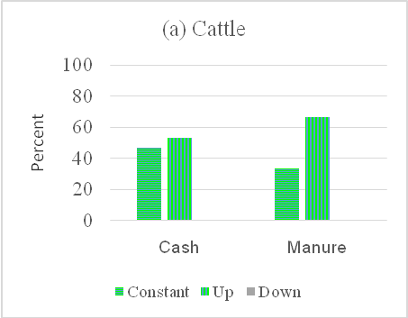 | 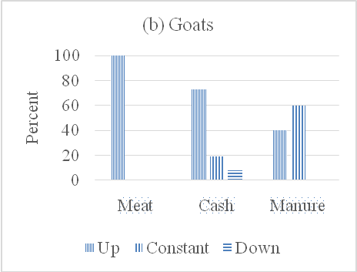
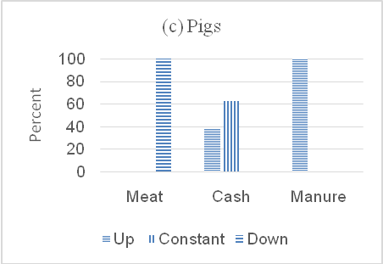 | 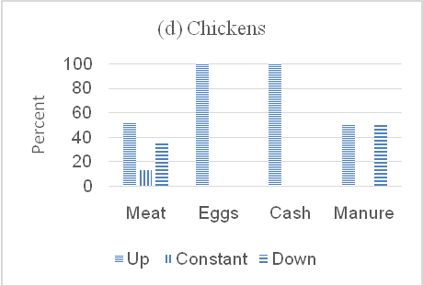
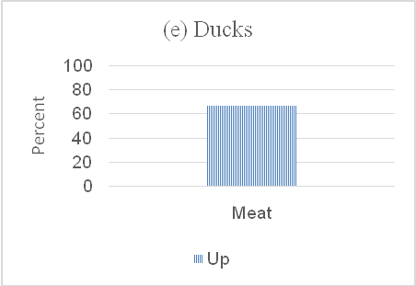 | 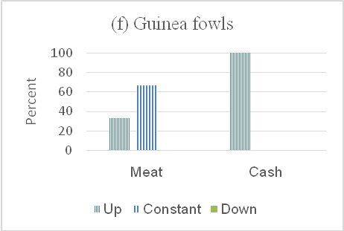
Figure 3-6: Trends in the levels of different products and services derived from livestock

General and climate related challenges facing livestock production
Table 3-11shows the major challenges that the livestock in the study areas are facing. The major challenges include diseases and lack of feed and water. Feed and water problems arise due to lack of grazing areas and watering points. Some infected cattle in the study are showing signs similar to those of lumpy skin disease (LSD). Goats are showing incoordination and moving in circles. Pigs and chickens are regularly infected and killed by African swine fever and Newcastle disease, respectively.

Table 3-11: Livestock challenges in general and those related to climate change impact
Species | Major general challenges | Challenges related to climate change
Cattle | LSD-like disease | Lack of grazing areas and feed scarcity
 |  | Lack of drinking water
Goats | Parasitiasis, polioencephalomalacia or listerosis | Lack of grazing areas and feed scarcity
Goats | Parasitiasis, polioencephalomalacia or listerosis | Lack of drinking water
Pigs | African swine fever | Lack of feed due to low crop yields
Chickens | Newcastle disease | Lack of feed due to low crop yields

The health problem is also worsened by the fact that in both EPAs, veterinary services are not adequate. The government veterinary officers have difficulties visiting the areas because in both cases, the study areas are far away from the EPA headquarters where the assistant veterinary officers (AVOs) stay, and the AVOs face transportation challenges. Moreover, the CADECOM field officers are more conversant with the other (crops) agricultural components of the production system than in livestock. The drug boxes that were established in the areas were also not working effectively. Although the farmers claimed that this was due to lack of drugs, as it was reviewed by the key informants that the problem was that farmers were sometimes unwilling to make use of the boxes, thereby making the whole system unsustainable.
Challenges related to climate change are lack of feed and water. These challenges are especially worsened because dambo areas (wetlands) where the animals could graze and get water are reserved for irrigation agriculture. The large animals—ruminants (cattle, goats and sheep) and pigs—are the most affected. Cattle and goats cope to feed pressure by tending to increase their grazing reach, leading to further loss of condition. As observed in Golomoti area (Figure 3-7), cattle grazing behaviour has changed towards sheep feeding on ground level grass, making land prone to degradation. The smaller animals that scavenge around the homes cause havoc in the homesteads, as they have to increasingly depend on leftovers from people’s tables and kitchens.

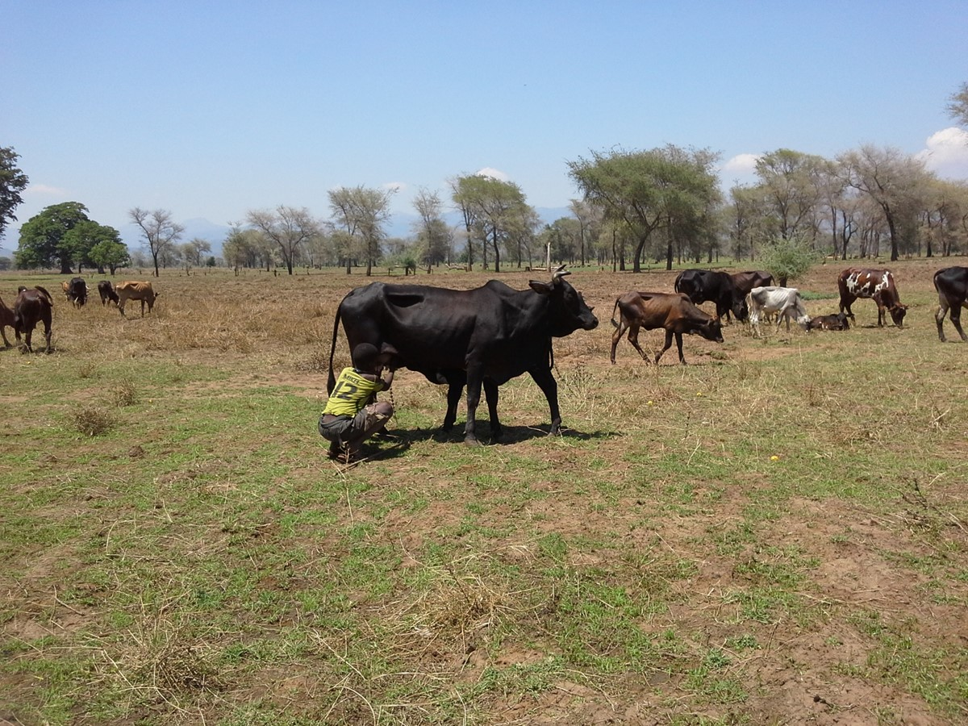
Figure 3-7: Cattle grazing in climate affected zones with long dry seasons.

Box 2: Effects of climate change on livestock diseases
The farmers also reported that recently, animals have taken to eating plant and other materials they did not eat before. This could be a direct result of inadequate feed as a result of changes in biomass yield in the areas. There is fear that this may lead to increasedcases of poisoning. There has also been an increasing trend of animals eating soil more than they used to do in the past. This may explain some of the disease conditions in the area, especially in the goats, in which farmers reported many cases of incoordination (Chizungulire) where the animals move in in circles. Animals are more likely to pick up parasites when they eat soil and other plant materials from the ground. Some parasites can lead to coordination disorders. Eating of soil particles also predisposes the goats to infection by bacteria, some of which can cause listerosis, leading to incoordination. The unusual appetite for soils mays also be a sign or deficiencies in the animals’ feed basket. Deficiency in thiamine is known to cause polioencephalomalacia, which may also lead to incoordination.

It is recommended that a study be carried out to determine the cause of incoordination in goats.

Relationship between household income and livestock ownership
Based on the 2013 respondents reported figures, the correlation between the number of different types of livestock owned and the household income was not significant (p (r) = 0.225). However, the correlation between the number of different types of livestock owned and the income from livestock was significant (p(r) = 0.032) (Table 3-12). These findings imply that the study areas have not yet achieved a livestock diversity that is enough to increase the contribution of livestock income to the household income.

Table 3-12: The correlation between different variables and the number of different types of livestock owned per household
Variables | n | r
2013 Income from livestock (n=32) | 32 | 0.380*
2013 Total household income (n = 49) | 49 | 0.177
* Significant p = 0.05

However, it is evident that households that owned more different species of livestock get more income from the livestock (Figure 3-2). More income from the livestock implies better adaptability to the effects of climate change.
Case study 2:Livestock diversification, a pathway for significant contribution of livestock to household income and resilience to climate change effects

Mrs Thokozani Bendara from Christina village Mbewe EPA in Chikhwawa who has been a livestock farmer since 1997 indicated that with a humble beginning with a goat she has currently have her herd increased and diversified in terms of species kept. Mrs Bendara indicated that some species such as Cattle are mainly used for cash while chicken and duck are mainly used for food. She also mentioned that she uses the cash to pay school fees for her children and manure from the Kraal to apply in her garden. The main source of income at her household comes from crops and livestock. Mrs. Thokozani testified that livestock in contributing substantially to her household income after crops. This implies that if farmers in Mbewe district can diversify in term of livestock species, their resilience to climatic shock could be enhanced.

Climate changes and the adaptability of livestock and households

Farmers’ perception of climate change issues
Table 3-13shows the farmers’ understanding of the term “climate change”. About 70% of the farmers indicated that climate change refers to changes in rainfall pattern. This is not strange, because to the farmers, the major determinant of climate is rainfall.

Table 3-13: Farmers’ understanding of the term climate change (n = 48)
Farmers’ understanding of the term “climate change” | Percent
Change in rainfall pattern | 70.8
Low crop yield | 10.4
Never heard of the term | 4.2
Drought | 4.2
Deforestation and droughts | 2.1
Loss of vegetation | 2.1
Low rainfall | 2.1
Rain and temperature extremes | 2.1
State of weather conditions | 2.1

Table 3-14shows effects of climate change and factors that are exacerbating them. The major effects of climate change are low crop yields, high temperatures and drought. Low crop yieldsare translating into low feed supply to livestock, as the amount of crop residues and crop by-products are correspondingly reduced. Farmers in the study area also claim that certain diseases have increased in due to unusually high temperatures.

Table 3-14: Climate change effects and factors that are exacerbating them
Variable | Value | Percent
Climate change effect | Low crop yields | 51.1
 | High temperature | 38.3
 | Drought | 36.2
 | Floods | 34
 | Livestock diseases | 12.8
 | Erratic rains | 8.5
 | Water shortage | 6.4
Exacerbating factor | Deforestation | 80.9
 | Population growth | 25.5

The factors that are perceived to exacerbate the effects of climate change in the study areas are deforestation and human population growth. In Mbewe EPA, deforestation is leading to silting of the Mwanza River and its tributaries. This is making irrigation even more difficult, and droughts even more severe. Droughts are more severe in Mbewe area because during the rainy season there are a lot of floods, but the water quickly runs off and the land dries up, unlike in Mganja, where there are reliable hill rivulets that are used for irrigation.In Mganja area, deforestation is mostly leading to land degradation.

Climate change impacts on livestock and adaptability of livestock to the impacts
Table 3-15shows the impacts of climate change on livestock and adaptability of livestock to the impacts.The farmers indicated that low crop yields affected goats, pigs and chickens, because these species generally live on crop residues and agro by-products from around the homesteads. Low crop yields leads to less by-products and leftovers for these species.

It was evident that livestock have adapted to the impacts of climate by increased grazing and scavenging, where the animals move further away from the villages in search of feed and secondly; increased diversity of feeds sources whereby animals consume plant materials that they did not previously prefer and encroachment into the protected, forests and irrigated areas.

Table 3-15: Impacts of climate change on livestock and adaptability of livestock to the impacts
Climate change impact | Lack of feed | Lack of drinking water | Increase in livestock diseases | Lack of grazing areas | Drought | Low crop yield
Species affected | Cattle  Goats  Chickens | Cattle  Goats | Cattle  Goats  Chickens | Cattle  Goats | Cattle  Goats | Goats, pigs and chickens
Positive effects on livestock | Farmers are forced to supplement | None | None | None | None | None
Negative effects on livestock | Low production | Low production | Low production | Lack of feed, Poor breeding | Lack of feed  Lack of drinking water | Lack of feed
How livestock cope with effect | Increased grazing and scavenging  Increased diversity of feeds sources | Increased grazing | None | Encroachment into the forests and irrigated areas | Increased grazing land | Increased grazing and scavenging
Case study 3: Livestock and household adaptation mechanism to feed scarcity

In response to low crops yield and population growth, farmers from Golomoti EPA started irrigation farming which has resulted in controlled grazing and encroaching the forest in search for feed to increase livestock adaptability to decreased grazing area. Mr Andrew Yona, a CADECOM beneficiary testified that the practice in helping the animals in particular goats to survive despite the risk of feeding the goats in the forest since the most of the time the herdspersons are normally the Children. It is clear that livestock in contributing substantially to her household despite a big amount coming from crops. This implies that if farmers in Mbewe district can diversify in term of livestock species, their resilience to climatic shock could be enhanced.

Integration of irrigation agriculture and livestock production
Irrigation has become an important component of the production systems in the study areas. Mganja area (Dedza) suffers from frequent droughts, which make irrigation a climate resilient intervention. Fortunately, the area has small rivers that provide water for irrigation, although the farmers indicated that these are drying quickly with time.On the other hand, Msiyamphanje area (Lower Shire) suffers from floods, the water from which tends to recede quickly, leaving the land dry. The Mwanza River and its tributaries have been heavily silted and when it rains in the catchment areas, the rivers flood very easily, but do not retain water as well as they used to do in the past. At times, farmers have to dig wells to provide water for irrigation.

About 16% of the respondents indicated that they engage in production of crops through irrigation. Of these, 88% indicated that they do integrate cattle and goat production through movement of inputs from one enterprise to the other. However, the flow of resources is not effective. This is because the animals are hardly allowed to use the crop residues. The animals are also not allowed to use the wells or the other watering points. The amount of manure applied to the crops is also limited due to transportation issues. Crop residues from rain-fed agriculture are normally used for fuel or burnt right in the field for easy land preparation. Crop residues from irrigated agriculture are generally inaccessible to the livestock since the crop fields are fenced off. It is therefore clear that crop and livestock production are operated as independent components of the production system instead of be integrated.

- There is perceived conflict between livestock and irrigation practices
- Both are means to promote climate resilience
- Current low correlations show lack of the two practices being integrated

Box 3: Balancing livestock production and irrigation agriculture
One of the major problems the study areas are facing is lack of access to drinking water for livestock, especially during the dry season. This is made worse because the few remaining watering points such as rivers, reservoirs and dambos are completely reserved for growing of crops through irrigation. Such areas are fenced off to keep the livestock out. Livestock manure is used to fertilize the soils in the irrigated areas, especially for vegetable production. When the crops are harvested, the crop residues are either burned or used as fuel. This especially occurs if the owner of the irrigated plot does not have livestock. In the end, the relationship between livestock and the irrigation component is generally one-sided. This hampers the adaptability of livestock to the effects of climate change. This may limit the use of livestock as an adaptation tool in the context of climate change.

The exclusion of livestock from the irrigated areas is forcing the livestock to move greater distances in search of water. In Mbewe EPA, the livestock are forced to encroach into Lengwe National Park, a practice that is not only illegal, but also exposes the animals to higher risk of contracting diseases from wild animals in the park.

It is therefore a recommended that farmers should strike a more favourable balance between livestock and irrigated crops. Some of the possible improvements are:
- Making of by-laws to collectively reserve certain watering points for use by livestock.
- Fencing around the cultivated field only but leaving the water points outside the fence.
- Livestock farmers may agree with people with irrigated fields to supply the latter with manure in exchange forrights to use the latter’s crop residues and crop by-products where possible, instead of having the residues burnt.

Preference for livestock breeds in the context of climate change
It was observed that most of the livestock in the study areas were local breeds. Only one farmer reported keeping exotic goats, and some farmers have just received exotic pigs. Table 3-16shows that the farmers prefer local cattle and goats due to their resistance and lower water requirements than exotic breeds.This implies that it is important that development programmes using goats and cattle as development tools should consider using local breeds.

Table 3-16: Farmer's preference for livestock breeds in the context of climate change
Species | Traits used as a basis of comparison | Preference
Species | Traits used as a basis of comparison | Local | Exotic
Cattle | Disease resistance, water requirements | Yes | No
 | Mature weight, milk | No | Yes
Goats | Disease resistance | Yes | No
Goats | Disease resistance | Yes | No

The adaptability of households to the effects of climate change
The majority of the farmers (95%) reported selling livestock for cash to buy food, farm inputs and other items (Table 3-17). The farmers indicated that in the absence of livestock, they would bank on casual labour and home industries to sail through difficult times orchestrated by climate change effects.

Table 3-17: Ways how households use livestock to increase their resilience to climatic shocks
Variable | Responses | Frequency | Percent
How farmers use livestock for adapting to climate change effects | Manure application | 1 | 2.5
 | Never used livestock before | 1 | 2.5
 | Selling to get cash | 26 | 65.0
 | Selling to get cash for buying food for the family | 12 | 30.0
 | Total | 40 | 100.0
Alternative coping mechanism | Business-Charcoal | 1 | 2.4
Alternative coping mechanism | Casual labor | 34 | 82.9
Alternative coping mechanism | No alternative | 1 | 2.4
Alternative coping mechanism | Receive food from relief programmes | 1 | 2.4
Alternative coping mechanism | Reduction of feeding frequency | 1 | 2.4
Alternative coping mechanism | Selling household assets | 2 | 4.9
Alternative coping mechanism | Selling of palm tree roots and leaves | 1 | 2.4
Alternative coping mechanism | Total | 41 | 100.0

Recommended livestock model for the study areas
A recommended livestock production model for the study areas is supposed to have the following desirable qualities:

Model that balances for:
- Livelihood and equity of distribution
- Adaptation to climate change
- Resilience to climate change
- Mitigation of soil degradation

To achieve these qualities, a crop-livestock integrated system is proposed to exploit resources and bye-products from rain-fed agriculture, livestock and irrigation agriculture. This would lead to the realization of synergy (value addition from the interaction between the integration).Irrigation agriculture and livestock production should be seen as complementary activities, and efforts should be made to really integrate the two to ensure that both benefit from the scarce water and other resources and also from each other. Chiefs and other local leaders should facilitate the establishment of by-laws to collectively reserve certain watering points for use by livestock. All the people in the area should be involved in coming up with such by-laws, including those that do not have any livestock. Where resources exist, fencing should only be done around the cultivated field only, leaving the water points outside the fence so that they are also easily accessible to livestock.

Livestock farmers should be encouraged to establish contractual agreements with people owning irrigated fields in the “dambos” to supply the latter with manure in exchange for rights to use the latter’s crop residues and crop by-products where possible, instead of having the residues burnt. There is also need to promote a culture of feed conservation during period of plenty and from irrigable crop residues to supplement during period of scarcity. This is especially applicable for cattle and goats, which can utilise crop residues from both rain-fed and irrigated crops.

For the system to operate, it has to accommodate other climate adaptation or resilient mitigation crop systems including the climate smart conservation agriculture. Instead, a modified approach should be compromised where crop residues or components worth feeding should first go to livestock feeding. Manure management needs to be built in, such that well conserved manure or mixture of manure and crops residues should be taken to crop or irrigable gardens.
Figure 3-8shows a case of livestock and conservation agriculture not fully integrated (leading to trade-offs); and Figure 3-9 show a proposed framework with synergy.

LIVESTOCK – CROP LAND USE SCENARIOS
Enhanced CA through CR
Increased use of
Crop Residues
Increased crop yield
Improved CR
Sustained soil and water
BUT
Reduced CR for livestock
Thin animals
Poor reproduction
Land degradation
Low animal output
Trade-off
Trade-off
Land – crop – soil side Livestock side

Figure 3-8:Livestock and Conservation Agriculture without or with partial integration

Enhanced CA through animal manure
Increased use of
Crop Residues
Increased crop yield
Improved Crop Residues
Sustained soil and water
Increased CR for livestock
Health animals
Good reproduction
Increased quality manure yield
High animal output
Synergy
Synergy
Land – crop – soil side Livestock side

Figure 3-9: Livestock and Conservation Agriculture with integration and intensification

From the above Figure 3-8andFigure 3-9, positive interaction is possible when Conservation Agriculture is integrated with a modified intensified livestock production. To ensure the model fits into production systems, collaborative action research is required during implementation. Further reading can be obtained from: Reference: IITA. 2010. Balancing Livestock Needs and Soil Conservation: Assessment of Opportunities in Intensifying Cereal-Legume-Livestock Systems in West Africa: CGIAR System wide Livestock Programme, Project Final Report. Addis Ababa (Ethiopia). 56 pp

When irrigation is done in isolation from livestock, conflicts on use of wetland exist as documented by Kambewa (2005) and from this report. This scenario is presented inFigure 3-10. Figure 3-11shows a potential that can be realised when irrigation technologies integrate livestock.

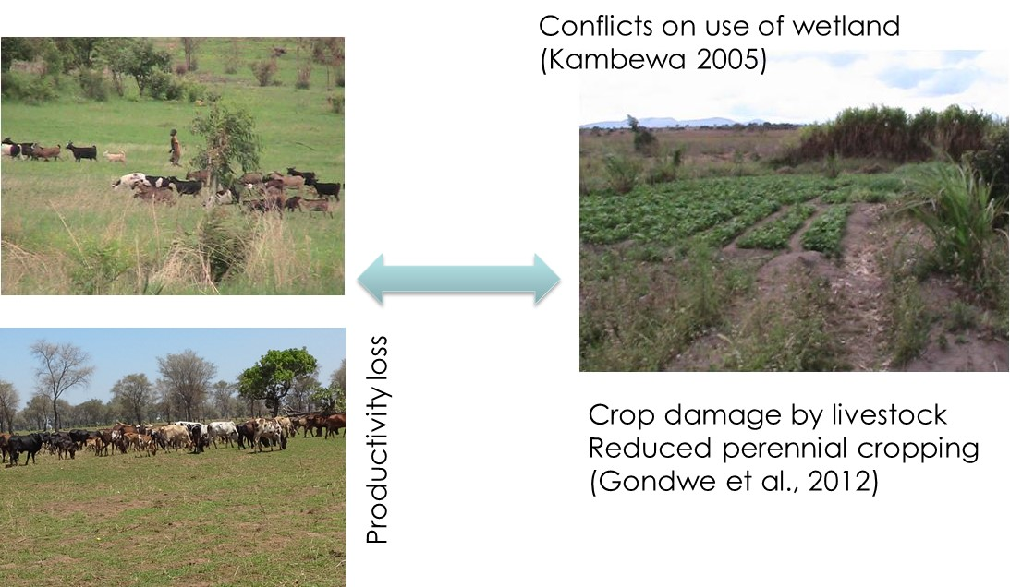

Figure 3-10: Livestock and Irrigation without integration

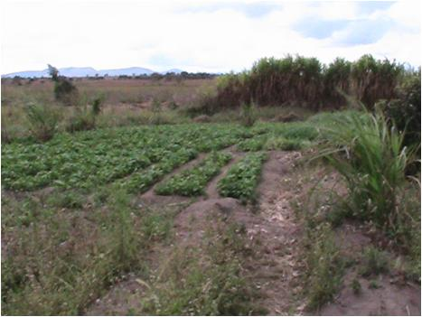
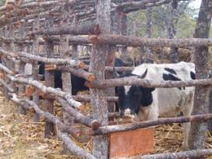
Productivity increased
Manure goes to irrigated gardens

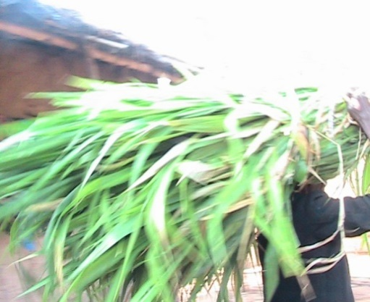
Crop residues from irrigation taken to confined livestock units

Figure 3-11: Optimal Livestock and Irrigation integration

The concept requires community approach and can best be implemented by the communities themselves. However, the communities need training and sensitization in terms of potential conflicts and synergies that arise, promoting crop residues conservation for livestock feed through supplementation, manure conservation and utilization, and valuing these by-products to ensure sustainable, win win trading between livestock and crop or irrigation farmers. The NGOs and Government could facilitate the trainings and sensitizations, in addition to monitoring based on set indicators that include:
- Number of communities reached and sensitized
- Strategies formulated by each community
- Level of adoption of the strategies and the concept
- Percent increase in crop yields from both rain-fed and irrigation
- Percent increase in flock sizes
- Percent increase in outputs from livestock
- Livelihood impact indicators

Through action research, monitoring and evaluation (M&E), comparisons can be made between adopters and non-adopters but practicing either livestock or climate smart agriculture to evaluate the synergy.

Recommended livestock species to promote as priority
Households should be encouraged to keep diversity of livestock based on their potential investments. That is, farmers with cattle, or pigs, or goats should go ahead with the species, and promote keeping more than one species as climate mitigation measure. Project interventions should be in the area of health and management. Drug boxes should be revamped and made to sustain on their own. Community Animal Health Workers (CAHW) should be refreshed or trained to operate drug boxes as business.

In terms of species of priority, a desirable model should balance for:
- Livelihood, diversity and equity of distribution
- Adaptation to climate change
- Resilience to climate change
- Mitigation of soil degradation
- Ensures breed improvement and conservation

Currently, goats and chickens are key species to be encouraged, with emphasis on the use of local breeds is recommended. These may need to be improved gradually, basically through within breed selection, not crossbreeding. The selection should be done up to levels that can cope to existing natural resources while at the same time improving the system itself in terms of feeding, health and housing. Where crossbreeding is promoted, there is need to establish a model that facilitates systematic mating such that:
- There is selection of local males to mate with local females (especially in goats) ~ this will provide improved local breed to be used as female line for crossing.
- There is selection of local females (from ‘a’) to mate with exotic males
- Exotic males are carefully bred to prevent cases of inbreeding
- Level of crossing is established to match the production environment of feeds, heat stress and disease adaptation (India case has fixed crossing at 50 %) ~ needs adaptive research and evaluation.

This means, regardless of a breeding strategy, within local breed selection is a must. This can best be promoted through community based breeding establishments, with communities empowered to choose traits of their like with desirable levels to be achieved, and devise tools how to choose the breeding animals based on their combined trait values. There is need for training in community based breeding programs, to be followed up by monitoring through record keeping and evaluation. Both field workers and communities need this training.
The selected breeding males (both local and exotic, whichever is applicable) need to be disseminated to reach wider communities. Artificial Insemination technology can be introduced. This is simple in goats and chickens, and communities can be trained through CAHWs or AI Technicians. The rest of the community members need to be trained in heat detection and record keeping.

Key indicators of breed improvement include:
- Number of community based breeding groups established
- Percent of livestock farmers participating in breeding programs
- Percentage increase in flock sizes
- Percentage increase in outputs from livestock
- Livelihood impact indicators

However, the improved breeds will require enhanced feeding and disease control, but this should be within cope of majority households to avoid inequity. This brings the two models to integrate (into the crop – livestock – irrigation) while introducing drug boxes and improved housing conditions. These require training sessions to farmers, CAHWs and field facilitators, and close monitoring through introduction of record keeping and evaluation. A business culture should be inbuilt during all trainings.

All the proposed concepts have high degree of replication into both climate change challenged and non-challenged areas. The system could fit into other agro-sectors, especially where smart-agriculture is being promoted. The interventions will also accommodate gradual system change to match with the improvement in livestock production and productivity.

CONCLUSIONS AND RECOMMENDATIONS

Conclusions

Replicable livestock practices and technologies
In this study, the potential livestock practices and technologies have been isolated specifically ideal for replication in other areas. These practices include controlled grazing and scavenging, construction of raised kholas for goats, fencing of irrigated areas leaving out the water points to allow livestock easily access without damage the crops, establishment of drug boxes and livestock diversification at household level.

Economic activities
The most important economic activity to farmers in the visited CADECOM impact areas is crop production, followed by livestock, home industryand wages according to the farmer’s perception. The orderchanges with wages coming before home industry using the 2013 household income data. The 2013 estimates also showed that the sale of crop produce gave farmers more money than any enterprise. However, it was evident that livestock play a major role in the adaptability of the farmers in the context of climate change. When there are droughts, floods and other disasters, livestock are normally sold. Even in periods of normal climatic conditions, the livestock are sold to buy farm inputs. That makes livestock a very important part of the production system.

Livestock diversity and production practices
The diversity of livestock owned by farmers in the study areas was on the lower side. The farmers keep fewer types of livestock (between 2 and 3 types) than is good for higher adaptability to the effects of climate change effects. There is need to increase the farmers’ livestock base, so that they do not depend on a few livestock species only.The most widely kept livestock species are goats, chickens, cattle and pigs. Most of the livestock are kept in extensive production systems, where the livestock are free to move around freely looking for feed (goats, pigs and the smaller animals) or are herded in the grazing areas (cattle). The study has shown that this system may be appropriate because it affords the animals more opportunity to access unconventional feedstuffs and water especially during times of scarcity. The housing structures are generally open kholas for the larger animals and roofed or raised kholas for the smaller ones. The production systems and housing structures are not bad for this level and scale of livestock production.

Livestock utilisation
Cattle, goats and pigs are mostly kept for sale especially when the family wants to buy something big (such as construction materials), farm inputs or even pay school fees. Goats, followed by pigs, are the most reliable source of income from livestock because they are highly marketable in this area, and their prices are reasonably high. Chickens, guinea fowls pigeons and ducks are used for meat for domestic consumption. Chickens and guinea fowls are also frequently sold for cash, especially to purchase less expensive household items. This utilisation of livestock has implication on the selection of appropriate species of livestock to be given to farmers depending on the objectives. The study has shown that increases in numbers of certain species at household simply lead to more sales and an increase in household income, not direct consumption of livestock products. Such species are cattle, goats, pigs, goats, chickens and guinea fowls. On the other hand, increases in flock sizes for species such as ducks and pigeons are likely to translate into direct increase in household consumption of products from these livestock.

Livestock challenges
The major challenges faced by livestock in the study areas were disease outbreaks and lack of feed due to erratic rains and droughts and the associate lack of drinking water. It was reviewed that lack of feed during the dry season is worsened by irrigation practices (fencing of water points) that are not favourable to the survival of livestock. This is making livestock have difficulties to cope with the effects of climate change, which in turn decreases the farmers’ ability to cope with the same or similar problems.

Relationship between livestock and household income
It has been demonstrated that there is a link between livestock income and the number of different livestock species owned by the farmers. Specifically, the more types of livestock a farmer keeps, the more the income. This implies that it is good to consider giving farmers a package of livestock species instead of concentrating on only one in order to give the farmer the opportunity to meet all needs of the household.

Recommendations
Specific recommendations are as follows:
- There is need to improve livestock diversity in the study areas in order to make the usability of livestock as a tool for adapting to climate change more effective.
- To address the problem of livestock diseases in the CADECOM impact areas or beyond, it is suggested that there should be a stronger collaboration with the government veterinary health workers responsible for the areas by adopting the PPP model.
- The promotion of indigenous breeds’ calls for the need to facilitate community based breeding programs that will provide local breed stock for livestock, and enhance breed development to increase yield and adaptation to local environments.
- A shift towards livestock intensification for some species, especially cattle needs to be an integral component of the program. This will allow proper integration into the crop-irrigation – livestock system.

APPENDICES

Appendix 1: Statistics tables
Table 5-18: Total number of livestock owned in Golomoti and Mbewe EPAs
EPA | Number of house-holds | Number of house-hold with livestock | Cattle | Goats | Pigs | Chickens | Ducks | Guinea fowls | Pigeons
Golomoti | 10 | 10 | 8 | 42 | 11 | 74 | 5 | 0 | 12
Mbewe | 40 | 39 | 67 | 220 | 26 | 203 | 21 | 41 | 4

Table 5-19: Mean number of livestock per household by extension planning area
Extension Planning Area | Statistic | Cattle | Goats | Pigs | Chickens | Ducks | Guinea fowls | Pigeons
Golomoti | N | 2.00 | 8.00 | 4.00 | 9.00 | 1.00 | - | 1.00
Golomoti | Mean | 4.00 | 4.25 | 2.75 | 8.22 | 7.00 | - | 12.00
Golomoti | Std. Deviation | 2.83 | 3.77 | 0.50 | 5.91 | - | - | -
Golomoti | Median | 4.00 | 3.00 | 3.00 | 8.00 | 7.00 | - | 12.00
Mbewe | N | 16.00 | 35.00 | 9.00 | 27.00 | 5.00 | 5.00 | 1.00
Mbewe | Mean | 4.19 | 6.29 | 3.22 | 7.52 | 4.20 | 8.20 | 4.00
Mbewe | Std. Deviation | 2.76 | 6.24 | 2.39 | 5.49 | 5.07 | 3.03 | -
Mbewe | Median | 3.50 | 4.00 | 2.00 | 6.00 | 2.00 | 6.00 | 4.00
Overall | N | 18.00 | 43.00 | 13.00 | 36.00 | 6.00 | 5.00 | 2.00
Overall | Mean | 4.17 | 5.91 | 3.08 | 7.69 | 4.67 | 8.20 | 8.00
Overall | Std. Deviation | 2.68 | 5.88 | 1.98 | 5.52 | 4.68 | 3.03 | 5.66
Overall | Median | 3.50 | 4.00 | 3.00 | 6.50 | 3.00 | 6.00 | 8.00

Table 5-20: Mean number of livestock per household by gender of household head
Gender of household head | Statistic | Cattle | Goats | Pigs | Chickens | Ducks | Guinea fowls | Pigeons
Male | N | 18.00 | 40.00 | 11.00 | 35.00 | 6.00 | 5.00 | 2.00
Male | Mean | 4.17 | 6.18ª | 3.27 | 7.74 | 4.67 | 8.20 | 8.00
Male | Std. Deviation | 2.68 | 6.01 | 2.05 | 5.60 | 4.68 | 3.03 | 5.66
Male | Median | 3.50 | 4.00 | 3.00 | 7.00 | 3.00 | 6.00 | 8.00
Female | N | - | 3.00 | 2.00 | 1.00 | - | - | -
Female | Mean | - | 2.33^{b} | 2.00 | 6.00 | - | - | -
Female | Std. Deviation | - | 0.58 | 1.41 | - | - | - | -
Female | Median | - | 2.00 | 2.00 | 6.00 | - | - | -
Overall | N | 18.00 | 43.00 | 13.00 | 36.00 | 6.00 | 5.00 | 2.00
Overall | Mean | 4.17 | 5.91 | 3.08 | 7.69 | 4.67 | 8.20 | 8.00
Overall | Std. Deviation | 2.68 | 5.88 | 1.98 | 5.52 | 4.68 | 3.03 | 5.66
Overall | Median | 3.50 | 4.00 | 3.00 | 6.50 | 3.00 | 6.00 | 8.00
Means with different superscripts in the same row are significantly different at p = 0.05

Appendix 2: Household interviews semi-structured questionnaire

DOCUMENTATION OF CLIMATE CHANGE ADAPTATION PRACTICES IN DEDZA AND CHIKHWAWA: THE CASE OF LIVESTOCK

Pre-amble
CADECOM would like to document livestock practices in the context of climate change in its projects areas. The objective of the activity is to identify livestock practices that have the potential to help communities adapt to climate change, so that these can be promoted in this and other areas. The purpose of this interview is to obtain information about livestock production practices in the context of climate change. Your contributions will be very invaluable to the study, and will be treated with the strictest possible confidentiality.

Questionnaire Number………………….
Section A: Administration

- Date of interview …………………………
- Name of interviewer …………….……
- District [1= Dedza, 2=Chikwawa] Code__
- EPA ………………………………………
- Village ……………………………………

Section B: Demographics

- Name of respondent …………………
- Position in household [1=Husband, 2=Wife, 3=Child, 4=Maid, 5=Relative, 6=Others.……………..] Code__
- Gender of household head
[1=Male, 2=Female] Code__
- Age of household head ………(Years)
- Household size M ………. F.............
- Total Land Holding Size …...[hectares]
- Total Land Farmed ………. Idle ……... For grazing…………… Irrigable……..

Section C: Economic activities and scale of production
- What are the major sources of income in your household? [Please rank the sources in order of importance. Rank 1 means the source that gives the farmer highest amount, not just based on the 2013 estimates only.]
Code | Source of income |  | Rank | Estimate for 2013 (MK)
1 | Crops
1 | 1A |  | 1
1 | 1B |  | 2
1 | 1C |  | 3
2 | Livestock
3 | Home industry/ vending
3 | 3A
3 | 3B
3 | 3C
4 | Salary/ wages
5 | Other (specify)

- Which livestock species do you keep? [Where possible indicate the breed within the species.]
Species | Number of livestock | Rank | System of production | Purpose for keeping the animals | Housing type
Cattle
Goats
Sheep
Pigs
Rabbits
G. Pigs
Chickens
Ducks
G. fowls
Pigeons
Ranking criterion: Please indicate the rank of the species in terms of its socio-economic importance to the farmer Codes: 1= Most important, 2=next most important, etc.
Production system codes: 1=Intensive, 2=Semi-intensive, 3=Extensive, 4=Backyard,
Purpose codes: 1= Meat, 2= Milk/eggs, 3= Work, 4= Breeding, 5=Manure 6=Hides 7=Cash from sales, 8=Investment, 9=Dowry, 10=Ceremonies, 11=Prestige 12 = other
Housing type codes: 1=none, 2 = Open khola, 3 =Yard, 4 = Roofed khola, 5 = Dwelling house 6 = raised 7=other (specify) ………………………………………………………………………...…………………………
- Estimate the number of livestock that were slaughtered, sold, bartered and given away (as gifts, dowry, etc.) and the quantity of livestock products and services that were realized from the household’s livestock in the last growing seasonin the las growing season. [Where possible indicate the breed within the species.]
Species | Slaughtered for food | Sold for cash | Bartered | Given away | Livestock products/ services realised
 |  |  |  |  | Power (specify units) | Manure (kg) | Eggs (number) | Milk (litres)
Cattle
Goats
Sheep
Pigs
Rabbits
G. Pigs
Chickens
Ducks
G. fowls
Pigeons

Section D: Climate change
What is your understanding of the term “climate change”?
____________________________________________________________________________________________________________________________________________________________________________________________________________________________________________________________________________________________________________
- In general, what are the main existing/tangible climate change effects in this area?
_________________________________________________________________________________________________________________________________________________________________________________________________________________________________
- What do you think are the main factors that are worsening the effects of climate change in this area?
______________________________________________________________________________________________________________________________________________________
- What are the current major challenges to the rearing of each species of livestock that you keep? [Where possible indicate the breed within the species.]
Species | General challenges | Challenges related to effects of climate change
Cattle
Goats
Sheep
Pigs
Rabbits
G. Pigs
Chickens
Ducks
G. fowls
Pigeons

- Based on your experience, how do livestock adapt to effects of climate change?
Climate change effect | Livestock species affected | Positive impact on livestock | Negative impact on livestock | How do the livestock cope with this climate change effect

- Which factors/ livestock management practices increase or decrease the adaptability of livestock to the effects of climate change?
Climate change impact | Factors/ livestock management practices that enhance adaptability of livestock | Factors/ livestock management practices that decrease adaptability of livestock

- What are the trends in the quantities of products and services derived from livestock in the context of climate change? Give the products/ services in order of importance. [For services, please estimate their monetary values. We are using 10 years ago as a benchmark. Where another benchmark is used, please specify.] For example, if meat is the most important product from goats, how much was the average carcass yield 10 years ago? What about today? Has it gone down, up or is constant? If cash is the next most important service from goats, what was the value of an average goat 10 years ago? What about today? Has the value gone down, up or is constant?

Species | Product/ service  1  (First most important) | Trend (1=up, 2=constant or 3=down) | Product/ service  2  (Second most important) | Trend (1=up, 2=constant or 3=down) | Product/ service  3  (Third most important) | Trend (1=up, 2=constant or 3=down)
Cattle
Goats
Sheep
Pigs
Rabbits
G. Pigs
Chickens
Ducks
G. fowls
Pigeons
Products/service codes: 1=Meat, 2=Milk, 3=Eggs, 4=Wool, 5=Cash, 6=Power 7=other (specify within the cell)

- Comparison of the productivity of livestock for selected traits between breeds within species. [If a household keeps different breeds of a species, document the numbers of the animals within the breeds, and let the farmer compare productivity of the animals for certain traits between the breeds; give the trends of the traits within each breed; and the farmer’s preference for specific breeds for mitigating climate change.]
Species | Breed | Number of livestock. | Basis of comparison between breeds (Traits) | Trend (1=up, 2=constant or 3=down) | Preference as a tool for mitigation of climate change impacts
Cattle
Goats
Sheep
Pigs
Rabbits
G. Pigs
Chickens
Ducks
G. fowls
Pigeons

- Interactions between livestock and other non-livestock components of the production system.
[Please match the components here with the sources of income already given in Question 13.]
(Non-livestock) component of the production system |  | How does this component of the production system interact with the livestock component? | What are the effects of climate change on the interaction? | In what ways are the interactions enhanced or reduced in the context of climate change?
Category | Component |  | What are the effects of climate change on the interaction?
Abiotic | Soils
Abiotic | Water resources
Abiotic | Temperature
Biotic-crops | Maize
Biotic-crops | Sorghum
Biotic-crops
Biotic-crops
Biotic-Agro-forestry
Biotic-Aquaculture
Biotic-Fisheries
Home industries
Home industries
Home industries

- Effects of crop irrigation systems as climate change adaptation strategies on livestock production. [Please do not ask this question if the farmer does not produce crops using irrigation]
Species | Breed | Current integration | Positive effect | Negative effect | How best it could be done
Cattle
Goats
Sheep
Pigs
Rabbits
G. Pigs
Chickens
Ducks
G. fowls
Pigeons
Breed codes: 1=Local, 2=Exotic, 3=Cross
Integration codes: 1=Integrated, 2=None-integrated (Independent)

- How does your household adapt to effects of climate change?
Climate change effect | Positive impact on your household | Negative impact on your household | How does your household cope with this effect of climate change?

- How does your household specifically use livestock as a coping mechanism to the effects of climate change? [Give the farmer ample time to explain].
  - ____________________________________________________________________________________________________________________________________________________________________________________________________________________________________________________________________________________________________________________________________________________________________________________________________________
  - __________________________________________________________________________________________________________________________________________________________________________________________________________________________________________________________________________________________________________________________________________
- How would you cope with the effects of climate change if you did not have livestock?
  - __________________________________________________________________________________________________________________________________
  - ______________________________________________________________________________________________________________________________________________________________________________________________________
  - ____________________________________________________________________________________________________________________________________________________________________________________________________________________________________________________________________
Thank you for your time and cooperation.

Appendix 2: Focus Group Discussion interview guide

DOCUMENTATION OF CLIMATE CHANGE ADAPTATION PRACTICES IN DEDZA AND CHIKHWAWA: THE CASE OF LIVESTOCK

Focus group discussion number………………….
Section A: Administration

- Date of discussion ……………………
- District[1=Dedza, 2=Chikwawa] Code__
- EPA …………………………………
- Village ………………………………
- Number of participants M F

Section C: Economic activity
- Generally, what are the major sources of income in this area?
[List all the sources first, and then rank them in order of importance. Rank 1 means the most important source of income. Notice that in the context of household vulnerability, Rank 1 source may not necessarily be the source that brings the community the largest income per se, but it is the source from which the majority of the people in the community derive their sustenance.]
Source of income | How many benefit from the source? (Few, a few, many) | Rank
- What are the major challenges to people’s livelihoods?
Challenges that have always been there, and are expected each year | Challenges that come occasionally or once in a while | Challenges that have become more frequent in the recent past (in the last one or two decades)
- How do people survive in times of adversity (such as during periods of hunger or during disasters such as floods, earth quakes, droughts, hail storms)?

- What is your understanding of the term “climate change”?

- In general, what are the main climate change effects in this area?
Category | Effects
Livelihood
Livestock
Crops
Marketing

- What do you think are the factors that are exacerbating the effects of climate change in this area?
- How do households adapt to effects of climate change?
Climate change effect | Positive impact on your household | Negative impact on your household | How do households cope with this effect of climate change?
- How do livestock adapt to effects of climate change?
Climate change effect | Livestock species affected | Positive impact on livestock | Negative impact on livestock | How do livestock cope with this climate change effect

- What are the trends in the levels of products and services derived from livestock in the context of climate change?
Species | Breed | Product/ service  1 | Trend (1=up, 2=constant or 3=down) | Product/ service  2 | Trend (1=up, 2=constant or 3=down) | Product/ service  3 | Trend (1=up, 2=constant or 3=down)
Cattle
Goats
Sheep
Pigs
Rabbits
Guinea Pigs
Chickens
Ducks
Guinea fowls
Pigeons

- Which factors increase or decrease the adaptability of livestock to the effects of climate change?
Climate change impact | Factors/ practices that enhance adaptability of livestock | Factors/ practices that decrease adaptability of livestock

- Effects of crop irrigation systems as climate change adaptation strategies on livestock production.
- Species | Breed | Current integration | Positive effect | Negative effect | How best it could be done
Cattle
Goats
Sheep
Pigs
Rabbits
G. Pigs
Chickens
Ducks
G. fowls
Pigeons
Breed codes: 1=Local, 2=Exotic, 3=Cross
Integration codes: 1=Integrated, 2=Independent

Thank you for your attention

Appendix 3: Key informants interview guide

DOCUMENTATION OF CLIMATE CHANGE ADAPTATION PRACTICES IN DEDZA AND CHIKHWAWA: THE CASE OF LIVESTOCK

Key informant number………………….
Section A: Administration

- Date of interview ……………………
- District [1=Dedza, 2=Chikwawa] Code__
- EPA ……………..……………………
- Village ……..…………………………
- Name of informant…….. ……..………
- Position ……………………………….

Section C: Economic activity
- How long have you lived in this area? _____________ (Years)
- What are the major challenges to livestock production in this area?
Challenges that have always been there, and are expected each year | Challenges that come occasionally or once in a while | Challenges that have become more frequent in the recent past (How recent = since _________ years ago )
- Which of the challenges in question 8 are attributable to climate change?
  - ___________________________________________________________________________________________________________________________________________________________________________________________________
  - ___________________________________________________________________________________________________________________________________________________________________________________________________
  - ___________________________________________________________________________________________________________________________________________________________________________________________________
  - _____________________________________________________________________________________________________________________________________________________________________________________________________________________________________________________________________________________________________________________________________
  - ___________________________________________________________________________________________________________________________________________________________________________________________________
  - __________________________________________________________________________________________________________________________________
- How would describe the level of livestock production in this area?

- Typical livestock and livestock product and services prices.
Species | Class | Typical weight | Price (MK)
Species | Class | Typical weight | On-hoof | By live weight
Cattle | Bull
Cattle | Young bull
Cattle | Ox
Cattle | Steer
Cattle | Bull calf
Cattle | Cow
Cattle | Heifer
Cattle | Heifer calf
Goats | Buck
Goats | Doe
Goats | Kid
Sheep | Ram
Sheep | Ewe
Sheep | Lamb
Pigs | Boar
Pigs | Sow
Pigs | Gilt
Pigs | Piglets
Rabbits | Buck
Rabbits | Doe
Rabbits | Kit
Guinea Pigs | Buck
Guinea Pigs | Doe
Guinea Pigs | Kit
Ducks | Adults
Ducks | Chicks
Guinea fowls | Adults
Guinea fowls | Chicks
Chickens | Cock
Chickens | Hen
Chickens | 6-week chick
Chickens | 1-day old chick
Pigeons | Adults
Pigeons | Chicks

Species | Product | Unit | Price
Cattle | Milk
Cattle | Beef
Cattle | Power /traction
Goats | Milk
Goats | Goat meat
Sheep | Mutton
Pigs | Pork
Rabbits | Dressed rabbit
Guinea Pigs | Dressed guinea pig
Chickens | Dressed chicken
Chickens | Eggs
Ducks | Dressed duck
Ducks | Eggs
Guinea fowls | Dressed guinea fowl
Guinea fowls | Eggs
Pigeons | Dressed pigeon
Pigeons | Eggs
Manure

- How do livestock adapt to effects of climate change?
Climate change effect | Livestock species affected | Positive impact on livestock | Negative impact on livestock | How do livestock cope with this climate change effect

- What are the trends in the levels of products and services derived from livestock in the context of climate change?
Species | Product/ service  1 | Trend (up, constant or down) | Product/ service  2 | Trend (up, constant or down) | Product/ service  3 | Trend (up, constant or down)
Cattle
Goats
Sheep
Pigs
Rabbits
G. Pigs
Chickens
Ducks
G. fowls
Pigeons

- How do households adapt to effects of climate change?
Climate change effect | Positive impact on your household | Negative impact on your household | How do households cope with this effect of climate change?

- Which factors increase or decrease the adaptability of livestock to the effects of climate change?
Climate change impact | Factors/ practices that enhance adaptability of livestock | Factors/ practices that decrease adaptability of livestock
- Typical livestock production parameters.
Species | Breed required | Production system | Desired traits | Current levels | Desired levels | Remarks, such as what can be done to improve
Cattle | Dairy |  | Milk yield/day, kg or liters
Cattle | Dairy |  | Butterfat, %
Cattle | Dairy |  | Milk protein, %
Cattle | Dairy |  | Calving Interval, days
Cattle | Dairy |  | Days to service, days
Cattle | Dairy |  | Lactation period, days
Cattle | Dairy |  | Weaning age, months
Cattle | Beef |  | Calving Interval, days
Cattle | Beef |  | Weaning age, months
Cattle | Beef |  | Calf growth rates
Poultry | Indigenous chickens |  | Carcass weight, g
Poultry | Indigenous chickens |  | Carcass %
Poultry | Indigenous chickens |  | No of eggs per year
Poultry | Indigenous chickens |  | Adult weight, g
Poultry | Indigenous chickens |  | Age at mature weight, days
Poultry | Indigenous chickens |  | No of hatches per year
Poultry | Indigenous chickens |  | No of chicks/hatch
Poultry | Indigenous chickens |  | Mortality of chicks
Poultry | Indigenous chickens |  | No of birds/HH
Poultry | Indigenous chickens |  | Size of eggs, g
Poultry | Indigenous chickens |  | Common phenotypes
Goats | Local |  | Carcass Weight, kg
Goats | Local |  | Carcass %
Goats | Local |  | Kidding interval, days
Goats | Local |  | Weaning age, days
Goats | Local |  | Adult weight, kg
Goats | Local |  | Age at mature weight, days
Goats | Local |  | Milk yield, kg or l
Goats | Local |  | Milk Protein, %
Goats | Local |  | Butterfat, %
Goats | Local |  | Mortality before weaning %
Goats | Crosses |  | Carcass Weight, kg
Goats | Crosses |  | Carcass %
Goats | Crosses |  | Kidding interval, days
Goats | Crosses |  | Weaning age, days
Goats | Crosses |  | Adult weight, kg
Goats | Crosses |  | Age at mature weight, days
Goats | Crosses |  | Milk yield, kg or l
Goats | Crosses |  | Milk Protein, %
Goats | Crosses |  | Butterfat, %
Goats | Crosses |  | Mortality before weaning %
Pigs | Local |  | Carcass weight, kg
Pigs | Local |  | Carcass %
Pigs | Local |  | Litter size
Pigs | Local |  | Furrowing Interval, days
Pigs | Local |  | Weaning age, days
Pigs | Local |  | Adult weight, kg
Pigs | Local |  | Age at adult weight, months
Pigs | Local |  | Pre-weaning mortality, %
Pigs | Exotic |  | Carcass weight, kg
Pigs | Exotic |  | Carcass %
Pigs | Exotic |  | Litter size
Pigs | Exotic |  | Furrowing Interval, days
Pigs | Exotic |  | Weaning age, days
Pigs | Exotic |  | Adult weight, kg
Pigs | Exotic |  | Age at adult weight, months
Pigs | Exotic |  | Pre-weaning mortality, %

Thank you for your attention

MoAFS (2012). Project Indicator Document. A tool to Harmonize Monitoring and Evaluation of Food and Nutrition Security Projects in Malawi. www.moafsmw.org
Pathak, H., et al. (2013). "Measurement of Greenhouse Gas Emission from Crop, Livestock and Aquaculture." National Initiative on Climate Resilient Agriculture Indian Agricultural Research Institute, (Indian Council of Agricultural Research), New Delhi.
Malawi Government (2011). “Initial National Communication of Malawi”. Environmental Affairs Department, Ministry of Natural Resources and Environmental Affairs, Lilongwe, Malawi
ARCC, 2013. Malawi climate change vulnerability assessment:-Annex B. detailed participatory rural appraisal report
Stein W. Bie, David Mkwambisi, McDonald Gomani, (2007). Climate change and rural livelihoods in Malawi, Review study report of Norwegian support to FAO and SCC in Malawi, with a note on some regional implications
The unit of measurement is a number if not specified.
These prices are estimates derived from key informant interviews. The actual prices vary according to location and time of the year.
Although some of these disposal methods do not bring the farmer any money per se, we assume that they do bring a given level of satisfaction or fulfilment, both of which are difficult to measure and valuate. In this study, we used the same value as that of selling a live animal.
PhD Thesis
0 means this breed is currently not available.

