DISASTER RISK REDUCTION TRAINING MANUAL 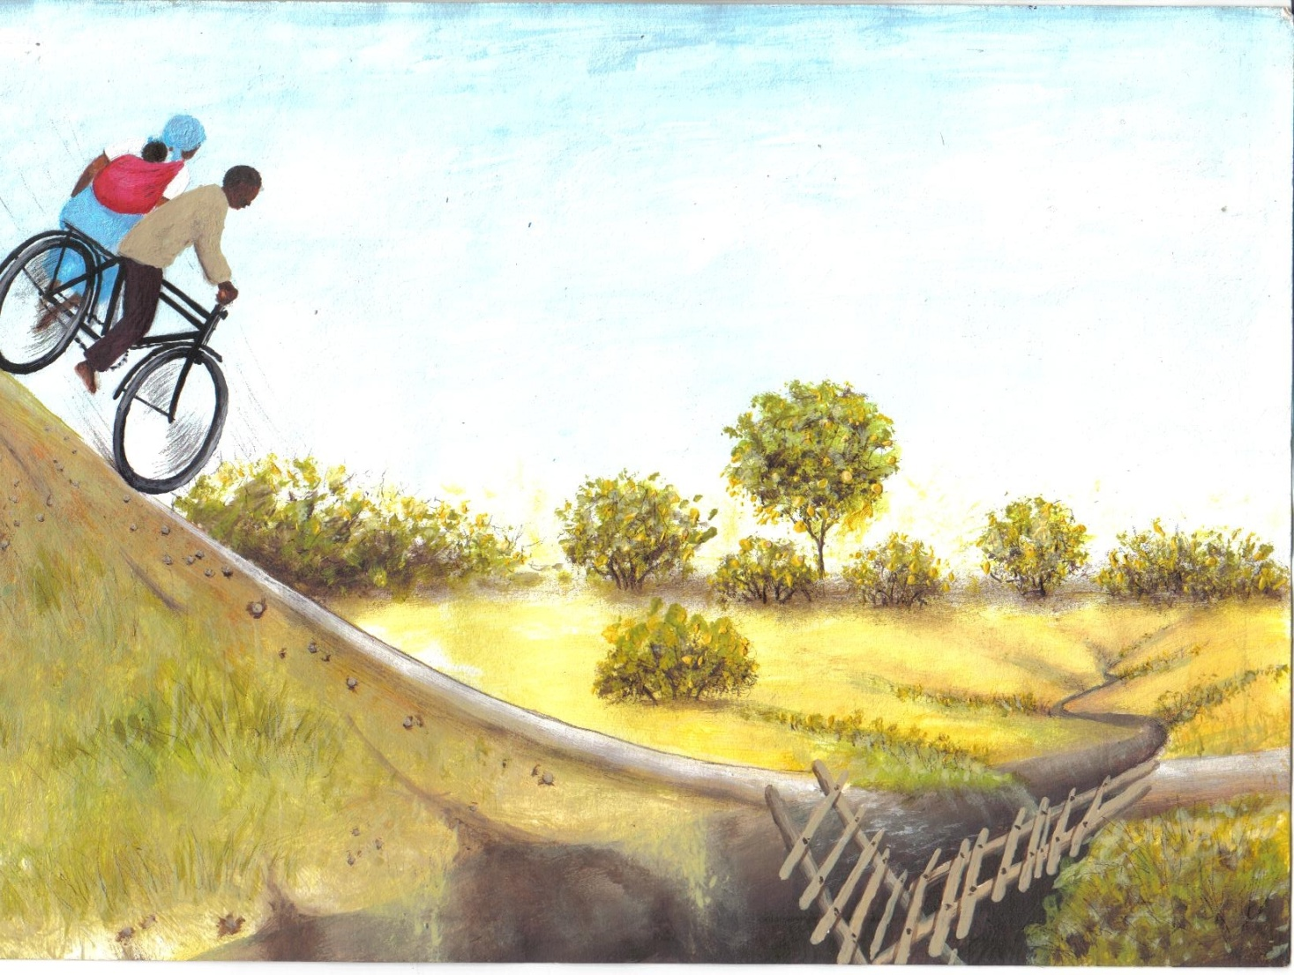
EPISCOPAL CONFERENCE OF MALAWI

TABLE OF CONTENTS

ACKNOWLEDGEMENTS iii
FOREWORD v
INTRODUCTION vi
ACRONYMS ix
MODULE 1 – UNDERSTANDING DISASTER RISK REDUCTION 1
MODULE 2 – UNDERSTANDING AND MANAGING RISKS 5
MODULE 3 – LIVELIHOOD ANALYSIS 13
MODULE 4 – HAZARD ASSESSMENT 21
MODULE 5 – VULNERABILITY ASSESSMENT 27
MODULE 6 – CAPACITY ASSESSMENT 38
MODULE 7 – DISASTER RISK ANALYSIS 48
MODULE 8 – COMMUNITY ORGANIZATION 52
MODULE 9 – COMMUNITY EMPOWERMENT AND PARTICIPATION 58
MODULE 10 – COMMUNITY ORIENTED PLANS 65
MODULE 11 – MAINSTREAMING HIV AND AIDS ISSUES IN DRR 68
MODULE 12 – MAINSTREAMING GENDER IN DRR 77
MODULE 13 – GOOD GOVERNANCE AND HUMAN RIGHTS 85
BIBLIOGRAPHY 94
ANNEX 1 95
ANNEX 2 109

ACKNOWLEDGEMENTS

Many people provided input without which this Training Manual could not have been developed; however, we would like specifically to acknowledge the following people:

Editorial Committee

Fr. Joseph Mpinganjira | - | Secretary General, Episcopal Conference of Malawi
Mr C. Mulume | - | National CADECOM Secretary, Episcopal Conference of Malawi
Mr. S. Munthali | - | CADECOM Secretary, Mzuzu Diocese
Mrs N. Kamba | - | CADECOM Secretary, Blantyre ArchDiocese
Mrs. Noreen Gumbo | - | Technical Consultant, Trocaire
Mrs. Margot Loof | - | Senior Program Officer – Emergency Aid & Construction, CORDAID

Technical Team

Mrs. Rexa Chakakala | - | Program Coordinator (National Relief and Emergency Coordinator, Episcopal Conference of Malawi)
Mr. Chris Mabwera | - | Technical Resource Person (National Training for Transformation Coordinator, Episcopal Conference of Malawi)
Mr Alfred Patel | - | Member (Disaster Risk Reduction Coordinator, Blantyre Archdiocese)
Mr Benard Kanyumbu | - | Member (Disaster Risk Reduction Coordinator, Dedza Diocese)
Mrs Fotina Imani | - | Member (Disaster Risk Reduction Coordinator, Chikwawa Diocese)
Mr. Robin Ngalande | - | Member (Diocesan Health Secretary, Dedza Diocese)
Mr Patrick Namakhoma | - | Member (Relief and Rehabilitation Coordinator, Mzuzu Diocese)
Mr William Kawenda | - | Member (Project Coordinator I.LIFE, Lilongwe Diocese)
Mr Bruno Banda | - | Member (CCJP Secretary, Mangochi Diocese)
Miss Chrissy Kayuni | - | Member (HBC Coordinator, Chikwawa Diocese)
Mrs Jane Chimbwanya | - | Secretary (Administrative Secretary, CADECOM – Episcopal Conference of Malawi)

Donor Partners

CORDAID of Netherlands and TRÓCAIRE of Ireland.
FOREWORD

Malawi has been hit by several disasters, including hunger, HIV/AIDS and flooding over the past years and their frequency is on an increase. These disasters could be prevented if proper corrective measures were undertaken. CADECOM as a developmental arm of the Catholic Church in Malawi has been in the forefront in trying to mitigate the effects of such disasters for the past three years through its Disaster Risk Reduction (DRR) Programme.

Based on the experience from the DRR Programme, CADECOM decided to come up with a training manual that will be used by all her technical staff in building the capacity of communities to prepare positively for disasters by reducing their risks.

This manual will act as a blue print for all future DRR interventions in Malawi as it is the first of its kind in our work. It is user friendly so that all DRR practitioners can easily use it.

This manual is a practical step that the Catholic Church in Malawi has taken to deal with issues of disasters and climate change. It is in line with the Malawi National Adaptation Program of Action and it is my conviction that our work will greatly contribute to the Malawi Disaster Risk Reduction Policy.

Accordingly, it is expected that all staff in DRR will use this manual so that our efforts are standardized in order to increase the capacity of the communities we serve to reduce risks that such disasters bring.

The Episcopal Conference of Malawi in general and CADECOM in particular extends its vote of thanks to Cordaid and Trocaire, who have made this publication a possibility. This is a great capacity building initiative that the Catholic Church in Malawi appreciates. The Church believes that most disasters are man-made and hence can be prevented. Let us share this paradigm shift and stop looking at disasters as acts of God but that they come mostly as a consequence of human action or lack of it..

-----------------------------
Rev. Fr. George Buleya
SECRETARY GENERAL
EPISCOPAL CONFERENCE OF MALAWI

INTRODUCTION

The Catholic Development Commission, the developmental arm of the Episcopal Conference of Malawi, implemented a 3 year (2005 - 2007) Disaster Risk Reduction Program in 21 communities of Chikwawa, Blantyre, Dedza, Mangochi, Mzuzu, Lilongwe and Zomba dioceses. The project was conceived after the 2002/03 food crisis that caught CADECOM off guard and revealed a weak capacity to deal with disasters. This posed a number of questions as to why CADECOM was unable to read the early warning signs despite being a National Organisation implementing food security programs in all the seven Catholic dioceses in Malawi. The project therefore aimed at improving the capacity of CADECOM technical staff and targeted communities to understand, prepare for, mitigate and respond to disasters appropriately and proactively.

In Disaster Risk Reduction, the community members themselves analyze their vulnerability and the potential hazards threatening their livelihood. They design their own programs and draw up Risk Mitigation Plans. CADECOM serves only to provide guidance and some technical support whilst communities implement the programs. This is a total reversal of how CADECOM used to work in emergency related programs where a top down approach was the order of the day, and community members were viewed as recipients of programs designed for them by CADECOM technical staff.

In March 2006 at a program review meeting of diocesan Disaster Risk Reduction Coordinators, CADECOM Secretaries and Field Officers from all the seven dioceses, it was noted that dioceses faced many challenges in implementing the program including inadequate capacity of technical staff to train the communities in Disaster Risk Reduction. Therefore this Disaster Risk Reduction Training Manual was developed to respond to this capacity gap.

ABOUT THIS MANUAL/OVERVIEW

This manual is primarily a tool for practitioners working on Disaster Risk Reduction Programs, specifically those people that are working with vulnerable communities. It has been developed in a way that it is user friendly for those that have been trained in Disaster Risk Reduction concepts, but can also be used by those that have no experience at all.

If you are planning to facilitate a series of learning activities in Disaster Risk Reduction, then this manual is the right tool for you. Please read and understand the manual first before facilitating any DRR related activity in the communities.

HOW TO USE THIS MANUAL

This Training Manual has seven modules which are arranged in the following order:

- MODULE 1 – UNDERSTANDING DISASTER RISK REDUCTION
- MODULE 2 – UNDERSTANDING AND MANAGING RISKS
- MODULE 3 – LIVELIHOOD ANALYSIS
- MODULE 4 – HAZARD ASSESSMENT
- MODULE 5 – VULNERABILITY ASSESSMENT
- MODULE 6 – CAPACITY ASSESSMENT
- MODULE 7 – DISASTER RISK ANALYSIS
- MODULE 8 – COMMUNITY ORGANIZATION
- MODULE 9 – COMMUNITY ORIENTED PLANS
- MODULE 10 – COMMUNITY ORIENTED PLANS
- MODULE 11 – MAINSTREAMING HIV AND AIDS ISSUES IN DRR
- MODULE 12 – MAINSTREAMING GENDER IN DRR
- MODULE 13 – GOOD GOVERNANCE AND HUMAN RIGHTS IN DRR

Each module is introduced with Session Objectives to guide the user. The modules have also taken into account session contents, materials required and tools as well as the time required for each session.

For effective results, community trainings should not last more than three hours in order to allow community members to undertake their daily activities.

If the manual is to be used in a workshop, time for each module allocation should be adjusted accordingly. However a period of one week is recommended at minimum.

The manual has also some tips for the facilitator on handling each session. The facilitator’s key points provide notes to support the delivery.

ACRONYMS

AIDS | Acquired Immune Deficiency Syndrome
CADECOM | Catholic Development Commission in Malawi
CORDAID | Catholic Organisation for Relief and Development Aid
DF | Development Facilitator
DRR | Disaster Risk Reduction
ECM | Episcopal Conference of Malawi
HIV | Human Immune Deficiency Virus
PRA | Participatory Rural Appraisal
SOP | Standard Operating Procedures
TFT | Training for Transformation
VDC | Village Development Committee

MODULE 1 – UNDERSTANDING DISASTER RISK REDUCTION

Case Study

Kalindiza village in Dedza Diocese experienced many problems before the village embarked on a DRR program. The problems included drought, food insecurity and lack of bridges, safe water and sanitation. After being exposed to DRR concepts, the community engaged itself in a number of activities to solve their problems.

One shallow well was dug and two bridges were constructed. Through the DRR process the community also came across an untapped resource, Nakhokoma River which contains running water throughout the year. The river became their hope – for more than a century they looked at the waters passing through to Lake Malawi and through DRR the same water has been recognized as a source of life.

The community began using the river for small scale irrigation. 146 households, 87 of which are female headed are participating in winter cropping production of maize and beans. Six canals have been built and a total of 26 hectares has been cultivated. The community is able to grow their staple food of maize three times a year.

SESSION OBJECITVES:

Overall Objective

To provide a deeper understanding of the common terms and concepts in relation to Disaster Risk Reduction

Specific Objectives

At the end of this module participants will be able to:
- Define Disaster Risk Reduction
- Understand common terms used in relation to Disaster Risk Reduction

SESSION CONTENT

- Meaning of DRR
- Concepts and terms of DRR

DURATION:

Two hours for 2 days

MATERIALS AND TOOLS

- Flip charts and stand
- Markers
- Masking Tapes.

FACILITATORS GUIDE

Step 1 Put participants in groups of two and let them define DRR
Step 2 Ask the participants to give feedback and list the responses on a flipchart
Step 3 Summarize the responses and give participants the right definition
Step 4 Put participants in small groups again and give them small pieces of paper with terms and concepts used in DRR for discussion
Step 5 Let participants list their definitions on a flip chart and present them to the plenary
Step 6 Summarize and define the terms and concepts accordingly

MODULE KEY POINTS
- Definition of Disaster Risk Reduction:
A systematic approach consisting of actions that aim to minimize the extent of disaster risks and loss and to strengthen the capacities of vulnerable communities, households and individuals in order for them to withstand the negative impact of possible hazards taking place in their areas.
- Definitions of Concepts and Terms used in Disaster Risk Reduction
Concept | Definition
Disaster | The serious disruption of the functioning of society, causing widespread human, material or environmental losses, exceeding the ability of the affected communities to cope using their own resources. Disasters occur when the negative effects of hazards are not well managed.
Risk | The probability of meeting a danger or suffering/harm  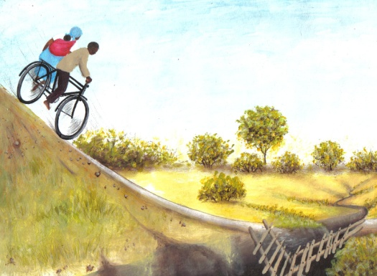  Risk
Vulnerability | The degree to which an area, people, physical structures or economic assets are exposed to loss, injury or damage caused by the impact of a hazard.
Capacity | The resources and skills people can possess, develop, mobilize and access, which allow them to cope with disaster risks and have more control over shaping their own future.
Hazards |  | 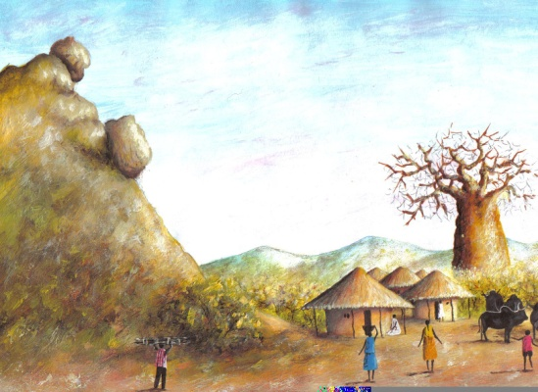  A potential event that could cause loss of life, or damage to property or environment  Hazard
Disaster Risk Reduction |  | Measures taken in order to curb disaster losses, through minimizing the effects of hazards, reducing exposure and susceptibility and enhancing coping and adaptive capacity. Good disaster risk reduction also continues after a disaster, building resilience to future hazards.
Survivability |  | To manage to stay alive or continue to exist, especially in difficult situations.
Readiness |  | Group/community organization functioning as a system prepared for any hazard that might occur.
Warning Signs/Signals |  | Scientific and indigenous indicators that a hazard is likely to happen.
Forewarning |  | Time between warning and impact.
Speed of onset |  | Rapidity of arrival and impact. We can distinguish between hazards that occur without almost any warning (earthquake), and hazards that can be predicted three or four days in advance (typhoon) to a very slow-onset hazard like drought and famine.
Frequency |  | How often a hazard occurs (Seasonally, once a year or every five years?).
Period of occurrence |  | Particular time of the year disaster occurs (Wet or Dry season).
Duration |  | The length of period a hazard is felt (i.e. earthquake and its aftershocks; days/weeks/months that area is flooded, length of military operations).

MODULE 2 – UNDERSTANDING AND MANAGING RISKS

KALINDIZA MODEL VILLAGE

Background information

The Diocese of Dedza implemented a three year disaster risk management project. The project started in January2005 and was implemented up to December 2007. The project was implemented in three impact areas, namely: Kanyama village in Dedza parish, Kalindiza village in Mua parish and Chinyamula village in Ntcheu parish.

The Goal of the project is ‘Increased resilience to livelihood shocks amongst rural communities in the Diocese of Dedza.”

Kalindiza village introduction

Kalindiza village has been taken as a model.
At the project onset the village identified its problems through livelihood analysis. Problems identified included lack of availability of safe drinking water, food insecurity, land degradation, soil infertility, prevalence of HIV/AIDS, deforestation, lack of access to markets, pests and diseases, poor road infrastructure, flooding and drought.

Project Location

The area lies within the great African Rift Valley floor at an altitude of 500 to 600 meters above sea level. The area is generally hot with erratic rainfall and is prone to drought and flooding. The soils are dark alluvial due to siltation caused by soil erosion in the upland and escarpment areas due to depletion of indigenous forests.

The average land holding size for a household is .6 ha. The members of the community are predominantly farmers. The crops grown are maize, groundnuts, beans, cowpeas, cassava, sweet potato, vegetables and a variety of fruits like mangoes pawpaws and bananas are found in the area.

(Continued next page)
SESSION OBJECTIVES

Overall Objective

To contribute towards reducing the impact of disaster through Risk Reduction

Specific Objective

- To identify factors that increase risks
- To increase participants understanding in Risk Reduction

SESSION CONTENTS

- Understanding Risk and contributing factors
- Road to Development/Key elements of Risk Management approach
- Characteristics of Disaster Risk Reduction Approach.

DURATION

3 hours per day for 2 days

MATERIALS AND TOOLS

- Flip charts, stand and markers
- Diagram of Road to Development
- A drawing of a man on a bicycle with his wife and a child approaching a cliff.

(Continued from previous page)

The livelihood analysis process used the following PRA tools:

Transect walk
Village mapping
Focus group discussions
Semi structured interviews
Venn diagrams
Wealth ranking
Problem tree
Objective tree
Development of community plan

The livelihood analysis instilled in the community a sense of ownership of programs and commitment during activity implementation. Through the project, seed money was available to assist the communities in implementing the identified activities.

Project Implementation

Below is a brief outline on how the project’s activities addressed the problems identified in the livelihood analysis.

Lack of safe drinking water

The community is on a site with two springs flowing with water throughout the year. On this site the community has established a well protected well. The Assemblies of GOD Church within the area assisted by providing drums and cement for the construction of the protected well. The community provided the labour, sand, stones and the builders.

The field supervisor and members of the DRR beside a protected will.

(Continued next page)

FACILITATORS GUIDE

Step 1 Introduce module objective clearly
Step 2 Introduce the following story:

A story

A man with his pregnant wife and a child had a journey on a push bike which had no brakes. However, before they started off, the man drank beer until he was very drunk. Finally, they started off the journey at high speed down a steep slope, approaching a broken bridge.
Step 3 Have participants brainstorm on the story by answering the following questions:
- What happened to the man?
- What lessons can we draw from this story?
- Do we have such scenarios in our areas?
- If it happens, why?
- What could be the consequences?
- What could be done to prevent such a risk?

Step 4 Introduce Session Contents as per session objectives. Relate these to the case study
(Continued from previous page)

Food insecurity

The main hazards affecting the community are drought and erratic rains which can lead to very poor crop yields.

To overcome this problem the members of Kalindiza village decided to embark upon an intensive irrigation project. During the livelihood analysis facilitated by CADECOM, they realized the potential of the two rivers passing through the community.

Currently the community of 417 households (310 MHH; 107 FHH) has managed to dig and construct 6 canals covering a distance of 26 ha., involving 59 MHH and 87FHH.The system used is river diversion.

The weir is a traditional method of river diversion.

Village headman Kalindiza in front of one several plots of maize on winter cropping.

(Continued next page)
Step 5 Define Session Contents by referring to the key points of the module
Step 6 Summarise the session and find out whether participants have understood the content
MODULE KEY POINTS
(Continued from previous page)

The community is able to harvest up 500kgs of maize from a .1 ha. plot. The community used to buy tomatoes and other vegetables from the market within the village which were produced by communities upland. The community members are now able to produce tomatoes of their own and even produce a surplus which they able to sell at the market.

Since the community members no longer have to cultivate other people’s fields for maize in the sounding villages, they are able to spend time tending their own gardens and doing other activities during the growing season.

The project also assisted the community with livestock to supplement protein intake and increase the resilience of the target households during times of food shortage. The livestock is given as a loan which will be repaid through a pass-on scheme.

Mr.Florensio Mpamu with 2 female goats
received from the project.

Poor infrastructure
Having identified poor infrastructure as a problem the community embarked the construction the village access roads and 4 bridges.

A bridge under construction

(Continued page 9)

Understanding Risk

Risk = Hazard x Vulnerability
Capacity
In order to understand risk better let us define elements contained in the formula above
Element | Definition
Risk | The probability of meeting a danger or suffering harm. There are two major factors contributing to the risk that an injury might occur during a hazard: vulnerability and capacity. When disaster risk is high, the probability of a disaster erupting is also high and when disaster risk is low the probability of a disaster is low.
Hazards | A potential event that could cause loss of life, or damage to property or the environment. Hazards are facts of life, be they droughts, or floods, earth quakes, armed conflicts, or otherwise. People who are highly vulnerable or who have low capacity to deal with hazards are at highest risk of injury.

Element | Definition
Vulnerability | The degree to which an area, people, physical structures or economic assets are exposed to loss, injury or damage caused by the impact of a hazard. With vulnerability one should think of aspects like socio – economic and/or physical vulnerability: e.g. being unemployed, living in slum area, living in an area where armed conflicts take place, being a single parent, being a person or family affected by HIV/AIDS, being an elderly or disabled person etc. Therefore the higher the level vulnerability the higher the element is subjected to a risk.
Elements at Risk | Refers to people and their property. The lower the capacity the higher the risk an element is subjected to.
Capacity | The resources and skills people possess or can develop, allow them to cope with disaster risks and have more control over shaping their own future (e.g. level of education, skills to build houses that can with withstand an earthquake, knowledge on how to survive if floods occur, ability to diversify income, conflict resolution skills etc). The higher the capacity the lower is the element at risk and vice versa.

- Road to Development /Key Elements To Risk Management

The road to development categorizes Disaster Risk Reduction interventions simply as pre, during and post disaster responses, which are carried out within the overall framework of sustainable development.

Pre Disaster | During Disaster | Post Disaster
Prevention  Mitigation  Preparedness | Emergency  Response | Rehabilitation  Reconstruction

Diagram of Road to Development

Disaster

Event | Pre-Disaster | During Disaster | Post Disaster | Post Disaster
Intervention | Preparedness | Relief | Rehabilitation | Mitigation & Prevention (Development)

Source: Livelihood Analysis Handbook

- Preparedness: These are interventions that take place before a crisis or disaster occurs. Examples of these interventions could be dissemination of cholera messages before an outbreak, AIDS awareness campaigns, or agricultural extension messages before the rainy season, etc.
(Continued from page 6)
The community contributed planks which were obtained in collaboration with the department of forestry, as well as stones and sand. Through the seed money provided by the project, the community was able to obtain nails and cement.

The Diocesan and National Cadecom vehicles crossing a newly completed bridge

Lack of access to markets

In collaboration with the food security program, the community formed an association. The formation process has reached an advanced stage. An account has been opened with a savings bank and a draft constitution has been formulated.

Deforestation

The community is involved in several activities to combat deforestation through the raising of seedlings and managing the forest in the government forest reserve.

Members of the forestry committee watering their seedlings

(Continued next page)
- Relief: Measures taken to alleviate immediate hardship and meet basic needs for shelter, water, food, sanitation, healthcare etc., as well as search & rescue.
- Rehabilitation: Processes undertaken by a disaster-affected community to fully restore itself to its pre-disaster level of functioning and which should enable it to become even more disaster resistant. These processes take place after a disaster has occurred.
- Mitigation: These are basically measures taken well in advance of a hazard alert to minimize the vulnerability of communities/households to a known expected threat (e.g. crop diversification in drought prone areas).
- Prevention Measures are designed to provide permanent protection or reduce the intensity of a hazardous event so it does not become a disaster. An example of such interventions could be reforesting an unstable slope to prevent landslides.

The Road to Development has proved to be a powerful tool that enables communities to analyze their own situations and design measures that can lessen the impact of such situations.

Characteristics of the Disaster Risk Reduction Approach

- It moves away from science driven (hazard identification) to an approach which is driven by and centred on people (Vulnerabilities and capabilities).
- It moves away from reactive action to proactive action, which involves identification and understanding of the causes of disasters in order to reduce their likelihood and recognizes the need to build response capacity.
- It promotes an approach where people take responsibility for their own wellbeing, assigning an auxiliary and complimentary role to “external” organizations.
(Continued from previous page)

Strategies Used :

- Review meetings.

Based upon the findings from the livelihood analysis process the community came up with community development plans. The plans were reviewed through fortnightly executive committee meetings and monthly community meetings.

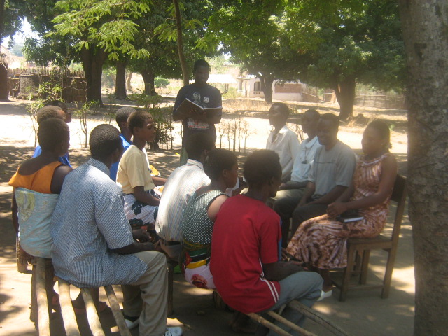

Executive Committee Meeting in Session

- Collaboration.

The community collaborated with several Ministries and organizations.

The Ministry of Agriculture has been actively involved from the beginning in dissemination of technical massages.

ILRAD, a World Bank funded project has, through the Ministry of Agriculture assisted with seeds and fertilizers in the promotion of winter cropping, their main area of focus.

Other organizations and government departments have played vital roles in the areas of environmental protection, health and agriculture.

- Recommendation

The DRR committee should undergo simple proposal development training to access funding from other sources such as the District Assembly to promote better integration with line Government departments and other stakeholders.

- It focuses on reducing the risk and not the disaster, understanding risk as a dynamic factor influenced by social causes.
- It understands humans as part of an environment which influences and is influenced by social causes.
- It makes it impossible to address development without considering risks and vice versa.

- Addresses root causes of vulnerability, taking into account socio-ecological disequilibrium in the world.
- Risk can be described in a formula:

Vulnerability X Hazard = Risk
Capacity
V X H = Risk
C

(Livelihood Analysis Handbook, Learning About Livelihoods, Rick de Satge, Logo Prints, Oxfam , Great Britain, 2002)

MODULE 3 – LIVELIHOOD ANALYSIS

SESSION OBJECTIVES

Overall Objective

To improve understanding of the community’s opportunities and strengths in designing appropriate strategies for its livelihood

Specific Objective

- To provide a deeper understanding of livelihood
- Provide skills for livelihood analysis
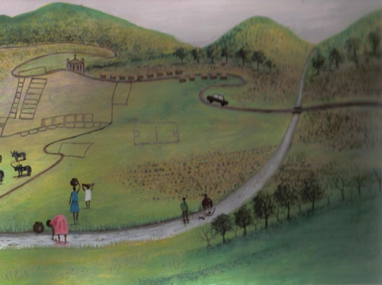
SESSION CONTENT

- Define livelihood
- Define livelihood analysis
- Purpose of livelihood analysis
- Discuss how livelihood analysis is executed
- Essential tools used in livelihood analysis

DURATION

2 hours 30 minutes per day for 5 days

MATERIALS AND TOOLS

- Flipcharts, markers, masking tape
- A drawing of a hunter watching a cocoon on a tree
- A drawing of livelihood framework

FACILITATORS GUIDE
Step 1 Introduce the module objective clearly
Step 2 Introduce the story of a hunter (Using the diagram of a hunter removing immature butterfly (maggot) from its cocoon/cover.
Story of a Hunter

One day, a small opening appeared on a cocoon. A man sat and watched the larvae, caterpillar inside for several hours

As it struggled to force its body through the little hole it appeared as if it had gotten as far as it could and it could not go any further. So the man decided to help the maggot. He took a pair of scissors and opened the cocoon; the maggot then emerged easily, but it had withered, it was tiny and had shrivelled wings.

The man continued to watch because he expected that any moment, the wings would open, enlarge and expand, to be able to support the maggot’s body and become firm. Neither happened! In fact, the maggot spent the rest of its life crawling around with a withered body and shrivelled wings. It was not able to fly and finally died.

Step 3 Brainstorm the story of a hunter using the following questions:

- Did the hunter do the right thing in helping the maggot out of the cocoon?
- Was the hunter’s help timely?
- Did the hunter assist the maggot at last?
- Which of the two (the hunter and the maggot) had good knowledge of the situation?
- Does this relate to our local village?
- What do we learn from the entire story?

Step 4 Introduce Session Contents as per session objectives. Relate these to the case study
Step 5 Introduce the livelihood framework, review and discuss it with the participants
Step 6 Define Session Content by referring to the modules key points
Step 7 Introduce essential tools in livelihood analysis (Refer to the PRA tools Annex1)
Step 8 Summarise the session and find out whether participants have understood the content
MODULE KEY POINTS

Introduction

Understanding a community's concerns enables us to effectively identify and analyze its needs and respond with appropriate interventions. In order to assess a community and create its profile, we need to discover those things that matter to the community, what issues the community feels are most important to address, and what resources are available to bring about change. By interviewing community members, conducting listening surveys, public forums and spending time in the place, we can develop a community profile that helps in identifying critical issues and planning for future interventions.

- Livelihood
Definition of Livelihood
Livelihood comprises the capabilities, assets (stores, resources, claims and access) and activities required for a means of living. Livelihood is sustainable when it can cope with and recover from stress & shocks – maintain and enhance its capabilities and provide sustainable livelihood opportunities for the next generation.

Livelihood Framework
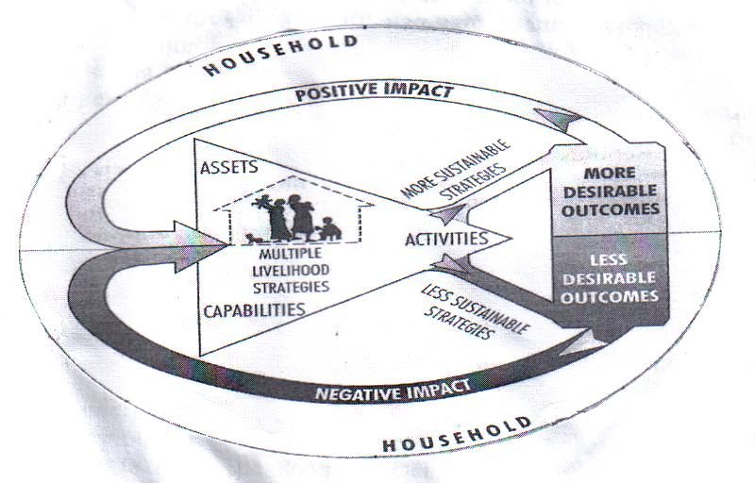

Livelihood Analysis Handbook

The livelihood framework puts people at the centre. Households have capabilities and access to a range of assets which they use to carry out different livelihood activities. There are many different shapes and sizes of households. Households are differentiated by their relative well-being and access to resources and power. The framework also looks at gender and age relations within and outside the household. Gender and age affect access to resources and the kinds of livelihood activities that are possible.

Households use their assets and capabilities to engage in many different strategies to try to secure livelihood. The more diversification there is in the livelihood strategies of a household, the more secure it is likely to be.

Different livelihood strategies have different outcomes, and they may be more or less sustainable. Desirable livelihood outcomes vary from household to household but increased well-being is usually a high priority. When a household is able to achieve a desired livelihood outcome, this has a positive impact on its assets and capabilities (its assets and capabilities improve). When livelihood activities have an undesirable outcome, this has a negative influence on a household’s assets and capabilities.

Local livelihood activities are affected by factors in the external (macro) environment on the local, national and international levels. The external environment includes the physical environment, the social environment, the political/institutional environment and the economic environment.

The environments can have an enabling influence on a household’s ability to engage in sustainable livelihood strategiesor they can undermine livelihood sustainability through shocks and stresses. In the same way that the external environment affects households, households affect the external environment. These influences can be positive or negative.

The livelihood framework is holistic. It can be used to analyze both the micro and macro environments and the influence that they have on each other. In this way, key trends can be identified which show how households in different categories of well-being are moving towards greater resilience and livelihood sustainability or falling into increased vulnerability. The framework also enables change over time to be brought into the analysis.

- Livelihood Analysis

Definition

Livelihood analysis is a process where a set of data collection techniques and analytical tools are employed to collect data that is used in assessing the community’s opportunities and strengths and helps in planning for appropriate interventions to address livelihood deficits. The analysis acts as a tool that assesses and addresses vulnerability.

- Purposes of Livelihood Analysis

- To analyze existing and potential livelihood strategies (assets, surrounding systems and structures, and the local vulnerability context).
- To identify practical, effective and socially acceptable strategies and interventions that would make the greatest improvements.
- To provide an understanding of community or target group’s primary local needs/constraints/opportunities.

  - How livelihood analysis is executed in the community

Step 1: Site selection
In this step the DRR team and the community choose the sites where livelihood analysis will be conducted as part of the development process.

Step 2: Selecting secondary data
In this step the community identifies potential sources of secondary data to provide background information on the sites they have selected. They must then decide what sort of data they need for the planning process.

Step 3: Determining entry strategies
Once the DRR team has selected the sites and collected some background information, it must decide on the best entry strategy. Who to talk to? How can the team ensure that voices of poor, marginal households are not silenced by more powerful and vocal interests?

Step 4: Building the team: Fieldwork principles, behaviour approaches
In this step, DRR team members orient and remind themselves of fieldwork principles, behaviours and approaches. The team needs to reflect on some of the dos and don’ts of working with people on the ground, and prepare properly to do the work.

Step 5: Initial assessment
This introduces a range of tools and methods that can be used to:
- Develop guiding questions
- Identify community issues
- Determine stratification and differentiation
- Reveal different household assets, livelihood activities and capabilities
- Isolate key influences and shape the vulnerability content

Tools used include Participatory Rural Appraisal (PRA) and Training for Transformation (TFT) to assist the research teams in covering the following areas: community profile, livelihood assets, structures, policies and processes, vulnerability context (shocks, cycles and trends), livelihood strategies and diversification and livelihood outcomes (Please refer to the tools attached as Annex 1 and 2).

During this step, participatory research methods are reviewed that can be used to collect qualitative and quantitative data. It examines how to develop household profiles using semi-structured interviews (SSI).

Stratification: in this context, refers to the fact that households have different levels of well-being.

Qualitative data: has to do with qualities rather than with things that can be measured or counted

Quantitative data: has to do with quantities – things that can be measured or counted.

Step 6: Analyzing the information
This step involves completing an analysis on the information collected through different participatory activities. The livelihood analysis team brings together secondary data and information from field work to identify key trends and the connections between different issues. At this stage the team needs to be particularly aware of its biases. It needs to re-examine how it saw the issues and problems at the beginning of the process. The team must make sure that it reflects assessment findings back to the community in an open-ended way so that local analysis can take place.

Step 7: Making the linkages (1)
Now that the planning team and local stakeholders have the information before them, they need to consciously make the connections between local trends and factors that are influencing them in the broader environment.

Step 8: Reflection, vision and prioritization
This step explores the process of reflecting on and analyzing the information that has been synthesized from field work and secondary data with local people. Who develops the criteria and indicators that are used to assess the information and prioritize issues? Professionals should not substitute their ideas for the analysis of local people. They should also recognize the limitations of narrow problem-based analysis. Appreciative planning approaches can enable people to develop a vision, priorities and ideas about key interventions, building on existing strengths.

Step 9: Proposal development
Strategic planning that builds on the vision and priorities of part 8 must be completed to develop a proposal for the start-up phase of the initiative. The start-up phase requires a baseline study (See part 10) to provide more in-depth information about the priorities which have been identified. Once the baseline study has been completed, the detailed program objectives and outcomes can be specified together with key indicators of success.

Step 10: Start-up: Baseline research
Once the proposal for the start-up phase of the initiative has been approved, the baseline study can be conducted. A baseline is a detailed, tightly-focused study in selected targeted households. The baseline deepens the knowledge of the community and enables targeted interventions to be made. It also provides useful information for future monitoring and evaluation purposes.

Step 11: Making the linkages (2)
Once in-depth research has been carried out, the team and local stakeholders need to revisit how the wider environment affects local livelihood and vulnerability. Once these links are clear, local people and the development agency can use them to lobby for policy changes.

Step 12: Program implementation
This step briefly summarizes how the intervention ideas are refined with the stakeholders and the community. A detailed intervention plan is agreed upon. (Refer to module 8)

Step 13: Participatory monitoring and evaluation
This is a final step that examines how the data from the baseline livelihood analysis and household profiles can provide important information for a monitoring and evaluation framework. This data enables the team to select indicators that will measure the impacts of development initiatives.

MODULE 4 – HAZARD ASSESSMENT

SESSION OBJECTIVES

Overall Objective

To enable participants to characterize selected hazards and identify their elements in terms of how they can affect the individuals and the community

Specific Objective

1. To identify and prioritize the selected hazard in a given community setting
2. To characterize a selected hazard using a hazard assessment tool

SESSION CONTENT

- Conducting hazard assessment

DURATION

1 hour 30 minutes

MATERIALS AND TOOLS

- Flipcharts, markers, masking tape
- Hazard assessment exercise forms

FACILITATORS GUIDE

Activity 1 – Brainstorming on hazards afflicting a community (30 minutes)

Step 1 Recap the key learning points in the previous session and explain that hazard, vulnerability and capacity assessments are the key components in disaster risk assessment. In this session, the focus is on hazard assessment as the first step.

Step 2 Ask the participants what types of hazards commonly afflict their community. Write their responses on a flip chart paper.

Step 3 Then ask the participants which among those listed are the five most significant hazards. If the participants give more than five hazards, ask them to vote by show of hands the top five hazards. Explain that they would be analyzing the five hazards in the next activity.

Activity 2 – Hazard Assessment exercise (1 hour, 10 minutes)

Step 1 Divide the participants into five groups. Ask each group to choose the hazard it would like to analyze, based on the members’ familiarity with the hazard.

Step 2 Distribute the Hazard Assessment form to each participant and explain that the key elements in profiling a hazard are force, warning signs and signals, forewarning, frequency, duration, period of occurrence and hazard description. Ask them the definitions of these terms. Refer back to the terminologies discussed during Module 1 b).

Step 3 Using as an example a hazard not prioritized by the group, illustrate how to characterize a hazard by using the prepared flip chart containing the Hazard Assessment form. Fill out the fields in the form together with the participants. (See example below.) Allow participants to debate on the correct answers.

Exercise: How will the hazard affect me and my community?

Hazard: Floods in Bondo Village

Community Profile:
Location: Bondo, T/A Mabuka, Mulanje
Population: 362
Agro ecology: Semi-arid
Vegetation: Shrubs and bushes
Resources: Schools, health centres, boreholes, rivers, community, forests, roads
Ethnic group : Lomwe tribe
Language: Lomwe
Food security status: Insecure

Characteristics | Elements | Analytical  Description of  Hazard | Exposure Variables
Characteristics | Elements | Analytical  Description of  Hazard | How will it affect me? | How will it affect  my community
Cause/Origin | -Heavy rains  -Deforestation  -Poor agricultural practices | Water levels in rivers rapidly rise and spreads to the land and sweeps away houses, property leaving people homeless and claiming lives | -homelessness  -No food  -Loss of property  -loneliness  -Socially, physically and psychologically affected | -Displacement  -Community development disturbed  -disease outbreak  -Power hunger in the new settlements
Force | Water
Warning signs  and signal | -Thunderstorms  -Heavy rains
Forewarning | -Heavy running water from highlands  -Size of water level in rivers  -Weather reports
Speed of  Onset | Rapid
Frequency
Period of
Occurrence

Duration

Step 4 Ask the participants to profile the hazard assigned to their group. Give the following instructions:
a. Identify a community familiar to one of the group members that is often afflicted by the hazard assigned to the group.
b. Develop a detailed description of the community: location, size, socio-economic status of the people, physical features, livelihood patterns, availability of basic social services, financial services, climatic conditions, etc.
c. Complete the hazard assessment form for the group’s selected hazard.
d. Write the community’s name, description and hazard assessment on flip chart papers for presentation.
e. Time allocated for group work is 30 minutes.

Step 5 Ask each group to report their community description and hazard assessment. After each presentation, allow the other participants to comment and ask questions.

Note to facilitator
From this point on let the participants take charge of the plenary session after you have instructed them how to facilitate.

Synthesis (10 minutes)
- Hazard assessment defines the threats and provides an understanding of the nature and behaviour of particular hazards.
- The assessment brings out information on the characteristics of hazards, specifically, the cause of the hazard, the hazard force, warning signs and signals, forewarning, speed of onset, frequency, period of occurrence and duration.
- The characteristics of a hazard in one community are different in other communities.

MODULE KEY POINTS

Conducting Hazard Assessment

Hazards are usually referred to by many people as disasters. A hazard only becomes a disaster when it hits a community which is unable to cope with its effects. This module seeks to clarify the definition of hazard and its categories. It will also discuss the elements involved in characterizing hazards and move towards discussing hazard assessment.

According to the Glossary of Terms of United Nations International Strategy for Disaster Reduction (UN-ISDR), a hazard is “a potentially damaging physical event, phenomenon or human activity that may cause the loss of life or injury, property damage, social and economic disruption or environmental degradation.”

Hazards can be divided as follows:

Those based in nature: earthquakes, droughts, floods, avalanches, etc.
Those based in violence: war, armed conflict, physical assault, etc.
Those based in deterioration: declining health, education and other social services; environmental degradation, etc.
Those based in the failings of industrialized society: technological failures, oil spillage, factory explosions, fires, gas leakages, transport collisions.

Source: Bellers, 1999

To further understand the behaviour and nature of a hazard, it is necessary to characterize a hazard. Answering the following questions will help us do this:

- What is the root cause of the hazard?
- What will hit me? (force)
- When will it hit me and how will I know that it will hit me?

The answer to these questions corresponds to the categories in the table below:

Character | What is it? I will be hit by what? | When will it hit me and how will I know that it will hit me?
Nature and behaviour | Force | Warning signs and signals, forewarning, speed of onset, frequency, period of occurrence and duration

Hazard assessment exercise form

Characteristics | Elements | Description of the hazards | Exposure Variables
Characteristics | Elements | Description of the hazards | How will it affect me? | How will it affect my community
Cause/origin
Force
Warning signs and signal
Forewarning
Speed of onset
Frequency
Period of occurrence
Duration

MODULE 5 – VULNERABILITY ASSESSMENT

SESSION OBJECTIVES

Overall Objective

To enable participants to undertake a vulnerability assessment guided by the chosen view that defines vulnerability in relation to location

Specific Objectives

1. To identify and differentiate the two views on vulnerability
2. To carry out a vulnerability assessment using the given tool

SESSION CONTENT

Undertaking a vulnerability assessment

DURATION

2 hours

MATERIALS AND TOOLS

- Flipcharts, markers, masking tape
- Vulnerability Assessment Exercise Form

FACILITATORS GUIDE

Activity 1 – Brainstorming on the definition of Vulnerability (20 minutes)

Step 1 Link this session to the previous one by explaining that Hazard is one of the three variables that needs to be assessed when measuring disaster risk. The second variable is Vulnerability. The third variable, Capacity, will be discussed in the next session.

Step 2 Ask participants what they understand by the word Vulnerability and list down their responses on a flip chart paper. Take as many responses as possible for about 15 minutes.

Step 3 Summarize their responses and explain the following:
Vulnerability is the degree of exposure of elements (people or things) at risk from the hazard. People’s lives and health are usually directly at risk from the destructive effects of the hazard. Their livelihood may also be at risk because of the destruction of assets they depend on, e.g. buildings, crops, livestock or equipment.

Activity 2 – Input on Vulnerability (30 minutes)

Step 1 Given the initial discussion on Vulnerability, ask the participants what factors affect vulnerability? Point out the differences and similarities in their responses. Explain that Vulnerability is a complex concept and people often get confused and misuse the term a lot.

Step 2 Draw a rock rolling down the slope of a hill and a person standing at the bottom. Explain that because of the falling rock, the man is an element at risk. He is vulnerable because he is on the path of the rock (location), thus exposed to the falling rock (hazard). However, if he decides to move far away (capacity) from the rock’s path (location), he will no longer be vulnerable.

Step 3 Give input on the two ways of viewing Vulnerability, referring to the handout.

Activity 3 – Group work on Vulnerability Assessment (1 hour, 15 minutes)

Step 1 Distribute the Vulnerability Assessment Exercise Forms and explain the various fields in the form. Allow for questions to clarify any confusion.

Step 2 Ask the participants to use the output of the Hazard assessment exercise in the previous session to assess the vulnerability of the element at risk. Allow 30 minutes for group work, after which they will report back to the plenary using flip chart papers.

Step 3 Let the participants facilitate the plenary reporting and discussions. The facilitator may now focus on noting the key points presented by each group.

Step 4 Wrap up the activity.

Synthesis (10 minutes)

- There are two ways of viewing Vulnerability:

Unsafe Location | Unsafe Conditions
Risk = Hazard x Vulnerability  Capacity  - Degree of exposure is measured in relation to the location of the element at risk and the force of the hazard  - Capacity differs from location | Risk = Hazard x Vulnerability  - Capacity determines the extent of vulnerability

- Vulnerability is hazard specific.
- This course adopts the concept of unsafe location in defining vulnerability and allows capacity to be measured separately.

MODULE KEY POINTS

Vulnerability Assessment

Vulnerability is a complex term and can be defined in several ways. Many end up more confused after reading the numerous materials about it. This handout seeks to provide clarity and presents the two ways of viewing Vulnerability. It also defines Vulnerability Assessment after explaining Vulnerability.

  - Vulnerability as the condition of the element at risk

Vulnerability here is defined is “a set of prevailing or consequential conditions, which adversely affect the community’s ability to prevent, mitigate, prepare for or respond to hazard events” (Anderson and Woodrow, 1989).

The International Strategy for Disaster Reduction (ISDR), which uses this definition, states that these conditions are determined by physical, social, economic and environmental factors or process, which increase the susceptibility of a community to the impact of a hazard.

The above definition can be represented by the following mathematical formulas:

- Vulnerability = unsafe conditions (which could be physical, economic, social, behavioural and environmental)
- Degree of Vulnerability = ideal safe conditions – (minus) existing unsafe conditions

The gaps between the ideal and unsafe conditions of the element at risk determine the degree of exposure to the hazard’s impact – or what is considered under this paradigm as the degree of vulnerability. This means the rich and the poor, although living in the same location, have different degrees of vulnerability because they have different socioeconomic and political status.

In measuring disaster risk based on the above assumption, the mathematical presentation is:

Disaster Risk = Hazard x Vulnerability

Here, Capacity is subsumed by Vulnerability.

With the assumption that vulnerability is the condition of the element at risk, categorizing or grouping vulnerabilities soon came about. Proponents of this definition group vulnerabilities into the following categories:

Categories | Example
Physical Vulnerability | communities in hazard prone locations (in flood plain or a coastal location exposed to cyclones)
Technical Vulnerability | structures and infrastructures (houses, roads, bridges, irrigation canals) unable to withstand and resist hazard events
Economic Vulnerability | insufficient assets and reserves to withstand loss; lack of economic diversification
Environmental Vulnerability | lack of biodiversity; incapacity of the ecosystem to resist and recover
Social Vulnerability | family size, existence of community organizations and social support mechanisms, age structure of community, gender differences, racial, ethnic or religious discrimination
Political Vulnerability | level of participation in decision-making processes, existence of authoritarianism and corruption, political violence, absence of justice and conflict resolution mechanisms
Cultural Vulnerability | systems of beliefs regarding hazards, vulnerabilities and disasters
Educational Vulnerability | lack of information or misinformation regarding risk scenarios
Institutional Vulnerability | lack of public services, planning, emergency preparedness and response

On the other hand, Anderson and Woodrow (1989) group them into three broad interrelated categories: physical/material, social/organizational and motivational/attitudinal.

Below are some examples of vulnerabilities based on this grouping:

Categories | Example
Physical/material vulnerability | - risky and insecure sources of livelihood  - lack of access and control over means of production (land, farm inputs, animals, capital)  - occurrence of acute or chronic food shortage  - lack of basic services: education, health, safe drinking water, shelter, sanitation, roads, electricity, communication  - high mortality rates, malnutrition, occurrence of diseases
Social/organizational vulnerability | - weak family/kinship structures  - lack of leadership, initiative, organizational structures to solve problems or conflicts  - ineffective decision-making, people/groups are left out  - unequal participation in community affairs  - rumours, divisions, conflicts: ethnic, class, religion, caste, ideology
Motivational/attitudinal vulnerability | - negative attitude towards change  - passivity, fatalism, hopelessness, dependence  - lack of unity, cooperation, solidarity  - lack of awareness about hazards and consequences  - dependence on external support/dole-out mentality
  - Vulnerability as the unsafe location of the element at risk

Vulnerability based on unsafe location refers to the “degree to which an area, people, physical structures or economic assets are exposed to loss, injury or damage caused by the impact of a hazard.” (Disaster Management: A Disaster Manager’s Handbook, Chapter 2 and Appendix A. Disaster Mitigation in Asia and the Pacific, p 30-40)

This definition defines Vulnerability as equivalent to location and can be represented in this mathematical formula:

- Vulnerability = the location of element at risk vis a vis the hazard (considering other factors like slopes)

- Degree of Vulnerability = Location of element at risks
Distance and time

The location of the element at risk (the rich and poor houses) determines the degree of exposure to hazard or the degree of vulnerability. This shows that whether rich or poor, all persons living in the same location have equal degrees of vulnerability to the impact of the hazard. Under this assumption, the socio-economic status has no bearing on the degree of vulnerability. Thus, vulnerability refers mainly to the location of element at risk and this becomes the main determinant in the degree of exposure to the hazard’s impact.

In measuring disaster risk based on the above assumption, the mathematical representation is:

Disaster Risk = Hazard x Vulnerability
Capacity

Here, capacity is recognized as a separate variable and subsumed by neither hazard nor vulnerability. Capacities can be categorized under the following: prevention, mitigation, preparedness and survivability.
The major strength of this view is that it allows Vulnerability to be determined by the most constant element in assessing disaster risk – the location of the element at risk in relation to the hazard. At the same time, it also gives weight to the economic, social and cultural conditions which are viewed not merely as negative factors that increase vulnerability but as elements that increase or decrease the capacity to cope with the hazard’s impact.

(Note: A more detailed discussion of capacity will be held in the next session.)

It must also be stressed that vulnerability under this assumption is hazard specific. Thus, calculating the degree of vulnerability should always be made in relation to the hazard.

Meanwhile, community vulnerability assessment is defined as the process of determining the susceptibility to various hazards of the elements at risk in the community.

The differences between the two perspectives on vulnerability and their implications are summarized in the table below:
 | Salient Features | Implications
1. DR = H x V | - Capacity is subsumed by vulnerability | - Putting value on capacity becomes difficult because it is already subsumed under vulnerability
 | - The difference between ideal capacity and existing capacity is the degree of vulnerability | - Categorization of vulnerability and capacity often have the same heading which causes confusion
 | - Common mistake: hazard is not factored in as a point of reference in calculating the degree of vulnerability | - Often, the list of vulnerabilities and capacities are not analyzed based on degree of vulnerability to a hazard.
2. DR = H x V  C | - Capacity is calculated separate from vulnerability | - Putting value to capacity is easier and more directed to the degree of vulnerability and nature of a hazard
 | - The interaction of various components of capacity - social, economic, political, geophysical, and technological elements – are factored in as a unit of analysis in relation to hazard and vulnerability | - Categorizing the capacities that address the degree of vulnerability and hazard is simple and straightforward. For example, capacities for addressing vulnerability can be grouped under “survivability of individuals” in the community. The readiness of the community systems and structures that helps individual to survive during hazard events can be grouped under prevention and mitigation.
 | - The degree of vulnerability is measured based on the proximity of the element at risk to a hazard. | - The different elements at risk in a community may have varying degrees of vulnerability depending on their location in relation to a hazard
Take note that the second view allows a more systematic and quantifiable measurement of the degree of vulnerability while still taking into account the social, economic, political, geophysical and technological conditions under capacities which are considered as one unit of analysis.

Capacities here are analyzed as the interaction of the resources and access to these resources by the people at risk as well as the over-arching systems and structures of a society – all these factors decrease or increase the capacity of the people at risk to confront the degree of vulnerability and behaviour of a hazard.

Vulnerability Exercise Form

Hazard Profile | Element at risk | Describe location of Element at risk in relation to Hazard | Grades |  |  | Why the element at risk is in that location?
Hazard Profile | Element at risk | Describe location of Element at risk in relation to Hazard | High | Medium | Low | Why the element at risk is in that location?
Summary Assessment

Sample Vulnerability Assessment Form completed during CADECOM DRR Training October 6 – 10, 2008

Hazard Profile | Element at risk | Describe location of element at risk in relation to hazard | Level of vulnerability |  |  | Reasons for level of vulnerability
 |  |  | High | Med | Low
-Hazard  Floods  -Location  Bondo vg.  Population  362  Language  Lomwe  Tribe  Lomwe  Vegetation  -artificial forest  -natural forest  Economic activities  -farming  -estate employment  Food security  -Insecure | a. Human Elements  - Women/Girls  - Children  0-8  9-17  - Men/Boys  - Elderly  - Pregnant/ lactating  b. Non Human Elements  - Economy  - Social life  - Culture  c. Critical Facilities  - Schools  - Health  - NGO | At home doing household chores, schools  At home, school  At school, garden  At gardens, pubs, school  At home  At home, antenatal under five clinic | X  X  X  X  X  X  X  X  X | X | X  X | Difficult to run away when disaster is happening  -they might be closer to where disasters are happening  Difficult to run away  They may be able to run away  They can ably run away  Difficult to run away  Difficult to run away  All economic and social activities will be affected more since people will have been displaced  Culture will be less affected  Schools will be affected since they will be occupied by displaced people  Health centres will congested with cases cholera etc  Pressure of  work will mount and they will change focus of programming
Summary Assessment

The community is likely to be more affected by floods which will lead to loss of life, property etc.

MODULE 6 – CAPACITY ASSESSMENT

SESSION OBJECTIVES

Overall Objective

This module explains how capacities are hazard and vulnerability specific. It also stresses that capacities are found both at the level of the individual as well as collective of the community. The module underscores how capacities determine the degree of disaster risk.
Case Story

Introduction of fish farming has improved the income and health of rural communities and also plays a crucial role in rural development and in the fight against hunger. Although fish is traditionally a large part of the Malawian diet, fish populations and consumption have declined due to over fishing in the Lake Malawi.

The Lingoni community originally built dams to provide irrigation, but also acknowledged that fish farming makes an important contribution to poverty alleviation and food security. The beneficiaries realized that they could use the irrigation dams for fishing purposes as well.

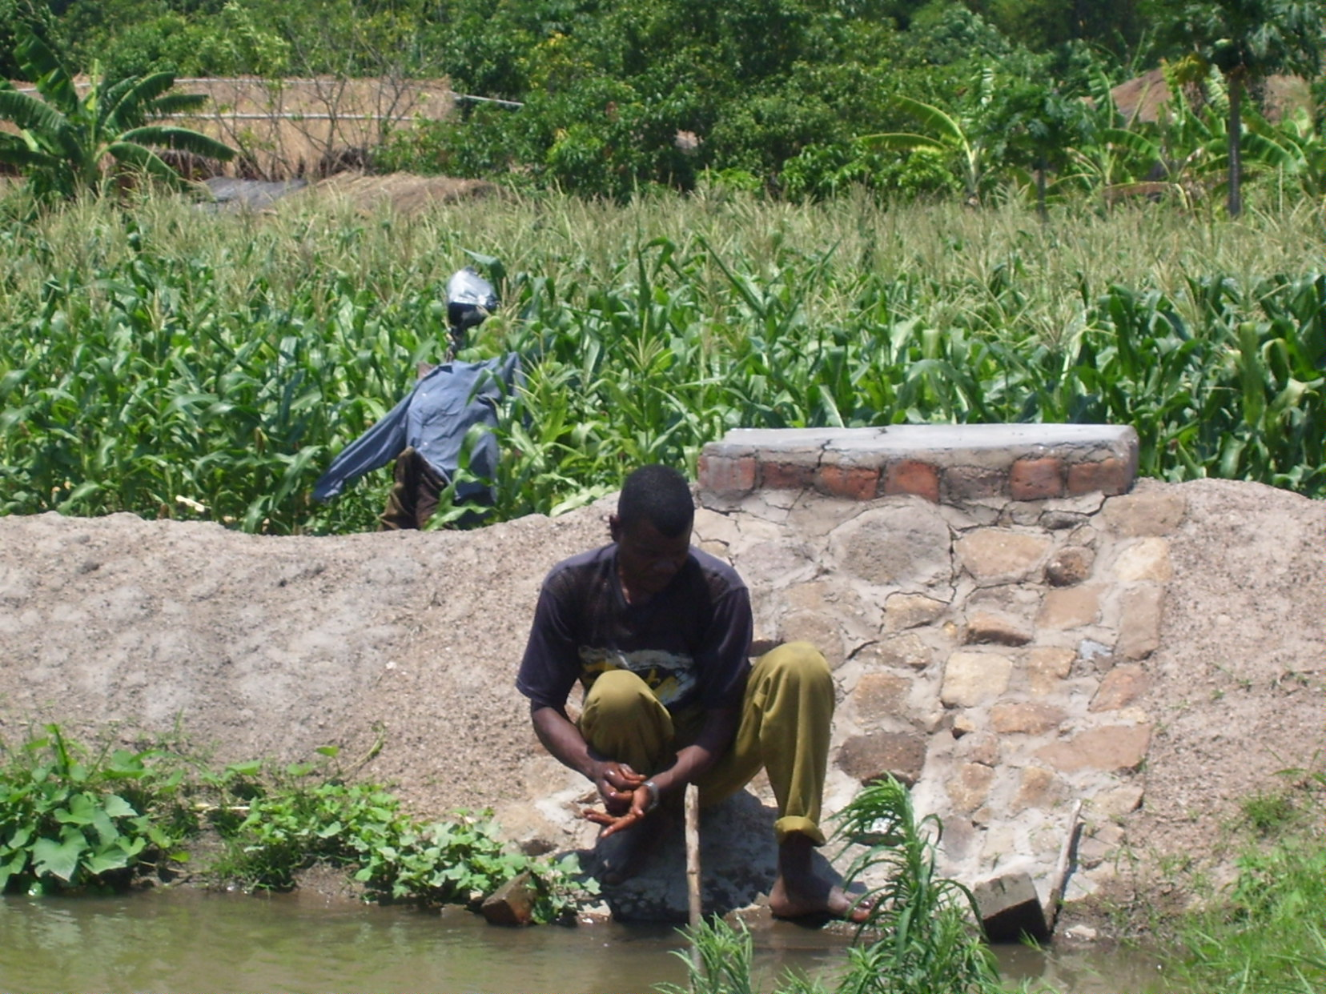
Beneficiary working on his dam
(Continued on next page)
Specific Objectives

1. To distinguish the various disaster resilience capacities
2. To carry out capacity assessment using a given tool

SESSION CONTENT

Capacity assessment

DURATION

1 hour 30 minutes

MATERIALS AND TOOLS

- Flipcharts, markers, masking tape
- Capacity Assessment Exercise Form

FACILITATORS GUIDE

Step 1 Distribute to the participants the Capacity Assessment Exercise forms and explain the different fields (Appendix 1)

Step 2 Explain that the final step in Disaster Risk Assessment is to identify the capacities needed to prevent or mitigate the hazard and to reduce or eliminate vulnerability.
(Continued from previous page)

Zomba CADECOM sourced and supplied fingerlings and provided training the beneficiaries in fish management, monitoring and evaluating the progress of work and also providing them with cement and pipes. The community provided fish feed, labour, day to day management of the dam and security of the fish.

The fingerlings were sourced from the National Aquaculture Center by Zomba CADECOM and put in the dam on 1ST December 2006. The first harvest was done in June2007.

The fish are fed with locally available resources and the growth of the fish is promising.

Seven beneficiaries have constructed individual dams, increasing both irrigation and fish farming in the areas, and others are also showing interest to construct individual dams.

Step 3 Ask the participants to go back to their respective groups to complete the forms and emphasize that they should focus first on the existing capacities of the community assigned to their groups. Give the groups 30 minutes to finish the group work and then ask each group to report in the plenary.

Step 3 Let the participants facilitate the plenary session while the facilitator takes note of the key points and asks after each group report questions that will help them think through what may be incorrect in their presentations

Synthesis:
- Capacity refers to individual and collective strength and resources that can be enhanced, mobilized and accessed, to allow individuals and communities to shape their future by reducing disaster risk.
- Capacities are analyzed as the interaction of the resources and access to these resources by the different groups at risk and the overarching systems and structures that decrease or increase the capacity to confront the hazard.
- In this manual, capacities are categorized as follows: Prevention and Mitigation capacities (the capacities that address the hazard) and Survivability and Readiness (the capacities that address vulnerabilities).

Capacities Assessment

For married women in Malawi, a song can held ease a difficult situation, particularly after a fight with their husbands. The lyrics of the song go this way:

Come all and witness what has befallen me.

This man who used to love me so much has now turned his back against me.

I vowed, and repeat my vows, he is my husband and nothing will separate us.

Songs can, indeed, be a powerful tool to settle conflicts not just between husbands and wives but also on larger scale (See box). They can also be used to unite villagers against common enemies and increase their confidence to fight.

Thus, in CMDRR context, cultural traditions like singing war and peace songs can be categorized as one of the community’s capacities, helping build the community’s resiliency.
A gender-based violence song in Chikwawa District, Malawi:
Chiri ndi ine chiri ndi ine .
Chiri ndi ine eeee (2X)
Amuna anga amene ndimawakonda
awaa
Chiri ndi ineeee
Ayamba Kundimenya usiku onseeee
Chiri ndi, ineeeeee
Ine ndikuti iwowa ndi amuna anga
mpakana muyayaaa
Chiri ndi ineeee

This handout defines capacities, coping capacities and capacity assessment.

(ISDR) refers to Capacities as a combination of all the strength and resources available within a community, society or organization that can help reduce the level of risks or the effects of a disaster.

Capacity may include physical, social, institutional or economic means as well as skilled personal or collective attributes such as leadership and management. Similar definition of capacities are strengths and resources, which exist or are present in individuals, households and the community – enabling them to cope with, withstand, prepare for, prevent, mitigate, or quickly recover from a disaster.

Another way of looking at Capacities and how they differ from capabilities is shown below:

Capacities | Capabilities
- Technological  - Social/human  - Economic  - Political  - Geophysical  - Time | - Knowledge  - Attitude  - Skills

i. Capabilities are embedded under human resource.

Capability to manage capacity is tantamount to coping capacity. ISDR secretariat defines coping capacity as the means by which people or organizations use available resources and abilities to face (to cope with) adverse consequences that could lead to a disaster. They added that in general, this involves managing resources, both during normal times in addition to times of crises or adverse conditions.

Coping capacity can be developed over time. Some coping capacities are acquired through experience, some through special trainings. Some are resources that can already be accessed by the individuals and the community, and by community organizations.

- Capacity in the context of disaster risk

It is also important to clarify how capacities should be looked at under the Disaster Risk formula:

Disaster Risk = Hazard x Vulnerability
Capacity

The above formula views capacity as a separate variable not subsumed under vulnerability, therefore requiring systematic valuation as a unit of analysis. The degree of vulnerability of elements at risk and hazard are the variables that determine specific capacities needed in order to reduce disaster risk.

Development NGOs involved in disaster-related work have different ways of categorizing capacities. Many treat capacity as synonymous with resources. Anderson and Woodrow (1989) have three categories: social, physical and motivational. The Department of International Development (DFID) considers it under sustainable livelihood framework as human, social, natural, financial and physical capitals; in economic terms, it is land, labour and capital. Dr. Y. C. James Yen, founder of the International Institute of Rural Reconstruction (IIRR) called it the “3 T’s” which stands for Time, Talent and Treasures.

Capacity in the context of disaster risk reduction is analyzed as the interaction between forces of resources and the access to these resources by the different groups at risk and the overarching systems and structures in society that decrease or increase capacity to face hazards. Because the behaviour of a hazard and degree of vulnerability determine the capacity needed to reduce disaster risk, capacities should be analyzed in relation to the hazard and vulnerability.

Based on experiences in implementing community managed disaster risk reduction, CADECOM categorizes capacities as follows:
Categories | Refers to:
Capacities addressing Hazards
Prevention and Mitigation (activities that deal squarely with the Hazard) | Mitigation covers measures that minimize the effects of hazards and thus lessen the magnitude of a disaster. Mitigation measures can range from physical measures such as flood defences or safe building design, to legislation and non-structural measures such as training, organizing disaster volunteers, public awareness, food security programs and advocacy on development issues.  Prevention covers activities designed to impede the occurrence of a disaster event and/or prevent such an occurrence from having harmful effects on communities and facilities. Examples are safety standards for industries, flood control measures and land use regulations. Poverty alleviation and asset redistribution schemes such as land reform, provision of basic needs and services such as preventive health care, education are some non-structural measures.
Capacities addressing Vulnerabilities
Survivability (activities that deal with individual vulnerabilities) | to manage to stay alive or continue to exist, despite the difficult situations
Readiness(activities that deal with community vulnerabilities) | group/community organization functioning as a system prepared for any hazard that is going to happen
Coping capacities are hazard and vulnerability specific. The diagram below demonstrates coping capacities that are specific to the degree of vulnerability.

The following table shows examples of capacities that address Vulnerabilities, with flood as the Hazard.

Categories | Time Element | Highly Vulnerable  to Flood | Medium Vulnerable  to Flood | Low Vulnerable to  Flood
Survivability | During the Hazard event | Swimming skills, first aid | Swimming skills, first aid | First aid
 | Before the Hazard Event | Strengthening livelihood, health, education and governance activities. | Strengthening livelihood, health, education and governance activities. | Strengthening livelihood, health, education and governance activities.
Readiness | During the Hazard event | Community Search and rescue, Evacuation system, Early warning , Logistics such as food and medical supply, transport and communication system | Community Search and rescue, Evacuation system, Early warning , Logistics such as food and medical supply, transport and communication system | Community Search and rescue, Evacuation system, Early warning , Logistics such as food and medical supply, transport and communication system
 | Before the Hazard Event | Strengthening community systems and structures for resilient and resistant livelihood, health, education and governance | Strengthening community systems and structures for resilient and resistant livelihood, health, education and governance | Strengthening community systems and structures for resilient and resistant livelihood, health, education and governance

The table below enumerates the coping capacities that are intended to eliminate or reduce the impact of the hazards, again using flood as the Hazard.

Mitigation | Flood spill way system, planting trees, soil and water conservation
Prevention | Building dams, deepening the flood canals, watershed management

Building on what people have

Each individual, community, society or nation has latent capacities that can be tapped in order to increase the individual and community resiliency. Efforts should aim to develop coping capacities of the individuals and the communities, and the organizations to develop resiliency from any type of hazard.

Community Capacity Assessment identifies the strengths and resources present among individuals, households and the community to cope with, withstand, prevent, prepare for, mitigate or quickly recover from a disaster. Coping means managing resources in times of adversity.

Capacity Assessment Exercise Form

Hazard Profile _____________________________________________

Capacities addressing hazard
 | Existing | Required | Gaps
Hazard Prevention Measures

Hazard Mitigation Measures

Capacities addressing Vulnerability
Element at Risk | Time Element | Existing | Required | Gaps
Individual Survivability “Consider Age and Gender” | During the hazard event
Individual Survivability “Consider Age and Gender” | Before the hazard event
Community Readiness | During the hazard event
Community Readiness | Before the hazard event
Other Element
at Risk

Sample Capacity Assessment Form completed during CADECOM DRR Training October 6 – 10, 2008

Hazard Profile: Floods

Nature of the hazard: Water levels in rivers rise and spread to the land and sweep away houses and property, leaving people homeless due to heavy rains.

Capacities | Addressing | Hazard
 |  |  | Existing | Required | Gaps
Hazard prevention measures |  |  | -Awareness by District assemblies/ key community leaders  -civil protection committees | Dike construction  -culvert and Gabion construction  -relocation | -knowledge  -Material resources  -financial resources  -attitude
Hazard mitigation measures |  |  | -Woodlots  -Marker ridges  -Civil protection committees | -Marker ridges  -Construction of drainage systems | -knowledge  -skills  -expertise

Capacities | Addressing |  | vulnerability
Element at risk |  | Time element |  | Capacities
 |  |  |  | Existing | Required | Gaps
Individual  Men/boys  Women/girls  Children  Men/boys  Women/girls  Children |  | During the hazard event |  | Able to run  Able to run  - | -knowledge  -energy  -skill  -knowledge  -energy  -skill  support from guardian | -knowledge  -skill  -knowledge  -skill  -Energy  -skill
 |  | Before the hazard event |  | Limited knowledge  Limited knowledge  Dependency on parents/ guardians | Knowledge  -skills  -knowledge  - | -expertise  -additional knowledge  -additional knowledge  -
Community  Readiness |  | During the hazard event |  | Some movements from high vulnerable area to low vulnerable area | Knowledge for some constructions as dikes and Gabions and skills | -resources  -gender sensitive during the hazard  -knowledge  -skills
 |  | Before the hazard event
Other element at risk

MODULE 7 – DISASTER RISK ANALYSIS

SESSION OBJECTIVES

Overall Objective

This module focuses on how to consolidate the results of hazard, vulnerability and capacity assessments and formulate conclusions based on them. It provides the participants the framework to analyze their assessment and prepare them for the next steps which are strategy formulation and disaster risk reduction measures.

Specific Objectives

1. To consolidate hazard, vulnerability, capacity assessments and determine the degree of risk
2. To draw conclusions and recommendations for disaster risk reduction measures

SESSION CONTENT

Disaster Risk Assessment

DURATION

1 hour 30 minutes

MATERIALS AND TOOLS

- Flipcharts, markers, masking tape
- Disaster Risk Assessment Exercise Form

FACILITATORS GUIDE

Activity 1 – Input on Disaster Risk Assessment (15 minutes)

Step 1 Explain to the participants that community disaster risk analysis consists of four steps:
a. Hazard Assessment - Identifies the most likely natural or human-made hazard or threat to the community, and seeks to understand its nature and behaviour.
b. Vulnerability Assessment - Identifies what elements are at risk because of the exposure of their location to the hazard.
c. Capacity Assessment - Identifies the status of people’s coping strategies which refer to the resources available for preparedness, mitigation and emergency response, as well as to who has access and control over these resources.
d. Disaster Risk Analysis – The process of consolidating the findings of hazard, vulnerability and capacity assessments and draw conclusions and recommendations for disaster risk reduction.

Step 2 Ask the participants if they have any question regarding the steps of disaster risk assessment and clarify unclear points.

Step 3 Explain to the participants that after that having done the hazard, vulnerability and capacity assessments for their community, the next step is to synthesize the analysis of the three variables and draw conclusions regarding the degree of disaster risk – high, medium or low.

Step 4 Wrap up the activity by stressing the following - the Community Disaster Risk Assessment provides:
- Community profile (introductory/background part)
- Hazard, vulnerability and capacity assessment (your findings)
- Degree (high/medium/low/) of Disaster Risk (your conclusions)
- Capacities needed to reduce the disaster risk (your recommendation)

Activity 2 – Group work (1 hour, 15 minutes)

Step 1 Ask participants to go back to their respective groups and undertake a risk assessment for their respective communities, with the following instruction:
a. Analyze the degree of disaster risk based on the hazard, vulnerability and capacity assessments the groups have already conducted.
b. Determine the capacities needed to prevent or mitigate the hazard as well as to reduce or eliminate the vulnerability of the community assigned to each group.

Step 2 Let the participants facilitate the plenary feedback session. The facilitator must take note of each group’s understanding of the exercise and provide additional explanations if needed.

Step 3 Wrap up the activity.

Synthesis (10 minutes)

Disaster Risk Assessment:

- It is a systematic process for determining and ranking community disaster risk.
- Contributes to the community’s awareness about potential disaster risks. This is usually the contribution of outsiders who bring with them scientific and technical information on hazards which the community may not yet be familiar with.
- Is an essential precursor to decision making in disaster risk reduction as well as in formulating development policies, strategies, plans, programs and projects.
- Prioritizes the risks to the community. The community’s actions and resources can be allocated accordingly, based on the frequency, extent of damage and other factors that have to be considered and which community members decide on.
- Ensures that disaster risk reduction is cost effective and sustainable. In many situations, the most viable tract in reducing risk is increasing the community’s capacities.
- Identifies external resources which can be tapped and the risk reduction strategies to address vulnerabilities that the community cannot address by itself.
- Provides a yardstick in assessing the community’s success in reducing disaster risk over time.
- Generates for specific baseline data that can be used in development and contingency planning purposes for the community and support agencies.

Disaster Risk Assessment Exercise Form

Hazard Profile
Element at Risk | Hazard |  | Vulnerability |  | Degree of  Risk (high, medium or low)
Element at Risk | Preventive capacity gaps | Mitigation capacity gaps | Survivability capacity gaps | Readiness capacity gaps | Degree of  Risk (high, medium or low)
Summary of findings:

Recommendation: Identify priority elements at risk and risk reduction measures (including the appropriate organizations)

MODULE 8 – COMMUNITY ORGANIZATION

SESSION OBJECTIVE

Overall Objective

To enable participants to appreciate the need for team work in Disaster Risk Reduction Programs.

Specific Objectives

- To provide deeper understanding on the importance of community organization in Disaster Risk Reduction
- To identify and strengthen available structures in the community

SESSION CONTENT

- Definition of Community
- Composition of Community
- Community Organization and Structures
- Importance of Community Organization
- Identification of Structures

DURATION

2 hours 30 minutes for five days.

MATERIALS
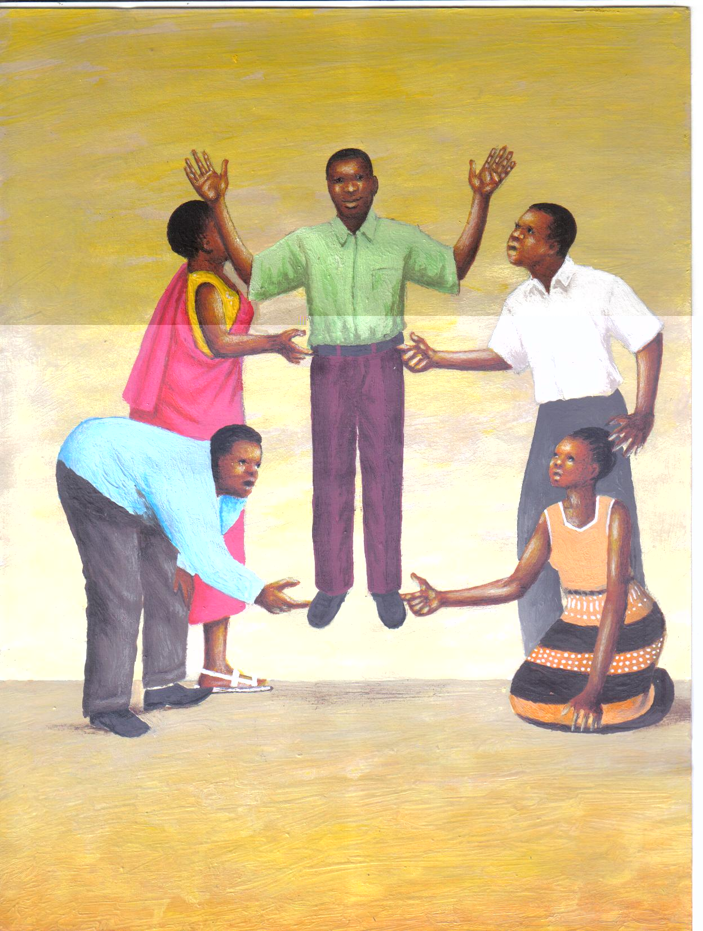
- Flip charts and stand
- Markers, masking tapes

FACILITATORS GUIDE

Step 1 Introduce module objectives clearly
Step 2 Introduce an activity where a few people carrying a huge person with one finger each
Step 3 Brainstorm the role play with the following question:
Role Play
  - Select one person from the group to be carried
  - Select three women and three men from the group
  - The men and women surround the person selected in Step 1
  - In an organized manner let the selected men and women lift the surrounded man with one finger each
Questions
- What have we seen?
- Why has it been possible?
- What are we learning from this exercise
- Is it possible for one individual to carry a person with one finger? Why?
- Let communities give some local proverbs that relates to ‘d’ above.
Step 4 Introduce Session Contents as per objective. Relate these to the case study
Step 5 Define Session Content by referring to the Module Key Points
Step 6 Summarise the session and find out whether participants have understood the contents

MODULE KEY POINTS

- Definitions

What is a Community?
A community is a group of people who are closely related and contained within a society. However in Caritas Malawi (CADECOM) a DRR community is composed of approximately 90 households.

- Composition of a Community
Sometimes it is taken for granted that when we talk about the composition of a community we mean the women, men and children within the community. Most assistance is given to the community without taking account of accessibility based on individual needs. A deliberate effort needs to be made to identify the different groups and individuals forming the community. The following groups need to be identified and considered:

- Children
According to the UN Convention on the Rights of the Child, a child is considered to be an individual below the age of 18. Depending on the cultural and social contexts, however, a child may be defined differently by different communities. It is essential that a thorough analysis of how a client community defines children be undertaken to ensure that no child or young person is excluded from humanitarian services.

- Older People
Older men and women are those aged over 60, according to the UN. However, cultural and social factors mean that this definition varies from one context to another. Older people make up a large proportion of the most vulnerable.

- Disabled People
In any disaster, disabled people who can be defined as those who have physical, sensory or emotional impairments or learning difficulties that make it more difficult for them to use standard disaster support services are particularly vulnerable.

- HIV/AIDS Affected and Infected
People living with HIV/AIDS often suffer from discrimination, and therefore confidentiality must be strictly adhered to and protection made available when needed. This debilitating disease affects not only individuals but also their families and communities, as young people in their productive years, especially women, are disproportionately affected – physically, psychologically and financially.

- Community Organisation and Structure
- What is an organization?
A social structure or human grouping deliberately constructed and reconstructed to seek achievement of a specific goal or a set of goals.

- What are structures?
They are organizations that shape and influence our values and behaviour. Some examples are: political parties, Religious organizations, Government ministries, communication networks etc.

- Properties of an Organizations
- Hierarchy of Authority
This is the stratification of authority which can be depicted by the organizational chart.

- It indicates who reports to whom and for what
- It indicates who carries orders from who in the organization
- It helps in the coordination and supervision of activities
- It helps in decision making

- Standard Operating Procedures (SOPs)/Rules, Regulations, Procedures and controls
Human beings are very unpredictable and in order to prevent chaos, they cannot be left to do what they want. In every organization (including informal ones such as families, villages and communities) rules, regulations, procedures and controls are put in place in order to standardize human behaviour.

- Formality of communication
In every organization, the work of each member is usually related to what other members are doing. In such context, use of standardized communication procedures avoids misunderstanding amongst the members.
The content of most interpersonal verbal communication tends to be formal (i.e. work related and precise) and there are well established channels of communication for effective communication to take place.

- Division of Labour
Division of Labour and specialization in most organizations tends to improve productivity. the greater the specializations, the larger the diversity of members and the greater the range of functional roles within the community organization.

- Specificity of Purpose
Every community organization must have an objective, purpose, aim or goal (what they want to achieve).
The policies of the organization should offer guidance to all, and wise policy making is dependent on an effective two-way communication system
New members in the community organization must be introduced to the background of the organization, its objectives and goals, regulations, communication system, leading personalities and amenities. He/she must also understand his/her role, his relationship with other members and how his/her role relates to the work of the organization as a whole.

- Importance of Community Organization

The reasons for having community organizations are as follows:
- They help to meet human needs: by grouping together, individuals can overcome limitations imposed by both the physical environment and their own biological limitations thereby achieving results which individuals can not achieve alone.
- To enlarge abilities: Organizations increase productive ability because they make use of pooled resources
- To accumulate knowledge: For subsequent use and further learning
- To save time: There is speed in achieving the set goals because of the synergistic effect (by bringing together two separate and individual ‘units of resource’ the output of the units combined will exceed the joint output of separate units).
- In DRR, CADECOM adopts the above definitions and descriptions of community organization are.

- Identification of Structures

In order to promote greater implementing power among the Village Development Committees (VDCs), the DRR team should develop close working relationships with key district authorities charged with implementing district development plans that include basic service provision and social protection. Through VDCs, the DRR Facilitating team will establish the existing structures within the community to facilitate the implementation of DRR interventions. Parallel decentralized new structures will not be established under DRR unless no other structures exist at the VDC levels. As required those new structures will be developed in collaboration with the relevant district authorities.

Efforts will be made to integrate DRR activities within the framework of the VDCs. With guidelines from the district authorities the Development Facilitator (DF) will re-organize the existing structures to mainstream DRR activities within the VDC development plans.

MODULE 9 – COMMUNITY EMPOWERMENT AND PARTICIPATION

SESSION OBJECTIVES

Overall Objective

To empower the local communities to fully participate in Disaster Risk Reduction programs

Specific Objectives
By the end of this module participants should be able to:

- Define empowerment and participation
- Explain the principles of empowerment and participation
- Appreciate the importance of identifying burning issues, pose them to the people concerned and come up with solutions.

SESSION CONTENT

- Meaning of Empowerment and Participation in DRR
- Types of Participation
- Key principles for peoples’ effective Empowerment

DURATION

Two and half hours for three days

MATERIALS

- Flip charts and stand
- Markers and masking tape
- Diagram depicting the ant story

FACILITATORS GUIDE

Step 1 Introduce module objectives clearly
Step 2 Introduce and brainstorm the story of the ants
- Give out or show the community the 1st picture and ask them what they see.
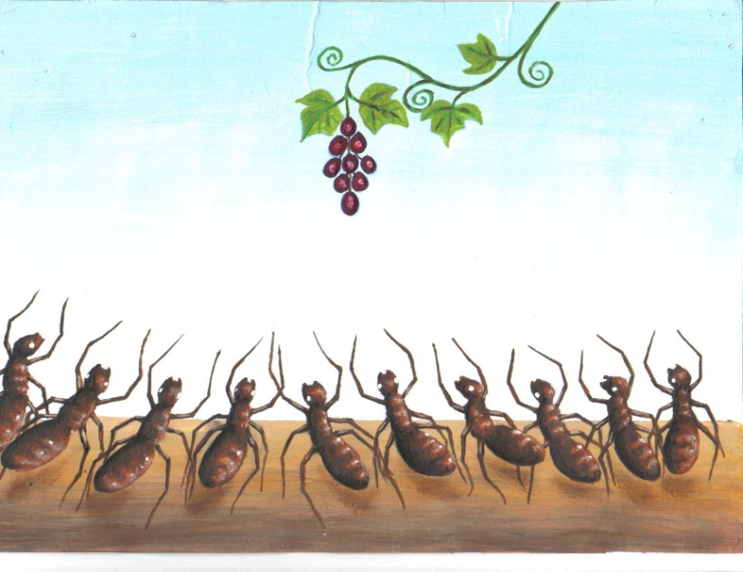
- Write down what they say.
- Ask them how they could reach the fruits individually first then as a group.
- After their contributions on the first picture (Make sure they exhaust their answers), show them the 2nd picture where the Ants have managed to get the fruits. 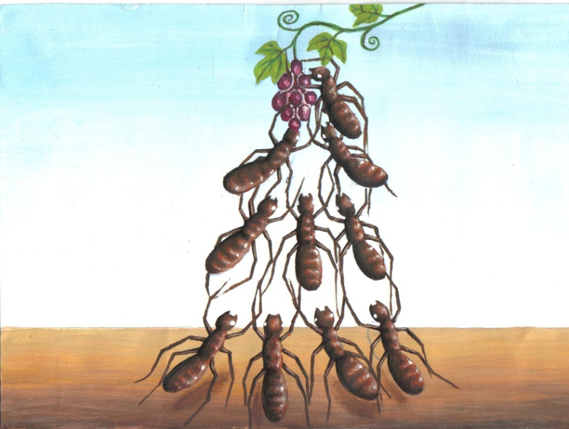
- Ask them the process the ants used.

- Ask : Does this relate to Community Empowerment?

Case Story

Mzuzu CADECOM was implementing a DRR Project in Kalambo Village which is found in Karonga District, 13 km to the north of Karonga along Karonga-Songwe road. The village was encountering disasters of drought and flooding caused by Lufirya River that passes though the village.

Through the DRR Project the community realised that they could do something to reduce the occurrences of flooding. With CADECOM facilitation, the community drew up action plans that included the construction of a contour ridge along the Lufirya River to control flooding.

A 300 meter long contour ridge has been constructed by the community without incentives from CADECOM. To make it strong, it has been planted with vertiva grass and trees sourced from Ministry of Agriculture. Since the construction, flooding has been greatly reduced in the village. The communities only need to rehabilitate the ridge annually. The absence of floods has also intensified sanitary practices in the village because toilets do not collapse and water sources don’t get contaminated.
Note the process of Community Empowerment and implementation:
- Planning
- Share of responsibility
- Implementation
- Evaluation

Step 3 Introduce Session Contents as per objective. Relate these to the story.
Step 4 Define Session Content by referring to the module key points.
Step 5 Summarise the session and find out whether participants have understood the contents.
MODULE KEY POINTS

- Meaning of Empowerment and Participation in DRR

  - Empowerment:

- The process of building capacities to enable women, men, boys and girls to exercise control over their own livelihood.
- A process of providing women, men, girls and boys with a climate to develop critical thinking skills and reactivate their minds to re-organize perceptions about themselves and the environment in which they live.

ii. Participation:

Participation has been defined by many people as:
- People’s involvement in problem identification, analysis, designing and implementation of programs/activities that affect them. It enables people to explain their vulnerabilities and prioritization, allowing problems to be defined correctly and responsive resources to be designed and implemented.
- Active involvement of people in making decisions about the implementation processes, programs and projects which affect them.

- Types of Participation

  - Passive participation:
People participate by being told what is going to happen or has already happened. This can be through a unilateral announcement by project staff without listening to people’s views or responses. The flow of information is one sided, only from external professionals. Sometimes people are asked to form groups just to rubber-stamp what has already been planned by experts. The groups have no real power over the situation they are overseeing. Similarly, a last minute forum is sometimes created to allow people to “air out their grievances’ without giving them time to fully understand what is being discussed and develop their own agenda.

  - Participation by information giving
People participate by answering questions posed by external researchers using questionnaires, surveys or similar approaches. People do not have the opportunity to influence proceedings, as the findings of the research are neither shared nor checked anyway. There is no channel for feedback, negotiation or action to put the information to use. Similarly information is often presented at the last stage of planning, giving people no opportunity to influence the design of program which is supposedly for their benefit.

iii Participation for material gains
In this type of participation people contribute by providing resources, e.g. labour in exchange for food, cash and other material incentives. It is common to see this called participation, yet the people have no reason to continue the activities when incentives end. Therefore the program will not be sustainable if people involved are looking only for material benefits.

iv Self mobilization
People participate by taking initiative independent of external professionals. They, on their own, identify problems, analyze them, come up with possible interventions and identify resources and technical advice.
The first three types of participation are incorrect interpretations of the meaning of “Participation”. In the true sense this is ‘Involvement’. People are being involved in other people’s agendas.
People’s participation in a Disaster Risk Reduction program is very vital. This alone will ensure sustainability of the program. Sustainability can only happen if people are able to mobilize themselves around an issue, to understand, analyze and deal with it.

- Key Principles for People’s Effective Empowerment and Participation Process in DRR

- Identification of relevant issues
To identify DRR-related burning issues in the community, a Listening Survey is used (see Annex 2). People normally act on issues which they talk about with strong feelings. There is a link between emotion and motivation to act.
The starting point of relevant livelihood analysis is to identify issues about which the local people speak with excitement, hope, fear, anxiety, anger and joy.

- Problem posing vs. banking approach
In using problem posing we assume that for people to objectively discuss an issue, they need to be recognized as subjects, not objects. They need to be recognized as thinking people with a capacity to solve their own problems. A problem/risk identified in the area must to be posed to the people concerned. If need be, then experts can add on to people’s suggestions/solutions.
On the other hand, the banking approach assumes that the teacher knows everything and people are seen as empty vessels to be filled with knowledge.
Therefore to achieve a meaningful empowerment and participation the problem posing approach is recommended.

- Dialogue on the burning issues
No individual is totally ignorant and no one has all the answers. People need to learn from each other through listening. Major problems about peoples’ livelihood can only be solved through a common search with everybody contributing. A problem often has many aspects and consequently the contribution of each person is valuable “Tili tiwiri ndi tianthu, kalikokha mkanyama”

- Action/Reflection/Action
It is important for people to come up with an action plan on the root cause of the problem. There is need to agree on: what will happen, who will do what, how, where, etc. As soon as people embark on the action, then there is need to agree on a time to reflect on what has transpired, to learn from the action and re-plan.

By setting a regular cycle of action and reflection a group is able to see what is successful and by critically analyzing the causes of mistakes the group members can become more capable of effectively transforming their daily lives.

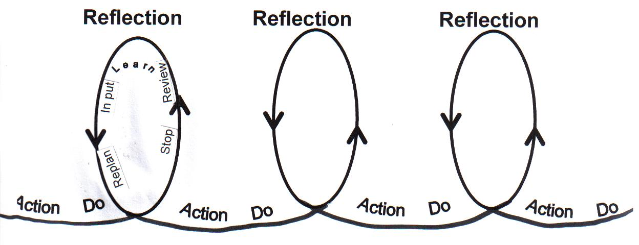

Source: TFT Books Anne & Hope

This cycle should become our pattern in life, reflection/action/reflection.

- Change/Transformation
By going through this process, people are slowly participating in the change which will affect them. This will result in the implementation of a change with a vision and in this case the vision behind Disaster Risk Reduction. (Refer to Annex 1 and 2 for tools for participation)
“Go with the people:
Live with them.
Learn from them.
Love them.
Start with what they know.
Build what they have.
But of the best leaders, when the job is done,
The task accomplished,
The people will all say,
WE HAVE DONE THIS OURSELVES”
Lao Tsu, China, 700 B.C

MODULE 10 – COMMUNITY ORIENTED PLANS

SESSION OBJECTIVES

Overall Objective

To enhance communities’ capacity in strategising to reduce the impact of livelihood shocks

Specific Objectives:

- To impart knowledge to the participants on the importance of formulating DRR community action plans.
- To equip participants with skills to actively develop, implement, monitor and evaluate their plans.

SESSION CONTENT

- Definition of a plan
- Importance of the community action plans
- Development of community action plans

DURATION
3 hours for 2 days

MATERIALS
- Flip charts and stand
- Markers
- Sticks, cartons and stones for a role play

FACILITATORS GUIDE
Step 1 Introduce module objective clearly
Step 2 Introduce the Role play (Silent Builders) review/discuss it with the participants

The Silent Builders (Role Play)
Instructions
- Ask for 2 groups of 4 volunteers each
- Give the building materials to each group
- Ask them to build a house together without talking to each other
- Reassemble the building materials
- Ask the team/volunteers to re-build the houses whilst talking (Give them enough time)
Questions for discussion:
- What have we seen?
- Does this happen in our village set –up?
- What can we do to prevent this?
- How come the team failed to build the first house?
- Ask them how they managed the second house.
- How do you relate this story to your community, situation?
Step 3 Introduce Session Contents as per objective and relate these to the role play
Step 4 Define Session Content by referring to the module key points
Step 5 Summarise the session and find out whether participants have understood the content

MODULE KEY POINTS

a. Definition of a plan
A plan is a tool that determines course for action. It provides an overall direction from where things are to where we hope they will be. DRR community work can be greatly enhanced by a clear vision, mission statement, objectives and action plan.

b. Importance of a DRR Community Action Plan
- It provides action steps for implementing DRR strategies
- It assists in assigning responsibilities, timeframe and resources
- It is a tool for checking the progress (monitoring) of DRR activities.

c. Development of Community Action Plan

- Describe community vision (Referring to the DRR issues to be addressed at hand)
- Set objectives
- List and prioritise activities
- Plan to do one thing at a time
- Allocate roles responsibilities and timeframe for each activity
- Determine and allocate resources required
- Determine source of resources
- Develop monitoring indicators for each activity
- Plans should not be rigid
- Plans should be reviewed periodically though open communication

d. Guidelines in developing an action plan

- Please observe he following:
- Plan to be smart
S = Specific
M = Measurable
A = Achievable
R = Realistic
T = Time bound

- Do not rely on external resources
- Observe protocol

Table I: Matrix of Community Action Plan

Issues being addressed | Activity | Timeframe | Resource | Source | Responsible Person | Monitoring Indicators

MODULE 11 – MAINSTREAMING HIV AND AIDS ISSUES IN DRR

Case Study

HIV/AIDS interventions have been taking place in Stambuli village in Mangochi District reaching 86 households through the Disaster Risk Management Project. Stambuli village is situated in Katema parish in Mthiramanja EPA in Mangochi district. Stambuli has a varied geography including flatland areas as well as hilly areas. 55% of the households live on the flat land and 45% in the hilly area.

All households in the village derive their livelihood from farming, small businesses and piecework.

Many people in the village are involved in initiation ceremonies, memorial functions, early marriages and casual sexual relationship. Polygamy is prevalent in the area and the village.

The Stambuli community were ignorant about HIV/AIDS and was not mainstreaming HIV/AIDS prevention in day to day life. As a result, the prevalence is high in the area (12%). After the village underwent an HIV/AIDS mainstreaming training the window of hope was opened.
SESSION OBJECTIVES:

Overall Objective

To increase community capacity to integrate HIV and AIDS issues in the DRR program

Specific Objectives

- Participants to describe HIV and AIDS situation and its impact on their livelihood
- To equip participants with knowledge and skills for mainstreaming HIV and AIDS

SESSION CONTENT:

- Description of the HIV and AIDS situation:
- Meaning of HIV and AIDS
- HIV transmission
- HIV and AIDS prevention
- Faces of HIV and AIDS.

- Description of mainstreaming:
- Definition of mainstreaming
- Why mainstreaming HIV and AIDS issues in DRR Programs
- Key areas of mainstreaming
- Strategies of mainstreaming

DURATION:

3 hours
MATERIALS AND TOOLS

- Different colours of markers
- Flip chart and stand
- Handout notes

FACILITATORS GUIDE

Step 1 Introduce module objective clearly
Step 2 Ask the participants to provide definitions of HIV and AIDS, list them down and conclude by writing correct definitions
Step 3 Ask participants how one can get HIV and conclude with writing correct information on transmission of HIV (include how it is not transmitted)
Step 4 Ask the participants how one can prevent contracting HIV and conclude with writing correct information on prevention on HIV transmission (emphasize that as a faith based organization, the supported prevention method is abstinence)
Step 5 Ask the participants how HIV and AIDS is impacting their lives. List issues caused by HIV and AIDS. Conclude by making a list of consequences of HIV and AIDS.
Step 6 Divide the participants in two groups
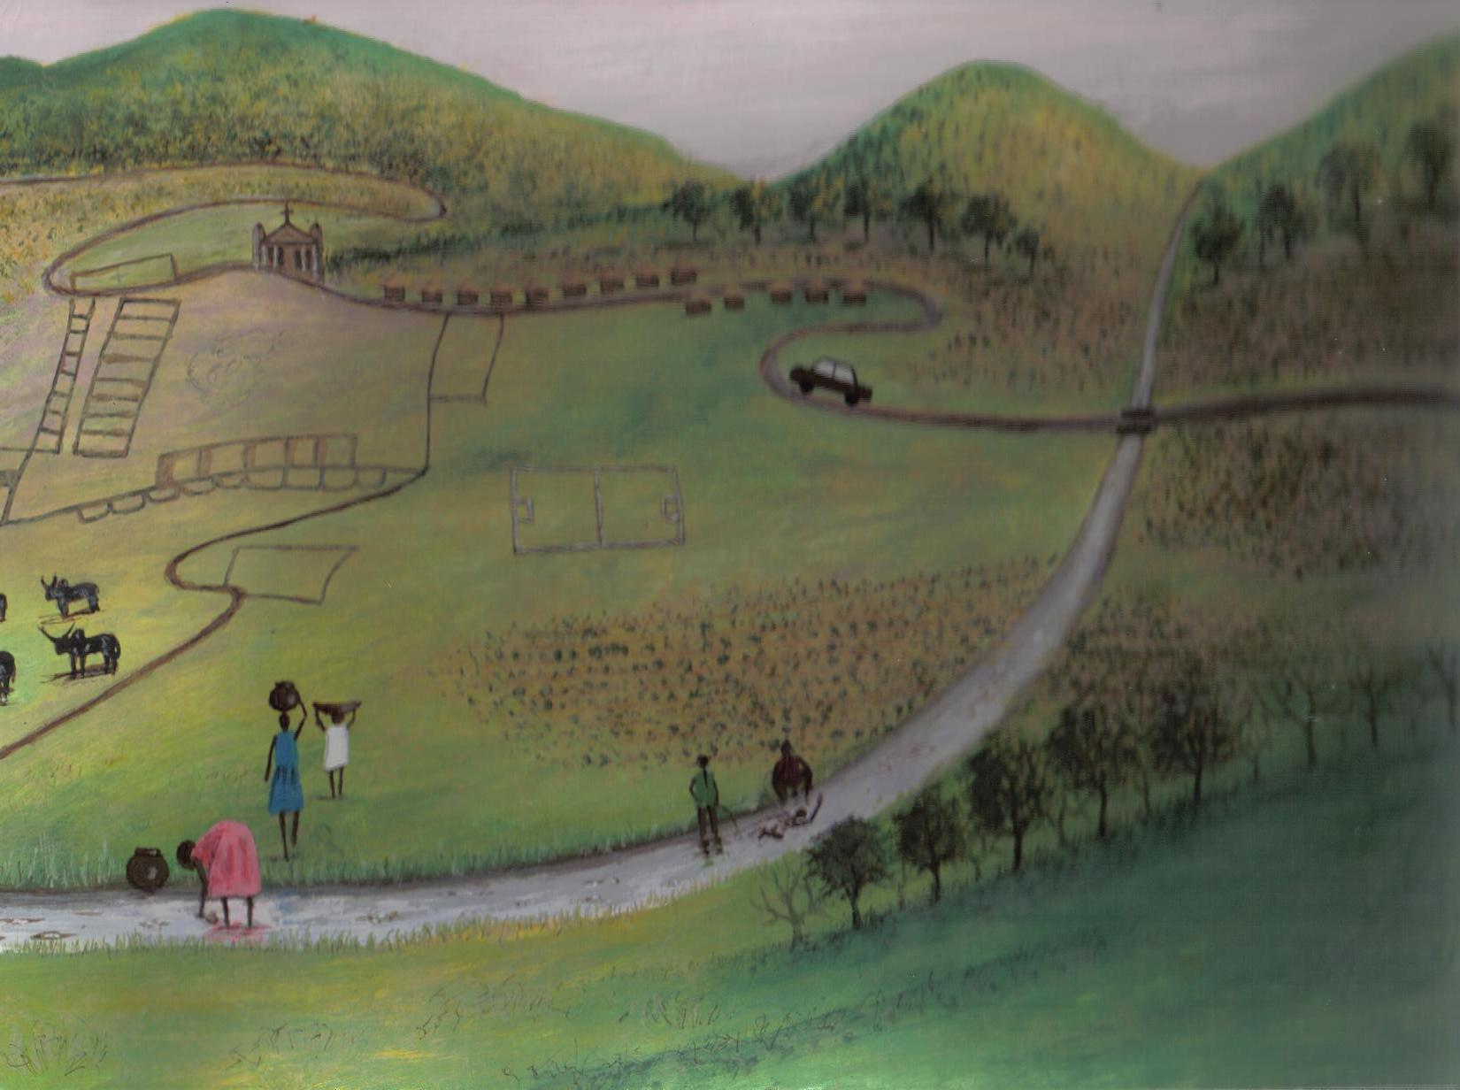

- Provide them with a diagram of a river with many tributaries
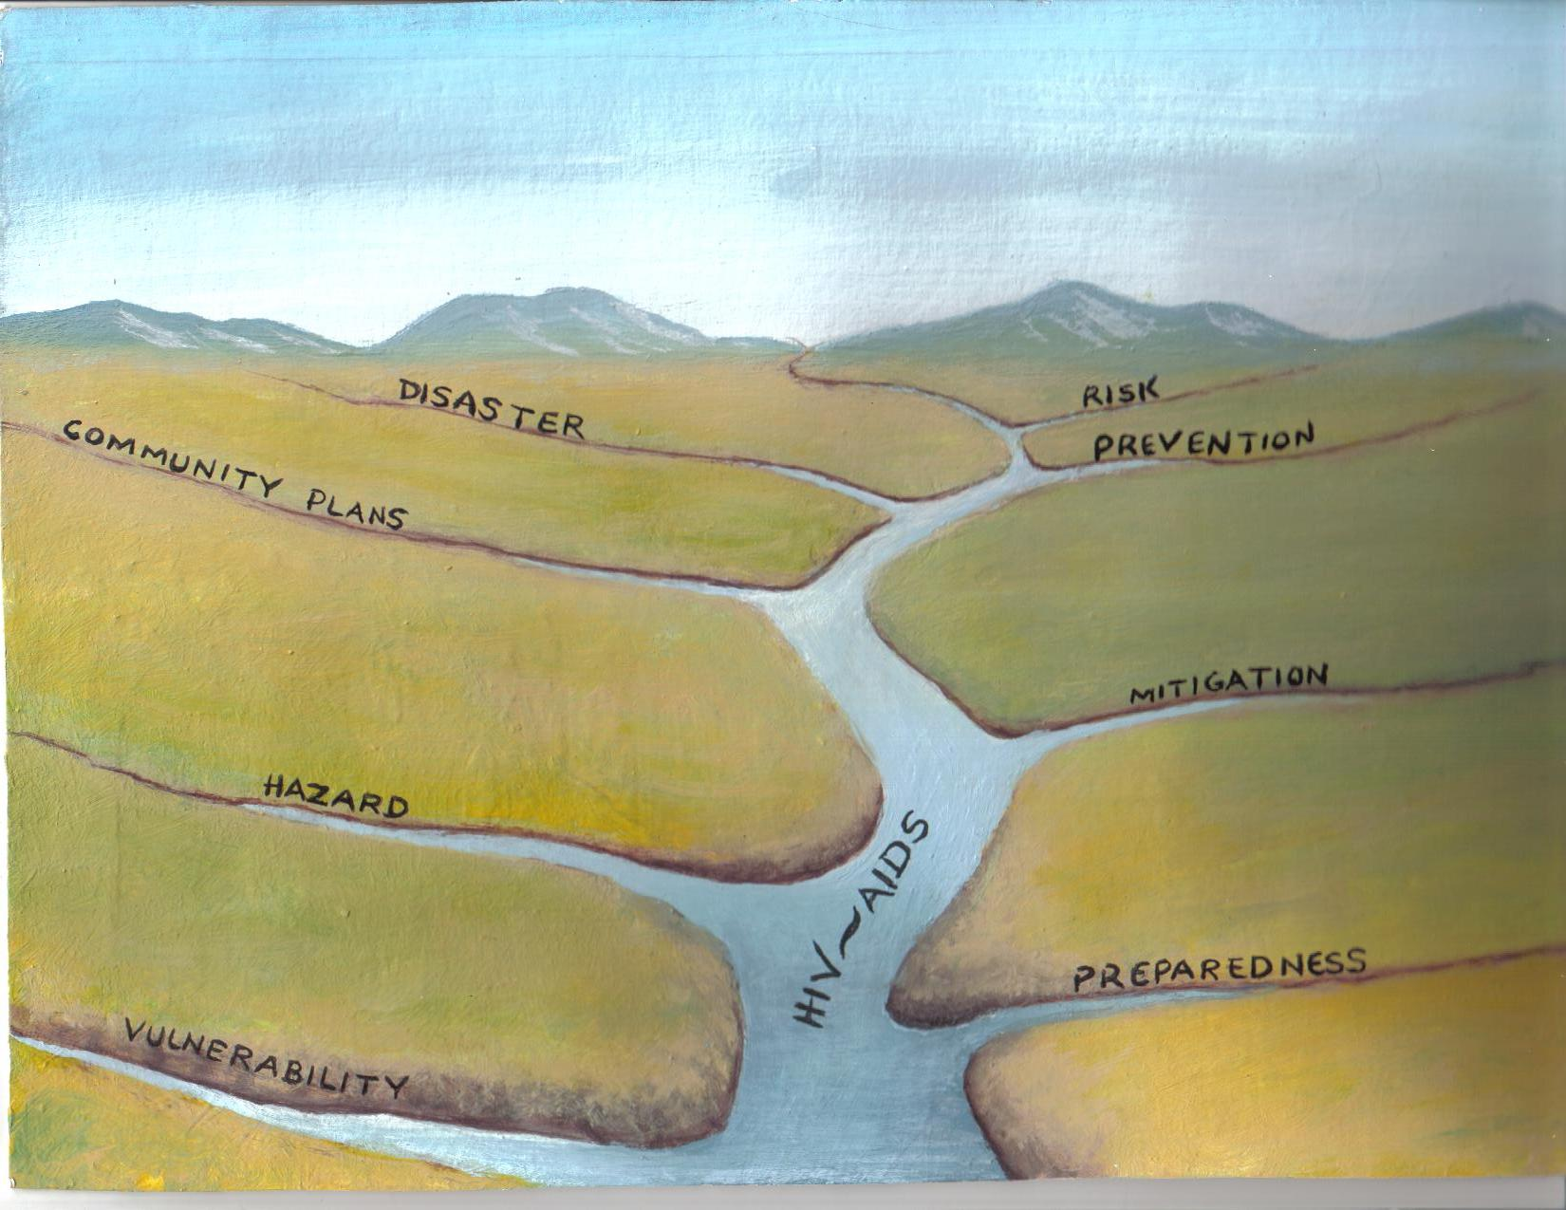
- Let them discuss the diagram
- Let the groups present to the plenary
- Ask participants to provide their own understanding of HIV and AIDS mainstreaming (relate to the diagram)
- Summarise their presentations by explaining how mainstreaming can be understood through the diagram
Step 7 Summarise the session, and find out whether participants have understood the content

MODULE KEY POINTS

- HIV is a very small virus and cannot be seen with the naked eye
- Only found in body fluids of human beings
- Some body fluids contain higher concentrations of the virus than others (e.g. blood, vaginal fluid, semen and breast milk)
- HIV is not present in urine, faeces, vomit and sweat but present in negligible quantities in saliva and tears
- There is a great risk of passing the virus from an infected person to an uninfected one when there is an exchange of body fluids (e.g. during blood transfusion or during sexual intercourse)

- Description of the HIV/AIDS situation
- Meaning of HIV and AIDS
i HIV - Human Immuno Deficiency Virus
ii AIDS - Acquired Immuno Deficiency Syndrome

- HIV Transmission
- Through unprotected sexual intercourse with an HIV infected partner - this is a major mode of HIV transmission throughout the world.
- From HIV infected mother to child during:
  - Pregnancy
  - Delivery of the baby
  - Breast feeding the baby
- Through blood to blood flood-nets which includes:
- Transfusion of infected blood
- Organ transplant
- Pricks by contaminated instruments and utensils (e.g. injections, razors, toothbrushes, etc)

Note: HIV is not transmitted through air, handshakes, associating with an HIV infected person, etc

- HIV and AIDS Prevention
HIV infection can be prevented by:
    - Abstaining from sexual intercourse
    - Being faithful to one and only one uninfected partner
    - Prevention from mother to child
- Having protected sex during pregnancy and while exclusively breastfeeding her baby.
- Seeking early and proper treatment for all sexually transmitted infections with her partner.
- Start attending antenatal clinic as early as 3 months into the pregnancy and keep all appointments.
- Deliver at a health unit while being attended by a health worker.
- Avoid unsafe and unsterilised materials or instruments during delivery of a baby.
- Either exclusively breastfeed the baby for not more than 6 months or use only alternative feeds. Avoid mixing breast milk with other fluids or food.
- Avoid breastfeeding when the breast or nipples are cracked.
- Sores on the baby’s mouth should be immediately treated
- Avoid getting blood transfusion from unscreened blood and pricks from contaminated instruments and utensils
- Condom usage (note that this method of prevention is not supported by the Catholic Church).
  - Faces of HIV and AIDS
i. AIDS as a Medical Problem
Client becomes chronically ill for a long time because of frequent infections that occur as a result of the ineffective immune system.

ii. AIDS as a Psychological Problem
Persons affected by the virus sometimes become inaccessible (difficult to reach out to) despite physical closeness. Some get mentally confused and suicidal; others become aggressive, abusive and angry with themselves and others. There is a self-stigmatization as well as discrimination by others – friends/relatives.

People infected with AIDS may have an irrational fear of imminent death and doom. The fear preoccupies their minds to the point of incapacitating them – making them non-functional.

iii. AIDS as a Contributor to Poverty
Due to the chronic illnesses suffered by AIDS patients they become less and less productive both at work and at household level. Because they are less productive they lose their employment; if they were doing business, their business may suffer. Spouses caring for sick partners sometimes lose their jobs, making it difficult for them to sustain the family financially. End results may include:

- Failure to continue with education: The poverty described above affects family members and dependants. Some fail to continue with their education, unable to afford decent clothing, food etc.
- Family disunity: Families have broken down due to the poverty that comes with the disease, in-laws from both sides may torture the diagnosed spouse, denying them their rights to family property and financial resources or even denying them their right of being with their spouse in time of crisis and terminal illness.
iv. AIDS as a Contributor to Food Insecurity
It is customary that close relatives and family members care for the sick members of their family as long as they are sick. The terminal illness associated with AIDS leaves clients helpless and dependant on others for the activities of daily living. This makes it difficult for immediate family members to concentrate on work in their fields. As a result, families affected by the pandemic are also food insecure. Starvation and malnutrition can occur, resulting in the deaths of children and even adults in the family.

v. AIDS as a Spiritual Crisis
It is a fact that only 2% of the total HIV infections are due to causes other than sexual intercourse implying that most of the people are infected through sexual intercourse with an infected person. This brings feelings of guilt as well as imagined rejection and unworthiness in the eyes of God.

vi. AIDS as a Spiritual Re-awakening
Some people become more close to God after realizing that they are HIV positive. They become religiously more conforming and participate more in activities at Small Christian Communities/Church/Parish level.

b. Description of HIV and AIDS Mainstreaming

i. Definition of Mainstreaming HIV/AIDS
Mainstreaming HIV and AIDS can be defined as the process of analysing how HIV and AIDS impacts on all sectors of peoples livelihood now and in future, both internally and externally, to determine how each sector should respond. It focuses on practices that protect individuals and others from vulnerabilities of the infection and support those who are living with HIV and AIDS.

It is vital that HIV and AIDS be a high priority issue in all DRR programs because its impact cuts across all sectors of livelihood.

ii. Why mainstream HIV and AIDS issues in DRR
From all the facets of HIV/AIDS shared above, it is obvious that if the DRR Program does not take HIV/AIDS into account during activity planning, infected and affected people may not be able to access the benefits of the program and could be denied access, when these are the people who most need support in the time of crisis.

We have to talk HIV/AIDS, think HIV/AIDS and act HIV/AIDS. HIV/AIDS is not remote! It is very close to us all, as close as our own shadows. Maybe the virus is not in us but certainly it is around us. To mainstream HIV/AIDS is to accept that AIDS is a reality in our settings because we are all affected in one way or another.

iii. Strategies for mainstreaming

1. Use of research, impacts and models

- As HIV and AIDS is a relatively new phenomenon, understanding the impact it has on all dimensions of society and economy is challenging but it is vital that we make these considerations.

2. Use of HIV focal points

- One of the first steps that the Malawi government (and many other institutions) takes in starting to mainstream HIV and AIDS is to establish focal points that have the responsibility of acting as a catalyst to mainstream HIV/AIDS activities within their department or sector.
3. Use of training

- Training of individuals within a sector is another strategy commonly used to kick off start the mainstreaming process
- Many people and institutions with experience in HIV/AIDS mainstreaming have pointed out the importance of providing training programs to individuals that focus on the personal dimensions of HIV/AIDS as well as attitudes, myths and misconceptions about the virus.

4. Use of influencing or advocacy strategies

- A key part of the work of HIV/AIDS focal points is to effectively influence a wide range of individuals at all levels both within the government and amongst other key stakeholders.

iv. Approaches to mainstreaming

There are two approaches to mainstreaming as follows:

a. Internal mainstreaming

Incorporating HIV/AIDS issues in the internal issues of the community
- Measure the impact of HIV/AIDS on the community and individuals.
- Identify strategies to reduce susceptibility to HIV infection and to support people living with HIV/AIDS, including all areas of prevention, care and support.
- Minimise the impact of AIDS on the functioning of the community. Look at the ways communities can respond to the impact of HIV/AIDS on the ability of the community to function effectively, including time needed for funeral attendance, skills transfer and morale levels.

b, External mainstreaming

Examine external work done by the community to provide general services to the general public.

- Examine how might work done by the community increase vulnerability to HIV infection or reduce capacity of households/communities to deal with the impact of HIV/AIDS.
- Examine the impact of HIV/AIDS on the work and decide what the sector should do to respond to these issues.

MODULE 12 – MAINSTREAMING GENDER IN DRR

Overall Objective
To sensitize the participants to the importance of mainstreaming gender in the Disaster Risk Reduction program
Specific Objectives
By the end of this module, participants will be able to:
- Define gender and gender-based violence
- Explain gender related terms
- Be able to understand the linkage between socialization process and gender-based violence
- Define gender mainstreaming
- Explain strategies for gender mainstreaming in DRR
SESSION CONTENT
- Defining gender and related terms.
- Defining gender based violence
- Socialization and gender violence
- Gender mainstreaming
DURATION
2 hours for 3 days
Materials
  - Flip chart, magic marker,
  - Masking tape,
FACILITATORS GUIDE
Step 1 Introduce module objectives clearly
Step 2 Ask participants to get into in pairs and define gender
Step 3 Ask them to share in plenary
Step 4 Summarize the discussion with an input on the definitions
Step 5 Divide the participants into groups, give them gender terms to define and let them share in plenary
Step 6. Refer to module key points for session content
MODULE KEY POINTS
Defining gender
Gender: Gender is an interactive term. It describes socially constructed differences between women and men, i.e. the behaviours and roles of males and females that occur as a result of social expectations. Gender changes from one culture to another, within cultures and from one social group to another and from time to time. While this is the cultural understanding of gender, gender-based violence has its roots in the same cultural background. Gender informs different roles, status and power assigned to women and men in society. Gender roles are then learned, and can be changed.

Gender related terms (1 hour)

Sex: This refers to the biological make up of a person. For example a man cannot produce milk in his breasts for a child. Likewise, a woman has no male sex organs.

Sex roles: These are roles performed by males or females because of their biological make up. For example, a man cannot give birth to a child or breast-feed a child. Likewise, a woman cannot make a man pregnant.

Gender equity: This is the state of being fair and socially just/impartial among all people regardless of sex in the utilization of resources and benefits. It is a stage or a strategy of achieving gender equality. For example, if a nation discovers that there are fewer women in certain positions of power, deliberate policies could be put in place to increase the representation of women. This is one example of affirmative action. Affirmative action is a deliberate policy put in place to assist the disadvantaged group.

Gender equality: This refers to provision of equal opportunities to all people regardless of sex. This means people should be treated in the same way in the same situations. This is also referred to as the absence of discrimination in dealing with women and men, girls and boys. It is the state of having the same status, rights, responsibilities and equal access to opportunities and resources for men, women, boys and girls in a society. It is based on the notion that no individual should be less equal in opportunity or in rights than any other.

Gender stereotype: Accepted beliefs and perceptions of males and females, which are generally accepted as true (e.g. “mwamuna salira” (a man does not cry) is a common stereotype associated with men while “mkazi ndi wopanda nzeru” (a woman has no wisdom) is a common stereotype associated with women).

Examples of Common gender stereotypes
Women are said to be implementers, peacemakers, cautious, fearful, spectators, weak, nurturing, cheerful and less important. Men are said to be decision makers, adventurous, aggressive, brave, doers, powerful, assertive, forceful and more important.

These stereotypes lead to ideals of 'real men and 'real women'. Where an individual fails to live up to these ideals, they face ridicule from their peers, which may lead to violence.

Gender bias: It is a tendency to make decisions or take actions based on one’s sex or favoring one sex against the other. For example, in projects or program planning, one gender might be considered without taking into account the impact that the project activities will have on the other gender.

Gender discrimination: This refers to special treatment that leads to one sex being at a disadvantage compared to the other. It is differential treatment given to one sex, usually at the expense of the other.

Gender balance: Refers to having equal status between men, women, boys and girls.

Gender division of labour: Refers to allocation of different roles, and responsibilities based on societal ideas of what activities are appropriate for men, women, boys and girls. For example, girls are expected to sweep and mop the floor of the classroom, homes and hospitals while boys are expected to slash the grass, dig graves, and dig latrines.

Gender gap: Refers to the quantitative or qualitative difference between men, women, boys and girls in terms of access to and control of resources e.g. leadership in the church is 84% male and 77% female. More boys are given leadership roles than women and girls.

Gender Awareness: It is the ability to identify gender gaps or disparities between men, women, boys and girls in their roles, responsibilities, relationships, status as well as their needs.

Prejudice: This is having a biased, often negative attitude towards a person or a group of people without getting more knowledge about them because of one attribute (in the case of gender, their sex).

Defining gender-based violence
Gender-based violence: Refers to any deliberate act that denies, suppresses, violates, or deprives another person’s rights on the grounds that the person is male or female. It refers to those characteristics of men and women that are socially determined by the society in contrast to those that are biologically determined. Gender-based violence can also be defined as any act that results in, or is likely to result in, physical, sexual or psychological harm or suffering to a person. This includes threats of such acts, intimidation or deprivation of liberty, whether occurring in public or in private life. Some books also define gender-based violence as violence directed against a person on the basis of gender or sex.
SOCIALISATION PROCESS AND GENDER VIOLENCE

The socialisation process plays an important role in shaping the character, behaviour and future of an individual. It is through socialisation and interaction in the community that a child acquires his/her concepts and views about life, expectations and norms. Therefore, gender issues cannot be separated from the processes of socialisation because it is through these processes that men and women are continuously formed. Agents of socialisation are individuals, groups, families, communities and institutions that provide structured situations in which socialisation takes place.

How society constructs the roles of males and females

In order to explain the way gender roles are constructed, it is important to understand the socialisation process. Socialisation is a process of internalising social values, beliefs and norms. It is also referred to as a process of formation of the roles of males and females. It involves interaction among people of different age groups in communities, families, school, police training schools, military colleges and/or seminaries.

Generally, gender is described as the behaviours and roles played by people as a result of what society expects of males and females. These behaviours and roles are prescribed to them on the basis of their being female or male and can change from culture to culture, time to time and from one social group to another.

When we say gender is socially constructed, we refer to how society as a system has a pattern in which it fits females and males. This takes place through a number of agents such as families, schools, churches, mosques, peers, traditions and many others.

It is worth noting that gender construction has an impact on one’s personality, social status and even on material well-being.

Some gender roles that are socially constructed by society include the following:

Female roles

Females are said to be implementers, second class persons, caring for the homes, taking instructions from husbands, playing multiple roles, assisting the men, submissive, getting married, satisfying the sexual desires of men, pounding, carrying or drawing water, fetching firewood, completing domestic chores, etc.

Male roles

Males are regarded as strong and so are said to be gravediggers, breadwinners, and decision makers, property owners (e.g. cars), commercial farmers, family protectors, influential decision makers, pursuing marriage, fishers, etc.

Agents of socialisation which play a role in social construction of gender

Society shapes females and males through different processes. This takes place through agents like families, clubs, bridal showers, folklores, schools, religion, peers, initiation ceremonies, proverbs, and media. Through a systematic and sustained process, these agents socially construct roles and responsibilities, expectations, attributes and attitudes that are eventually incorporated in males and females. This process however, has created a power imbalance between males and females and this is the root cause of gender-based violence and discrimination. Generally, most communities in Africa and the world at large are patriarchal, with gender disparities that are deeply rooted. Men generally dominate the home, the workforce and the entire life of the society.

Effects of gender constructions

The roles and responsibilities of a man in society are given higher status than those of a woman. Gender construction affects peoples’ personality, material well-being and even their status. During the socialization process the individual is shaped in the following ways:

- Different roles for males and females are established and cemented
- Attitudes of males and females towards each other are formed
- The behaviours of females and males are created and established
- Power and values are determined for males and females
- The relationship of subordination and domination between males and females is established and re-enforced
The role of men in patriarchal and matrilineal societies is established and enforced. Some names that boys are given create expectations, which are difficult for them to achieve. When they fail, they are regarded as weak and as a result they easily become violent as a way of proving that they are strong.

GENDER AND VULNERABILITY

The impact of disasters on women can be very different from the impact on men. In general, the negative impacts of disasters affect women more than men. For example when there no food in the house it is normally women who are concerned and it is always their role to ensure that the children get something to eat. It is generally the women’s role to stay with the children while men go in search of work, hence they may suffer psychologically when things are not ok at home. Yet it is not always women who are hit hardest. Men who are to work away from home may be more vulnerable to certain kinds of hazard: for example, deaths from cyclones are often particularly high among those who go fishing in the lake. But compared to men, women’s access to things such as education, resources and income earning opportunities is more limited. Decision making is still largely under male control in many households, be it about control of assets etc., and this difference calls for mainstreaming gender in disaster management.

GENDER MAINSTREAMING

Gender mainstreaming is a strategy for making concerns and experiences of both men and women an integral dimension of all stages in the development and implementation of programs and policies, so that inequalities are not perpetuated. It is a process to move towards the achievement of gender equality, since the effects of marginalization of one gender are borne by all. Mainstreaming gender in DRR requires a good collection and analysis of sex disaggregated information based on qualitative and quantitative data. Different roles lead to different experiences, knowledge, talents, and need. Gender analysis also explores these differences so disaster programs and projects can identify and meet the different practical needs of women and men.

Elements to consider in gender mainstreaming strategies

- Awareness-raising on gender at all levels at the community as well as the organization level. The effects of marginalization of one generation are borne by all, and thus a concern for all. Transformation of attitudes and perceptions on gender-related issues requires a conversion of minds and hearts.
- Empowerment of women: a deliberate effort must be made to empower women. In order to provide equal opportunities for participation we must take into account the impaired point for departure for women as compared to men. We must empower women so that they can benefit from improved access and decision making. Sometimes empowerment of women is a required first step towards their participation in decision–making. This helps to ensure that women’s views are properly represented in project planning and implementation – before, during and after a disaster and from this foundation to tackle both the immediate and root causes of their vulnerability. Use of participatory approaches is paramount in this empowerment process.
- Promoting the role of men: The mainstreaming process should not only focus on women’s empowerment but also promote a closer look at the role of men in a society, their expectations and other peoples’ perception of them, and how these influence their behavior in a society.
- Establishing ownership through inclusiveness (Inclusive participatory process): This involves inclusion of all stakeholders (men, women, boys and girls) in decision making. This type of participatory approach documents the lives and activities of men and women, their skills, capacities and coping mechanisms. It also helps the community to understand and appreciate the experiences of women and men from their point of view and how they perceive their status as women and men.
- Using sex-specific language in documents, meetings and statements. This means stating explicitly that men and women, girls and boys are all included.

MODULE 13 – GOOD GOVERNANCE AND HUMAN RIGHTS

Overall Objective

To understand the roles of good governance players in reducing the impact of disaster through risk management

Specific Objective

To explore measures and structures involved in the reduction of disaster impact

SESSION CONTENT

To understand the human rights approach in the reduction of disaster impact.

DURATION

2 hours 30 minutes.

MATERIALS

Flip charts, stand, markers, masking tape

FACILITATORS GUIDE

Step 1 Introduce the module objective.

Step 2 Ask participants what their understanding of good governance is.

Step 3 Input on good governance and human rights by the facilitator.

Step 4 Ask participants to divide themselves into small groups (between 5 and 8 members each).

Step 5 Each group should identify a secretary to record and report in a plenary session.

Step 6 In their groups, ask participants to identify a disaster experienced in their areas and what human rights that were affected.

Step 7 Let participants explore what roles have been played by different players of good governance in Disaster Risk Reduction in their areas.

- How did the approach respect or fail to respect human rights?

- How would each player identified above better contribute to Disaster Risk Reduction?

Step 8 Have group secretaries make presentations to the plenary. The session is open to critiquing by other group members.

MODULE KEY POINTS
Definition of Governance:

- It is an exercise of economic, political and administrative authority to manage a country's affairs at all levels.

- It is management of public affairs at various levels from the family to the state.

- It is also a system of rule and regulations by which people are governed.

- It is also defined as an act/manner of exercising influence or power over others.
Governance comprises the mechanisms, processes and institutions through which citizens and groups articulate their interests, exercise their legal rights, meet their obligations and mediate their differences.
Governance is a system that involves more than just the various agencies of the government in the processes of policy formulation and implementation. It includes people and other institutions or organizations outside the government. The governance responsibilities in any country are therefore not confined to the government but rather extend to civil society and the private sector.

Levels of Governance
          - Family level
In a family, the family members share duties and responsibilities. Decisions are arrived at after discussing and sharing thoughts and ideas. In this way, every family member feels being part of the decision-making process and decisions taken bind on all the family members.
          - Community/Association level
In a clan, village or association, members need to initiate dialogue on many issues that affect them for purposes of order, to maintain harmony and for them to prosper. However, as the numbers of people involved in the decision making process increase, the process becomes more complicated. It may be difficult for everybody to directly participate in the process. Also, since more people are affected by any particular decision, it becomes difficult to accommodate each and every individual's views and wishes. In such a case, the members of the group may express their views through representatives. This requires the provision of communication channels and frequent dialogue between the representatives and those that chose them. Duty bearers are not there to direct the right-holders, but as servants of the right-holders. As result duty bearers are required to consult the rights holders on matters that affect them.

          - National or state level
In a state or nation, there are too many groups of people with different interests, for all of them to be heard. However, the state can attempt to listen to the many voices by opening up multiple channels of communication and dialogue. Principles of good governance oblige the state or the government to ensure the interests of the diverse people are considered, and as much as possible, they are satisfied. To do this, the state needs to practice democratic principles of equality, liberty and social justice.
    - International level
At the international level, there are bodies that contribute to the management of public affairs. These could be states, international organizations, development agencies, or agreements between states that do not necessarily constitute political or economic bodies. Examples include UN and its agencies, the World Bank, the International Monetary Fund (IMF), State development agencies such as DFID, GTZ, International NGOs such as World Vision, CARE and RED CROSS. State agreements could be bilateral or multi-lateral agreements for trade, defence (military) or other purposes.

Actors of Governance
The main actors in a governance system are government, the private sector and civil society.
i. The government
The government is the implementing machinery of the state. It is comprised of three arms, namely the executive, the legislature and the judiciary.
The Executive
The executive is the presidency, vice presidencies and the cabinet. The cabinet may include positions other than ministers as appointed by the president to become part of the cabinet. The executive has the power to make policies and propose laws for passage by Parliament. It also has the responsibility to ensure that laws and the constitution are obeyed and that whosoever acts contrary to the law and constitution faces punishment.
Functions of the Executive arm of government (president and cabinet ministers)

- To advise the president;

- To direct, co-ordinate and supervise the activities of government departments, including parastatal bodies;
- To initiate bills for submission to the National Assembly and to explain those bills;
- To prepare, explain and formulate for the Parliament the budget of the State and its economic programs;
- To be available to Parliament for the purposes of answering any queries or participating in any debate pertaining to the content of the policies of the Government;
- To assist the president in determining what international agreements are to be concluded or acceded to and to inform Parliament thereon;
- To take responsibility for the implementation and administration of laws; and
- To carry out such other functions reasonably necessary for the performance of their duties in accordance with the Republican constitution or prescribed by an Act of Parliament or the president.
- All ministers are responsible to the President for the administration of their own departments.
The Legislature
Legislature is the law making body of government.
It consists of the national assembly and the president in his capacity as
Head of State (not government).
Functions of the Legislature (members of Parliament)
- Law making
- Representation
- Oversight duties
The Judiciary
The judiciary is simply another name for courts.
Functions of the Judiciary
- Interpretation of the law
- Protection of the constitution and laws
- Enforcement of the constitution and other laws.
- The civil society
The civil society comprises all the citizens, non-governmental organizations (NGOs), religious organizations, trade unions, professional organizations, community based organizations, academic institutions, traditional leaders and social and economic groups that operate outside the state institutions.

Functions of the civil society in a governance system

- Political checks
Civil society's main function is to check on the state and stop it from using an excess of power. In this case, civil society exposes the state to the public when the state accumulates too much power and when it ignores the interests and the voices of the citizens. Civil society may call for reforms in the state, or even its removal.

- Policy making
The policies from which the public is supposed to directly benefit (public policies) are generally a result of either civil society pressure or citizen participation. Policies based on people's participation are more effective since they are more likely to reflect the needs of citizens and receive the citizens' willing cooperation.

- Goods and services delivery
Civil society organizations are regarded to be more efficient sources of goods and services. Development programs implemented by civil society organizations can be more effective than those provided by the state itself. Private associations, clubs, charities and communal networks are seen as more effective means of addressing citizens' social and economic needs. These could be in education, health, social welfare, and developmental facilities.

What role has the civil society contributed to the Disaster Risk Reduction in your area?

How else would they better respond to Disaster Risk Reduction in your area?
The Private Sector

The private sector is all the businesses and companies that produce Goods and offer services in order to make money, and they operate Outside the state institutions.

Function
To produce goods and offer services.

The Fundamental Principles of Governance

- Legitimacy
This means being lawful as well as popularly or widely accepted. According to the Malawi constitution, section 6 states that legitimate authority to govern is derived from the people of Malawi as expressed through universal suffrage in elections held regularly and in a free and fair manner.

- Mandate
A mandate is the legitimate authority to act. In governance the mandate or authority to govern is gained through the social contract that is granted through periodical elections. In Malawi, presidential, parliamentary and local elections are conducted every five years.

- Transparency and accountability
Transparency implies openness and the sharing of information. The public should have access to free flowing and unrestricted information. It includes free circulation and acceptance of diverse views and opinions.

- Accountability
This means to be answerable. Those that govern are required to be answerable to those that are governed. Successful accountability depends on the availability of appropriate and effective mechanisms for checking the actions of those holding public offices.
- Separation of powers
It entails separate duties for three branches of government. Separation of powers works if each branch operates without undue influence from the others. However, it does not mean that the three branches of government work in isolation from each other. In fact, it also includes checks and balances, which means that each branch of government is mandated to control excess use of power by the other branches.

- Rule of law
The rule of law implies two things - firstly, existence of the the law and secondly, that the law must always rule. Every individual must operate within the existing law and that nobody is above the law. All people are equal before the law.

- Constitutionalism
Constitutionalism refers to the supremacy of the constitution, contents of the constitution and the spirit of the constitution. Every section of the constitution was written for a purpose, and needs to be read, interpreted and applied to reflect that purpose. The Malawi constitution binds every person and office to respect it under section 12 (iv). The constitution, itself, is the highest law of the land.
Are there laws or sub laws that exist in your area that facilitate your better response to the Disaster Risk Reduction?
Are there any law proposals that would enhance your efficiency in responding to Disaster Risk Reduction?

- Citizen participation
CItizens should be taking part in the public affairs of their country. Participation is both a right and a duty of every citizen. It is a process through which stakeholders influence and share control over the priority setting, policy making, resource allocation and access to public goods and services.

What measures and structures are there in area to enhance citizen participation in Disaster Risk Reduction?

How effective are the identified measures and structures above?
What is a human right?

A human right is an entitlement for every human being.

Every person is born with human rights. Therefore human rights are not given to anyone by the government or any other body or person.

These rights may include but not limited to: a right to food, freedom of expression, a right to equality, a right to life, a right to education, a right to marry, freedom of the press, the right of access to information, freedom of association, freedom of assembly, freedom of movement and residence, freedom of opinion, a right to fair and safe labour practices and to fair remuneration.

However, human rights have corresponding duties as well. In other words when one is enjoying human rights, they must respect other people’s rights as well.

The person who has human right is called the right-holder. The state, the governors who have the duty related to the rights are known as duty bearers. Hence, duty- bearers are answerable to rights-holders for the performance of their duties.

The duty-bearers (governors) and the right-holders (governed) enter into a social contract. If the duty-bearers fail to perform their duties, the right-holders have a right to take them to court or remove them from office with vote of no confidence.

As a measure to promote the accountability of the duty-bearers to the right holders, the republican constitution included section 64, known as recall provision, however this was removed by the parliamentarians.

Questions
What role can or did the following duty bearers play in the Disaster Risk Reduction in your area?
- The executive
- The legislature
- The judiciary
What was or can your role be in the Disaster Risk Reduction identified in your area above?
Which of the above good governance principles are:
- The most practiced in the Disaster Risk Reduction in your area and why?
- The least practiced in the Disaster Risk Reduction in your area and why?

BIBLIOGRAPHY

ADPC. 1995. Hazard Assessment and Vulnerability Assessment, DMC Hand-out
Anderson, M.B. 1995. Vulnerability to Disaster and Sustainable Development: A General Framework for Assessing Vulnerability in Clarke Munasinghe, Disaster Prevention for Sustainable Development, World Bank
Anne Hope and Sally Timmel, Training for transformation, A Handbook for Community Workers, Mambo Press, Gweru, Zimbabwe. 1996.
Bellers, R. 1999. Disaster Risk Assessment Workshop sponsored by the South Banks University and Center for Disaster Preparedness
Blaikie, P. et al. 1994. Disaster Pressure and Release Model in At Risk: Natural Hazards, People’s
Caritas India, Animation for Social Change: Empowering the Poor, New Delhi, 1995
Disaster Pressure and Release Model and Access to Resources and Coping in Adversity of At Risk: Natural Hazards, People’s Vulnerability, and Disasters by P. Blaikie, T. Cannon, I. Davis and B. Wisner
Ecumenical Couseling Centre (ECC), Gender Based Violence Manual, Lilongwe 2007.
John Twigg, Good Practice Review, Disaster Risk reduction: Humanitarian Practice, Network(HPN), Overseas Development Institute, London , 2004.
Sphere Project, Humanitarian Charter and minimum standards in Disaster Response, The Sphere Project, Geneva, Switzerland
Vulnerability and Disasters. Routledge London Davis, I and Wall, M (eds.). 1992. Christian Perspectives on Disaster Management: A Training Manual. Interchurch Relief and Development Alliance, London
Y.C. James Yen Center, Silang, Cavite, Building Resilient Communities; A Training Manual on Community-Managed Disaster Risk Reduction, International Institution of Rural Reconstruction (IIRR), Cordaid, The Hague, Netherlands, 2007.

ANNEX 1

PRA TOOLS USED IN LIVELIHOOD ANALYSIS

- TRANSECT WALK AND OBSERVATION

Definition
A cross-section or straight line through a community to capture the greatest diversity of ecosystems, land use, etc.

Why Use It?
- Organise and refine spatial data gathered through direct observation.
- Summarise the local conditions and the community’s problems and opportunities.

A transect may be identified from
- North to South.
- High or low in any direction as long as it covers all major ecological and production zones and assures representation of maximum topographical, resource and socio-economic variation of the community.
- A transect provides details on specific characteristics like slope, drainage, vegetation, water, soils, other resources that refine the PRA teams understanding of the area and the interactions between the Physical environment and Human activities.
- A large and highly variable community may require more than one transect.

By whom?
- A multi-disciplinary team of researchers, extension staff and members of the community
- Break into small groups (of 3-5 participants) to complete this exercise
- Gender balance the groups as much as possible
- Pair-up with villagers

Application
- Find local people who are knowledgeable and able and willing to walk and help.
- Discuss with them aspects to be noted (soil, trees, crops etc) and appropriate route.
- Assign tasks in the team.
- Observe, ask, listen and enjoy yourself (Don’t lecture).
- Note constraints and changes and identify zones.

- FOCUS GROUP DISCUSSION (FGD)

Definition
It is one type of semi-structured interview that guides and assists interviewers to become more focussed during interviews.

Why Use It?
- It is a group process wherein participants exchange ideas and options.rather than a way of conducting individual interviews in a group setting.
- It can provide an idea of the extent to which different opinions and behaviours exist in the population.

Application
(i) Define the topic
- Assess the community situation through a meeting or observation.
- Review existing related literature.
(ii) Develop interview guide/checklist
- Define characteristics of the groups to be interviewed by age, sex, profession, language.
- Determine number of group interviews.
- From open ended questions e.g. “What dimba crops do you grow?” as opposed to close-ended questions e.g. “Do you grow maize here?”
(iii) Pre-test and revise the interview guide/checklist
- Pre-test done in order to:
- Refine the interview guide/checklist.
- To assist the facilitator to get familiar with the interview guide/checklist.
(iv) Conducting group interviews
- Explain the task clearly before hand,
- Gender consideration should be taken care of depending on the topic under discussion and anticipation.
- The group should at least comprise six to ten people.
- Apply semi-structured interview techniques during the discussions and involve people (facilitators) who are quite knowledgeable.

- MATRIX SCORING

Definition
It is a tool that is used for prioritising and ranking a set of options or choices.

Why Use It?
- Prioritise problems in relation to agreed criteria.
- Help groups of people come to an agreement on options or choices by making people state their reasons for choosing them.
- Make decisions on options or choices.
- Evaluate services and identifying which services need to be improved and how they can be improved.
- Select strategies according to agreed criteria.

Application
- Ask the participants to act as farmers from one village.
- Ask participants to brainstorm on different types of crop that are grown in the dimba and write responses on flip chart.
- Ask the participants to suggest through brainstorming why they grow those crops.
- Let participants discuss and find symbols to represent the crops and other symbols to represent criteria or seasons they have suggested.
- Advise them that they should all discuss and agree on a symbol before it is accepted and that each symbol should only represent one thing.
- Have the participants put crop symbols on the ground in a horizontal line from left to right and the criteria symbols on the ground where the crop symbols start vertically in a straight line.
- Draw a matrix on the floor with the participants together.
- Since participants may not have an idea of what a matrix looks like, take a leading role by asking questions and providing suggestions and contributions. If no proper guidance is given, you may take a lot of time to come up with a matrix or even fail to do it. Give examples to answer these types of questions.
- Ask the participants if they understand scoring and discuss with them together what it means and what materials they will use for scoring.
- Ask them to select maximum scoring materials for each cell and a maximum for each row.
- Ask participants to go and collect total scoring materials for all the rows.
- Ask them to place scoring materials against each criteria and crop bearing in mind that the larger the number of scoring materials the greater the relevance of that criterion to the crop and visa-versa.
- Ask participants to discuss fully and review their scoring if necessary when new ideas come up.
- Discuss the results of the matrix with the participants by probing what the results tell them. Strong probing and analytical skills are required in order to find out why they do certain things.

Remember that the matrix diagram is not as important as the discussion and collective analysis that will come from it. This brings awareness and understanding as to why the community does things in certain ways. Adding up a number of scores for the crops horizontally or vertically in the matrix and finding which crop has highest number of scores is meaningless and misleading. The criteria are different and as such not able to be added. Advise participants that they have now changed roles and they should take themselves as PRA workshop participants and no longer as farmers.

Example
Ask a member of the subgroups to collect a certain number of stones/voting materials and as a group they should place the highest number of stones/ranking material against the most pressing problem that contributes to their vulnerability to shocks. If the group considers one problem to be the most pressing, they may put all stones/voting material against this problem. If there are several pressing problems they may be divided amongst them. For example if a subgroup has come up with five problems (lack of seeds, HIV/AIDS, government polices, population pressure, social changes) and they are to allocate 20 stones to these problems, the group may allocate nine stones to problem of seeds, five stones to government policies, no stone to population pressure, four stones to HIV/AIDS and two stones to social changes. This means that the subgroup has identified the highest priority problem as lack of seeds and that, population pressure is not a pressing problem to the subgroup.

Order on line | Problem | No. of stones | Ranking order
1 | Social Changes | 2 | 4
2 | Government Policies | 5 | 2
3 | Lack of seeds | 9 | 1
4 | Population Pressure | 0 | -
5 | HIV/AIDS | 4 | 3

Hints:
- Let the group discuss the problems with regard to each criterion.
- Facilitators need to keep probing in order to understand the criteria used in scoring
- Make sure that the group is aware that the decision to place the scoring materials is not a task of an individual but a collective decision.
- What counts is not the final scores but the process of discussion and debate that ensues as the Matrix is being created.
- Do not give people the criteria; let them come up with their own criteria. Remember that we want to understand their perceptions and not our own perceptions.
- The ranking process should be discussed within the subgroups and make sure that the outcome is a result of the contribution of every member (group consensus and not by dominating/influential members only).
- If you give a certain amount of stones and let the groups choose where and how to put the stones, you will not only get the ranking of problems but also some information/reasons why the group is ranking the problem in that order.

- WEALTH AND WELL-BEING RANKING

Definition

This tool provides information about how social and economic status is defined by the respondents under their specific local circumstances or conditions. Criteria for determining social and economic status as well as different socio-economic levels existing in the village/community are identified. In the end, the matrix shows the percentage or number of families belonging to each social group.

Why Use It?
- To learn about different levels of household poverty in the village/community.
- To understand specific problems and surviving strategies for different households in the village/community.
- To identify and target the neediest households in the program area.
- To be able to design and develop sustainable development programs.

Participants
3-4 key informants to be interviewed one by one separately. Ensure that the informants represent the population in terms of their status and gender.

Venue
A private place, where the card sorting exercise can be carried out confidentially and without disturbances

Materials
Cards bearing household names

Application
- Identify informants or members trusted in the community. Brainstorm on indicators of wealth and applicable categories and record them.
- Find a good a place that will assure confidentiality.
- Ask the respondents about the criteria for assessing well-being in their village/community (e.g. having access to water, owning land).
- Ask the respondents how many categories they would like to divide the people in the village/community into (e.g. some respondents may choose two categories, i.e. rich and poor, while others would prefer three – rich, poor, and very poor, and also very poor, poor, moderate and rich).
- Discuss characteristics associated with poverty and wealth in that particular village.
- Based on the above classification, allow participants to sort out cards bearing household names into various categories of poverty levels.
- During the exercise try to find out why households were being classified into those categories.
- Ensure that cards are being sorted out into the following category: well-to-do, poor and very poor. Also discuss the asset availability associated with each category.
- Repeat the exercise with each key informant.
- Take note of orphan headed households and the elderly and find out where they belong.
- Draw a matrix with the criteria for well-being on one axis (vertical) and the stratification categories on the other axis (horizontal). Discuss each column and fill it in with detailed information.
- Ask for the percentage or number of families in each of the categories. Calculations are done as follows:

Number of Households in each livelihood category (Rich) x 100

Total number of Households (the rich, poor and very poor households)
Example

Criterion (Livelihood Indicator) | Rich | Moderate | Poor | Very Poor
Family Size | 2-4 | 2-6 | 5-8 | 6-12
Land Size | 100-150 ha | 75 ha | 15 ha | 0.5- 2 ha
Enterprise/ Business | Cereals of high quality, different crops and businesses | Cereals of high quality, different crops and few businesses | Few cereals of low quality | None
Hired Labour | If required | If necessary | None | None
Ganyu (casual labour) | None | None | Yes | Yes
Radio | 5 HI-FI radios (Sony, Panasonic)) | 2 HI-FI radios (Sony, Panasonic)) | 1 Nzeru radio | None
Bicycle | If required, especially for school going children | If required, especially for school going children | At least one | None
Cars | One for work and one for private | One for work and one for private | No car | No car
Livestock | 200-300 | 100-150 | 5-10 | None
Food Stocks | 300 bags of maize (90 Kg) | 80 bags of maize (90 Kg) | 5-8 bags of maize (90 Kg) | 2-3 bags of maize (90 Kg)

Hints

- Combine informants’ results.
- Note ambiguous cases and clarify with the informants.
- Encourage discussions among informants.
- Identify female and orphan headed households.
- Identify households and put them into different wealth categories.
- Make a list of households based on their wealth categories.
- Thank the participants for their participation.

- MAPPING

Definition
Graphic representations of main features in a defined area

Types of Maps
There are three types of maps.
(a) Social/ Household Maps: these are maps that depict socio-economic data, usually consisting of village boundaries, households and locations of some main features like rivers and hills.
          - Resource maps: are maps showing topographical data, natural resources available in the village and how the community relates to them.
(c) Opportunity maps: opportunity maps are similar in definition to resources maps, but also include services which are not related to the topographical data, both within the community and outside (e.g. maps with hospital services etc.).

Why Use Them?
- Tools for information gathering
- Used to empower community members to analyse and better understand their condition
- Helps in starting a discussion between a facilitator and the community
- Used to show natural resources like water, land, forests and also depicts issues of population distribution and socio-economic opportunities.

Application
- Introduce or explain the purpose of the map
- Let participants choose a favourable place for the mapping. It should be large and open for most people to become involved and suitable for drawing on the ground
- The map should be visible to everybody
- They should decide the type of map to be drawn in relation to the definition above.
- During the map drawing exercise, participants and facilitators must agree on the symbols to use for different features.
- Help the people in getting started, standing as a reference point.

Hints
- During time of map drawing:
  - Let them use any available local materials as symbols to represent any important issues e.g. to present houses, schools, rivers, roads etc
  - Make sure that every group member is able to participate and to follow the process
  - Try to integrate dominating and shy people in the process to ensure full participation
  - Make sure that those who are not participating in the mapping exercise participate in other activities (e.g. transect walk).
  - Make sure that the map drawing exercise is not disturbed (e.g. people walking over or removing symbols).

- SEASONAL CALENDAR

Definition
This is a technique which is used to analyse or learn and understand the occurrence of activities in specified distinct time periods (per season, month, week, year) in a community. All major changes occurring within the year are represented including climate related changes, cropping patterns, livestock and labour demand. Changes in prices may also be included.

Why Use It?
The seasonal calendar presents large quantities of diverse information in a common time frame. It compares community activities month by month. It helps to determine common periods of excessive environmental problem, or opportunities over a normal year (e.g. when no new crops could be grown).
- It assists the community in conducting effective work load planning in order to determine labour availability.
- It identifies when communities carry out different activities during the period to determine timing for the project activity by identifying times of disease outbreaks, food shortages and variations in cash flow.

Application
Seasonal calendar attempts to establish the following:
- Regular cycle
- Pattern of activities
- Occurrences within a community over or up to 18 months

It is important to clarify with those involved whether calendars will monitor changes between weeks, months, seasons, or years. This will depend on the indicators that have been selected and the rate at which they change.

Hints
The themes to be included will vary from community to community. The following topics are commonly used:
- Annual rainfall
- Water availability
- Cash and food crops
- Labour and demand periods when conservation and community development work takes place
- Variation in labour demand by gender/age or adult/child
- Animal disease
- Human diseases

- PREFERENCE RANKING

Definition

This tool allows participants to determine main problems by preference.

Application
Ask a member of the subgroup to collect a certain number of stones/voting materials and as a group they should place the highest number of stones/ranking materials against the most pressing problem(s). If the group considers one problem to be most pressing, they may put all stones/voting material against this problem. If there are several pressing problems the voting materials may be divided amongst them. For example if a subgroup has come up with five problems (low income, long distance to a maize mill, unprotected water, land degradation and low yield) and they are to allocate 20 stones to these problems the group may allocate nine stones to problem of land degradation, five stones to low yields, no stone to low income, four stones to long distance to maize mill and two stones to unprotected water. This means that the priority problem to the subgroup is land degradation. While low income is not a pressing problem to the subgroup at all.

Example
Order on line | Problem | No. of stones | Ranking order
1 | Unprotected water | 2 | 4
2 | Low yield | 5 | 2
3 | Land degradation | 9 | 1
4 | Low income | 0 | -
5 | Long distance to the maize mill | 4 | 3

Hints
- The ranking process should be discussed within the subgroups and make sure that the outcome of every member is included (group consensus and not by dominating/influential members only).
- If you give a certain amount of stones to the participants and let the groups choose where and how to put the stones, you will not only get the ranking of problems but also some information/reasons why the group is ranking the problem in that order.

- HISTORICAL TRENDS AND TIMELINES

Definition
This tool demonstrates the chronology of major events, activities, vulnerability, planted crops, etc. over a certain time span. The items are listed with approximate dates. This is displayed along a line drawn on paper, starting with the oldest event at one end and marking or symbolising subsequent events up to the present day (or the other way round).

Why Use It?
- To discuss how things have changed in relation to time and each other
- To discuss why things have changed
- To look at people’s differing views of how and why things have changed
- To identify emerging concerns or hopes for the future
- To trace trends in resource use
- To gain an overview of resource use over time, changes and reasons for these changes
- To cross-check information obtained from secondary data

Application
- Agree on what indicators/events are important to the situation at hand. Ask respondents for landmarks in time when severe changes occurred.
- Draw a line indicating the time scale. Then draw columns and rows to make a matrix. List dates going along the top. For example, write at the head of three columns: “Today”, “5 Years Ago”, “10 Years Ago”.
- Discuss changes in the accessibility of assets.

Example
Ask participants to list all natural resources used by the community to support local livelihood. Once they have been placed along the vertical axis of a matrix, ask them to use ten seeds or stones and determine which time period enjoyed the healthiest natural resource base (in terms of abundance and/ or quality). This must be done for every period (using up to ten seeds each time). Refer to the matrix below for a hypothetical example.

Resources | Today | 10 Years Ago | 20 Years Ago
Food security | XXX | XXXX | XXXXXXXXXX
Rainfall | XXX | XXXXXX | XXXXXXXXXX
Crop production | XXX | XXXXXXX | XXXXXXXXXX
Soil fertility | XX | XXXXXXXX | XXXXXXXXXX
Water for animals | XX | XXXXXXX | XXXXXXXXXX
Drinking water | XXX | XXXXXXXX | XXXXXXXXXX
Pasture land | X | XXXXXXX | XXXXXXXXXX

Hints
- Historical trend lines show changes from one year to the next and therefore, provide a good means of tracking longer-term changes.
- Historical trends/timelines differ from seasonal calendars in that they show a sequence of activities or progressive change, while seasonal calendars illustrate cyclical changes.
- Discussing history carries the risk of getting into long-winded discussions. The interviewer should limit the discussion to issues relating to structural changes.

- SEMI STRUCTURED INTERVIEWING (SSI)

Definition
- A dialogue where important information develops out of casual conversation.
- Guided interviewing where only some of the questions are predetermined and new questions come up during the interviews.
- Semi-structured interviews are the core of PRA. It is a tool to conduct a special form of interviews, but it is also the base in terms of manners and acting with community members.

Why Use It?
- It is a group process wherein participants exchange ideas and options, rather than just a way of conducting open ended interviews in a group setting.
- It can provide an idea of the extent to which different opinions and behaviours exist in the population.

Types of SSI
Individuals = for representative information
Key informants = for special information
Groups = for general community information
Focus groups = to discuss a specific topic in detail

Application
(i) Define the topic
- Assess the community situation through a meeting or observation.
- Review existing related literature.
(ii) Develop interview guide/checklist
- Define characteristics of the groups to be interviewed by age, sex, profession, language.
- Determine number of group interviews.
- Form open ended questions e.g. “What dimba crops do you grow?” as opposed to close-ended questions e.g. “Do you grow maize here?”
(iii) Pre-test the interview questions to ensure that they are appropriate and accurate enough, and that the answers permit useful analysis.

Hints
- SSIs can easily be used in combination with other methods (e.g. transect walk).
- Group interviews require more detail. Use simple language and avoid technical jargon or expressions to be certain that the least informed person in the group understands the questions.
- Consider before what might be politically and culturally sensitive as controversial issues can raise strong emotions leading to conflicts within the group.

ANNEX 2

PARTICIPATORY TOOLS

1. LISTENING SURVEY (A tool for problem identification)

For change to happen, people have to be very sensitive to the environment around them. They need to know issues affecting their lives, understanding and analyze them and find ways of solving them.

Identifying issues/problems is a skill. Throughout this process, a listening survey is very helpful.

The objective here is to identify what the community’s concerns are in relation to their livelihood.

Through the listening survey, community members are able to identify issues in the world around them and their potential to affect it. It is not good to ask people questions. Questions attract answers, which relate to your identity or area of specification and responsibility.

People normally talk and share about their life experiences, issues, which are very relevant to their situation with strong feelings, sadness, anger, anxiety, etc.

It is only when you listen to them that you can get burning issues in the area affecting their lives.

How to conduct a listening survey

1. First, identify a target area where the listening survey will be conducted.

2. Find at least 8 people among the target group of different age and background. These people will do the listening in places where they usually go. The members of the team should represent different interests in the community (e.g. youth, elders, women etc.).

  - Train the team in listening survey skills and the places to go where they are likely to hear people expressing their feelings freely. This is where they are likely to hear people expressing strong feelings about livelihood issues/development issues etc. Such places include public places such as bars, markets, funerals, buses, rivers, shallow wells where women wash clothes.

  - Keep record of all the findings and organize a meeting every two weeks to share the findings.

  - After a period of one month, prioritize the issues – the ranking matrix below can be used to identify the most burning issues.

A simple way of prioritizing issues is to look at which issues are coming to the attention of many people in your team share their any other issues.

Note: All along the listening exercise, the team keep the information secretly to avoid people’s misconceptions about the team.

- CODIFYING (A tool for problem posing)

After a proper listening survey has been conducted and burning issues have been identified, the survey team codifies the issues. By codify, we mean that the community must organize or systematically collect together the information collected. This step is the key to the critical awareness process because the process stimulates dialogue on issues.

Dialogue is the core of the participatory learning process.

But what is codification?

The organization and systematic collection of information allows the community to fully analyze the identified issues. The process can be completed using several different tools, including plays, songs, stories, pictures, movies etc.

Qualities to remember

- It must be prepared by a team
- It must deal with a burning issue
- It must show a familiar scene
- It should not provide an answer
- It shouldn’t take more than 3 minutes in case of a play
- It must stimulate interest and touch people’s hearts to draw them into discussions that can lead to actions.

The purpose of this analytical tool is to help people to be aware of their situations, accept their problems, analyze them and come up with an intervention to solve them. It is important that the problem should be posed to the people concerned to allow people to analyze it and come up with a solution.

3. DISCUSSION OUTLINE (Tool for dialogue and planning)

Codification only promotes a useful discussion if it is relevant to the people (i.e. depicting a particular situation which needs to be addressed). It is used to help people think about themselves, about the situation they live in and to gain a deeper understanding about themselves and their area, to work for transformation and development. An outline of questions is used to discuss the issue. These questions help the people to go right to the roots of the problem. It is very important to note that superficial discussions lead to wrong conclusions and focus only on symptoms of the problem.

For example: We might talk about poverty but the question would be: why poverty? Superficial answers would include: people are lazy, drinkers. These are just symptoms of a deeper cause.

We must go deeper and ask “Why are people not working efficiently? Why are they drinking?” We follow the - But why method. At the end of the day, we might find that the real cause of the problem is lack of knowledge or lack of hope because people see no possibility of change. People might resort to drinking because they have lost hope and did not know what to do with their problems.

Please note that the discussion outline should not be seen as a classroom question and answer session, but rather as a method to get the community to discuss their problems. The question outline only gives the guideline. The community should be helped to discuss problems in as much depth as possible.

Description: This the easiest part of the process, especially if there are small groups. At this stage one asks questions like “What do you see in the picture? “What do you think each of the people is doing? What do think each one is feeling?”

1st Analysis: This stage is when we start to ask “Why are people doing what they are doing?” The group is challenged to move from observing to thinking, but at this stage people still have the ease of talking about the problem in play.

Real Life: When the group is thoroughly involved in the discussion, focusing their attention on the main issues, one can ask “Does this happen in real life?” If one has hit on a real generative theme (issue) and portrayed it well in the codification, the answer to this question is likely to be ‘everyday, or, all the time”. It is important to give the people a chance to give examples, to describe some of the situation solidly in reality.

Related problems: From here one moves naturally to other problems related to the initial symptom portrayed, but sometimes that problem is too close to the group. One tries to help the group stick to it.

Root Cause: In this step, we start to challenge the group to analyze on a much deeper level like a doctor goes beyond the symptoms of a problem to diagnosing the cause of the illness. Only when we get to the root causes will we be able to find a cure. There may be many reasons: it could be helpful for the group to brainstorm their ideas. Try to help the group bring it close to home, not talking about problems far away. These questions are at the heart of becoming more conscientious.
The “but why?” method is from Doctor David Werner, author of the book “Where there is no Doctor”.
The child has a septic foot! BUT WHY?
Because she stood on a thorn! BUT WHY?
Because she had no shoes! BUT WHY?
Because her father couldn’t afford to buy them! BUT WHY?
Because he is paid very little as a farm labour! BUT WHY? Etc. etc.

Summary of the questions

- What have you seen in the codified information? This is to focus on the information, not interpreting but describing it.
- Why did this happen? Find reasons for various actions performed by the actor.
- Does it happen in real life? Moving the people from the sketch to actual life.
- What are the consequences? Let people find problems, which come as a result of the action.
- What is the root cause of each of the problems identified? Let them go into the root causes. The idea is to uproot these causes.
- What can we do to solve the problems? People have to look for solutions and plan for action. They should also plan for evaluation.

Action Planning: - after this, the community has gotten enough details to come up with their own Risk Mitigation Plans plan action.

