EPISCOPAL CONFERENCE OF MALAWI
CATHOLIC DEVELOPMENT COMMISSION IN MALAWI


Empowering Communities

Final Report

For

Impact Study for Community Managed Disaster Risk Reduction (CMDRR) Programme: The case of Chikhwawa Diocese

By

David Mkwambisi, PhD
Millennium Centre for Research and Development Limited
Eco-Learning Centre Complex
Bunda Road
PO Box 2142, Lilongwe. Malawi
Email: ddmkwambisi@gmail.com or mcrdmalawi@gmail.com

For the

Catholic Commission Development in Malawi (CADECOM)
PO Box 30384
Lilongwe 3

With Support of
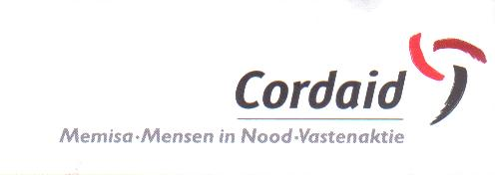
Catholic Organization for Relief and Development Aid (Cordaid)

November, 2013

TABLE OF CONTENTS
TABLE OF CONTENTS 2
LIST OF TABLES 3
LIST OF FIGURES 3
ACKNOWLEDGEMENT 5
ABBREVIATIONS AND ACRONYMS 6
EXECUTIVE SUMMARY 7
Chapter 1 Introduction 9
1.1 Background and overview of the CMDRR 9
1.2 Objectives of the Impact Study 11
Chapter 2 Methodology and Approaches 12
2.1 Methodology 12
2.2 Impact study sites and Sample size 13
2.2.1 Chikhwawa District 13
2.2.2 Nsanje District 16
2.3 Data and information collection 16
2.4 Information collected 16
Chapter 3 Literature review 17
Summary 17
3.1 Community managed disaster risk reduction 17
3.2 CADECOM Interventions 18
3.3 Community Participation 19
3.4 Capacity building 19
3.5 Knowledge management and documentation 19
3.6 Lobbying and advocacy 19
3.7 Best practices 20
3.8 Conclusion 20
Chapter 4 Demographic characteristics of respondents and assets base 21
Summary 21
4.1 Gender of respondents 21
4.2 Age of respondents 22
4.3 Marital status 22
4.4 Period at current location 22
4.5 Education status 23
4.6 Household size 24
Chapter 5 Sources and Change in income 25
Summary 25
5.1 Asset ownership and control 25
5.2 Sources of income and programme contribution to income 26
5.3 Percent contribution of CMDRR to household income 28
5.4 Household Income Contribution 29
Chapter 6 Implementation of Programme Interventions 30
6.1 Involvement in interventions 30
6.2 Conceptualization of the CMDRR 31
6.3 Level of knowledge on CMDRR 33
6.4 Level of skills acquired through the CMDRR programme 34
Chapter 7 Community Capacity Building 36
Summary 36
7.1 Capacity building approaches and training provider 36
7.2 Type of training received 38
7.3 Impacts of training programmes at household level 40
7.4 Impact of programme at community level 42
Chapter 8 Knowledge management and documentation 44
8.1 Extent to which programme imparting knowledge on DRR 44
8.2 Data and records being managed by communities 46
8.3 Training and documentation process 47
8.4 Extent to undertake activities related to CMDRR 51
8.5 Progress attained under the CMDRR 51
Chapter 9 Best Practices 54
9.1 Community conceptualisation of the CMDRR 54
9.2 Effective engagement of community Extension Volunteers 54
9.3 Designing and delivery of training programmes in DRR 55
9.4 Pedagogical Learning Approaches 55
9.5 Community data management 55
Chapter 10 Conclusion and Recommendations 55
10.1 General conclusions 56
10.2 Specific recommendations and programme consideration 57
References 59
Appendices 60
Appendix A1: Brief information on tools used to collect information 60
Appendix 1: Checklist for Document Review 61
Appendix 2: Checklist for CADECOM staff 63
Appendix 3: Checklist for Focus Group Discussions with Communities 66
Appendix 4: Household Questionnaire 68
Appendix 5: Case study guidelines 82
Appendix 6: Checklist of key informants 85
Appendix 7: Proposed community-based technology development conceptual framework depicting stages for climate change adaptation 86

LIST OF TABLES
Table 4-1 Statistical information for respondents at household level 21
Table 4-2 Responses on marital status of the respondents 22
Table 4-3 Education status of the respondents 23
Table 5-1 Responses on asset ownership 25
Table 5-2 Responses (%) on who controls the assets 25
Table 5-3 Responses on climate related hazards that affect assets 26
Table 6-1 Responses (%) on the level of involvement in the CMDRR process 32
Table 6-2 Responses (%) on the level of knowledge in the CMDRR process 33
Table 6-3 Responses on the level of skills acquired 34
Table 6-4 Responses (%) on the level of change on skills and attitude between 2008 and 2013 35
Table 8-1 Responses (%) on the extent to undertake activities related to DRR 51

LIST OF FIGURES
Figure 4-1 Age of respondent (years) 22
Figure 4-2 Period (Years) at current residential area 23
Figure 4-3 Number of persons per household 24
Figure 5-1 Annual household income between 2008 and 2013 27
Figure 6-1 Responses on interventions undertaken under the CMDRR 31
Figure 6-2Conceptual framework for CMDRR process 32
Figure 7-1 Responses (%) on the type of approaches used in building the capacity of beneficiaries 37
Figure 7-2 Responses (%) on those that delivered training programmes 37
Figure 7-3 Responses (%) on type of training received 38
Figure 7-5 Responses on the changes that have occurred due to the capacity building programmes 40
Figure 7-6 Responses (%) on the perceived impact of the capacity building programmes at community level 42
Figure 7-7 Responses on the new things that they have learnt through the programme 43
Figure 7-8 Responses (%) on pathways to transfer skills 43
Figure 8-1 Responses (%) on whether the programme has imparted knowledge on DRR 45
Figure 8-2 Responses (%) on approaches taken to impart knowledge and skills to beneficiaries 46
Figure 8-3 Responses on the type of data collected by communities 47
Figure 8-4 Responses on the quality of training 47
Figure 8-5 Responses (%) on issues related to training programmes 48
Figure 8-6 CADECOM Extension Worker checking moisture for proper storage to avoid post-harvest loses 49
Figure 8-7 Samples of Woodlots at household level 49
Figure 8-8 CADECOM extension worker proudly present a stove to a woman beneficiary 52
Figure 8-9 A house that is being constructed with incomes from an agricultural intervention promoted by CADECOM 53

ACKNOWLEDGEMENT

I am very grateful to the consultants and to all those who contributed to this impact study. I would specifically wish to acknowledge the contributions made by the research and editorial teams. I am greatly indebted to Mr Ken Machira and Mr Kondwani Kamanga who participated in the designing of data collection tools in reference to the intended outcomes of the assignment, designing the data entry platform in SPSS, oversee data collection, entry and participate in data analysis. I very much appreciate the contribution on Ken Machira, Ms Tapiwa Gongwe and Dr Wezi Mkwaila who contributed to specific chapters and provided technical input to the finalisation of the report.

I would like to thank Ms Patience Mkwambisi, Mathero Kang’ombe, Thomas Malope and Lucy Manjita, who participated as Research Assistants throughout the whole research work and provided significant input to the preparation of the data collection tools.

I specifically acknowledge the contributions and technical contribution made by Mr. Carsterns George Mulume ( National CADECOM Secretary ) and Mr. Louis Abinala Kawenda ( National Program Coordinator – DRR & Emergency) , and MS. Margot Loof of CORDAID in the Netherlands who provided technical expertise, support and development related guidance throughout the research and reporting period on several programme thematic issues.

I greatly appreciate the time and valuable contribution to this assignment from several experts and officials especially CADECOM for logistical support, technical input to data collection tools and providing important technical and community information for the success of this assignment.

The provision of information by district officers (name them), officials from the diocese is much appreciated and acknowledged. Finally, I would like to be grateful to the Cordaid and CADECOM for entrusting me with the assignment and providing the required funding and technical guidance as per the terms of reference for the study.

David Mkwambisi, PhD
Team Leader
November, 2013

ABBREVIATIONS AND ACRONYMS

CADECOM | Catholic Development Commission of Malawi
CMDRR | Community Managed Disaster Risk Reduction
CORDAID | Catholic Organization for Relief and Development Aid
CCA | Climate Change Adaptation
CCJP | Catholic Commission for Justice and Peace
DARS | Department of Agricultural Research Services
DDP | District Development Plans
DEC | District Executive Committee
DRR | Disaster Risk Reduction
DRRM | Disaster Risk Reduction and Management
EAD | Environmental Affairs Department
ECM | Episcopal Conference of Malawi
GVH | Group Village Headman
IPCC | Intergovernmental Panel on Climate Change
M and E | Monitoring and Evaluation
MoAFS | Ministry of Agriculture and Food Security
MUAC | Malawi Vulnerability Assessment Committee
TA | Traditional Authority
VSL | Village Savings and Loans

EXECUTIVE SUMMARY

1.0 Background

The Community Managed Disaster Risk Reduction (CMDRR) programme is national programme that has been implemented by the Catholic Development Commission in Malawi (CADECOM) with support from the Catholic Organization for Relief and Development Aid (Cordaid) from April 2008 to September 2013 in all Dioceses in Malawi. The programme’s rationale is clearly tied to the fact that reducing disaster risks and building resilient livelihoods among vulnerable communities is important for poverty alleviation and resilience to climate change variations. With this in mind, the interventions aimed to “improve and increase the social-economic and political resilience of vulnerable people in disaster prone areas”. A mixed method approach was applied and included the use of several evaluation data gathering tools including questionnaire for beneficiaries, checklist for focus group discussion and key informants. Primary data was collected from Traditional Authorities Tengani and Ngabu in Nsanje and Chikhwawa districts respectively.

2.0 Scope of the impact study

The study evaluated the extent to which Cordaid’s CMDRR programmes of the last 5 years in Chikhwawa Diocese of Malawi have contributed to building more resilient communities, in Nsanje and Chikhwawa Districts. It focused on the (i) progress of the CMDRR programmes, (ii) outcomes of the CMDRR programmes and (iii) impact of the CMDRR programme. Particular attention was given to the (a) implementation of the programme by partners and communities (b) capacity building and (c ) knowledge management (‘linking & learning’) and documentation (by communities and partners (d) lobby & advocacy by communities, partners, and by networks in which they participate (e) collaboration with different stakeholders by communities and partners, with others and (f) fundraising activities by communities themselves, by Cadecom, and by Cordaid). In addition, on the ‘capacity building’ strategy, the impact study assessed the extent to which the CMDRR capacity building contributed to the programme’s progress and impact.

2.0 Summary of Findings

The progress of the CMDRR programme
The progress of the CMDRR has been appreciated by several stakeholders including the beneficiaries, government officials and other NGO officials. It has allowed communities to have the capacity of implementing DRR interventions with minimal supervision from the funding and coordinating agency. The programme faced few challenges to promote community participation. It is very clear that most of the interventions were planned in advance and the conceptualization process allowed communities to understand the problems that there were to address. The engagement of other stakeholders especially in the capacity building themes provided the opportunity to beneficiaries to acquire the necessary skills and the change in the attitude.

The outcomes of the CMDRR programme

Most of the planned interventions have been achieved and there is empirical evidence on the ground on the outcomes that have resulted due to the CMDRR. The implementation of this programme has promoted crop diversification, irrigation, water conservation and afforestation programmes that have all contributed to community resilience. Over 70% of the beneficiaries are now getting their income through agriculture and the programme has managed to introduce small and medium enterprises that were not common in 2008. On average 45% indicated that household income has increased because of the programme interventions. It is very clear that risks associated with disasters are now well understood and communities are able to protect themselves and their properties from such risks. Communities have been participating in several interventions including Village Savings and Loans.

Level of knowledge on the CMDRR has improved among most of the respondents unlike in 2008 when less than 10% of the respondents where knowledgeable. The findings further shows that the level of skills acquired during the period has improved especially in DRR, technology application and attitude change. However, there is need to improve the delivery of interventions that promote data collection and management as well as to allow community participate in budget planning and auditing. The outcomes of the programme through training programmes is also very clear since more of the beneficiaries are not using CMDRR approaches.

Impact of the CMDRR programmes
The findings of this study provide empirical evidence that there the short term impact have been achieved. There is improved resilience among the communities and results have also shown that rural livelihoods, food security and household incomes have improved. Other impacts that have been manifested by the programme include reduced health related challenges, improved human right and gender issues. Due to improved collaboration and coordination, more projects have been implemented further improving the community status in terms of knowledge, skills and attitude towards development. The programme has managed to allow full participation of other partners in the implementation of the interventions including the involvement of the government officials.

Recommendations
- The programming could consider a business approach where incentivises are introduced to create local level employment while protecting the environment and improving the livelihoods. In this case, the Village Savings Loans model must be linked to natural resource conservation and modern agriculture. We recommend that families that have potential to create off farm employment must be identified and trained to start small and medium enterprises.
- There is need to establish information management and transfer nodes within the communities. These nodes can be used to promote technologies, share experiences and provide platforms for development of plans
- The programme should also put in place mechanisms that will show how much contribution is coming from the communities, other partners in relation to the inputs from the funding and coordinating agencies.
- The beneficiaries that have more experience in conceptualising the CMDRR must be supported to up-scale the concept to other communities through social learning forums. This will also help to provide platforms to solve other social challenges associated with climate change and weather variability
- The approach used by the CMDRR programme could be further documented and used as a teaching tool among primary and secondary schools in the districts. This concept could be expanded to address other challenges including community health and sanitation issues.
- Future training programmes could consider identifying households that could be directly involved in developing training, testing and validating training materials. Content of the training materials could be discussed with district officials and other NGOs and where possible produce a booklet that can be used at district level. In this case, higher learning institutions could be involved.
- The programme should have innovative mechanisms of raising funds and build the capacity of beneficiaries in raising funds. In this case, the revolving fund for the village development committee and other interventions could be created.
- At programme designing level, we recommend that all field officers from CADECOM should meet and share the lessons learnt over time and redesign the delivery based on the best practices that have been identified through this impact study.

- Introduction

  - Background and overview of the CMDRR

Climate variability and climate change present great challenge to many countries in Africa requiring that food security, nutrition, public health, improved livelihoods, and disaster risk reduction (DRR) be major focus areas for adaptation programmes. Over 1 billion people are hungry in the world today and climate related risks and disasters are a significant threat to community resilience even more so with recent revelations in the recently endorsed and adopted International Panel on Climate Change report (IPCC, 2013) . This has resulted in programmes that are changing the way we look at developing and protecting lives, properties and livelihoods.

According a review by a consortium of seven organisations to implement a Norwegian funded programme in Malawi and Tanzania, the most vulnerable communities often live in fragile areas that are prone to climate change and other hazards where additional shocks can have devastating effects. The review further indicates that exposure to high levels of risk of disasters and lack of capacity to manage these risks, compounded by factors such as poor access to markets and income-generation opportunities, trap poor households in a cycle of food insecurity and poverty that quickly deteriorates into a food crisis and disaster with devastating effects for health and all dimensions of society.

Malawi like many developing countries has not been spared from the above challenges and is being faced with several climate and weather variability challenges especially that it depends on rain-fed agriculture. This has been confirmed in several government reports (GoM, 2013, GoM, 2012 GoM, 2010). Research findings have shown that the most vulnerable groups are those that are below the poverty line (less than 1 dollar/person/day (Simelton et al 2013; Stringer et al 2012; Schensul et al., 2013; Kakota et al 2013; Mkwambisi et al., 2012, 2013). This situation is very worse in districts that are in the Lower Shire Valley (Nsanje and Chikhwawa) because of several severe climate related risks including floods and prolonged dry spells. Over time, this has resulted in poor communities to be vulnerable through loss of land, infrastructure, and access to health services, safe and clean water and low yield. In addition, livestock and other off-farm livelihoods have been affected (reference). The Government of Malawi confirms that the risks associated with climate change and weather variability have increased in their intensity and frequency over time (GoM. 2007, GoM, 2010)

Based on this situation, the Episcopal Conference of Malawi (ECM) through Catholic Development Commission in Malawi (CADECOM) has been implementing a Community Managed Disaster Risk Reduction (CMDRR) programme with support from the Catholic Organization for Relief and Development Aid (Cordaid) and Trocare since 2008 in seven Dioceses in Malawi namely Mzuzu, Lilongwe, Dedza, Mangochi, Zomba, Blantyre, and Chikhwawa. The goal of the Cordaid Disaster Risk Reduction (DRR) program is to improve and increase the social-economic and political resilience of vulnerable people in disaster prone areas, and to reduce the disaster risks and building resilient livelihoods in fragile contexts.

The overall country programme supported by CORDAID and implemented by CADECOM aims to contribute to strategies that enable 76 direct communities (6,840 households) covering over 30,000 people at most risk increased their resilience to disaster thereby improving their livelihoods.

Specifically, the programme has interventions aimed at (i) improving the livelihoods of 76 direct communities through small mitigative works (ii) facilitating, monitoring, evaluative learning and documenting of the best livelihoods and other practices instituted by Episcopal Conference of Malawi (ECM) staffs and the affected communities (iii) lobbying and advocating for national DRR issues that include DRR policy and food security policy and (iv) increasing and expanding knowledge among CMDRR and CCA exit strategies among 40 ECM staffs and 76 communities.

So far, Malawi programme expect five results by end of September 2013. The results include among others the following aspects: (i) improved livelihoods of 76 communities through small scale mitigative works (ii) improved resource mobilization and linkage through monitoring, learning and documentation and sharing of best practices (iii) harmonized implementation of DRR among stakeholders within Malawi through the formation of national DRR forum and development and approval of National DRR documents (Policy, ACT, framework, handbook, guidelines) (iv) established a national data bank for DRR monitoring and planning at partner level (ECM, Diocese and Community) and (v) increased knowledge, skills and attitudes in CMDRR and CCA exit strategies.

The programme used a conceptual framework that facilitated the delivery of the capacity building and implementation of CMDRR. The conceptual process further facilitated the implementation of community oriented action plans in order to respond to different hazards. The process covered several stages including (i) conceptualization of the intervention (ii) participatory risk-hazard assessment, (iii) participatory planning, (iv) building and training community DRR, (v) community managed implementation (vi) documentation (vii) advocacy (viii) participatory monitoring and evaluation and (ix) redesigning projects. Throughout the process communication and gender were crosscutting issues.

The current CMDRR came to an end at the end of September 2013.However, a new programme is set to be produced aimed to re-defining CADECOM, its partners’ and communities’ objectives and aspirations. In many cases, accountability, learning and planning systems (Alps) require that a review of the country’s operations and strategy is conducted at the end of programme lifecycle, hence the need to conduct the impact study.

As a pilot impact analysis, the study has been undertaken to provide the progress and impact of the programme in Chikhwawa Diocese - covering Traditional Authority Tengani and Ngabu in Nsanje and Chikhwawa districts respectively which was one of the sites where CADECOM has been facilitating implementation of the CMDRR program in the Diocese of Chikhwawa. CADECOM National Office also played a crucial role in the program as far as lobbying and advocacy, documentation, capacity building of staff and other stakeholders resource mobilisation as well as collaboration with other stakeholders at national and district level is concerned.

1.2 Objectives of the Impact Study

The overall objective of the study was to verify the extent that Cordaid’s CMDRR programmes implemented for the last 5 years along Chikhwawa Diocese of Malawi have contributed to building more resilient communities in the districts of Nsanje and Chikhwawa. More specifically, the study looked at the following areas:
- Assess the progress of CMDRR programme at partner and community levels
- Analyze the outcomes of CMDRR programme at partner and community levels
- Evaluate the impact of CMDRR programme per various types of interventions namely;
  - Implementation of the programme / projects (by partners and communities)
  - Capacity building (of partner organisations and communities)
  - Knowledge management (‘linking & learning’) and documentation (by communities and partners)
  - Lobby & advocacy (by communities, partners, and by networks in which they participate)
  - Collaboration with different stakeholders (by communities and partners, with others)
  - Fundraising activities (by communities themselves, by Cadecom, and by Cordaid)
- Assess the approaches used in implementation of the programme/projects by partners and the communities
- Document best practices of various types of interventions such as implementation of CMDRR measures.
- Provide recommendations to the client for future programming per each type of intervention

The impact study further assessed the programme strategy’s (i) effectiveness as shown through the extent to which activities and achievements concur to the objectives, in particular with regard to effective community-based approaches and working with partners (ii) The programme’s efficiency in terms of the relation between inputs and outputs (iii) the strategy’s relevance as a model (iv) the programme’s replicability through documentation of actions and impacts; and (v) the sustainability of interventions and the continuity of impacts.

  - Study Limitation
The main limitation of this study was time constraints especially during field consultations. There was more information that the study could have collected but due to other issues, such opportunity was not available. Assessment of the actual impact was also a challenge especially that data linked to the impact was not available and in other communities there are other organisations supporting similar interventions.

- Methodology and Approaches

2.1 Methodology

The end of project evaluation exercise has used several evaluation techniques, some of them as described by Laws et al., (2008). The overall approach has been mixed of quantitative and qualitative methods, however, the quantitative approach has been used to a large extent to produce this report. Quantitative methods were used to find out how many households in terms of percentage out of the sampled respondents did practice a certain food insecurity coping strategy or a mix of strategies, how many in terms of percentage received different seeds/planting materials, acres planted as well as yields realized and how long the same is going to last, how many households have been trained in different training fields such as proper agronomic practices and disaster risk reduction.

This approach has also been used to allow generalization of findings among the sampled population and to ensure that the sample is statistically represented (Rice & Ezzy, 1999:42). The limitation under quantitative approach was that some of the sampled households were not aware of the frequency of the coping strategies due to lack of documentation and record keeping of the same while, also, others were not aware of the acres planted and the crop yields that are going to be realized as harvesting was still underway for most crops such as maize and sweet potatoes.

The qualitative approach was used to document reasons why they practiced the coping strategies in that way, impact of the different trainings, challenges encountered and lessons learnt with the aim of enriching the data of the evaluation exercise so as to make a comprehensive report. The qualitative approach posed a challenge of transcribing as a lot of data was collected which took much time to do the required coding and synthesis.

A literature review was also conducted to establish national status of food security situation. Comparison, as far as the frequencies of food insecurity coping strategies are concerned, was also undertaken with the baseline study report of the project. This was done to establish changes brought in by the project as far as addressing the food insecurity strategies were concerned as evidence of the same.

Secondly, a semi-structured questionnaire was formulated to capture data regarding the terms of reference such as: frequencies of food insecurity coping strategies, amount of seeds/planting materials received vs. acres planted and yields realized, trainings attended and impact of the same, strategies put in place to avert another food insecurity situation, challenges encountered and lessons learnt. A total of 110 survey instruments out of 120 planned were administered on a one-to-one basis by the project enumerators with technical backstopping from the project National Relief and Emergency Officer which is based at the CADECOM National Office. The 110 questionnaires that were fully administered and completed by the said enumerators, provided a response rate of 92%.

The sample size was selected using different techniques. Simple random sampling has been used in this evaluation which allowed every member of the population to have an equal chance of being selected to participate in the end of project evaluation exercise. A sampling frame of all targeted households was compiled from list of the same. In addition to simple random sampling, purposive sampling has also been used to sample those household members categorized to be more vulnerable such as the elderly, the chronically ill and the physically challenged among others for in-depth evaluation as recommended by (Rice & Ezzy, 1999:42).

Four focus group discussions (FGDs), one in each Diocese involving 15 people (10 females and 5 males), were conducted for approximately 3 hours each. This was done to allow participants to mention some of the project outcomes/success and enable documentation of the same as case studies/quotes, strategies put in place to avoid another food insecurity situation, challenges encountered and lessons learnt among others. Focus group discussions allowed consensus building among the focus group teams pertaining to the project i.e. key challenges and lessons learnt as well as reasons for different frequencies of food insecurity coping strategies despite provision of uniform food package per each targeted household.

Key informant interviews targeting local leaders, church leaders, district government staff and key CADECOM staff were also conducted to acquire their analysis of the project outcomes, challenges and lessons learnt. The process of triangulation (Neuman, 2003:139) has been used in this end of project evaluation exercise to ensure reliability, credibility and validity of the data. The quantitative data collected in this evaluation has been analyzed using SPSS as per attached work file while qualitative has been analysed through transcribing and synthesis of the same.

2.2 Impact study sites and Sample size

2.2.1 Chikhwawa District

Chikhwawa is one of the 28 Districts in Malawi located in the Southern Region of Malawi. It is one of the border districts sharing the country's international boundary with Mozambique to the West and district boundaries with Mwanza to the North, Thyolo to the East, Blantyre to North East and Nsanje to the South. Its main topographic features are the flat basin of Shire River and the Thyolo-Chikhwawa Escarpment.

The district has a total land area of Four Thousand Seven Hundred and Fifty- five (4,755) square kilometres. (GoM,2006). According to 2008 Population and Housing Census report ( NSO, 2008) , Chikhwawa had a population of 438,895 compared to (356,682) people in 1998. Of the 438,895 people220,914 (representing 50.3 percent) are female while the male population is 217,981 (49.7%). (GoM, 2008). The annual population growth rate for the district is 1.1% and has an average family size of 4.5.. Of the population person’s aged 10 years or older in Chikhwawa District, 74.1% are economically active. The majority of them (63.1%) are subsistence farmers and a further 10.7% are employed in other activities.

The government report (GOM, 2006) indicated that the district faces a number of problems such as food insecurity, low accessibility to safe water and sanitation, high morbidity and mortality rates, high illiteracy rates, poor communication infrastructure, environmental degradation, poor urban planning, low household income levels, high prevalence of HIV/AIDS and orphan hood, poor livestock management, unsustainable technologies and projects, decline in fish stocks, wild life and human conflict, rise in crime rates, and increase in vulnerability of people.

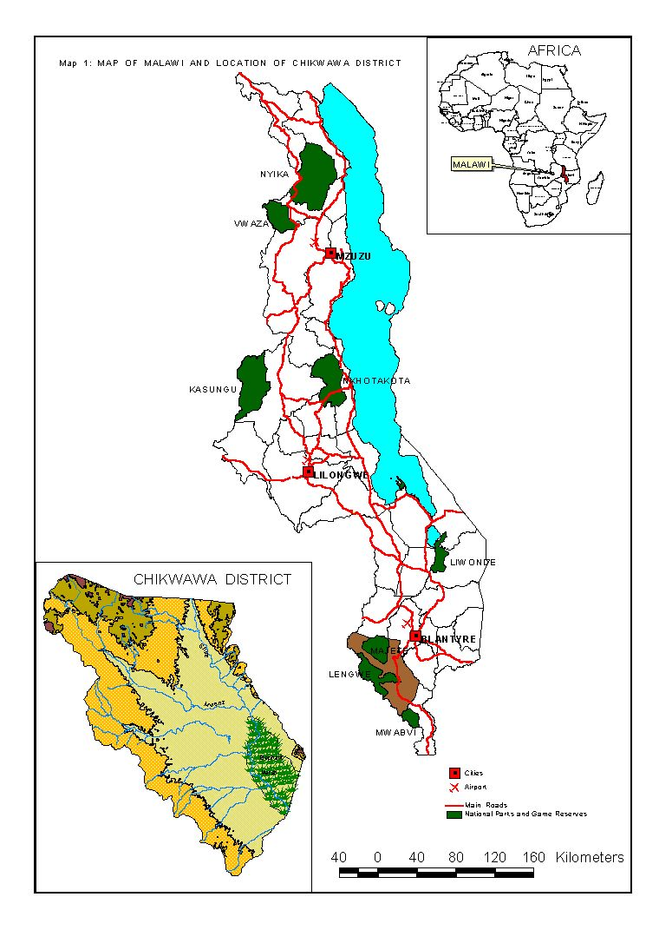
Map 1 Chikhwawa District (Source: NSO 2008)
The district experiences general unreliable and variable rainfall ranging from about 967.6 mm to 170 mm maximum and minimum rainfall respectively probably because the district lays in the Shire Highland leeward sides. Temperatures are generally high with a maximum of about 37.6 °C usually experienced in November and a minimum of 27.6 °C in July every year whilst the mean monthly temperatures are usually above 20 °C.

2.2.2 Nsanje District
Nsanje District is one of the thirteen districts in the Southern Region of Malawi. It is situated at the southern tip of the country within the Lower Shire valley. The District is bordered by Chikhwawa in the North East., Thyolo in the North and the rest of the district is surrounded by the Republic of Mozambique. The total land area of the district is 1,942 sq. Km.

Most of the western part is characterized by a rift valley scarp whose average height ranges from 457m within the rift valley to 914m over the Malawi Hills (Chididi Range). Most of this range is deeply dissected and is best left for watershed protection. While the Lower Shire valley is classified as the rift valley floor and the average height is 61m around the District Boma area. Marshes occur along the Shire River. Dinde is the major marsh area in the District covering an area of 16 sq. Km. The Elephant Marshes are located above Chiromo Bridge. The fringes of the marshy areas are suitable for growing rice and dimba cultivation.

The climate of the district is characterized by two well defined seasons: a dry season from May to October and a rainy season from November to April. The average annual rainfall is 813mm. There is a steady increase of rainfall with increasing topographic gradient from Shire River to the Western Hills where the average annual rainfall reaches 1317mm. Temperatures fall to their lowest from June to July when the average minimum and maximum for the valley are 13.4 and 27.4 degrees Celsius respectively. The average minimum temperature is highest in October when it rises to 37.5 degrees Celsius. These temperatures are the highest compared to the rest of the country.

The most predominant soils are the lithosols. These are shallow and stony occurring mainly in the rift valley scarp. Pockets of ferrallitic soil found within this zone are suitable for intensive cultivation of maize, tobacco, and groundnuts. Alluvial calcimorphic soils and grey brown earths occur around Elephant and Dinde Marshes as well as along Shire River. These are intensively cultivated during the dry season.

TAs Mlolo and Mbenje are the most highly populated with population of 57,075 and 43,768 respectively which count over 42% of the total population of the District. Makoko and Nyachikadza are the least populated TAs with only 3,675 and 6,659 people respectively. Over the years people have been vacating most of the areas in the two TAs, especially in TA Nyachikadza as a result of floods.

2.3 Data and information collection

The impact study applied several research techniques to collect data and information including (i) consultations with the Programme Support Unit at CADECOM National Office (ii) literature review covering several programme documents such as proposals, progress reports, evaluation reports, baseline reports and other national and global documents (iii) consultations with officials from the diocese and government department (iv) consultations with local leaders and communities where the programme is being implemented (v) consultations with other key informants using a checklist for each intervention area (vi) focus group discussions with selected groups of beneficiaries (vii) semi-structured interviews with communities (viii) case study documentation (ix) community observation and (x) triangulation of different sources of data collected.

2.4 Information collected
Consultations with the Programme support team helped to assess and understand linkages with other DRR and/or livelihoods activities to ensure synergies and avoid duplication of activities. The consultants used this information to plan for specific areas that covered in this assignment. Information at this level include programme design, implemented approaches, community participation, challenges, and observed changes in community skills, attitude and knowledge on several CMDRR related issues among others.

National, districts and community consultations targeted officials and key informants at district and community level that are directly involved with CMDRR issues including lobbying and advocacy initiatives, capacity building, knowledge management, fund raising, community resilience and gender issues were collected. The approach was to know how the programme has been contributed to policies, guidelines and interventions on CMDRR and how the programme is addressing vulnerability issues, what best practices in CMDRR can be show-cased and up-scaled. For more details refer to Appendix A1.

Literature review

Summary

3.1 Community managed disaster risk reduction

Community Managed Disaster Risk Reduction (CMDRR) is defined as “a process of bringing people together within the same community to enable them to collectively address common disaster risks, and pursue common disaster risk reduction measures. It is a process that mobilizes a group of people in a systematic way towards achieving a safe and resilient community. It envisions a dynamic community that is cohesive in making decisions, deals with conflicts, resolves issues, manages collective and individual tasks, respects the rights of each individual, demands their rights and addresses and bounces back from hazard events” (Binas, 2010).

Malawi just like other Sub Sahara African countries is experiencing an increase in number, frequency and severity of hazards such as drought and floods in particular. These hazards are predicted to increase with climate change and further worsen the incidence of associated disasters in the region. Floods and drought are the most frequently occurring natural hazards in Malawi and have been classified to cause the highest economic losses. With regards to economic losses, in recent history, Malawi was most affected by droughts of 1987, 1992, 1994, 2004 and 2005.
For instance, the 1991/92 drought affected 6.1 million people through hunger; the 2000/2001 floods affected 660,000 people through loss of livelihoods while the 2001 food crisis as a result of the drought affected 3.2 million people; 2004/2005 drought affected 5.1 million people ( Department of Disaster Management Affairs). The majority of these hazards are associated to be caused by climate change (MVAC, 2012; FEWSNET, 2012, CADECOM, 2012 & DoDMA, 2010).
It is further noted that Malawi continues to be vulnerable to effects of climate change. During the 2012/2013 season, the Malawi Vulnerability Assessment Committee (MVAC, 2012) did put the number of people affected by food insecurity at 1,630, 007 during the last quarter of the year and about 2 million people during the first quarter of 2013. The main attributing factors of the food insecurity situation included poor crop harvests due to prolonged dry spells and floods which occurred during the 2012/2013 cropping season.

Disasters (droughts and floods) cause acute food insecurity at household level. For Instance the 2012 season was characterized by food shortage arising from dry spells in both Chikhwawa and Nsanje districts. During the month of February 2012, which is a critical period of crop development, the impact areas of Nsanje and Chikhwawa received little or no rains hence little was harvested per unit area.

Disasters strongly affect development patterns in affected households and countries through loss of lives, damage to physical, natural and environmental assets, losses in human and financial wealth, erosion of social capital and governance systems. In 2008, there were 96 disasters recorded in sub-Saharan Africa. They included 44 floods and nine droughts that affected 16.3 million people. The resultant economic losses incurred were estimated at one billion dollars. The Community Managed Disaster Risk Reduction (CMDRR) is there to build people’s capacities to prevent and mitigate the impact of hazards of communities at risk. This is achieved by enhancing individual survivability and community readiness. Building resilient communities means strengthening the foundation of safety and enhancing disaster risk reduction measures.

3.2 CADECOM Interventions

Looking at the severity of food insecurity at household level caused by drought and floods in Malawi, CADECOM had to intervene so as to help the communities build resilient livelihoods in fragile contexts. The International strategy for disaster Reduction (2002) describes a resilient community as the one with ability to recover quickly from or adjust easily to misfortune, change or disturbance, in that it has the capacity of a system, community or acceptable level of functioning and structure.

In trying to enable communities to resist hazard impact, bounce back after disasters and to adapt and change to ensure effective recovery, CADECOM targeting Vulnerable people which included Rural resource poor households living below the poverty line, food insecure households, and the households that are infected or affected by HIV/AIDS and Domestic violence implemented a community managed Disaster Reduction (CMDRR) in several districts in Malawi including Chikhwawa and Nsanje. This project was implemented in TA’S Ngabu and Tengani.

The project’s main objective was to improve and expand knowledge and implementation of Disaster Risk Reduction Best Practices in the rural areas of Chikhwawa and Nsanje. The activities of intervention involved included irrigation, food preservation, manure making, soil and water conservation, crop protection, vegetable production, procurement of various farm inputs, fruit tree grafting.

3.3 Community Participation

All projects on Community Managed Disaster Risk Management should promote community participation through the adoption of specific policies, promotion of networking, the strategic management of volunteer Resources, attribution of roles and responsibilities and the delegation and provision of the necessary authority and resources. (Davis Ian 2006). In the Disaster Risk Management under CADECOM, the community members themselves were having their vulnerability situations and the potential hazards threatening their Livelihoods analyzed and also designed their own projects. It is from such a process that Risk Mitigation Plans (Community Action plans) were drawn and CADECOM in liaison with other stakeholders provided guidance and some technical support, whilst communities implemented the project activities.

3.4 Capacity building

After looking at the capacity and knowledge of its staff, the program came up with programs which aimed at improving the capacity of CADECOM technical staff and targeted communities to understand, prepare, mitigate and respond to disasters appropriately and proactively. The knowledge gap was identified on issues that are associated with DRRM in the districts where the project was being implemented. Disaster risk reduction measures such as preparedness, prevention, mitigation, adaptation, survivability, readiness and response needed to be imparted in the technical staff for programme to be successful. The trainings were on various areas that include gender, HIV and AIDS, goat production and group dynamics and risk reduction related areas.

For instance through CADECOM national Office, CADECOM Chikhwawa secured funding from OXFAM to carry out trainings for its technical staff and properly execute disaster preparedness projects in Chikhwawa and Nsanje. Capacity building continued through the training of 45 ECM staff in health, development, CCJP, education commissions and 76 communities in documentation and sharing of best practices which was most important in implementing the best practices. CADECOM extended the capacity building through exchange visits to two well resilient communities by 50 people i.e. Mua in Dedza. The communities were also trained in Small scale Business management, energy saving Stoves making, hygiene and sanitation and leadership skills as part of capacity building.

3.5 Knowledge management and documentation
The Project also looked at the need of the documentation of the projects success and failures. During the program, they also worked with media houses which publicized some of CADECOM work on CMDRR and CCA in newspapers and radio and two newspaper inserts were produced for the program.

3.6 Lobbying and advocacy

Advocacy is a strategy to influence policy makers when they make laws and regulations, distribute resources and make other decisions that affect peoples’ lives with an aim to create policies, reform the policies and ensure that they are implemented. There are a variety of advocacy strategies that can be used, for instance the problem may be directly discussed with policy makers, delivering messages through the media and even strengthening the ability of local organizations to advocate. (Care USA 2001).

Knowing that countries and communities that develop policy, legislative and institutional frameworks for disaster risk reduction and are able to develop and track progress through specific and measurable indicators have greater capacity to manage risks and to achieve widespread consensus for engagement in and compliance with disaster risk reduction measures across all sectors of society CADECOM and other stakeholders in the sector of DRR and CCA also played a critical role to lobby and advocate for:
- the formulation of the National DRR Policy
- review of the ACT
- the establishment of the National DRR Platform
- a continued lobby and advocacy to ensure that these key DRR documents have been approved by Cabinet as the same will provide a legal framework to enable harmonization of the DRR works in Malawi
- lobbying and advocating for formation of national DRR platform which will act as a watchdog for harmonization of DRR work in Malawi

CARE USA identified several advocacy issues of which some are Capacity Building, Child participation, Education and Training, Research, Impact and effectiveness, Cooperation and Partnering and Vulnerable population Reduction. These Issues of Advocacy can be achieved through vehicles namely: Alliances and Work groups, Conferences and Forums, Lobbying, funding, Demonstration Projects, publications, media and workshops.

3.7 Best practices

On best practices the projects looked at several things that were to be put into practice to help the communities in DRRM IN Chikhwawa and Nsanje. Issues of environmental management, irrigation, food stability, HIV and AIDS among several other practices were carried out in Chikhwawa and Nsanje. Many people targeted in the programme came forward to narrate their best practices as far as disaster risk reduction programme is concerned. They included the changes which have taken place in their lives, as individuals, families and committees.

Since floods and drought are the most frequent natural hazards in the country and Chikhwawa and Nsanje being the districts that are at the receiving end of these natural disasters many people do lose their livelihoods. With best practices put in place in these districts many people have food stability in the families and minimized on their coping mechanism such as charcoal burning which had degraded the environment.

3.8 Conclusion

In terms of food security status, literature review shows that availability of food was directly dependent on weather and climate variability in general and that the programme interventions especially irrigation provided the required supplemental food entitlement (CADECOM, 2011, 2012). Further document analysis shows that most of the households were able to cope to the impact of climate variability through sale of livestock which were mostly provided by the programme. This clearly shows the need to integrated crop and livestock for sustainable local level autonomous adaptation.

In terms of irrigation, the study has shown that membership to clubs increased and more materials were provided to the irrigation clubs (CADECOM, 2011, 2012). This was supported by responses from key informants and project beneficiaries who have confirmed that the irrigation component was very key in achieving food security goals.

The programme managed to mobile and sensitise key stakeholders at district and national level and participated in several national climate variability related programmes including contribution to the development of the National Climate Change Policy (EAD, 2013). The programme further provided updates to the District Executive Committee (DEC) as well as to prominent officials from the Diocese (CADECOM 2011, 2012). For example, the programme in collaboration with Ministry of Agriculture and Food Security (MoAFS) trained farmers in small scale irrigation and maintenance of treadle pumps. This approach has allowed the programme to contribute to both district and country development plans and strategic goals.

- Demographic characteristics of respondents and assets base

Summary
The chapter provide key demographic information of the beneficiaries who provided information during field consultations.

4.1 Gender of respondents

The planned sample size was 120 (60 from each district) however, only 110 respondents were available for interviews. Table 4.1 shows that 60 households were covered in Chikhwawa (42 males and 18 females) while 50 households were covered in Nsanje (11 males and 39 females)

Table 4-1 Statistical information for respondents at household level
GVH | TA | Nsanje |  | Chikhwawa
GVH | TA | Males | Females | Males | Females
Lombe | Ngabu | 31 | 9 | - | - | 40
Nyambiro | Ngabu | 11 | 9 | - | - | 20
Chitsa | Tengani | - | - | 11 | 39 | 50
Total |  | 42 | 18 | 11 | 39 | 110

This is a representation of 51.8% of women and 48.2% by men. More males were present in Nsanje than women because of the advance notification of the interviews and they were also from the same Group Village Headman (GVH). In Chikhwawa the interviews were attended by more women than men because most of the men were busy working in their fields. According to National Statistics Office (GOM, 2008) it is reported that 67.8 percent of the population in Nsanje are male headed households while only 32.2 percent are female headed households. In Chikhwawa, statistics indicates that the female headed households represent to about 32.2 percent.

4.2 Age of respondents

Information on the age of respondent is presented in Graph 4.1 and shows that most of the beneficiaries were within the productive range of 25 and 50 years. The data further show that the aged have also benefited from the programme interventions including those that are aged over 70 years.

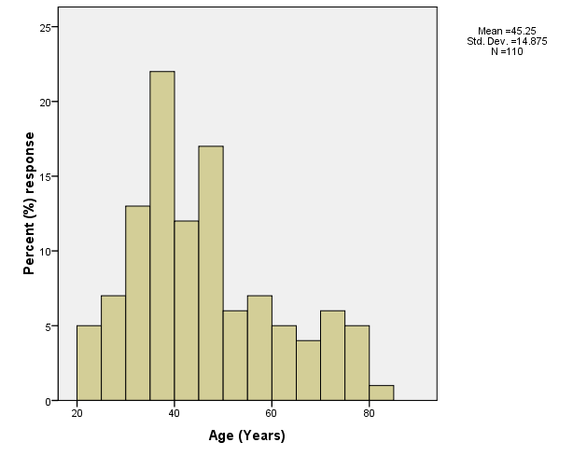
Figure 4-1 Age of respondent (years)
Graph 4.1 further shows that a wide range of beneficiaries in age terms have benefited from the programme including those that are young.

4.3 Marital status

In terms of marital status, Table 4.2 shows that majority of the respondents (78.2%) are married followed by those that are widows (10.9%)

Table 4-2 Responses on marital status of the respondents
GHV | Single | Married | Separated | Divorced | Widow/er
Lombe | 0.0 | 82.5 | 2.5 | 7.5 | 7.5
Nyambiro | 0.0 | 80.0 | 0.0 | 15.0 | 5.0
Chitsa | 6.0 | 74.0 | 0.0 | 8.0 | 12.0
Total | 2.7 | 78.2 | 0.9 | 7.5 | 10.9

These results show that the family unit is very strong where both men and women are making decisions. It is also ideal for the effective participation in different programme activities as they require different gender roles.

4.4 Period at current location

In terms of community stability, Graph 4.2 shows that the beneficiaries have been at the current place of residents for at least 27 years.
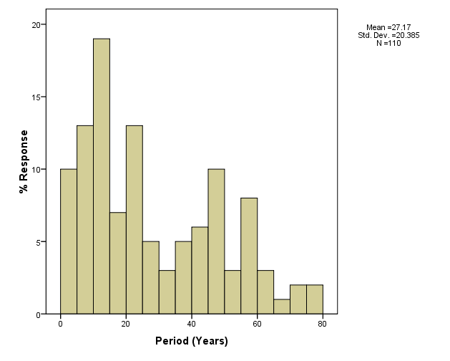
Figure 4-2 Period (Years) at current residential area
This information also shows that the communities are resilient to several climate related risks including flooding and prolonged dry spells. This outcome is also ideal for the programme since there is community cohesion for participation in the programmes as well sharing of knowledge among generations.

4.5 Education status
However, information on education status (Table 4.3) show that over 35% of the respondents have not been to any school and that only 51 percent have been to primary education level with 11.8% reaching secondary school level.

Table 4-3 Education status of the respondents

GVH | None | Primary | Secondary
Lombe | 37.5 | 52.5 | 10.0
Nyambiro | 40.0 | 45.0 | 15.0
Chitsa | 36.0 | 52.0 | 12.0
Total | 37.3 | 50.9 | 11.8

This calls for different approaches to build the capacity of communities and the inclusion of indigenous knowledge. In addition, the programme could further introduce training programmes that are based on pedagogical approaches. Noting that iliteracy is quite high in many areas, this can have an implication for adaptation to climate change as it affects adoption of technologies and understanding other technical issues that can enhance the communities’ resilience to climate change risks and hazards among other shocks.

For example, less than 12 of the households covered in this study have gone beyond secondary education. Illiteracy and lack of skills restricts communities to use off farm opportunities that can complement to their agricultural interventions. As such more people still depend on natural resources an issue that is even causing their areas to be more vulnerable as some of these get depleted and fail to replenish within man’s life span.

4.6 Household size
In terms of household size, the study has found that the average number of persons per household in 6.7 which is very large as compared to the national figure of 4.6 persons. The implication with this outcome is the impact on natural resources especially that the communities depend more on agriculture as their main economic activity. Such numbers put pressure on resources and with time most of the resources become inadequate to support the rising demand hence making the communities even more vulnerable

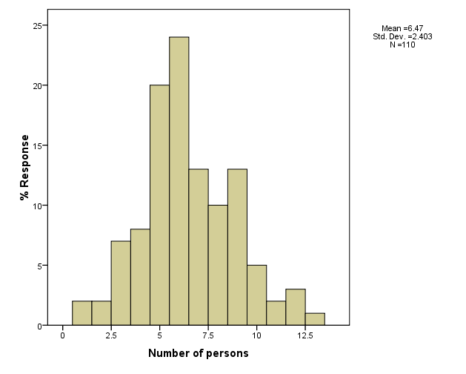
Figure 4-3 Number of persons per household
This also shows that the dependence ratio is very high within the communities thereby bring burden to those that support the families. In many cases, such situations also contribute to low support for education thereby leading to high school drop outs as the school-going children lack the necessary materials such as learning materials, food and school uniforms. Such scenarios also increase the demand for and this heightens the likelihood in the increase of school dropouts as most of the children are forced to offer supplementary labour in agricultural production which is basic on the local household economy.

Sources and Change in income

Summary
This chapter presents issues of asset ownership and control and further provides the main sources of income for the beneficiaries and also presents data on income change directly linked to the programme. Some of the challenges faced by the households in securing livelihoods have also been presented

5.1 Asset ownership and control

Table 5.1 has information on assets ownership at household level. Most of these assets were cooking utensils, agricultural tools and equipment and in some cases radios, bicycles and cell phones. The study has shown that most of the assets are owned by the family (52.7%) in general.

Table 5-4 Responses on asset ownership
GHV | Assets Ownership
GHV | Husband | Wife | Both | Single headed
Lombe | 27.5 | 12.5 | 55.5 | 5.0
Nyambiro | 10.0 | 0.0 | 70.0 | 20.0
Chitsa | 32.0 | 6.0 | 44.0 | 18.0
Total | 26.4 | 7.3 | 52.7 | 13.6

However, there are some assets such as bicycles and treadle pumps that were specifically mentioned that they are owned by husbands (26.4). These results further show that some of single headed household have challenges in owning assets. This could be the group that could be targeted with interventions especially female headed households. The study could not confirm the actual impact on the assets since the baseline information could not provide most of the assets that the beneficiaries had. The next programming could provide a framework that could identify assets as they link to production, income generation, raising awareness as well as social norms.

When it comes to control of assets, the study has shown that 44% of the respondent indicated that the assets are controlled at household level with about 33.6% being controlled by men. The results also show that women have little power on their own to control the assets (See Table 5.2)

Table 5-5 Responses (%) on who controls the assets
GHV | Assets Controller
GHV | Husband | Wife | Both | Single headed
Lombe | 35.0 | 12.5 | 47.5 | 5.0
Nyambiro | 20.0 | 0.0 | 60.0 | 20.0
Chitsa | 38.0 | 10.0 | 34.0 | 18.0
Total | 33.6 | 9.1 | 43.6 | 13.6

In many cases, this outcome has negative implications on women and children and that the programme could also introduce interventions that could empower women to own assets in line with their tradition and culture. Deliberate efforts could be made to have local level policies that promote asset ownership by women and children. Studies have shown that most of the women become more vulnerable when they lose their husbands due to grabbing of the household properties by relatives of the deceased.

When asked which natural related factors affect their assets, the results show that over 80% of the respondents indicated that floods is the main problem followed by prolonged dry spells (71.8%) and strong winds (32%) (See Table 5.3)
Table 5-6 Responses on climate related hazards that affect assets
GVH | Climate related hazards that affect assets
GVH | Floods | Prolonged dry spells | Strong winds | Erratic rains | Water run-off
Lombe | 90.0 | 72.5 | 35.0 | 20.0 | 22.5
Nyambiro | 85.0 | 80.0 | 45.0 | 60.0 | 30.0
Chitsa | 80.0 | 68.0 | 26.0 | 30.0 | 20.0
Total | 86.4 | 71.8 | 32.7 | 31.8 | 22.7

Focus groups discussions also confirmed these challenges and they are directly linked to agricultural production having impacts on both crop and livestock production. During FGDs, one woman farmer said:

In the past, our properties including livestock and crops were not affected by these disasters. But now, every year crops and properties are being damaged by floods. This is because river banks have been destroyed and there is too much sand now in the rivers.

The implication of such loses results in low crop yield, loss of biodiversity and indeed scarcity of water. The focus group discussions further revealed that more damages are also observed to infrastructure such as bridges, roads and houses. This also further destroyed infrastructure that protect flooding in some communities. When damages affect learning facilities, the study has shown that more girls are affected and has a direct link to class attendance. This is even worse when such risks affect health facilities where women and children tend to have more challenges. It was also revealed that such risks are associated with more water borne diseases.

However, compared to past situation before the CMDRR, the communities confirmed that they have now in place mechanisms to manage these risks especially those that they know their early warning signs. The beneficiaries indicated that the main challenge is that the risks are natural issues that in many cases can not be controlled through human mechanism. Key informant indicated that in areas where the CMDRR is being implemented , the resilience of the communities is very high in terms adaptation to climate related risks.

5.2 Sources of income and programme contribution to income

The major sources of income were through the sale of crops (72%) and piece work (66.4%). Some respondents were also involved in businesses (30%) while the sale of livestock contributed a little towards the household income (18.2%). None of the respondents were involved in ‘formal’ employment as a means of earning income (Table 5.4).

Table 5-4 Responses on main source of income
GVH | Main Source of income
GVH | Sale of Livestock | Sale of Crops | Piece work | Business | Employment
Lombe | 17.5 | 70.0 | 75.0 | 32.5 | 0
Nyambiro | 10.0 | 70.0 | 65.0 | 30.0 | 0
Chitsa | 22.0 | 74.0 | 60.0 | 28.0 | 0
Total | 18.2 | 71.8 | 66.4 | 30.0 | 0

Within the GVHs, the results show that communities of Chitsa have an opportunity to engage in livestock production (22% responses) as well as crop production (74.0%). The results also show that piece work is one of the main sources of income. The implication with this source is that employees are mostly exploited and there is no formal contractual arrangement between partners. In addition, the employees tend to transfer their labour from household food production especially during rainy season that can lower food production. In this case, the programme could create other forms of employment such as community based eco-tourism.

Results from this study have shown that household annual income ranged from just below MK1000.00 to a maximum of MWK75000. Within the GVHs, on average annual income ranged from MK300.00 to MWK10000.00 in the period between 2008 and 2012 indicating a 60% increase over a five year period (Figure 5-1).

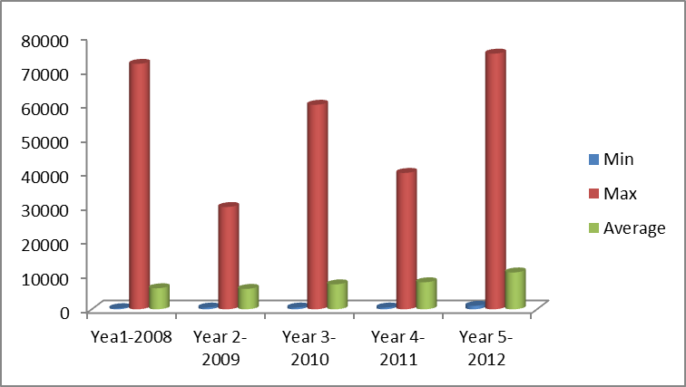
Figure 5-4 Annual household income between 2008 and 2013
These results shows that there the changes are not statistically different (p<0.05) between years and among GHVs. The results revealed that the average annual income in 2008 was K6000.00 whilst in 2012 was MK 10,000.00. However, the maximum annual income of MK72, 000.00 in 2008 should be treated with caution as is fails to justify the main source of this income. Consultations showed that the programme has helped to increase incomes at household level. One implication on the income is that most of the household don’t keep records of their incomes and there is need to provide mechanism to capture this data in the course of programme implementation.

5.3 Percent contribution of CMDRR to household income

A large number of respondents (45%) indicated that the program had contributed over 75% towards household earnings especially in GVH Lombe (52%) and Chitsa (50%) while 35% of the respondents had 50-75% income from the program (Table 5-5)

This is shows that holding everything constant, there is change in the household income due to the programme interventions. Whilst annual income is not being considered as a very good impact indicator, the results show that at household level, change in income on daily basis is due to the programme.

Table 5-5 Responses (%) on how much the programme contributes to household income
GVH | Programme contribution to household income
GVH | 0-25% | 26-50% |  | 51-75% |  | 76-100 | Don’t know
Lombe | 0.0 | 5.0 | 42.5 |  | 52.5 |  | 0
Nyambiro | 20.0 | 20.0 | 40.0 |  | 20.0 |  | 0
Chitsa | 8.0 | 14.0 | 26.0 |  | 50.0 |  | 2.0
Total | 7.3 | 11.8 | 34.5 |  | 45.4 |  | 0.9

The results on programme contribution further show that over 50% of the respondents appreciate the role that the programme has done to their lives both at household and community level. Whilst was difficult to assess the actual disposable income, community consultation revealed that there are several examples that have brought change including farming and training.

Further assessment was on the most important programme intervention that has contributing to the household income (Table 5.6). The results show that the village loan saving scheme (66.4%), production of compost manure (66.4%) and intercropping (59.0%) were regarded as the most interventions that increased household income.

Table 5-6 Responses (%) on the interventions that increased household income
GVH | Livestock production | Fruit tree production | Compost manure | Intercropping | Village loan Saving | Horticulture | Bee Keeping
Lombe | 62.5 | 27.5 | 62.5 | 55.0 | 70.0 | 10.0 | 2.5
Nyambiro | 20.0 | 15.0 | 65.0 | 50.0 | 80.0 | 15.0 | 0
Chitsa | 44.0 | 6.0 | 70.0 | 66.0 | 70.0 | 20.0 | 0
Total | 46.4 | 15.5 | 66.4 | 59.0 | 66.4 | 15.5 | 0.9

Unlike in the annual income contribution, Livestock production has been significant in GVH Lombe (62.5%) while bee keeping contributed least to the household income in all the villages. The results further confirm that micro finance related interventions could be short ideal incentives in programmes that bring long term outcomes related to climate change resilience and disaster risk reduction.

5.4 Household Income Contribution

The major contributors to household income were husbands (51%) in all the villages followed by all family members (30%). Wives only contributed an average of 10% towards the household income while single headed households had an average of 8%. Less than 1% of the household income was in form of aid (Figure 5-2).

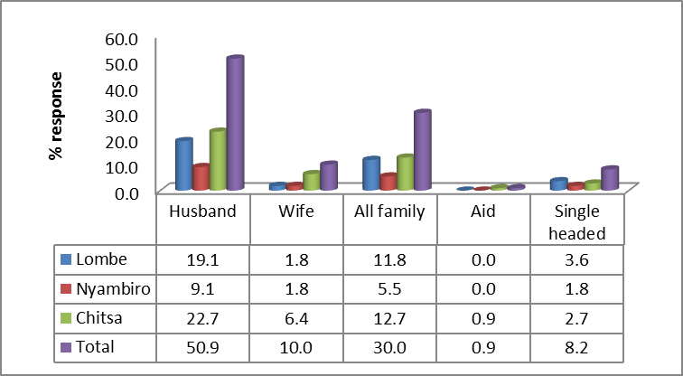
Figure 5-2 Responses on who contribute to household income
These results lead to gender roles and responsibilities when it comes to household labour distribution and generation of income. The household interviews, FGDs and observations revealed that women, men, the youth and the elderly have different roles and responsibilities in their households and communities It was noted that the responsibilities depended on cultural and religious beliefs while roles and activities were common across different cultures.
Results showed that in all the communities, men are responsible for providing the needs of the households. In some instances, such as farming, it is the responsibility of both women and men including older children But, there is a shift in the responsibilities whereby the responsibilities that were previously for men are now shared responsibilities for both men and women due to unreliability in the main source of livelihood, agriculture. Consultations at community level clearly show that women, for instance, are taking a leading role in providing household requirements in terms of food and other materials. One implication of this outcome is that it provides a picture as if women don’t contribute much to household income. This is attributed to culture as well where man is regarded as head of household and incomes generated by women is taken as that of the head of the household.
Moreover, farming activities are aligned to gender groups. Clearing the garden and ploughing are mainly carried out by men in the study areas while women are responsible for planting, weeding and harvesting. However, it was noted that all the farming activities are carried by women in female-headed households. Thus, climate risks such as late rains affect women greatly because they plant more than once.
It is worth to note that apart from roles and responsibilities that are common for men and women, women have extra roles and responsibilities such as collecting water and firewood, fetching and preparing food, household chores, taking care of children and the sick, and child bearing. The discussions also revealed that the girls assist their mothers while boys assist their fathers. In other words, the roles for men are also played by boys while girls play female roles.
The study further noted that due an increase in the demand for women roles at the household, boys in all cultures are playing roles that were mainly for girls such as cooking and collecting water. Most of the women/girls roles are carried out on daily basis and are routine activities while men’s roles are mostly demanded when need arises. The timeline during the FGDs revealed that women are engaged in one role or the other throughout the day while men have some free time in which they engage in income generating activities or beer drinking.
The results also showed that most of the women’s roles are dependent on natural resources such as water and fuel wood and hence a reduction in these affect women more than men. These findings are consistent with similar studies conducted in other developing countries (Babugura et al., 2010; Ribeiro and Chaừque, 2010; Kakota et al., 2011). In female-headed households, all the roles and responsibilities are taken by a woman and sometimes assisted by her elder children. This renders female-headed households more vulnerable when resources are scarce.
Although women are assessed as victims of climate change, this study has also found that they are agents of change. Their roles that are mainly dependent on natural resources empower them to carry out sustainable conservation strategies to lessen the burden that occurs when the resources are scarce and there was high participation of women in the CMDRR programme.
In conclusion, it be indicated that there several assets that the families are own for a normal life. These assets have low value and they are mostly for household usage. Some of the assets such as cellphones and radios could be utilized by the programme especially in sending early warning messages. Most of the assets are owned by men this calls for empowerment of women and girls. The study has also shown that the programme has contributed more to the change in the household income since 2008 and the village savings loans is the key intervention to this change. Finally, there are differentiated roles and responsibilities between different groups that the programme could consider for sustainability of the programme.

Implementation of Programme Interventions

6.1 Involvement in interventions
The impact study assessed the areas in which the communities were involved (See Graph 6.1). The results reveal that communities were involved in almost all the interventions especially Compost making, Village loan savings and growing of drought tolerant crops.

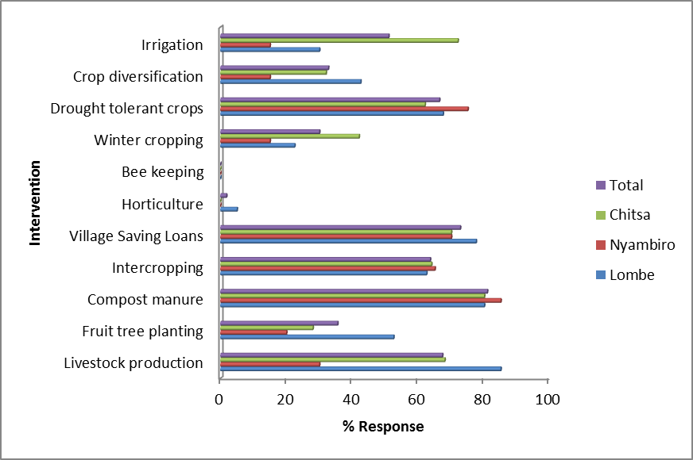
Figure 6-5 Responses on interventions undertaken under the CMDRR

The results further show that horticulture and bee keeping were not fully implemented by the programme. Overall, the programme has empowered communities with different interventions which are not requiring heavy investment for sustainability. In addition, most of the interventions are directly contributing to local level adaptation to climate change especially those in the agricultural sector. While fruit tree planting has been part of the intervention, there is need to consider more natural resource based interventions including regeneration of natural trees and promotion of local biodiversity for both food and medicine.

6.2 Conceptualization of the CMDRR
A key component of this programme was the conceptualization of the CMDRR by the communities. This conceptual framework provides the platform where communities have undertaken interventions based on the local level mapping of challenges and how such challenges can be addressed while building resilience to climate change related hazards. Figure 6.2 has the conceptual framework that was developed by the programme implementers.

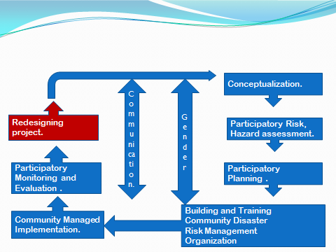
Figure 6-6Conceptual framework for CMDRR process
As indicated in the diagrammatic illustration above the framework was designed to promote the participation of the communities. In addition, the conceptual framework promotes the inclusion of gender and communication that are vital in any community set up. The framework also allowed the communities to redesign their interventions based on the emerging outcomes.

Based on the above theoretical framework, the study found that beneficiaries were highly involved in most of the interventions throughout the phases of this conceptual framework (See Table 6.1). High scores were observed on conceptualization process, identification of hazards, training in DRR and implementation of the DRR.

Table 6-7 Responses (%) on the level of involvement in the CMDRR process

Intervention | GVH | Highly involved | Partly involved | Low participation | Not involved
Conceptualization of CMDRR | Lombe | 97.5 | 2.5 | 0.0 | 0.0
Conceptualization of CMDRR | Nyambiro | 90.0 | 10.0 | 0.0 | 0.0
Conceptualization of CMDRR | Chitsa | 64.0 | 14.0 | 10.0 | 12.0
Identification of hazards | Lombe | 67.5 | 32.5 | 0.0 | 0.0
Identification of hazards | Nyambiro | 65.0 | 30.0 | 5.0 | 0.0
Identification of hazards | Chitsa | 62.0 | 12.0 | 12.0 | 14.0
DRR Assessment | Lombe | 80.0 | 5.0 | 10.0 | 5.0
DRR Assessment | Nyambiro | 70.0 | 20.0 | 0.0 | 10.0
DRR Assessment | Chitsa | 58.0 | 12.0 | 12.0 | 18.0
Participatory planning | Lombe | 62.5 | 22.5 | 10.0 | 5.0
Participatory planning | Nyambiro | 40.0 | 30.0 | 20.0 | 10.0
Participatory planning | Chitsa | 56.0 | 14.0 | 14.0 | 16.0
Participatory Budgeting and costing | Lombe | 32.5 | 5.0 | 30.0 | 32.0
Participatory Budgeting and costing | Nyambiro | 25.0 | 5.0 | 35.0 | 35.0
Participatory Budgeting and costing | Chitsa | 28.0 | 6.0 | 12.0 | 54.0
Participatory budget tracking/audit | Lombe | 20.0 | 5.0 | 37.5 | 37.5
Participatory budget tracking/audit | Nyambiro | 20.0 | 5.0 | 40.0 | 35.0
Participatory budget tracking/audit | Chitsa | 24.0 | 4.4 | 14.0 | 58.0
Training in DRR | Lombe | 67.5 | 25.0 | 2.5 | 5.0
Training in DRR | Nyambiro | 70.0 | 20.0 | 10.0 | 0.0
Training in DRR | Chitsa | 64.0 | 8.0 | 12.0 | 16.0
Implementation of DRR | Lombe | 85.0 | 15.0 | 0.0 | 0.0
Implementation of DRR | Nyambiro | 65.0 | 35.0 | 0.0 | 0.0
Implementation of DRR | Chitsa | 62.0 | 12.0 | 8.0 | 18.0
Redesigning the programme approach | Lombe | 42.5 | 27.5 | 30.0 | 0.0
Redesigning the programme approach | Nyambiro | 35.0 | 25.0 | 40.0 | 0.0
Redesigning the programme approach | Chitsa | 46.0 | 20.0 | 10.0 | 24.0
Participatory M and E and Learning | Lombe | 57.5 | 27.5 | 15.0 | 0.0
Participatory M and E and Learning | Nyambiro | 45.0 | 40.0 | 10.0 | 5.0
Participatory M and E and Learning | Chitsa | 46.0 | 10.0 | 12.0 | 32.0

There are some areas that the beneficiaries fill that there is need to improve and allow them to be highly involved. These include participatory budgeting, monitoring and evaluation, budget tracking and audit. Most of these issues were raised by communities from Chitsa GHV and the programme could target this GVH for such shortfalls. This will then entail clear identification of the interventions and joint budgeting to achieve the goals.

6.3 Level of knowledge on CMDRR

When evaluating the change in level of knowledge on CMDRR, the results (Table 6.2) shows that most of the beneficiaries did not even had the knowledge in 2008 represented by 52.5%, 45.0% and 46.4% for Lombe, Nyambiro and Chitsa GVHs respectively.

Table 6-8 Responses (%) on the level of knowledge in the CMDRR process
GVH |  | Year | High | Average | Low | None
Lombe |  | 2008 | 7.5 | 7.5 | 32.5 | 52.5
Lombe |  | 2013 | 100.0 | 0.0 | 0.0 | 0.0
Nyambiro |  | 2008 | 6.0 | 5.0 | 50.0 | 45.0
Nyambiro |  | 2013 | 100.0 | 0.0 | 0.0 | 0.0
Chitsa |  | 2008 | 0.0 | 4.0 | 54.0 | 42.0
Chitsa |  | 2013 | 92.0 | 6.0 | 2.0 | 0.0
Total |  | 2008 | 2.7 | 5.5 | 45.5 | 46.4
Total |  | 2013 | 96.4 | 2.7 | 0.9 | 0.0

The results further show that the five years of programme implementation, 100% sampled beneficiary households from Lombe and Nyambiro are now able to conceptualize CMDRR while 93.0% from Chitsa can comprehend the concept. These results were backed up by findings from both FGDs and key informants interviews. The advantage with this outcome is that the communities are able to undertake activities linked to CMDRR without the engagement of the CADECOM facilitators. This is one of the positive outcomes of the programme that could be up-scaled at district level (see also Chapter 9).

6.4 Level of skills acquired through the CMDRR programme

Because the communities were highly involved in the implementation and during the CMDRR process, the results show that they have fully acquired several skills (See Table 6.3)

Table 6-9 Responses on the level of skills acquired
Intervention | GVH | High | Medium | Low | None
DRR | Lombe | 97.5 | 2.5 | 0.0 | 0.0
DRR | Nyambiro | 85.0 | 15.0 | 0.0 | 0.0
DRR | Chitsa | 76.0 | 16.0 | 6.0 | 2.0
Technology application | Lombe | 95.0 | 5.0 | 0.0 | 0.0
Technology application | Nyambiro | 90.0 | 10.0 | 0.0 | 0.0
Technology application | Chitsa | 70.0 | 22.0 | 8.8 | 0.0
Attitude change | Lombe | 97.5 | 2.5 | 0.0 | 0.0
Attitude change | Nyambiro | 80.5 | 15.0 | 5.0 | 0.0
Attitude change | Chitsa | 68.0 | 14.0 | 10.0 | 0.0
Data collection methodologies | Lombe | 27.5 | 17.5 | 25.0 | 30.0
Data collection methodologies | Nyambiro | 15.0 | 20.0 | 35.0 | 30.0
Data collection methodologies | Chitsa | 14.0 | 10.0 | 26.0 | 50.0
Data management | Lombe | 30.0 | 15.0 | 25.0 | 30.0
Data management | Nyambiro | 10.0 | 20.0 | 40.0 | 30.0
Data management | Chitsa | 16.0 | 12.0 | 20.0 | 52.0
Dissemination | Lombe | 47.5 | 15.0 | 7.5 | 30.0
Dissemination | Nyambiro | 30.0 | 30.0 | 10.0 | 30.0
Dissemination | Chitsa | 38.0 | 16.0 | 6.0 | 40.0
Application of practices | Lombe | 95.0 | 5.0 | 0.0 | 0.0
Application of practices | Nyambiro | 85.0 | 15.0 | 0.0 | 0.0
Application of practices | Chitsa | 86.0 | 8.0 | 4.0 | 2.0

It is very pleasing to note that the communities have gained several skills in the course of implementing this programme. For example, results show that over 70% of the beneficiaries are able to undertake DRR related interventions and are able to apply and have adopted technologies introduced under this programme. The results further reveal that they are able to apply practices that they have acquired throughout the programme. As discussed above, the results clearly shows that there is still need to work towards data collection and management that can effectively feed into the M and E process.

In this regard, the programme could utilize the social learning model to make sure that data and information is collected and managed by the beneficiaries themselves or assigned field staff for easy monitoring and evaluation and continued improvement of the programme in the process achieving maximum effectiveness and efficiency.

In addition to change in skills and knowledge, the results also show that there is a change in the level of skills and attitude between the baseline and end of line status. Table 6.4 provides the responses on this change. It can be observed that the opinion of communities confirm this change in the last 5 years by almost 100% confirmation.

Table 6-10 Responses (%) on the level of change on skills and attitude between 2008 and 2013
GVH |  | Year | High | Average | Low | None
Lombe | Skills | 2008 | 0.0 | 7.5 | 35.5 | 57.5
Lombe | Skills | 2013 | 100.0 | 0.0 | 0.0 | 0.0
Lombe | Attitude | 2008 | 0.0 | 12.5 | 32.5 | 55.0
Lombe | Attitude | 2013 | 100.0 | 0.0 | 0.0 | 0.0
Nyambiro | Skills | 2008 | 0.0 | 10.0 | 40.0 | 50.0
Nyambiro | Skills | 2013 | 100.0 | 0.0 | 0.0 | 0.0
Nyambiro | Attitude | 2008 | 0.0 | 5.0 | 50.0 | 45.0
Nyambiro | Attitude | 2013 | 100.0 | 0.0 | 0.0 | 0.0
Chitsa | Skills | 2008 | 0.0 | 10.0 | 54.0 | 36.0
Chitsa | Skills | 2013 | 94.0 | 4.0 | 2.0 | 0.0
Chitsa | Attitude | 2008 | 2.0 | 14.0 | 52.0 | 32.0
Chitsa | Attitude | 2013 | 98.0 | 2.0 | 0.0 | 0.0

This is a positive development outcome especially that when communities change their attitude in the manner they approach issues; they can easily apply and implement the activities. This is also a positive outcome as it can be easily transferred to other generation vertically from old to young and horizontally from one community to the other.

Finally, the study looked at the satisfaction of the beneficiaries on the overall programme implementation. The results has proved that all the respondents in Lombe and Nyambiro and about 84% in Chitsa strongly agree that there was very good supervision from the Diocese and over 80% also strongly agree that seed money and inputs were provided by the programme. Other interventions that were fully appreciated by the communities include exchange visits, provision of different training programmes, conducting community meetings, compost making, reviewing of hazards and re planning of the interventions.

In summary, this chapter has provided some of the responses from the communities and other key informants and shows that the programme has changed several issues since 2008. The observations on the ground and focus group discussion further support that the CMDRR interventions have contributed positively to the livelihoods of the communities. There is evidence that skills, knowledge and attitude have changed among the communities and this will very likely contribute to the sustainability of the programme. The programme designers could also try to promote social learning models to make sure that the beneficiaries are collecting data and also participating in the monitoring and evaluation of the programme.

Community Capacity Building

Summary
The chapter provide the changes that have come due to the impact of the programme’s training and capacity programmes. We look at the effectiveness of the approaches, and then the type of the trainings received. The impact is looked at both at individual and community levels.

7.1 Capacity building approaches and training provider

Findings reveal that the programme generally used group mapping more (38.1%) than any other approach. This was followed by Reflect (36.4%) and classroom and community workshops (32%) each. Within the GVH, the results show that Reflect was still an effective way of imparting the knowledge to communities within Lombe (50%) and Nyambiro (40%)

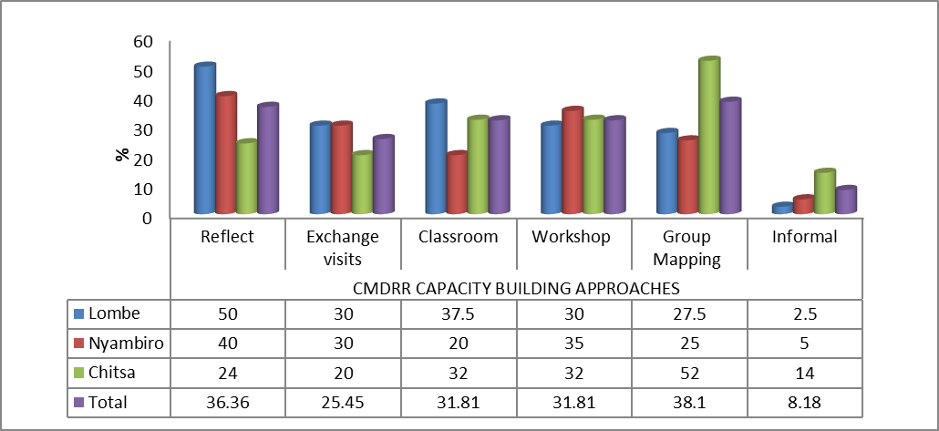
Figure 7-7 Responses (%) on the type of approaches used in building the capacity of beneficiaries

The first two approaches promote community participation and more local knowledge and sharing or experiences are also encouraged. Group mapping also provide the opportunity to handle other challenges faced by the communities including those that affect health, education, natural resource destruction, social challenges that cannot be all handled in a classroom approach. For future programme, several informal learning approaches could be utilised including social learning models that encouraged including paring households between GVH who can spend a day or two together sharing experiences.

The findings have further showed that CADECOM were the main providers of the training in all the GVH followed by the official from government (see Graph 7.2). This type of blending brings changes at community level based on different approaches and experiences of training providers.
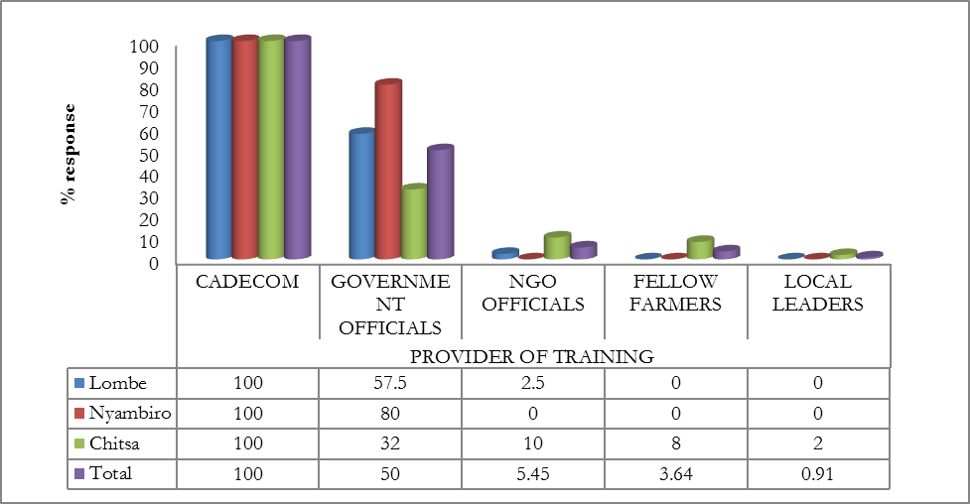
Figure 7-8 Responses (%) on those that delivered training programmes

The future programme could consider joint planning and delivering of such programmes with partners from other organisations including from the universities and colleges and other research institutions. The model of producing specific households to take lead in training programmes could also be explored. Such households could be identified as lead households and this could use the same approach as one used in identifying lead farmers who help deliver messages and give technical advice to fellow “junior” or ordinary farmers. This could also help reduce the costs incurred on human resource as such lead households could work on voluntary bases.

7.2 Type of training received
The study further looked at the type of training that these communities received to link to the impact of the interventions. Graph 7.3 show that on average, issues of agriculture and livestock took centre stage (90%).

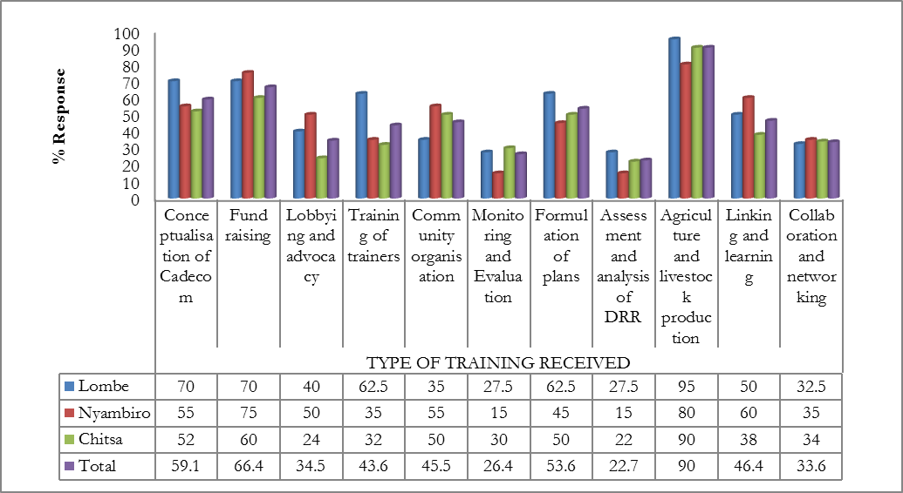
Figure 7-9 Responses (%) on type of training received
The graph further show that fund raising (66.4%) as an issue of sustainability was considered by the beneficiaries as one of the key issues they have learnt. One critical observation is that the communities are able to formulate plan (54%) unlike the situation when the programme was being initiated in 2008 (CADECOM, 2008). However, an issue of participatory Monitoring and Evaluation has not coming out very clearly among the responses. This also entails that future programming could consider this issue and bring new approached in achieving the goals. This has to be linked to data collection and organise a specific course on monitoring and evaluation, this will allow collection of relevant data by the communities to feed in the redesigning on the interventions.

7.3 Impacts of training programmes at household level

Based on the approaches, type of training and institutions that delivered the study has revealed that these three things have several impacts at different levels. Firstly, it is very clear that households attribute to this intervention to clear conceptualisation of the DRR concept where according to Graph 7.4 shows that (98%) increased understanding of human rights and gender issues (97%).

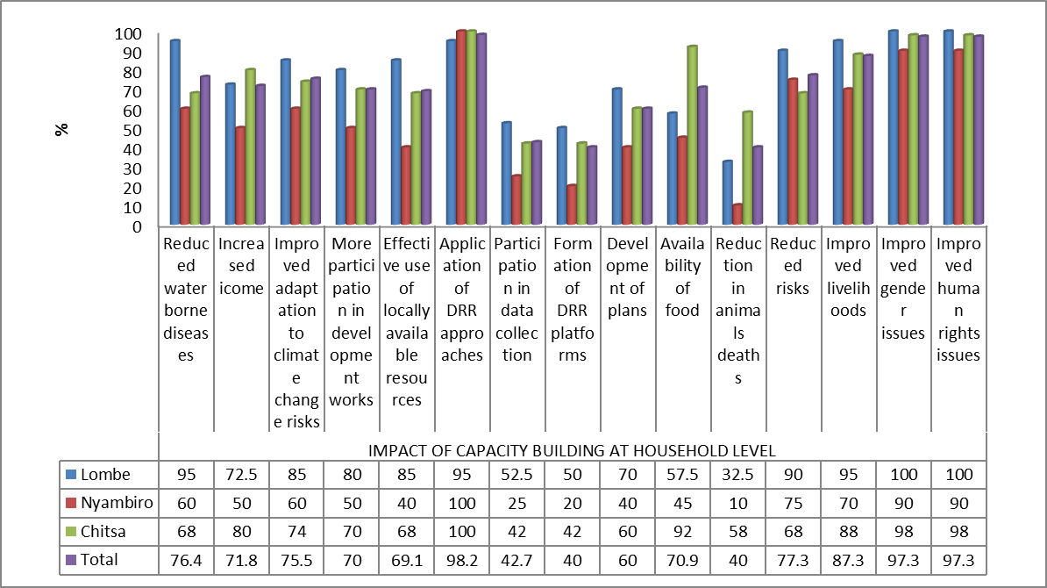
Figure 7-10 Responses on the changes that have occurred due to the capacity building programmes
Other areas that the communities have appreciated due to the training interventions include: improved livelihoods (87%) reduced water borne diseases, reduced climate change related risks (76%), improved adaptation to climate change (75%), increased income (71%), improved participation in development issues (71%) and availability of food (70%). Despite that the impact study did not look at the control or comparison group, these findings can be concluded that the diffusion effect have resulted in more people around these beneficiaries to benefit from the interventions. For example, the GVH Lombe indicated that several local leaders have been mimicking what his people have been doing to improve their livelihoods. However, there are areas that future programming could consider especially issues of data collection which is directly linked to the level of training that they received. In addition, training in relation to animal health in general and specifically to production could also given enough attention.

7.4 Impact of programme at community level

The impacts of the programme that have been observed at household level, have also been clearly been observed at community level (See Figure 7.6). The results show that all the respondents confirm that the programme has improved rural livelihoods in general.

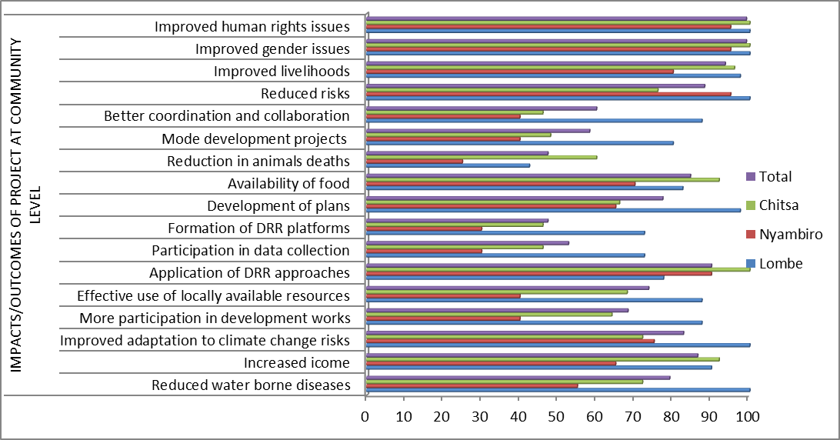
Figure 7-11 Responses (%) on the perceived impact of the capacity building programmes at community level
In addition, the results further show that they are able to apply the concept of DRR approaches and it has also helped to improve their capacity to adapt to clime change including managing risks associated with climate change.

Looking at new interventions that the beneficiaries have learnt due to the programme, Graph 7.7 clearly shows that the beneficiaries are able to protect themselves from disasters that are directly linked to climate and weather variability (94%). Apart from this protective outcome, responses further show that the programme has brought new agricultural related technologies including that of conservation agriculture (94%) and growing of tolerant crops (88.2%) that are important to promote local level autonomous adaptation.
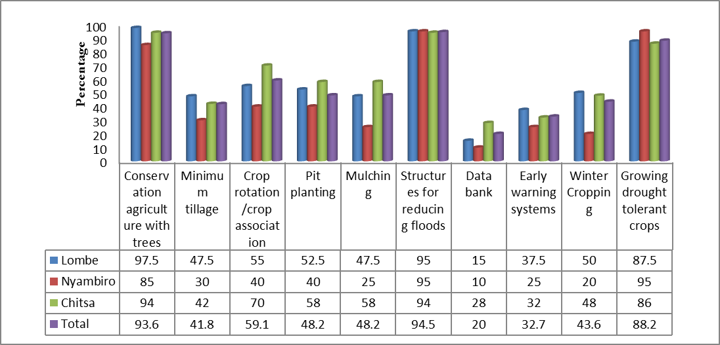
Figure 7-12 Responses on the new things that they have learnt through the programme
Within the same sector, respondents (59%) indicated that they are able to practice crop rotation and winter cropping (44%). The promotion of drought tolerant crops is of important noting that previous studies have shown that the two districts have been facing problems including prolonged spells and that residue cropping has been affected.

The transfer of skills, information to other beneficiaries an control groups is important not only for sustainability of the interventions but also for sharing the knowledge and skills. The results (Graph 7.8) shows that on average, community meetings (86%) was the main pathway of transferring skills followed by demonstrations (64%).

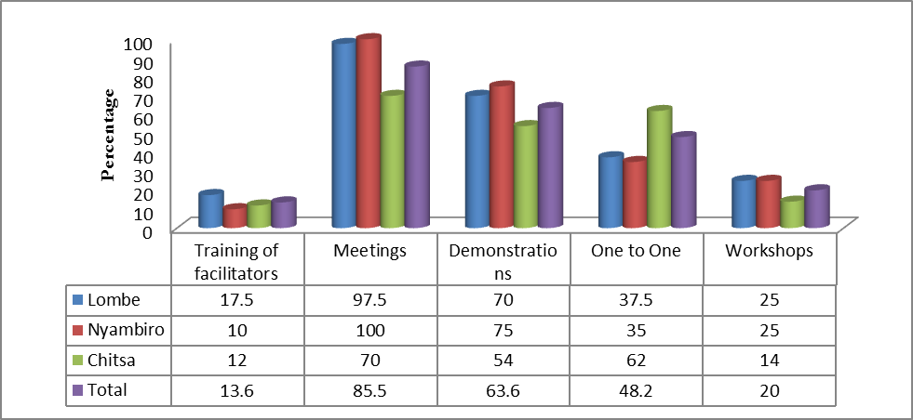
Figure 7-13 Responses (%) on pathways to transfer skills

The advantage of these pathways is that they promote social interaction and sharing of experiences among different groups of people. Future programming could consider the village to village replication of the interventions and identifying both control and beneficially treatment.

In conclusion, the study (without looking at the control clusters) shows that the programme has brought several changes through the capacity building programme. If we look at the counterfactual situation (areas that did not receive interventions), the impact area could have more problems associated with climate change risks and hazards and few technologies could have been introduced. This could further result in community vulnerability including poverty and health related challenges. Observations clearly show that some of the villages that were not targeted have low capacity in managing hazards and disasters. Finally, the results show that the CMDRR programme has brought several impacts including resilience of the communities and improved livelihoods. There is clear change in attitude, skills and knowledge among beneficiaries on issues related to DRR

Knowledge management and documentation

8.1 Extent to which programme imparting knowledge on DRR
The study weighed the opinion of the beneficiaries (where a score of 1 was strongly agree and 5 strongly disagree) on whether the programme has imparted knowledge on DRR. Figure 8.1 clearly shows that the interventions undertaken under this programmes have imparted knowledge on DRR among the beneficiaries.

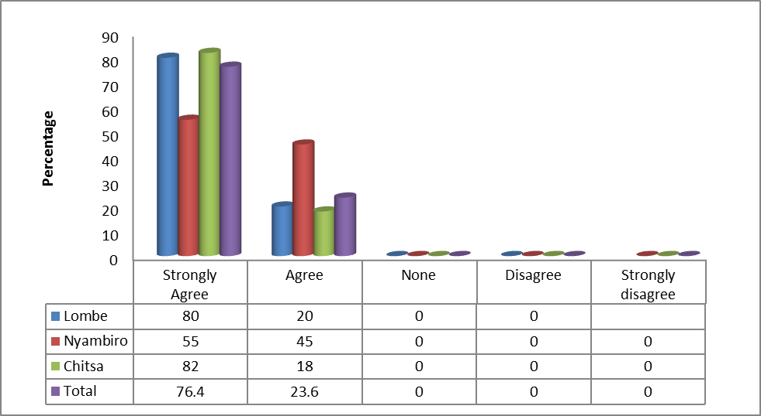
Figure 8-14 Responses (%) on whether the programme has imparted knowledge on DRR
For example over 80% from Chitsa GVH and 80% from Lombe indicated that they have improved their knowledge on the concept of DRR because of the programme. Even though the responses from Nyambiro was low (55%), FGD revealed that the communities have more knowledge now as compared to 2008. This outcome, was further backed by change in behaviour of communities who showed that they has skills in identifying early warning signs of climate change related hazards

The study has further found that for the communities to have such confidence in the change of their levels of knowledge, several approaches were taken by the programme to transfer several skills to the beneficiaries (See Figure 8.2). The results show that establishment of social clubs was one of the critical intervention that yielded this outcomes (92% responses).

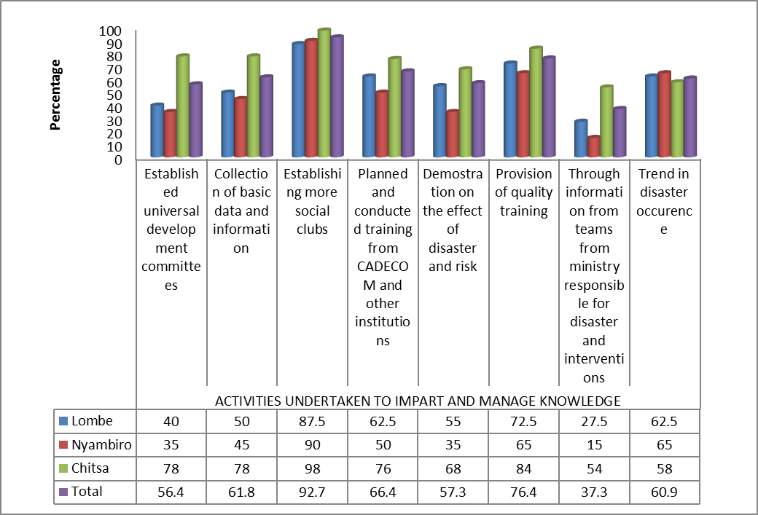

Figure 8-15 Responses (%) on approaches taken to impart knowledge and skills to beneficiaries
The figure further show that provision of quality training (76% responses), integrated planning and delivery of training programmes with other partners (66.4%) and demonstrations on the effects of disasters and risks (57.3%) were considered as good practices in transferring skills. All these outcomes are mostly being appreciated because of the partnerships as well as participation of the communities. Since there are variations among the three communities, future programming could engage those that have more skills to support those that have low capacity. For example on the processes of establishing committees, communities can learn from people of Chitsa.

8.2 Data and records being managed by communities
The programme incorporated several approaches in order for the communities to collect different data. Collection of data is a very key process that can provide several indicators to monitor and evaluate the progress of the programmes at all level. In this study, like many other findings at community level, there is low level participation of communities to collect the data.

Figure 8.3 has findings on the type of data that was being collected and shows that only 43.6% managed to collect crop related data followed by those that engaged in livestock data (36.6%). The results further show that data on disaster occurrence (37%), population (25%), weather (14%) and natural resources (8.2%) received very little attentions.
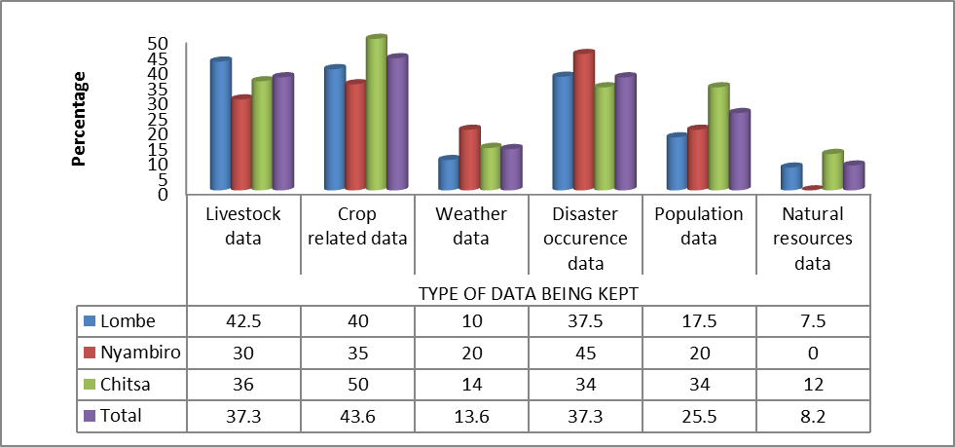
Figure 8-16 Responses on the type of data collected by communities
Noting that data is very critical for making several decision including revising intervention goals, future programme requires to have social learning model that shall promote data collection at household and community level. In this regard, formation of information hubs could be considered and that deliberate training could be designed on data collection and management.

8.3 Training and documentation process
The beneficiaries were asked to rate the quality of training provided to them by the programme (See Figure 8.4). The results show that on average quality of training was rated very highly by the respondents.

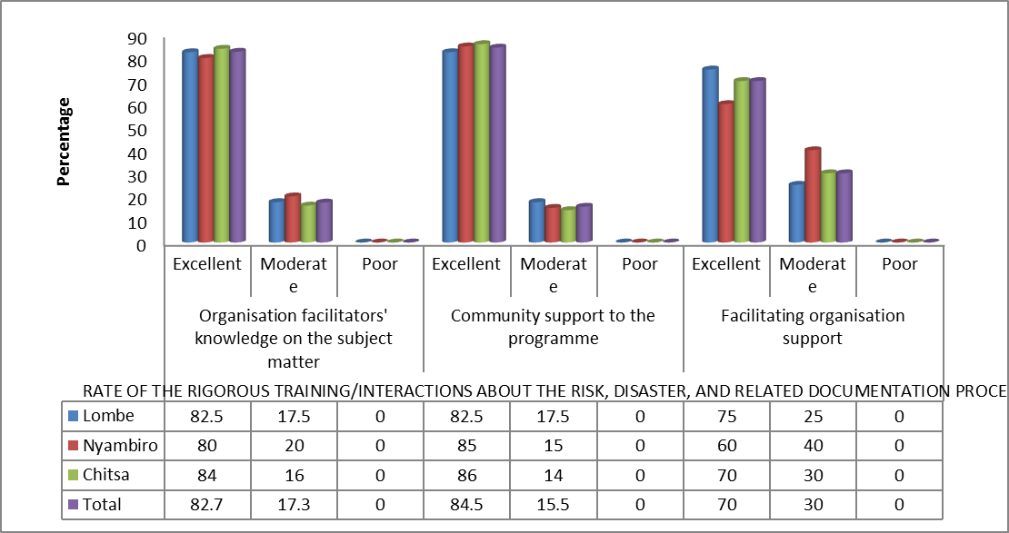
Figure 8-17 Responses on the quality of training
This rate covered the knowledge of the facilitator’s on the subject matter (83%), community support to the programme (85%) and support from the programme (70%). The immediate impact of such outcome is that several challenges such as low level of knowledge on DRR are easily achieved.

Focus group discussions further revealed that the trainings were being attended by all social groups and in particular women. This is a very interesting outcome since it is directly linked to programme sustainability. Future programming could further consider unveiling traditional knowledge that can further be documented and incorporated with modern issues to generate hybrid knowledge.

The impact study also looked at several issues linked to the training programmes and findings are presented in Graph 8.5). These results provide a clear picture that all the issues related to the delivery of training programmes were impressed by the communities. For example, involvement of participants (80%) and quality of training material (75%) were rated excellent by the respondents, while the training environment was also scored highly by almost 80% of the respondents.

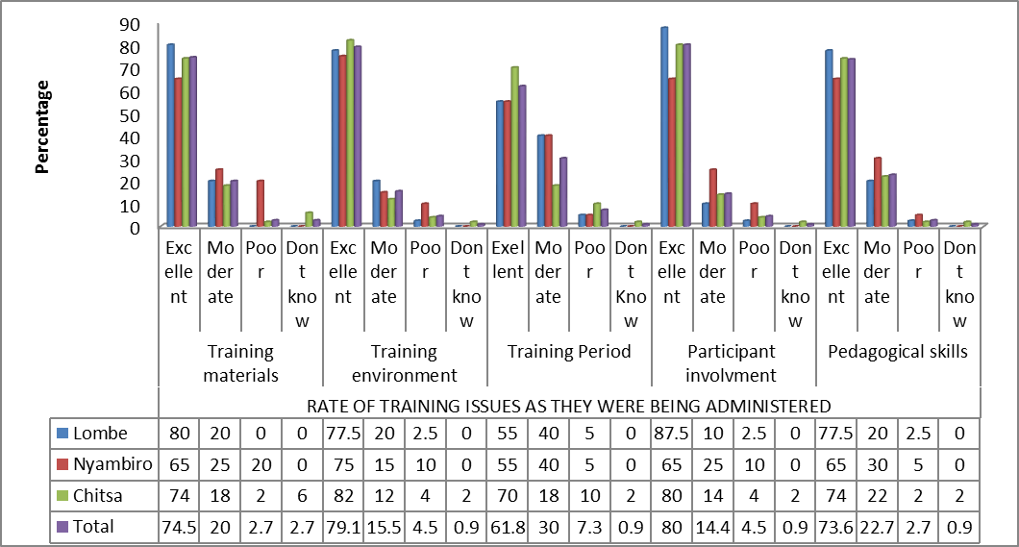

Figure 8-18 Responses (%) on issues related to training programmes
In addition, high scores were observed on training period (62%), and use of pedagogical skills (74%). These results shows that capacity building programmes when handled in a participatory process could yield into better results. This is why the local leader from Nyambiro said:

CADECOM used better approaches to change our behaviour in several areas including food production, raising income and protecting our natural resources. They have been with us and training us like young people. One good thing, they also utilised some of our way of thinking in the delivery of their programmes.

Further assessment showed that because of this approach of working and involving communities, there are several impact indicators that are exclusively and inclusively alluded to the programme. It is very clear that some of the interventions that are show cased are as a result of the CMDRR programme. The programme has been providing support to the agricultural extension systems. Figure 8.6 provide evidence that CADECOM extension workers were very supporting rice growing farmers.

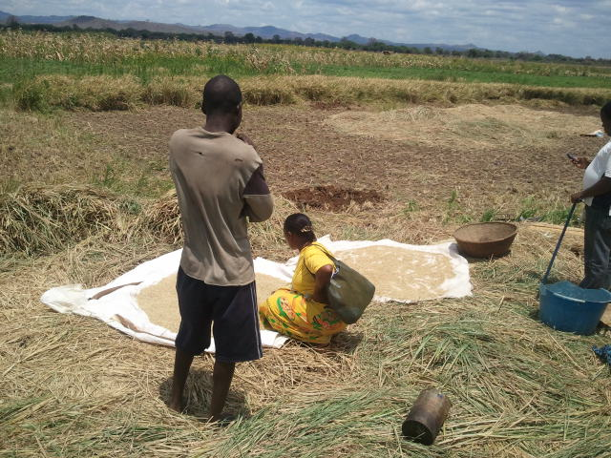

Figure 8-19 CADECOM Extension Worker checking moisture for proper storage to avoid post-harvest loses

The owner of this plot said: Previous, we were not provided with timely extension services on several practices. But under CADECOM, most of agricultural interventions are being facilitated by their extension workers who are mainly from within the communities.

Some of the indicators include the woodlots that have been established with support from the programmes. Figure 8.7 has such a woodlot that has been established as a flood control structure as well as source of shed and firewood. Some of the products from this woodlot will be used to feed their livestock.

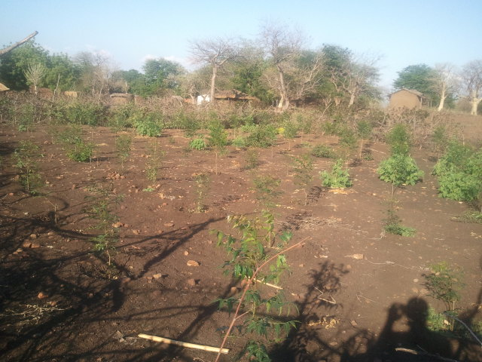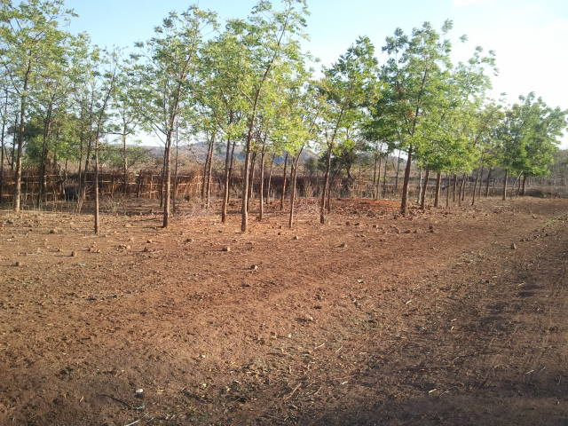

Figure 8-20 Samples of Woodlots at household level

One of the beneficiaries said:
These trees over time have reduced the impact of strong winds on our houses and the amount of dust has also been reduced. This has saved our incomes that we used to repair houses and even air pollution related diseases have been reduced.

Further assessment has shown that at house hold levels, the impact of knowledge management have empowered people to understand better techniques in food preservation, improved knowledge to differentiate variation among varieties of the same seeds in terms of better survival rates in conditions where rains do come in short supply. In this case, the development have resulted in community look for crops that do benefit them other that the standard one like maize which in most cases have some low propensity to withstand extensive dry spell. Among the crop that the knowledge bases have enlighten the communities to advocate includes: Millets, Sorghums, Ground nuts and Chitowe.

The study has also shown that the introduction of community extension volunteers enhanced their knowledge on several issues. These volunteers were not only given para-formal training in disaster risk reduction strategy but were also e given extensive exchange visits for them to appreciate how similar interventions is provided in other areas in the region.

Because of the purification of organisations working in the same impact areas, there is need to closely monitor the spill over effects. However, due to the training that CADECOM is providing, one female beneficiary said.

Goal Malawi, is implementing similar disaster risk reduction program. In their program, they have given goats to people in Nsanje district. This is in the same village that CADECOM is implementing CMDRR programme. As such people in the village do compare the incentives and supports that the organisation (CADECOM) provides thus concentrate their attention in the organisation’s interventions that they seem to benefit a lot.

However, there are some interventions by the other organisations that are affecting some areas of the programme. For example a village headman in Chikhwawa said:

Lutheran Church is implementing a Village Savings Loans scheme to the community where CADECOM is conducting the CMDDR programme. The CMDRR programme could have introduced agri-business entrepreneurship knowledge that is aimed at empowering communities to operate viable businesses. As such people within the community are getting loans under pressure from other communities and are failing to manage the loans. We have seen that that a lot of the people in the village have their houses and properties taken away due to their failure to repay the loan.

In this regards, there is therefore need to develop agri-business entrepreneurship rural prone course with the aim of empowering the rural communities in the business and loan Management. In addition, the need to jointly plan some of the interventions with the other NGOs could also help to reduce these effects.

8.4 Extent to undertake activities related to CMDRR
Further assessment has revealed that the communities are able to undertake several activities that are associated with CMDRR. Table 8.7 shows that communities from Lombe, Nyambiro and Chitsa are able to facilitators and other communities with 97.5%, 85% and 70% responses respectively.

Table 8-11 Responses (%) on the extent to undertake activities related to DRR
Variable | GVH | Very competent | Average capability | Low capability | Lack of capability
Training of facilitators and communities | Lombe | 97.5 | 2.5 | 0.0 | 0.0
Training of facilitators and communities | Nyambiro | 85’0 | 5.0 | 10.0 | 0.0
Training of facilitators and communities | Chitsa | 70.0 | 18.0 | 0.0 | 0.0
Participatory disaster risk assessment | Lombe | 77.5 | 10.0 | 10.0 | 2.5
Participatory disaster risk assessment | Nyambiro | 75.0 | 25.0 | 0.0 | 0.0
Participatory disaster risk assessment | Chitsa | 62.0 | 28.0 | 6.0 | 4.0
Formulation and implementation of development plans | Lombe | 75.0 | 15.0 | 5.5 | 5.0
Formulation and implementation of development plans | Nyambiro | 65.0 | 35.0 | 0.0 | 0.0
Formulation and implementation of development plans | Chitsa | 60.0 | 18.0 | 16.0 | 8.9
Community organisation | Lombe | 80.0 | 17.5 | 2.5 | 0.0
Community organisation | Nyambiro | 65.0 | 25.0 | 10.0 | 0.0
Community organisation | Chitsa | 64.0 | 27.0 | 8.0 | 6.0
Community managed M and E, documentation and learning | Lombe | 82.5 | 10.0 | 7.5 | 0.0
Community managed M and E, documentation and learning | Nyambiro | 60.0 | 15.0 | 25.0 | 0.0
Community managed M and E, documentation and learning | Chitsa | 40.0 | 30.0 | 20.0 | 10.0

The table further show that on average, over 60% are able to formulate and implement development plans with more responses (75%) coming from Lombe Village. However, responses from Nyambiro show that there still some groups of people that require more interventions on developing plan. One critical finding is that the communities are very much competent to undertake participatory disaster risk assessment with more responses coming from Lombe GHV (77.5%).

8.5 Progress attained under the CMDRR

The impact study has shown that most of the areas where the programme was implemented have experienced tremendous agricultural initiative aimed at catering the effect of disaster in the area. For example, the communities are now using wood saving stoves that have reduced deforestation. Figure 8.9 show the CADECOM extension worker and a rural woman illustration firewood saving burner in Chikhwawa district.

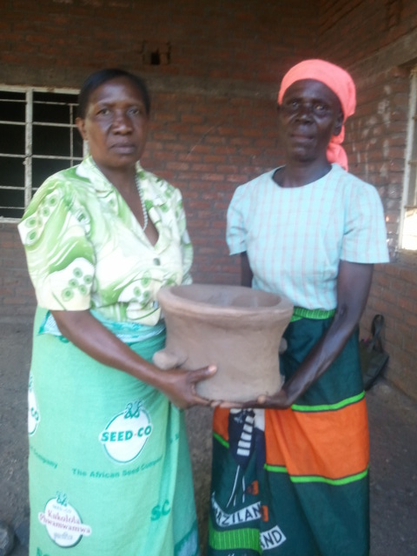

Figure 8-21 CADECOM extension worker proudly present a stove to a woman beneficiary

Before this technology was introduced farmers were using a pile of firewood per week and that women were going to fetch for firewood two times a week. This situation resulted in a lot of farmers’ compromise in their agricultural initiatives. This resulted in farms not been prepared in time and accelerated rate of deforestation. This burner has resulted in reducing the time to fetch fire wood twice a month. As such farmers are free to interact and participate in CMDRR and other related programme.

The Programme of CMDRR taught farmers a lot of initiatives. Some of them are extensive planting of trees. For example several trees have been plated to reduce deforestation. This initiates extents to their residential areas. This has resulted to instil discipline among the communities to become more conscious about the danger of deforestation. Before the project was introduced in the area, a lot of beneficiaries hardly had trees due to lack of knowledge about the danger of extensive cutting down of trees and change in climate.

Figure 8.10 shows the house that farmer built following retain from the agricultural farming in Nsanje district. The farmer use irrigation farming in times when the normal rains stops. The development is feasible because the farmers do get proper husbandry practice from the extension worker from CADECOM and Government.

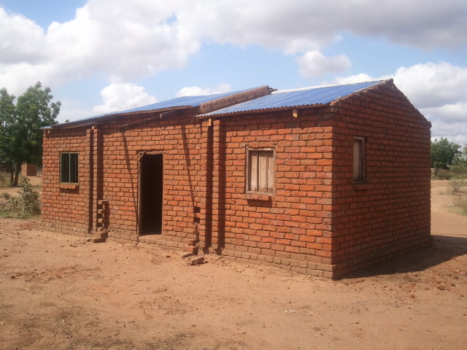
Figure 8-22 A house that is being constructed with incomes from an agricultural intervention promoted by CADECOM

The farmer got an inspiration to do extensive irrigation agriculture from the incentive that the farmers receive in the form of treadle pump from CADECOM. Reportedly due to large number of farmers in the area, there are very few treadle pumps to support more than 150 household in the district. Close range questions response pointed out that the communities could have done better yield wise if more treadle pumps were available and handy to support this summer farming.

In conclusion, it can be indicated that the need to impact knowledge to beneficiaries and proper planning of training programmes has a very big impact on both medium and long term goals for development. Within this issue, there are several best practices that the programme has introduced at community level that can easily be up-scaled and be replicated (see Chapter 9). However, lack of collaboration and networking among development partners can results in negative impacts of the community based interventions.

Best Practices

9.1 Community conceptualisation of the CMDRR

Since 1994 CADECOM has been implementing food security programs in a number of districts in Malawi. Despite these programs being in place communities continued to face problems of hunger. After conducting several studies it was revealed that most of the communities were lacking capacity to respond disaster. The main question asked was why disasters throughout the year? It was against this background that CADECOM introduced Community Managed Disaster Risk Reduction (CMDRR) framework.

The introduction of this framework was regarded as a useful tool because it encourages communities to take a leading role in coming up with solutions to reduce impacts brought by disasters. This ensures that community’s capacity are strongly built and therefore become more resilient to disasters. In order to increase community participation in CMDRR community members were given a role to understand and rectify hazards, characterise them and at the end draw up working plans.

Staff trainings were conducted with an aim to equip them with knowledge in CMDRR. The training included both local and international trainings. On international training staff attended trainings in Ethiopia, Uganda and Kenya and later on trained their Malawian counterparts. The training covered issues on understanding disasters, response and preparedness just to mention a few.

For the concepts to be introduced successfully inputs like knowledge and training materials were used. Much of the knowledge came from community members and the trainers used locally available materials for demonstrations. At each stage the participants were encouraged to participate. One of the assignments which they were given was to do a proper hazard assessment especially for those hazards that greatly affect communities. This encouraged the communities to be able to identify what they felt were a great hazard to them. This made the participants to become convinced that they can change their livelihood and they understood the type of hazard that they were dealing with. This gave them the courage that they could stand on their own without external support hence reducing their level of vulnerability to disasters. About 22,800 people participated in the CMDRR.

  - Effective engagement of community Extension Volunteers

Despite the good outcomes from CMDRR there was a challenge of lack of extension workers especially from government side hence the use of extension multipliers from CADECOM who were not enough. In order to deal with the problem lack of extension workers, extension volunteers from the communities were identified by the extension multipliers. These were identified through observations depending on their level of interest in the program, those who commanded respect and those who were able to deliver. The selected individuals were trained through formal trainings and participated in review meeting. They were also mentored by attaching them to government and CADECOM extension workers. The information was generated from them through interviews and face to face discussions. The information generated was further transferred to others through demonstrations.

There are changes that have been observed at both household and community level. These include: Improvement in understanding the techniques in dealing with disasters through the understanding of concepts, increase in food security, increase in income and level of vulnerability to disasters has reduced and resilience has increased

  - Designing and delivery of training programmes in DRR

The problems were identified through participatory analysis and modules were produced through consultations with the communities and technical people. The communities were given case studies of other communities who experienced disasters but through DRR they were able to deal with the problems. Formal and informal trainings were used as forms of module delivery. This was through village meetings and demonstrations using locally available materials. The modules contained information such as: understanding of key terms and concepts; critical assessment of hazard, vulnerability, capacity; analysis of DRR concept; community action plan and mobilisation; and advocacy.

Local knowledge and best practices was documented. Social norms like cultural beliefs the was respected during the trainings in order to prevent conflict, however where community programs were in existence these were used as platforms for conducting trainings . The cultural beliefs also helped to identify the best practices in dealing with disasters. CADECOM works in collaboration with CISONEC and Malawi Vulnerability Assessment Committees (MVAC).

  - Pedagogical Learning Approaches
Social learning platforms during the training included reflect circles, mapping, clubs and village development committees which were formed in a participatory manner. Everybody participated in these platforms depending on the themes which they were undertaking. These platforms were used to share information like best practices which lead to an increase in crop yield.

Approaches can be up scaled by identifying rightful interventions for instance making communities identify on their own what they feel is the main problem in the area. The participants should be provided with knowledge and necessary resources.

  - Community data management
The main problem with community data was that communities don’t have proper documentation of data as such there is need to come up with good strategies like participatory training, monitoring, learning and evaluation so that through this communities are able to document their problems. This helps to obtain data such as hazard, frequency of occurrence, impact on livelihood and best practices. The data is collected by communities who are facilitated by extension workers. The data collected is used to inform future programming and advocacy. Tools used to collect this data was inform of data collection form which is developed at community level and later goes to parish then diocesan level. To effectively use the data at community level there is need for proper documentation and then sharing of data with local leadership.

- Conclusion and Recommendations

The findings of research are concluded and recommendation provided. The chapter also includes some of the suggestions for future programming.

10.1 General conclusions
In conclusion, the impact study has found that when the capacity of communities is enhances with well-designed and conceptualised interventions can increase their resilience. It is very clear that the concept of CMDRR that entails bringing people together within the same community to enable them collectively address common disaster risks and pursue common disaster risk reduction measures has been well received in the impact area.

The interventions have been undertaken in areas that are very vulnerable to climate related risks but these have been contained for improved livelihoods among all the social groups. It can also be conclude that demographic characteristics show that the household size are very high that can also lead to negatively impact the outcomes of the interventions.

The findings further provide a clear picture that some of key themes that were part of the programmes including community participation, capacity building, lobbying and advocacy have been undertaken by the communities with minimal CADECOM supervision. In terms of household assets, it can be concluded that there was no direct link between acquisition of assets and the programme interventions. However, there is evidence that some of the assets have been acquired because of the programme. Further observation is on the main sources of income. It was observed that though issues income generation and household income were not a priority in the programing most households have improved their income status because of the interventions. Results further reveal that husbands are the main contributors of household income in all the study areas.

The study has further revealed that the communities were highly involved in the implementation of the programme activities starting from the conceptualisation of the programme to revisiting the intervention objectives. This has allowed the level of knowledge to improve but also for the beneficiaries to have better skills and also change their attitude towards DRR issues. Some of these skills have been transferred to other communities.

The impact study clearly shows that the capacity building and training programmes were well designed delivered and evaluated. The approach to have other stakeholders participate in the training programmes and to involve the communities in designing the training programmes was also regarded as one of the effective approaches to empower the beneficiaries. Because of these well designed training programmes, there is empirical evidence at both household and community level in terms of improvement of livelihoods, including local level adaptation to climate change and weather variability, reduced water borne diseases, application of DRR concept and availability of food.

Finally, there are some areas that need to be improved and require redesigning for more success stories. The critical areas for consideration include data and records management. The process of documentation and participatory budgeting and auditing of programme intervention has also been regarded as the most challenging among them interventions by the communities.

10.2 Specific recommendations and programme consideration

- Based on several socio-demographic characteristics, the programme could consider introducing interventions that will address issues of population and natural resources management. In this regards, issues of family planning and other health related interventions could be included in the programme. There is need to raise awareness on the impact of population growth on resources in areas that are vulnerable to climate change impacts. Explain the relationship between population growth and vulnerability to climate change. Education programmes must provide solutions to the increasing population and link this population growth to demand for natural resources such as trees for fuel wood and timber increase. The more resources we extract with result to increased vulnerability.

- Several social-learning models could be considered in the delivery of capacity building programmes cite examples of the social leraning models i.e. exchange visits or model/lead farmers . As such, programme interventions could consider empowering families, individuals or clubs to provide training in other communities. This could involve staying for few days interacting with their counterparts whilst sharing knowledge and skills.

- We further recommend that development of district plans must be done in partnership with the district officials as the first phase before the engagement of the communities. This will allow the CMDRR programme to contribute effectively to the achievement of district development goals. In addition, there is a need to form partnerships with other organisations working in the impact area to avoid duplication of efforts and waste of resources. Development of district development plans should start from the community i.e. identification of development issues to be incorporated into the district development plans should come from the communities. The District officials should only consolidate these development issues identified by the communities. In addition, the district development plans should have clear resilient building strategies i.e. through mainstreaming of community managed disaster risk reduction and climate change adaptation and mitigation strategies

- Future programming could also consider introducing pedagogical or informal education interventions to reduce illiteracy rate which is very high in both districts. There is need to engage University graduate volunteers who could deliver adult literacy training programmes at community level. The advantage of this approach is that the graduates act as role models to both adults and school going children. In addition, students from one village could be used to provide training programmes in another village through social learning approaches. Illiteracy rate should only be linked with adoption rate of resilient building interventions or research findings. Resilient building is all about increasing the capacities of the vulnerable households so that the associated risks are reduced

- The programme could be designed as a business model that addresses social, environment and economic challenges faced by the communities. There is need to provide incentives that can be linked to DRR whilst increasing household income. Small and Medium Enterprises (SMEs) could be introduced after attending comprehensive business trainings and undergoing vocational training that promote off-farm community industries. I agree with the idea of entrepreneurship. However, other strategies such as village savings and loans associations which do not depend on financial incentives need to be promoted. In addition, entrepreneurship culture needs to be promoted and there is need for capacity building on the same.

- Interventions that could increase household assets could be included in the programming of the interventions. This could begin with improved assets that promote irrigation framing including solar powered irrigation interventions. Asset base could also be enhanced through semi-intensive livestock production that integrates crop production. Deliberate development of extension messages could be put in place in collaboration with relevant stakeholders. Targeted vulnerable households need to diversify their livelihood strategies i.e. a combination of agriculture related, entrepreneurship and other resilient building interventions could ensure that the households assets do increase and the same are protected

- Some of the communities have adopted the concept of CMDRR more than others. These could be considered as CMDRR community volunteers who could form specific groups for up-scaling the concept. Special training interventions could be provided to the volunteers so that the up-scaling of the concept is fed into the district development plans. There is need for more learning among the communities so as to have a multiplier effect of the adoption of the CMDRR concept, principles and practices

- The programme could consider establishing information transfer notes at village and community levels such that the interventions are easily supported by the district management structures. Within these nodes, there is need to provide critical interventions that will promote effective collection of data and information and management. The identification of data holders and delivery pathways could be considered through the use of mobile phones, note books and wherever possible use of solar powered computers. In addition, there is need to establish communication structures from the Village Civil Protection Committees to the Area Civil Protection Committee and then to the District Civil Protection Committee

- Future programming must consider participatory budgeting, auditing and procurement of resources. This could be achieved through the identification of community Monitoring and Evaluation volunteers. Joint monthly meetings at district level in collaboration with officials from the Diocese, government and CADECOM could be encouraged to transparency and accountability. Training in budget and budget tracking will be required in the future phases of the program. This has to be supported with efficient and effective monitoring and evaluation system in place. Government departments and Non-Governmental Organisations working in the District need to open up to allow tracking of the financial resources meant to contribute towards resilient building of the communities at the district level .

- The programme has several best practices that could be up-scaled. We recommend that a special programme should be funded to document the process of these best practices through videos and be shared with other stakeholders. These documentaries could be in different languages for wider application. Some of the best practices include small scale irrigation, livestock pass on scheme, environmental rehabilitation through afforestation, early warning systems for floods and village savings and loans associations

- Finally, we recommend that the programme could consider the conceptual framework proposed in this report when introducing new technologies at community level. This recommendation is based on several interventions that the programme is promoting. Our argument is that the proposed conceptual framework (see Appendix 7) may be followed to support adaptation to climate change in the agriculture and natural resource sector.

References
CORBIN, J. & STRAUSS, A. L. (1990) Grounded theory research-procedures, canons and evaluative criteria. Qualitative Sociology, 13, 3-21.

CADECOM (2012) Disaster Risk Reduction progress report for November 2011 to June 2012. Cadecom Secretariat, Lilongwe. Malawi

CADECOM (2011) Disaster Risk Reduction progress report for May 2011. Cadecom Secretariat, Lilongwe. Malawi

GLASER, B. G. & STRAUSS, A. L. (1967) The discovery of grounded theory: strategies for qualitative research, Chicago, USA, Aldine Publishing Company.

Appendices

Appendix A1: Brief information on tools used to collect information

Checklist for document review
A checklist for document review was developed (Appendix 1). The checklist contained several pieces of information including: the source of the document, type of the document (work plan, Guidelines, Manuals, Strategies, reports, among others), level of issues (international, national or district or local), scope of information and linkage to the current assignment. Most of the documents were provided by the client.
Checklist for Programme Support staff
A checklist was developed for data collection at national and district level. The checklist Appendix 2 was used to collect information on programme implementation, impacts, coordination, integration, best practices, contribution to policy and national strategies, changes in livelihoods and associated resilience. Further information covered the extent to which the CMDRR approach has contributed to building the resilience of the communities, validation of climate related hazards and risks, and identifying models that can be implemented to further increase the resilience of the communities and how has the capacity building approach contributed to the programmes progress.
At Programme Support Unit, the approach was through (i) expert meeting and (ii) individual interviews with those directly involved in the implementation of the programme. Some of these members of staff were consulted at district level. Within the district, interviews were conducted with government officials, local leaders, officials from the Diocese and those from other organisations.
Checklist for Focus Group Discussions (FGDs)
A checklist was used to facilitate focus group discussions (see Appendix 3) with women, men, youth and the elderly. In total, 2 FGDs were conducted per district. The first was at Tidzi Village, TA Tengani in Nsanje and the second was undertaken in Chikhwawa
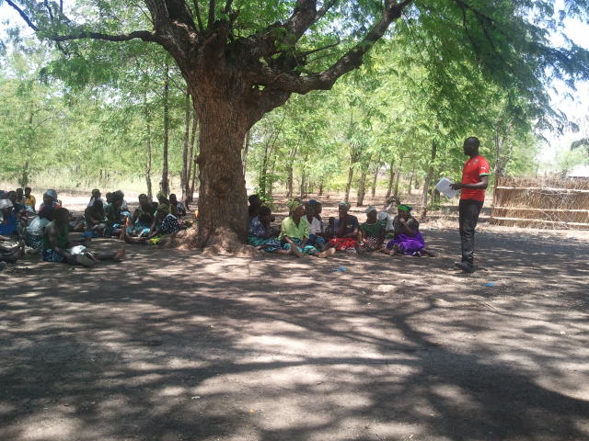
Focus Group discussion in Chikhwawa district
Household Questionnaire
The questionnaire was administered to individual programme beneficiaries to understand specific impacts of the programmes. The questionnaire (Appendix 4) was administered to men, women, youth and the elderly to understand differentiated impacts of the programme at individual, community and household level. Information at this level has helped to understand the outcome of the CMDRR programme, the progress of the programme, challenges encountered, best practices and lessons learnt. In total, 110 individuals were sampled. Of these, 60 (18 males and 42 females) were interviewed from Chikhwawa while 50 (11 males and 39 women) were covered in Nsanje.
Case study guidelines
A guideline was used to document specific community case studies and best practices (See Appendix 5). Information include the scope of the case under study, the interventions, changes observed, outcomes, cost benefit analysis, lessons learnt and future plans
Checklist for key informants
A checklist was developed for data collection at national and district level. The checklist Appendix 6 was used to collect information on how other stakeholders have observed in the programme implementation, impacts, coordination, integration, best practices, contribution to policy and national strategies, changes in livelihoods and associated resilience. Further information covered the extent to which the CMDRR approach has contributed to building the resilience of the communities, validation of climate related hazards and risks, what models can be implemented to further increase the resilience of the communities and how has the capacity building approach contributed to the programmes progress.

Appendix 1: Checklist for Document Review
Item No. | Title | Type of Document | Source | Scope | Main findings
1
2
3
4
5
6
7
8
9
10
12
13
14
15
16
17
18

Appendix 2: Checklist for CADECOM staff
Secretariat |__| District |___| Community |___|
Name of the Respondent | Gender | Position of the Officer | Section | Date of joining the Section | Date Started at current place of work | Highest Qualification

- What is your role in the CMDRR?
_____________________________________________________________________________________________________________________________________________________________________________________________________________________________________________________________________________________________________________________

- How were you involved in the programming of the activities?
______________________________________________________________________________________________________________________________________________________________________________________________________________________________________________________________________________________________________________________
- What was your level knowledge on CMDRR approaches at the start of the programme?
______________________________________________________________________________________________________________________________________________________________________________________________________________________________________________________________________________________________________________________
- What approaches were used to build your capacity in the programmes?
______________________________________________________________________________________________________________________________________________________________________________________________________________________________________________________________________________________________________________________
- How did you engage other stakeholders in the implementation of the activities
Work mates:

NGO officials:

Government officials:

Community members:

Academia:

Policy makers:

The youth:
6. What dissemination approaches did you apply?
______________________________________________________________________________________________________________________________________________________________________________________________________________________________________________________________________________________________________________________
7. How has the programme interventions influenced decision making at policy level?
______________________________________________________________________________________________________________________________________________________________________________________________________________________________________________________________________________________________________________________
8. Which strategies effectively support the implementation of the programme?
______________________________________________________________________________________________________________________________________________________________________________________________________________________________________________________________________________________________________________________
9. What approaches did you use to build the capacity of other partners?
______________________________________________________________________________________________________________________________________________________________________________________________________________________________________________________________________________________________________________________
10. What approaches did you use to build the capacity of communities?
______________________________________________________________________________________________________________________________________________________________________________________________________________________________________________________________________________________________________________________
11 What strategy is in place for knowledge and information management?
______________________________________________________________________________________________________________________________________________________________________________________________________________________________________________________________________________________________________________________
12. What mechanisms were in place to transfer knowledge to communities?
______________________________________________________________________________________________________________________________________________________________________________________________________________________________________________________________________________________________________________________
13 How has the programme empowered you in areas of lobbying and advocacy?
______________________________________________________________________________________________________________________________________________________________________________________________________________________________________________________________________________________________________________________
14 How have the communities and other partners be empowered in the areas of lobbying and advocacy? What approaches were used?
______________________________________________________________________________________________________________________________________________________________________________________________________________________________________________________________________________________________________________________
15 What strategies were put in place to effectively collaborate with partners and communities?
______________________________________________________________________________________________________________________________________________________________________________________________________________________________________________________________________________________________________________________
16 What fund raising approaches were in place during the implementation of the programmes?
______________________________________________________________________________________________________________________________________________________________________________________________________________________________________________________________________________________________________________________
17. What are the observable impacts of the CMDRR?
______________________________________________________________________________________________________________________________________________________________________________________________________________________________________________________________________________________________________________________
18 What are the outcomes of the CMDRR at national, district and community levels?
______________________________________________________________________________________________________________________________________________________________________________________________________________________________________________________________________________________________________________________
19. What is the overall impact (building resilience at community level) of the CMDRR programme? (Evidence based)
______________________________________________________________________________________________________________________________________________________________________________________________________________________________________________________________________________________________________________________
20. What is the overall impact (DRR lobby and advocacy) of the CMDRR programme? (Evidence based)
______________________________________________________________________________________________________________________________________________________________________________________________________________________________________________________________________________________________________________________
21. What are some of the challenges that the programmes has faced? How were these dealt with?
______________________________________________________________________________________________________________________________________________________________________________________________________________________________________________________________________________________________________________________
22. Briefly explain any interventions that can be showcased as a best practice?
____________________________________________________________________________________________________________________________________________________________________________________________________________________________________________________________________________________________________________________________________________________

Appendix 3: Checklist for Focus Group Discussions with Communities
Number of participants; Males {_______} Females {________}
Village name: _________________________________________________
Group Village Headman: _______________________________________
Traditional Authority: __________________________________________
District

Questions

Learning focus: Hazard assessment:

- What was the most likely natural or human-made hazard or threat identified by the community?
- What was its nature and behavior?
- What tools were used on identifying the risk
- What tools in prioritizing the disaster risk reducing the risk

Learning focus: Vulnerability assessment
- What kind of elements were at risks?
- What were the measures of degree of vulnerability of element at risk to a hazard?

Learning focus: Capacity assessment
- What were the capacities needed to address the nature of hazard
- What were the summary of capacity gaps in four areas of prevention, mitigation (addressing Hazard), individual survivability and community readiness (addressing Vulnerability)

Learning focus: Disaster Risk Analysis
- What recommendation and conclusions were drawn for disaster risk reduction?

Learning focus: Learning
- What kind of local knowledge have the communities accumulated in addressing hazard events?

Learning focus: Participatory Community Disaster Risk Assessment and Analysis

- What kind of risks did the community identify?
- What process and participatory tools enabled the people in the community to share and analyze and conclude their degree of disaster risk?
- Who participated in the risk assessment and analysis? What were their roles and responsibilities?

Learning focus: Disaster Risk Reduction (DRR) Measures
- What community plans were drawn to solve its disaster risk by translating the result of the risk assessment to development?
- What were the development plans to be taken for long term solutions and implemented before the hazards comes.
- What were the contingency plans to be taken during the hazard events?

Learning focus: Organization of Risk Reduction Group

- How were the roles and responsibilities shared?
- How often were the meeting times?

Learning focus Participatory Planning, Monitoring, Evaluation and Learning (PPMEL)

- What system was put in place for members of the community to learn, keep track of their disaster risk reduction measures and the development of their organization, identifying their strengths and weaknesses, the external threats and opportunities; and determining achievements?

Learning focus: Role of the facilitator

What kind of support did they get in the following?

- Facilitate Participatory Community Disaster Risk Assessment and Analysis
- Assist in identifying gaps and risk reduction measures
- Assist in coming up with development and contingency plans
- Assist in developing a stronger community organizations as a new emerging power at the community, leading the most at risk, to empower themselves and be part of the wider community
- Facilitate DRR project proposals to resource providers.
- Make ways and means that will complement and strengthen community DRR plans (accompaniment plan), specifically training needs and exit strategy.
- Develop success indicators based on his/her efficiency and effectiveness as DRR facilitator
- Document, prepares and submit updated reports on DRR projects
- Document and popularize change stories/impact stories, lessons learned and best practices using action photos, videos, prints and other medium.

Learning focus: CMDRR Concept conceptualization
Aim: To find out if the communities internalized the concept of CMDRR
- Processes used to conceptualize the concept (how was this initiated?
- Document process of participation in risk assessments
- Document processes for participatory planning- how was this achieved?
- What models were used to building community disaster risk management organisations
- Conceptualization of the community managed implementation
- Processes used for monitoring and evaluation
- Document redesigning process
- Assess how issues of gender and communication were incorporated.

Learning Focus: Progress towards the 5 CMDRR

  - Training of facilitators and communities on CMDRR
  - Participatory disaster rsik assessment & analysis
  - Formulation & implementation of development plans (risk prevention / mitigation) and contingende plans (preparedness)
  - Community organization for DRR
  - Community managed M& E and documentation and learning

Relationship with Donor investment

Ask the group things that the project has brought/ Or project outcomes/impacts

Appendix 4: Household Questionnaire

QUESTIONNAIRE FOR HOUSEHOLDS

IMPACT STUDY ON COMMUNITY MANAGED DISASTER RISK REDUCTION PROJECT IN MALAWI:
THE CASE OF CHIKHWAWA AND NSANJE DISTRICTS

The main objective of this questionnaire is to collect information that will help to assess the impact of the Community Managed Disaster Risk Reduction (CMDRR) at the household and community levels in Chikhwawa and Nsanje districts. The study aims to verify to which extent Cordaid’s CMDRR programme of the last 5 years in Chikhwawa Diocese of Malawi have contributed to building more resilient communities, It will provide information and data that will aim to assess the progress, outcome and impact of the programme.

MODULE 1: INTERVIEW SUMMARY
101 District Code |____|____|
01=Chikwawa 02=Nsanje
102 Traditional Authority |____|____|
01=Tengani 02= Ngabu 03= Ndamera
103 GVH (name) ___________________________
104 Village (Name) ___________________________
105 Questionnaire Number |__1__|__01__|e.g. First household in Chikhwawa
106 Date of interview |___|___|/|___|___|/|___|___| D D / M M / Y Y
109 Enumerator (Code) CMDRR |__________| e.g. 01= Enumerator 1
To be completed by Supervisor
Date: DD/ MM/Y Y
|____|____|\|____|____|\|____|____|
Name of supervisor___________________________________
Data entry clerk_____________________________________

MODULE 2: RESPONDENT DEMOGRAPHIC INFORMATION

201 Name of respondent |____________________________________________| Optional
202 Age of respondent |____| Years. If not known estimate |____|
203 Sex 1=Male 2= Female
204 Marital status |____| 1= single, 2= married, 3= separated, 4= divorced, 5= widower/widow
205 How long have you been living at your current residential place? |_____| Years
206 Highest level of education attained |____| 0=None 1= Primary, 2=Secondary,
3= Post -Secondary, 4=University degree, 5= Adult literacy,
207 Household size |___| persons
208 Are you the head of your household 1= Yes |___| 2=No |___|

MODULE 3- HOUSEHOLDS ASSETS

301 Compare the changes in the number and type of assets in 2008 and 2013 (Note: Put numbers)

Type of asset | 2008 | 2013 | Type of asset | 2008 | 2013
Plough/Ridger |  |  | Axe
Radio |  |  | Hoe
Wheelbarrow |  |  | Panga
Shovel/pick |  |  | Sickle
Treadle pump |  |  | Motorized pump
Bicycle |  |  | TV
Cell phones |  |  | Mattress
Sewing machines |  |  | Tables
Ox-cart |  |  | Household furniture
Mosquito net |  |  | Improved house
Indigenous woodlot |  |  | Exotic woodlot
Kitchen utencils |  |  | Others (Specify)

302 How has the programme assisted your household to own these assets?
1= Fund raising, 2= New agricultural technologies, 3= Improved skills, 4= Improved knowledge 5= Not application 6=Others (specify)________________________

303 Which of the project interventions has contributed to an increase sources of income?
________________________________________________________________________________________________________________________________________________________________________________________________________________________________________________________________________________________________________________________

304 Who own most of the assets? 1= Husband, 2= Wife, 3= Both, 4= Single headed

305 Who has control over the above assets
1= Husband 2= Wife, 3= Both

306 What climate change related risks/hazards affect your assets negatively? 1= Floods, 2= Prolonged dry spells, 3= Strong winds, 4= Erratic rains, 5= Erosion, 6=Others (specify)

MODULE 4: SOURCES AND CHANGE IN INCOME

401 What are your main sources of income?

1= Sales of livestock |__| 2= Sales of crops |__| 3= Ganyu |___|
4= Business |__| 5= Employment |__| 6= Other (specify) ________________

402 What was your average annual income per month in these years?
Year | 2008 | 2009 | 2010 | 2011 | 2012
Income (MK)

403 How much has the programme contributed to your household income?
1=0-25% |__|, 2= 26-50% |__|, 3= 51- 75% |__|, 4= 76-100% |__|,
5= Don’t know |__|

404 Who contribute to household basket income?
1- Husband, 2= Wife, 3= Family, 4= Aid 5= External support 6= Others_________________

405 Which intervention has provided more household income? (Tick more than one if possible) If they are keeping records collect data
1= Livestock production, |___|
2 = Fruit tree planting, |___|
3= Production of composite manure, |___|
4= Intercropped Agricultural Yield, |___|
5=Village Saving Loans |___|
6=Horticulture |___|
7=Bee Keeping |___|
8=Other Specify ___________________________

406 Which of these interventions were you involved in the CMDRR programming? (Tick more than one if possible)
1=Livestock production, |___|
2 = Fruit tree planting, |___|
3= Production of composite manure, |___|
4= Intercropped Agricultural Yield, |___|
5=Village Saving Loans |___|
6=Mushroom Production |___|
7=Bee Keeping |___|
8= winter cropping |___|
9= Growing tolerant crops |___|
10= Crop diversification
11= Small-scale irrigation
12= Promotion of drought tolerant crops
10=Other Specify ______________________

MODULE 5 IMPLEMENTATION OF THE PROGRAMME INTERVENTIONS

501 What was your level of knowledge about CMDRR in 2008?
1= High 2= Average, 3= Low, 4= None

502 What is your level of knowledge on the concept of CMDRR now?
1= High 2= Average, 3= Low, 4= None

503 To what extend did the programme allow you to acquire the following attributes during the implementation of the intervention? 1= High, 2= Medium, 3= Low, 4= None/Don’t know

Attribute | Score
Skills
Technologies
Change in attitudes
Data collection
Data management
Dissemination of results
Application of practices

Phase | Involvement level  1- Highly involved 2 = Partly involved 3= Low involvement, 4= Not involved
Conceptualisation the CMDRR process (Hazards, vulnerability, capacity assessment, risk analysis
Identifying the hazards
Disaster risk assessment
Participatory Planning
Participatory budgeting and costing
Participatory budget tracking audit
Training on community risk management organisation
Implementation CMDRR
Participatory Monitoring and Evaluation and Learning
Redesigning the programme approach

504 Were you involved in the following project cycle related interventions?

R= H* V/C
Where: R= Risk, H= Hazard, V= Vulnerability, C= Capacity

505 To what extent do you agree that the programme has contributed to the implementation of the Programme?

 | Implementation of the project parameters  1=strongly Agree, 2=Agree, 3=none, 4=Disagree, 5=Strongly Disagree | Rate your Preference
 |  | Tick
 |  | 1 | 2 | 3 | 4 | 5
1 | Diocesan Supervisory visit implemented
2 | Seed money and/ or resources given
3 | Exposure visits to successful groups implemented
4 | Different training modules conducted
5 | Community review meetings done
6 | Post-harvest management of communal produce and record keeping were conducted
7 | Community training in monitoring and data collection done
8 | Canal construction for irrigation done
9 | Soil fertility improvement through manure making implemented
10 | Follow-up on health and sanitation implemented
11 | Participatory M&E training conducted
12 | Key hazards reviewed with the communities
13 | Procurement and distribution of treadle pumps done
14 | Farmers trained in plot layout, use and maintenance of treadle pumps conducted
15 | Farmers taught on different intervention methods
16 | Poly tubes procured and distributed
17 | Agroforestry practices implemented
18 | Training in HIV/AIDS
19 | Monitoring and implementation of community risk mitigation done
20 | Key disaster risks reviewed with communities
21 | Livestock procured and passed on
22 | Tank gate valves procured
23 | Training was conducted in livestock management
24 | Drought tolerant crops procured
25 | Mapping of hazard done
26 | Training on gender done
27 | Training on Human rights done
28 | Training on lobbying and advocacy done
29 | Follow up on and governance done
30 | Exchange visit conducted

506 What was your level of skills about CMDRR in 2008
1= High 2= Average, 3= Low, 4= None

507 What is your level of skills about CMDRR now
1= High 2= Average, 3= Low, 4= None

508 What was your level of attitude about CMDRR in 2008
1= High 2= Average, 3= Low, 4= None

509 What is your level of attitude about CMDRR now
1= High 2= Average, 3= Low, 4= None

510 What are some of the major impacts/outcomes of the project?
________________________________________________________________________________________________________________________________________________________________________________________________________________________________________________________________________________________________________________________

511 What were some of the unique things you have learnt during project implementation?
________________________________________________________________________________________________________________________________________________________________________________________________________________________________________________________________________________________________________________________

512 What other things would like to be done in the project?
________________________________________________________________________________________________________________________________________________________________________________________________________________________________________________________________________________________________________________________

513 What were the challenges in implementing the project activities?
________________________________________________________________________________________________________________________________________________________________________________________________________________________________________________________________________________________________________________________

514 How can these be addressed for the success of the project?
________________________________________________________________________________________________________________________________________________________________________________________________________________________________________________________________________________________________________________________

MODULE 6: COMMUNITY CAPACITY BUILDING
601 Which approaches were used to build your capacity in CMDRR?
1= REFLECT 2= Exchange visits, 3= Class room, 4= Workshop 5= Group mapping
6= Informal
602 Who provided the training?
1= Cadecom
2= Government officials
3= NGO officials
4= Fellow farmers
5= Local leadets

603 What type of training have you received?
1= Conceptualisation of DRR |___|
2= Fund raising |___|
3= Lobbying and advocacy |___|
4= Training of trainers |___|
5= Community organisation |___|
6= Monitoring and Evaluation |___|
7=Formulation of plans |___|
8= Assessment and analysis of DRR |___|
9= Agricuture and livestock production |__|
10= Linking and learning |__|
11= Collaboration and networking |___|
12= Others (specify) ___________________

604 What are the issues that you have learnt through the training?
________________________________________________________________________________________________________________________________________________________________________________________________________________________________________________________________________________________________

605 What do you know about CMDRR?
________________________________________________________________________________________________________________________________________________________________________________________________________________________
________________________________________________________________________

606 What do you know about climate change?
________________________________________________________________________________________________________________________________________________________________________________________________________________________
________________________________________________________________________

607 What impacts have the capacity building brought at household level? (Ask for all the responses and tick for those provided)

1= Reduced water borne diseases |____|
2= Increased income |____|
3= Improved adaptation to climate risks, |____|
4= More participation in development work|____|
5= Effective use of locally available resources|____|
6=Application of DRR approaches|____|
7= Participating in data collection|____|
8= Formation of DRR plat forms|____|
9= Development of plans|____|
10= Availability of food
11= Reduction in animal deaths
12= Reduced risks |__|
13= Improved livelihoods |___|
14= Improved gender issues
15= Improved human rights issues

608 What impacts/outcomes do you observe at community level due to the project interventions? (Ask for all the responses and tick for those provided)
1= Reduced water borne diseases |____|
2= Increased income |____|
3= Improved adaptation to climate risks, |____|
4= Functional DRR committees|____|
5= Effective use of locally available resources|____|
6=Application of DRR approaches|____|
7=Establishment of DRR data bank|____|
8= Formation of DRR plat forms|____|
9= Development of plans|____|
10= Availability of food
11= Reduction in animal deaths
12= Mode development projects
13= Better coordination and collaboration
14= Reduced risks |__|
15= Improved livelihoods |___|
16= Improved gender issues
17= Improved human rights issues
609 Which new things/technologies have you learnt due to the projects?
1= Conservation agriculture with trees | ___|
2= Minimum tillage | ___|
3= Crop rotation/ crop association | ___|
4= Pit planting | ___|
5=Mulching | ___|
6= Structures for reducing floods |___ |
7= Data bank |___|
8= Early warning systems |___|
9= Winter cropping
10= Growing drought tolerant crops |___|
11=Others _________________________________

610 How are you transferring the skills that you have learnt to other people?
1= Training of facilitators |___|
2= Meetings |___|
3= Demonstrations |___|
4= One to one |___|
5= Workshops |___|
6= Others (specify) _______________

609 What are the new topic you would like to learn more?
________________________________________________________________________________________________________________________________________________________________________________________________________________________________________________________________________________________________________________________

610 What are the challenges that you faced during training and capacity building?
________________________________________________________________________________________________________________________________________________________________________________________________________________________________________________________________________________________________________________________

611 How can these be addressed for future programming?
________________________________________________________________________________________________________________________________________________________________________________________________________________________________________________________________________________________________________________________

MODULE 7: KNOWLEDGE MANAGEMENT AND DOCUMENTATION

701 To what extent to you agree that the programme has imparted knowledge on disaster risk reduction? 1= strongly agree, 2= Agree 3= None, 4= Strongely disagree

702 What has been the impact of providing clear understanding of the CMDRR at household level?
________________________________________________________________________________________________________________________________________________________________________________________________________________________________________________________________________________________________________________________

703 What has been impact of knowledge management at household level?
________________________________________________________________________________________________________________________________________________________________________________________________________________________________________________________________________________________________________________________

704 What activities were undertaken to impart and manage knowledge in this area? (Multiple responses are accepted) Mark 1 for Yes and 0for No
1= Established Universal development committees|___|
2= Collection of basic data and information |___|
3= Establishing more social/community clubs |___|
4= Planned and conducted training from CADECOM and other Government 5=Demonstrations on the effect of Disaster and risk. |___|
6= Provision quality training |___|
7= Through Information from teams from Ministry responsible for Disaster Preparedness and interventions |__|
8= Trend in disaster occurrence |__|
9= Others specify |____|

705 What type of data and records are you keeping?
1= Livestock data 2= Crop related data, 3=weather data, 4= disaster occurrence data,
5= population data, 6 natural resources data 7= Others (specify)

706 Explain in brief the data and information management approaches
______________________________________________________________________________________________________________________________________________________________________________________________________________________________________________________________________________________________________________________________________________________________________________________________________

707 What challenges are you facing in knowledge management?
________________________________________________________________________________________________________________________________________________________________________________________________________________________________________________________________________________________________

708 How can you rate the rigorous training/interactions about the risk, disaster and related documentation process
(a) Organisation facilitators’ knowledge on the subject matter?
1=Excellent; |___|2 = Moderate |___| ; 3= Poor |___|
(b) Community Support to the programme
1=Excellent; |___|2 = Moderate |___| ; 3= Poor |___|
(c) Facilitating Organisation Support
1=Excellent; |___|2 = Moderate |___| ; 3= Poor |___|

709 What new things might like to be included in the knowledge management approaches?
________________________________________________________________________________________________________________________________________________________________________________________________________________________________________________________________________________________________________________________

710 How did you rate the following training related issues as were being admistered?

1= Excellent, 2= Average, 3= Poor, 4= Don’t know

Training materials |__|
Training environment |__|
Training period |__|
Participant involvement|__|
Pedagogical skills |__|

711 What was the impact of the knowledge management in programmes?
________________________________________________________________________________________________________________________________________________________________________________________________________________________________________________________________________________________________________________________

712 What were the challenges in the capacity building/training programmes?
________________________________________________________________________________________________________________________________________________________________________________________________________________________________________________________________________________________________________________________

713 How can these challenges in capacity building be addressed?
________________________________________________________________________________________________________________________________________________________________________________________________________________________________________________________________________________________________________________________

714 How have you been involved in the documentation of best practices?
________________________________________________________________________________________________________________________________________________________________________________________________________________________________________________________________________________________________________________________

MODULE 8 PROGRESS TOWARDS 5 CMDRR STEPS

801 To what extent are you able to undertake the following activities
1= Capable, 2= Average, 3= Low 4= Not capable
Number |  | 1 | 2 | 3 | 4
1 | Training of facilitators and communities on CMDRR
2 | Participatory disaster risk assessment
3 | Formulation and implementation of development plans
4 | Community organisation for DRR
5 | Community managed M and E, documentation and Learning

802 What changes have come due to the CMDRR project?
Items | 2008 | 2009 | 2010 | 2011 | 2013
Land arable (ha)
Land irrigation (ha)
Yield Maize (Kg)
Yield Millet (Kg)
Yield Sorghum (Kg)
Yield vegetables (kg)
Cattle (Numbers)
Goats (Numbers)
Chickens (Numbers)
Rabbits (Numbers)
Burnt brick house (Numbers)
Flood resilient houses
Flood protection local bands/contours

803 General recommendation to make this programme more successful in future?
________________________________________________________________________________________________________________________________________________________________________________________________________________________________________________________________________________________________________________________
804 In general what has been your contribution in the project? Try to costs and quantify in monetary terms?

Item | 2008 |  | 2009 |  | 2010 |  | 2011 |  | 2012
Labour
Sand
Stones
Poles
Bricks

The End

Appendix 5: Case study guidelines

CASE STUDY FOR COMMUNITY MANAGED DISASTER RISK REDUCTION

The objective of this effort is to assemble an extensive set of case studies that adequately demonstrate various approaches and the value or benefit of the results of community managed disaster risk reduction projects in various communities in the Diocese.

Title
Name of the intervention by the community members.

Summary
- Fill in short / concise descriptor of scope / application / approach about the intervention and changes experienced by the community members.

Rationale (Problem or issue)
Explain in about 10 sentences the need, importance, and significance of your program In other words, describe briefly the problem situation.
Objectives
What did they want to achieve?
Methodology
What did they do to achieve the objectives?
Results
What happened as a result of the intervention, what are the key findings or results?

Programme Impact
What impact did your program have on participants, families, and communities? Have people learned new things, and are they using them in their day-to-day needs? Are people doing anything differently than they used to do before?

Future potential

What potential does your program have in the future? Help people understand your program's contribution to the well-being of the society?

Dissemination
Well-written success stories can be published as "Exemplary Programs" or "Showcase of Programs" or "Programs of Excellence" in newsletters of professional organizations, conference proceedings, local newspapers, Extension publications, Staff Updates, Impact statements, etc., and some even can be turned into a journal article.

Cost Benefit analysis of the intervention.
- Short / concise bulleted narrative.
- Duration (from start to substantially complete, i.e., results) and effort (including community contribution, in then current Malawi Kwacha) involved.
- Value from community perspective.

CADECOM role in relation to community mobilization.
Describe the role of CADECOM in meeting the above Project changes and Outcome described above.

Lesson Learnt
- Short / concise bulleted narrative of problems that arose and how to solve them in the future, e.g., unreasonable expectations.
Conclusion and Recommendation.

Write a one paragraph describing the conclusion on the project duplication to other areas. Also include at least one recommendation for any changes or improvement for the project.

Appendix 6: Checklist of key informants
Name of Organization/Ministry/ Department____________________________________
Name of the Respondent | Gender | Position of the Officer | Office/Department | Date of joining the Department | Date Started at current place of work | Highest Qualification

- What are the interventions that CADECOM is undertaking in this areas?
________________________________________________________________________________________________________________________________________________________________________________________________________________________________________________________________________________________________

- How have the communities in this area benefited from the interventions?
________________________________________________________________________________________________________________________________________________________________________________________________________________________________________________________________________________________________
- How have you been involved in the interventions?
_____________________________________________________________________________________________________________________________________________________________________________________________________________________________________________________________________________________________

- What have been the impacts/outcomes of the interventions?
________________________________________________________________________________________________________________________________________________________________________________________________________________________________________________________________________________________________
- What were the weaknesses in their approaches?
________________________________________________________________________________________________________________________________________________________________________________________________________________________________________________________________________________________________
- How can these be improved for future programming?
________________________________________________________________________________________________________________________________________________________________________________________________________________________________________________________________________________________________
- For government:
How has the interventions helped to contribute to district development plans?
________________________________________________________________________________________________________________________________________________________________________________________________________________________________________________________________________________________________

Appendix 7: Proposed community-based technology development conceptual framework depicting stages for climate change adaptation

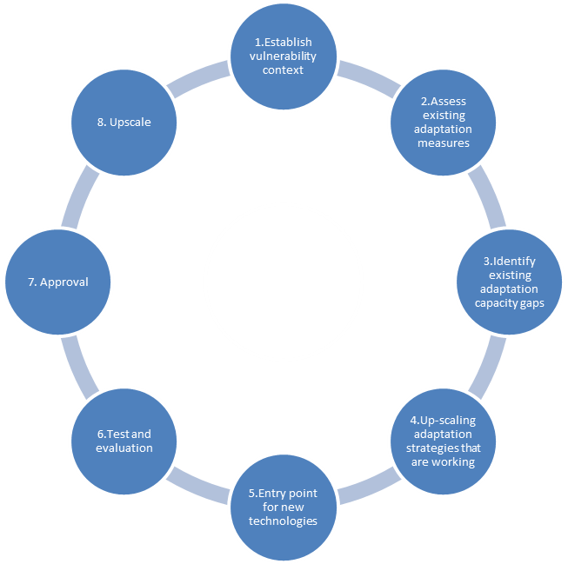

Phase I: Establishing vulnerability Context
Our observations have revealed that levels of vulnerability differ from area to area depending on several factors including poverty levels and severity to climate and weather variability related risks, livelihoods capitals among others. This requires the need to understand specific context and the scale in which various risks impose vulnerability among difference communities. The development of technologies should undergo Phase I in order to set the boundary, recognise stakeholders affected, production systems, and how they respond to various climate change stimuli. The setting of the boundary considers the importance of engaging the communities, their cultures and local knowledge- pertinent in technological development.

Phase II: Assessing existing adaptation capacity
There was clear indication of duplication of efforts and resources in development and introduction of technologies at the community level. As such, this phase is proposes undertaking a detailed assessment of the adaptation capacity of the communities and existing efforts as a starting so as to effectively utilise existing resource. This will entail identifying measures that are providing positive outcomes in terms of food security, biodiversity conservation, water and land management as well as measures that provide mitigation co-benefits such as crop diversification.

Phase III: Identify existing adaptation capacity gaps

Our findings have confirmed that the intensity and frequency of climate change relate risks are increasing in the study areas. While technologies promoted to adapt to the current experiences are perceived to be effective, they may not be adequate to address the magnitude of future impacts projected in the literature. Current technologies are limited to individual farmers leaving the larger part of the community. At this phase, a community level adaptation assessment to identify gaps and how to address them to meet projected impacts is of paramount importance. This should examine available natural resources base in terms of its resilience, the human capacity, the required financial investments at the local level and institutional capacity and local knowledge to enable them withstand climate change related future impact.

Phase IV: Up-scaling working adaptation strategies
The study indicates that there are strategies that smallholder farmers have employed over years that are supporting adaptation whilst providing mitigation co-benefits. Most of the technologies are localised within small pockets of farms by few smallholder farmers within small acreage. This phase will involve expanding working strategies (see Phase II) in meeting adaptation and mitigation needs to a large scale. The Lead Farmer Concept of Study Circles currently pursued in the study areas are promising mechanisms through which this can be achieved.

Phase V: Introducing new technologies
In case existing or working technologies are deemed inadequate for future climate change adaptation, this phase allows an entry point for introduction of new technologies proven useful elsewhere (within or outside the local area). In case there are no existing criteria for the approval of the technology, we propose the following:
- Environmental: There is need to accept the technology based on its impact on the environment. If environmental risks outweigh the benefits, there is need to review the technology. Environmental benefits should include strengthening biodiversity and promoting environmental sustainability in order to maintain or increase resilience of the agro-ecosystem.

- Awareness and Information: The technology should provide the opportunity for environmental awareness and education. It should have detailed information on how it works and the possibility of adapting to the local environment. In the absence of this information, more work will be required.
- Productivity: This is the extent to which the technology supports natural processes such as nutrient cycling to conserve adequate biological conditions for future production. It should enable farmers to produce enough and support food security and finally it should improve crop quality and productivity. The technology must be easy to disseminate and replicate.
- Economic: The technology must add value to the current adaptation measures in particular the economic benefits it will bring at household and community level. If there are any expenditure, the economic returns must outweigh the costs. Otherwise, the technology must be improved to reflect prevailing economic conditions. The technology must generate various products that can be used as food, fibre or feed.
- Cultural: The extent to which (i) respect cultural diversity (ii) allows for an inter-cultural dialogue and incorporation of ancient and local knowledge (iii) understandable and easily applied by farmers in their current context
- Political: Compatibility with existing national and global policies and can be scaled up for wider implementation

Phase VI: Testing and Evaluation

For all new technologies, the initial testing and experimenting in the field will be required. In this phase, adaptive research will by the right tool to allow scientific acidification, farmer engagement and participation. This will also provide an opportunity for wider acceptability of the technology. In terms of evaluation, issues to be considered include contribution to livelihoods entitlements, applicability in local context, labour saving, environmental compatibility, enhance social; economic, culture, no conflicts. In general, the evaluation should verify whether the technology is meeting the criteria suggested in Phase V.

Phase VII: Approval
Existing national procedures for approving new technologies must be followed. For example, the Department of Agriculture Research (DAR) could be the legitimate authority. After the technical approval, the technology must be subjected to up-scaling as in Phase IV above.

- The Ministry of Agriculture could adopt the Community-Based Technological Development framework proposed in this report in order effectively advance a more pragmatic climate change response in the agriculture and natural resource sectors.
- There are significant barriers to the diffusion of available climate-wise technologies, particularly among smallholder farmers. National investments in research, development, demonstration, and deployment of climate change mitigation and adaptation technologies must be significantly increased to spur needed levels of innovation development and absorption.
- Many players continue working in isolation resulting duplication of efforts. We recommend the development of coordination mechanisms at various organisational levels. In particular, the Ministry of Agriculture should have the authority over controlling the processes in the proposed framework. At district level, there is need to put in place institutional arrangements that will oversee the introduction of new technologies by other players.
- The lack of continuous involvement of research institutions and financing hamper progress in technological development in adaptation to climate change. Research institutions in collaboration with smallholder farmers who have local knowledge should work very closely to generate data and information that will contribute to technology development.
- In developing District Development Plans (DDP), there is a need to include the research agenda to facilitate development of technologies for specific vulnerability contexts.
- Mechanisms for up-scaling technologies that are working are lacking. As such, existing structures within the farming systems should be utilised to facilitate technological research and development for example the use of the lead farmer concept should be explored.
- We recommend that the lead farmer or study circle groups could be used with the engagement of organisations that are working with farmers at community level.

Government of Malawi (2006) Chikwawa Development Plan 2006-2009. Chikwawa, Malawi
This is a traditionally elected leader heading between 5-15 villages within a community. He reports to the Traditional Authority who in turn report to the District Commissioner
As of October 2013, USD$1= MK400.00
The amount of money that households have available for spending and saving after income taxes have been accounted for
SA= Strong agree, A= Agree, N= Not agree and D= Disagree
Technologies for Climate change adaptation- Agriculture Sector. UNEP (2011)

