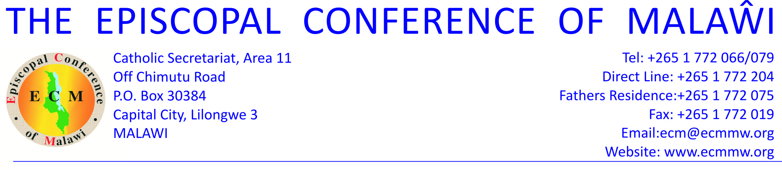

**11 October, 2014**

**SPECIAL ANNOUNCEMENT**

**CONCERNING THE CRUSADES SCHEDULED FOR OCTOBER 2014 IN LILONGWE**

The Catholic Secretariat of the Episcopal Conference of Malawi (ECM) has been receiving calls from different media stations and individuals concerning the crusades scheduled for the above-mentioned dates.

We wish to announce to the Catholic faithful, especially the youth, that the Catholic Church is not part of this arrangement.

While the ECM champions ecumenism in Malawi, the bishops require that they consent to any ecumenical activities, which has not been the case with the said activities. As such, Catholics that wish to attend these sessions will do so at their own will.

We also wish to remind the faithful that October is traditionally the Marian and mission month for the Church. Therefore, Catholics are expected to promote the activities as organized in their parishes for these causes.

Reverend Fr Emmanuel Chimombo.

**National Pastoral Secretary.**